Oregon SIP Infrastructure for Addressing the Interstate Transport of Ozone and Fine Particulate Matter

Clean Air Act Section 110(a)(2)(D)

Oregon Department of Environmental Quality

November 5, 2009

Contents

Addressing Interstate Pollutant Impacts under the Clean Air Act 3
1. Significant Contribution to NAAQS Violations 5
2. Interfere with Maintenance Requirements 13
3. Prevention of Significant Deterioration Requirement 17
4. Protect Visibility Requirement 18

Contact:

Carrie Capp
Air Quality Division
(503) 229-5035

Addressing Interstate Pollutant Impacts under the Clean Air Act

Overview

Some amount of air pollution transport occurs routinely across all state borders and across all regions of the country. This document discusses Oregon’s ability to address interstate air pollution transport as it relates to four key aspects of the Clean Air Act; compliance with federal air quality health standards for PM2.5 and ozone, maintenance with federal air quality health standards for PM2.5 and ozone, prevention of significant deterioration, and the protection of wilderness areas and national parks from air pollution that causes “haze” and can degrade visibility. Based on the information summarized in the sections that follow, DEQ concludes that particulate and ozone precursor emissions from Oregon sources do not significantly contribute to violations of national ambient air quality standards in other states, or interfere with other states efforts to meet air quality standards, prevent significant air quality degradation, or protect visibility. In developing this submittal DEQ consulted with EPA staff and air quality agencies in Washington, California, Nevada and Idaho. DEQ’s conclusions are based on its understanding of air pollution problems in adjacent states, and the emission sources, meteorology (weather patterns), and topographic features (mountain ranges, etc.) that influence air quality problems in these states.

DEQ will collaborate with Washington, Idaho, Nevada, California and other state air agencies whenever necessary to evaluate case-specific air quality problems that may involve regional transport of air pollution. DEQ’s Section 110 infrastructure SIP provides the framework and legal mechanism for DEQ to act as needed to reduce any Oregon emissions found to significantly contribute to air quality problems in other states. Two recent examples of DEQ’s ability and willingness to address problems involving interstate transport are the Portland-Vancouver ozone attainment and maintenance plans, and Oregon’s regional haze plan. The cities of Portland, Oregon and Vancouver, Washington share a common air shed. In the mid 1990s and again in 2007 DEQ collaborated with the Southwest Clean Air Agency (i.e. the air agency with jurisdiction over Vancouver) to develop bi-state ozone attainment and maintenance plans. These plans included emission reduction strategies needed to attain and maintain compliance with federal ozone standards. In 2008-09 DEQ worked with the States of Washington, Idaho and California, as well as Federal Land Managers in developing Oregon’s Regional Haze plan. Under that plan DEQ adopted several emission reduction strategies, including emission control requirements for the PGE Boardman coal-fired power plant, to reduce the interstate transport of haze forming emissions.

The map below (Figure 1) illustrates the significant distances and mountain ranges that in many areas separate Oregon from communities in Washington, California, Idaho, and Nevada, and can help limit the long range transport of air pollution. DEQ’s consultation with air agencies in adjacent states suggests that high PM2.5 levels in their respective communities are driven largely by local pollution sources during events of air stagnation. Local air stagnation events would generally preclude interstate air pollution transport as a significant contributor to high PM2.5 levels jeopardizing NAAQS compliance. Conceptually, regional emissions from all Pacific Northwest states could play some small role in regional background ozone levels depending on the location and circumstances; however, based on the discussion presented in this document DEQ concludes that Oregon does not significantly contribute to ozone problems in other states. If any future violations of ozone standards occur, Oregon would work with other air agencies and EPA as necessary to evaluate the role of interstate air pollution transport. Regarding regional haze pollution, DEQ will continue to work with other states, federal land managers, and others on interstate transport issues for haze pollution through its on-going state Regional Haze planning process.

Figure 1: Map of Oregon and major mountain ranges 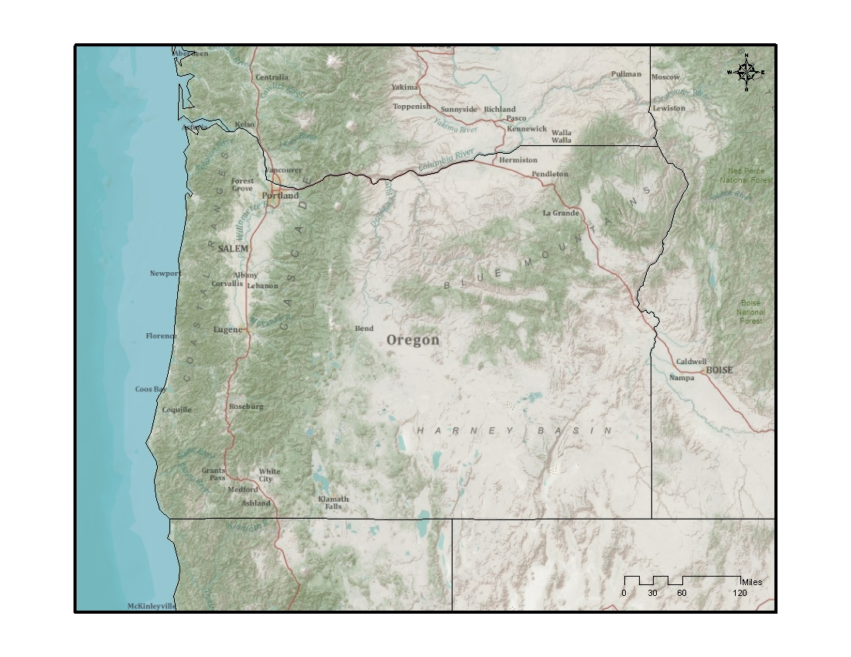
Section 110(a)(2)(D)(i) of the Clean Air Act

The state of Oregon developed this SIP revision to meet requirements under Section 110(a)(2)(D)(i) of the Clean Air Act. In 2006 and 2007 respectively, EPA promulgated revised primary and secondary National Ambient Air Quality Standards (NAAQS) for fine particulate (PM2.5) and ground level ozone (O₃). When EPA adopts a new or revised NAAQS, each state must ensure that its SIP is adequate to implement, maintain, and enforce the NAAQS. Among other things, the SIP must meet the interstate transport requirements of Section 110(a)(2)(D)(i) of the Act.

Section 110(a)(2)(D)(i) requires each state to submit a SIP that ensures a state can and will prohibit any emissions source or other type of emissions activity within the state from emitting air pollutants in amounts that will:

- Contribute significantly to nonattainment or interfere with maintenance of a primary or secondary NAAQS in another state, or
- Interfere with measures in another state’s SIP to prevent significant deterioration of air quality or protect visibility.

EPA issued guidance to the states on August 15, 2006, and additional guidance on September 25, 2009 regarding Section 110(a)(2)(D)(i) requirements for the 8-hour O₃ and PM_{2.5} NAAQS. The state of Oregon relied on both guidances in developing this document. The EPA guidance divides Section 110(a)(2)(D) requirements into the following four categories:

- “Significant Contribution” requirement.
- “Interfere with Maintenance” requirement.
- “Prevention of Significant Deterioration” requirement.
- “Protect Visibility” requirement.

Each of these categories is discussed below.

1. Significant Contribution to NAAQS Violations: Section 110(a)(2)(D)(I)

The Oregon State Implementation Plan (40 CFR 52 Subpart MM) provides the mechanism required under the Clean Air Act to prohibit as necessary any emissions source or type of emissions activity within the state from emitting air pollutants in amounts that will contribute significantly to nonattainment in another state with respect to the PM_{2.5} and 8-hour ozone (O₃) NAAQS. DEQ can and would take action as necessary to assist states in preventing or correcting any violation of federal air quality health standards.
Location of Nonattainment Areas in Neighboring States and General Topography:

For PM2.5, the closest nonattainment areas in neighboring states are the Tacoma area (Pierce County) in Washington; the Chico area (portions of Butte County) in California, and the Cache Valley area in Southeast Idaho (portions of Cache County, Utah and Franklin County, Idaho). For Ozone, currently all areas in Washington, Idaho and northern California are designated as attainment/unclassifiable by EPA. See Figures 2 and 3 for EPA maps of currently designated ozone and PM2.5 nonattainment areas.

The area of highest Oregon emission densities (Portland Metro area) is separated from ozone and PM2.5 nonattainment areas in Washington, Idaho and California by significant distances and major mountain ranges up to approximately 7,000 feet (see Fig 1). The one exception is the Portland-Vancouver metro area, which shares a common air shed between Oregon and Washington. As discussed below, both Portland and Vancouver are in attainment with both the PM2.5 and 8-hour ozone standards. The Portland-Vancouver air shed is managed for ozone under the bi-state Portland-Vancouver ozone maintenance plan. Distances from the Portland-Vancouver Metro areas to neighboring nonattainment areas are significant: Portland to Tacoma, WA – approx. 120 miles, Portland to Franklin County, Idaho – approx. 590 miles, Portland to Seattle, WA – approx. 145 miles, Portland to central California nonattainment areas (e.g. Sacramento, San Francisco Bay Area, Los Angeles range from approximately 500 to 800 miles.

Figure 2: EPA Map of designated PM2.5 nonattainment areas Regions 9 and 10 (2009)
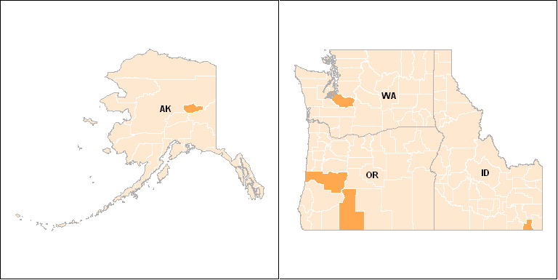

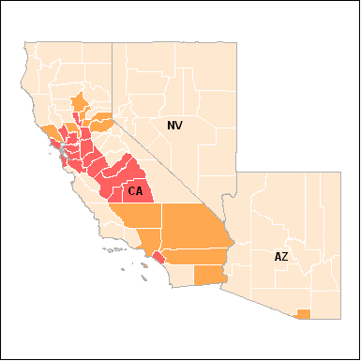

Figure 3: EPA Map of designated 8-hr ozone nonattainment areas (2009)

Meteorology/Climatology: Violations of the 24-hr PM2.5 NAAQS in neighboring states occur under winter conditions when air speeds are low and/or localized air inversions occur. Figure 4 below illustrates typical seasonal wind patterns during the winter when PM2.5 levels are highest. Wind direction is typically variable with the majority of wind speeds less than 8 miles per hour, and a significant portion of low winds less than 5 miles per hour. These low wind speeds and air stagnation conditions do not lend them to long distance air pollution transport. The Portland area can experience high wind speeds in the winter travelling through the Columbia River Gorge east of Portland. These high wind conditions (i.e. good ventilation) are not conducive to the buildup of air pollution. General meteorology supports the conclusion that high winter time PM2.5 levels in Pacific Northwest communities are typically dominated by local emission sources.

Figure 4: Example wind rose for winter PM2.5 season.

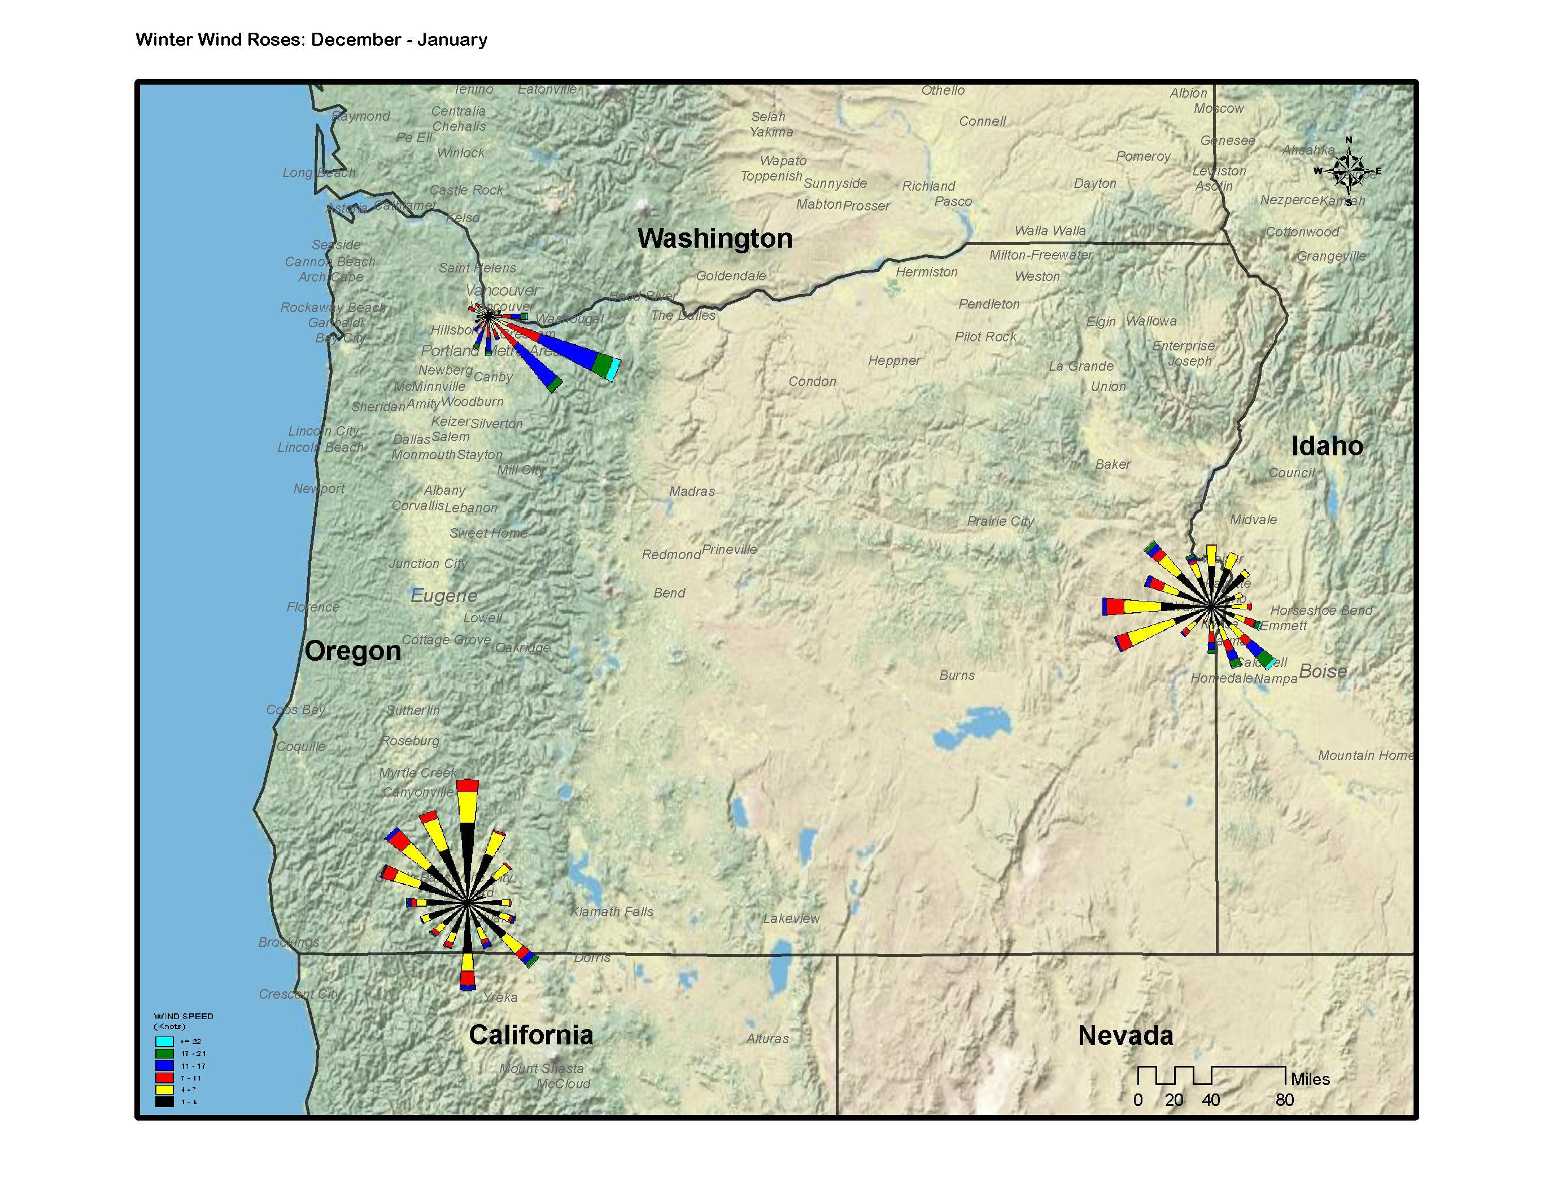

In the Pacific Northwest, exceedances of the 8-hr ozone standard occur in the summer months. In Oregon, prevailing winds are predominantly from the north to northwest and would preclude any significant influence from Oregon on Washington ozone nonattainment areas (see Figure 5). Prevailing summer winds could result in some interstate transport of ozone forming emissions from Oregon to western Idaho, Nevada and northern California. However as discussed in the sections below, significant distances and topography (such as major mountain ranges that separate Oregon from California, Idaho and Nevada) would likely minimize the significance of these impacts on other states. For example, the largest major urban center in Oregon (the greater Portland area) is approximately 400 to 700 miles away from urban areas in western Idaho, Nevada, and northern California, and is separated by at least one major mountain range (the Cascades). DEQ has consulted with air agencies in each state and concludes that Oregon emissions do not play a significant role in high ozone levels in others states. Oregon’s infrastructure SIP provides DEQ the ability to work with EPA and others states as needed to address regional ozone problems in the future should they arise.

Figure 5: Example wind rose for summer ozone season.
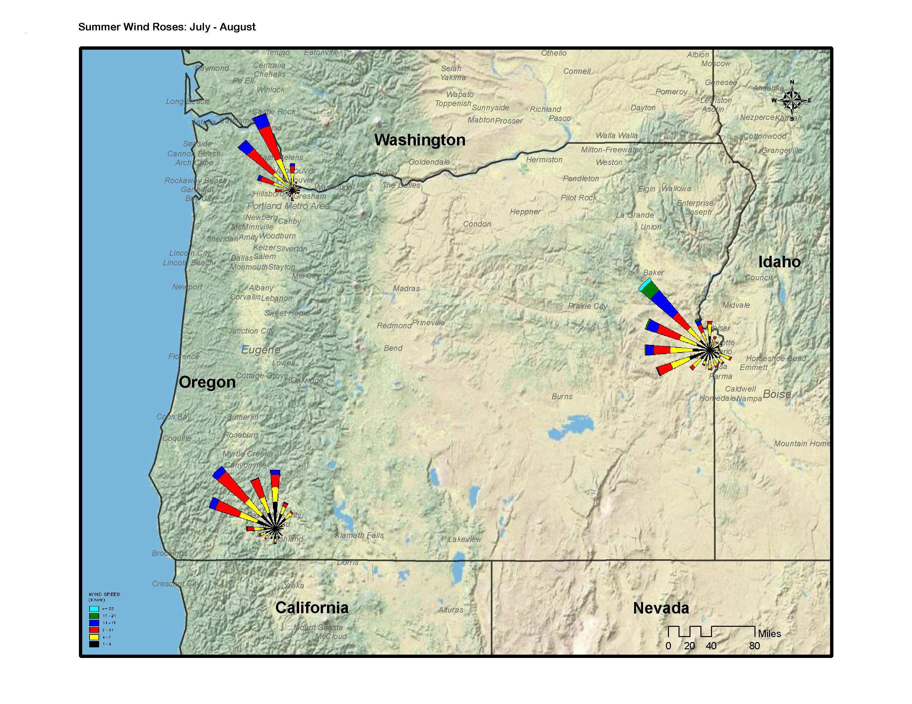

Monitoring: Figures 6 and 7 show the distribution of 2008 federal reference PM2.5 and ozone monitoring in Oregon, Washington, Idaho, Nevada and California. In the sections below, DEQ describes ozone and PM2.5 attainment problems areas in these other states, as well as likely contributing sources based on conversations with other state air agencies. Monitoring data in all states is reviewed routinely by air agencies and EPA. High PM2.5 or ozone levels that threaten the NAAQS are investigated as needed to identity contributing sources, including any potential role of interstate transport. The state Section 110 infrastructure SIP elements ensure the capacity for each state to coordinate with each other and with EPA to characterize air quality data, identify contributing emission sources (both local and regional) and evaluate other factors that may jeopardize NAAQS compliance.

Figure 6: Map PM2.5 Monitoring (FRM)

Figure 7: Map Ozone (O3) Monitoring (FRM)

Modeling: As part of EPA’s initial development of the federal interstate air pollution rule, known as CAIR (Clean Air Interstate Rule) EPA modeled air transport to determine any significant contributions to nonattainment. EPA concluded that because of geography, meteorology, and topography it was reasonable to exclude the Western U.S from the CAIR rule. Based on EPA’s conclusions , and the information summarized in this document, DEQ believes that additional modeling of interstate PM2.5 or ozone transport is not needed at this time to support DEQ’s conclusions.

Summary of Consultation with Washington, Idaho, Nevada, and California.

In preparing this document, DEQ consulted with air agency staff in Washington, Idaho, Nevada and California to determine the ozone and PM2.5 nonattainment status of communities, and get a sense of what the local air agencies believe are the likely causes of air quality concerns or violations of PM2.5 and ozone NAAQS. The following sections summarize DEQ’s discussion with each state air agency and DEQ’s review of EPA technical support documentation for recent nonattainment area designations.

WASHINGTON

Washington PM2.5 Nonattainment

In December 2007, the State of Washington recommended that a portion of Pierce County (Tacoma area) be designated nonattainment for the 2006 24-hr PM2.5 standard. EPA has concurred with the states recommended nonattainment area designation and boundary. Pursuant to section 107(d) of the Clean Air Act, EPA must designate as nonattainment those areas that violate the NAAQS and those nearby areas that contribute to violations. The state of Washington and EPA evaluated nearby counties in the Seattle, Tacoma and Olympia areas for their contributions to fine particulate levels in the Tacoma area; including an assessment of pollutant emissions, air quality data, population density and degree of urbanization, traffic, growth, meteorology (including back trajectories), and topography. Based on this analysis, EPA has designated the Wapato Hills-Puyallup River Area (a portion of Pierce County) as nonattainment for PM2.5.

Significant emission sources in the Wapato Hills-Puyallup River area contributing to wintertime PM2.5 violations include outdoor open burning (24%), mobile sources (27%), fireplace and woodstove emissions (39%), and miscellaneous other sources (10%). Air emissions from the state of Oregon were not identified by Washington or EPA as a contributor to violations of the PM2.5 standard.

Portland-Vancouver Interstate Ozone Area

The Portland-Vancouver Interstate Ozone Area comprises Portland, Oregon and Vancouver, Washington. The area was a maintenance area for the 1-hour ozone standard, and has been meeting the 8-hour ozone NAAQS since the standard was promulgated in 1997. In 2007, the Oregon Department of Environmental Quality (OR DEQ) and Southwest Clean Air Agency (SWCAA, Vancouver, WA) worked together on a modeling analysis and updated ozone maintenance plan that demonstrates that the Portland-Vancouver area will continue to attain the O₃ NAAQS through 2015. This bi-state plan will ensure Oregon and Washington emission sources do not interfere with maintenance of the ozone NAAQS. EPA is currently reviewing the Portland-Vancouver ozone maintenance plan.

IDAHO

Idaho PM2.5 Nonattainment

EPA has designated portions of the Cache Valley area in Southeast Idaho as nonattainment for PM2.5. The nonattainment area boundary encompasses portions of Cache County, Utah and Franklin County, Idaho. In establishing the nonattainment boundary the State of Idaho and EPA evaluated information on significant contributing emissions sources, including factors such as an assessment of pollutant emissions, air quality data, population density and degree of urbanization, traffic, growth, meteorology and topography.

Franklin County is essentially topographically separate from the rest of the state as it is surrounded by mountain ranges. EPA concluded that it is very unlikely that surrounding counties contribute to violations of PM2.5 standards. EPA further concludes, along with both the states of Idaho and Utah, that exceedance levels of PM2.5 are produced by air inversions and confined to the lower Valley areas. Thus no areas other than the partial county areas in Cache and Franklin Counties are appropriate for consideration within the nonattainment area. EPA’s conclusion indicates that air emissions from Oregon do not contribute to PM2.5 nonattainment. Oregon DEQ supports this conclusion.

Ozone Nonattainment:

As Shown in Figure 3, all counties in Idaho are in compliance with federal ozone standards.

CALIFORNIA

Northern PM2.5 Nonattainment:

The Chico area (lower elevation portions of Butte County) is the most northerly area in California currently designated nonattainment for PM2.5. The state of California and EPA conducted an analysis to identify emission sources contributing to violations of the PM2.5 NAAQS and to designate an appropriate nonattainment area boundary. This analysis included an evaluation of emissions data (primary and secondary PM2.5 such as SO2, NOx, VOC and NH3), as well as air quality data, population density and degree of urbanization, traffic, growth, meteorology and topography. An analysis of air pollution rose indicates that elevated levels of 24-hr PM2.5 concentrations for the Chico area occurs primarily when the wind is from the south, but occasionally when the wind is from the north. The pollutant rose analysis also indicates that elevated 24-hr PM2.5 values occur during the cool season, during periods of low wind speeds. These meteorological conditions would preclude significant air pollution transport from Oregon. EPA concludes that the majority of contributing PM2.5 emissions is from local residential wood smoke, with some PM2.5 contribution from surrounding county sources. Air emissions from the state of Oregon were not identified by California or EPA as a contributor to violations of the PM2.5 standard.

Ozone Nonattainment:

Mid-state ozone nonattainment areas include metro areas such as Sacramento and the San Francisco Bay Area. Distances from the Portland-Vancouver Metro area to mid-state California are on the order of 500 miles. More southerly portions of California such as Los Angeles are designated as nonattainment for ozone as well and are on the order of 500- 800 miles from Oregon. Oregon DEQ and California air agency staff do not believe that Oregon contributes to ozone NAAQS violations in California given the long distances involved, topographic features and weather patterns that would limit any significant ozone transport from Oregon.

NEVADA

PM2.5 Nonattainment

The entire state of Nevada was classified attainment/unclassifiable under the 1997 PM2.5 NAAQS.
EPA is in agreement with Nevada's recommendation that the entire state be designated attainment/unclassifiable based on the 2006 PM2.5 NAAQS.

Nevada Ozone

The Las Vegas area was designated as an ozone nonattainment area based on the 1997 ozone NAAQS. The rest of the state was designated as unclassifiable/attainment. Nevada has recommended the same designations for the 2008 Ozone NAAQS as for the 1997 standards. The air agency for Clark County (Southern Nevada) has conducted detailed studies, emissions inventories, and modeling work to address ozone issues. Study results indicate that Clark County is often impacted by transport of ozone and ozone precursors primarily from Southern and Central California; and under certain scenarios, by transport from areas outside of the southwestern region (including Southern California and Arizona). Nevada has no data suggesting impacts on ozone concentrations in Southern Nevada caused by transport from the state of Oregon.

Conclusion:

Based on the information described above, DEQ concludes that emissions from air pollution sources in Oregon do not significantly contribute to nonattainment of the 8-hour ozone or PM2.5 NAAQS in other states.

2. Interfere with Maintenance Requirements:

Section 110(a)(2)(D)(I)

The Oregon State Implementation Plan (40 CFR 52 Subpart MM) provides the mechanism required under the Clean Air Act to prohibit as necessary any emissions source or type of emissions activity within the state from emitting air pollutants in amounts that will interfere with the maintenance of PM_{2.5} and 8-hour O₃ NAAQS in another state.

As described earlier in this document, factors such as major mountain ranges, significant transport distances, and the nature of high ozone or PM2.5 events (such as seasonal wind flows and winter air stagnation events) make it unlikely that emissions transport from Oregon would interfere with the maintenance of ozone or PM2.5 NAAQS in other states. DEQ’s Section 110 infrastructure SIP ensures that Oregon DEQ has the ability to participate as needed in future studies on regional air pollution issues, or collaborate with other states if air quality concerns are identified that require a case-specific evaluation of interstate transport. Oregon’s infrastructure SIP also ensures the legal mechanism for DEQ to take action as needed to reduce emissions to help attain or maintain compliance with federal NAAQS.

Topography/Meteorology/Climatology: The same topography and meteorology described in Section 1 above applies when evaluating maintenance of NAAQS in adjacent states. High PM2.5 concentrations in adjacent states typically occur under winter conditions when air speeds are low and/or localized air inversions occur. Figure 4 above illustrates typical seasonal wind patterns during the winter when PM2.5 levels are highest. Wind direction is typically variable with the majority of wind speeds less than 8 miles per hour, and a significant portion of low winds less than 5 miles per hour. These low wind speeds and air stagnation conditions do not lend them to long distance air pollution transport.

Occasional high 8-hr ozone levels occur in the summer months. Prevailing winds in Oregon are predominantly from the north to northwest and would preclude any significant influence from Oregon on Washington ozone nonattainment areas (see Figure 5). Prevailing summer winds could theoretically result in some interstate transport of ozone forming emissions from Oregon to western Idaho, Nevada and northern California. However as discussed in the sections above, significant distances and topography (such as major mountain ranges that separate Oregon form California, Idaho and Nevada) would likely minimize the significance of these impacts on other states. For example, the largest major urban center in Oregon (the greater Portland area) is approximately 400 to 700 miles away from urban areas in western Idaho, Nevada, and northern California, and is separated by at least one major mountain range (the Cascades). As shown in Figures 6 and 7 and discussed in the next section, EPA’s monitoring data for 2006-2008 shows that both PM2.5 and ozone design values in all counties adjacent to Oregon are below the PM2.5 and ozone NAAQS.

Monitoring:

EPA monitoring data for 2006-2008 shows that both PM2.5 and ozone design values in all counties immediately adjacent to Oregon are below the PM2.5 and ozone NAAQS.

Three northern California Counties (not adjacent to Oregon) have PM2.5 or ozone design values above the NAAQS but have not yet been designated nonattainment by EPA. Plumas and Shasta counties in northern California have 24-hr PM2.5 design values above the NAAQS. Tehama County in northern California has an 8-hr ozone design value above the ozone NAAQS. Consultation with air agency staff in these counties suggests the primary cause of PM2.5 exceedances are local wintertime woodstove smoke, summertime road dust and wild fire impacts, and possibly some local industry. In Plumas Co, high ozone values are typically experienced when transport winds are from the southwest, not from the north. Plumas County is downwind from the Sacramento metro area, and southerly winds are thought to produce the highest ozone readings.

Similarly, in Tehama Co., measurement of ozone transport suggests the main area of influence to be the greater San Francisco Bay Area. Ozone transport monitoring in Tehama Co. is located at the 2000-foot level, and suggests that predominant transport winds move pollution through the San Francisco bay/delta areas; blow along the foothills and up to the monitor.

No other attainment counties in Washington, Nevada, Idaho, or northern California have design values violating the PM2.5 or ozone NAAQS. Monitoring data and conversations with state and county air agency staff (summarized here and below) supports DEQ’s conclusion that Oregon emission sources are not interfering with NAAQS maintenance in adjacent states.

Summary of Consultation with Washington, Idaho, Nevada, and California.

As in Section 1 above, DEQ consulted with air agency staff in Washington, Idaho, Nevada and California to determine the ozone and PM2.5 status of communities, and get a sense of what the local air agencies believe are the likely causes of air quality concerns for maintaining compliance with PM2.5 and ozone NAAQS. The following sections summarize DEQ’s discussion with each state air agency and DEQ’s review of EPA monitoring data for Washington, Idaho, Nevada, and California.

WASHINGTON

PM2.5 Maintenance: As shown in Figure 2, with the exception of the Tacoma area all other areas in Washington are designated as Unclassifiable/Attainment at this time. If any Washington PM2.5 nonattainment areas are identified in the future ODEQ will work with the Washington Department of Ecology or Southwest Clean Air Agency as needed to evaluate any contribution from interstate air pollution transport. DEQ’s infrastructure SIP ensures the ability to collaborate with other air agencies on transport analysis when and if needed.

Ozone Maintenance: As shown in Figure 3, all counties in Washington are currently in attainment with ozone standards. The city of Seattle currently meets the federal ozone NAAQS. Each summer, Seattle experiences elevated ozone levels that typically occur under northerly winds (i.e. winds blowing from north to south). This strongly suggests that Oregon emissions sources (approximately 175 miles to the south of Seattle) have no significant affect on Seattle’s summer peak ozone events. If future violations of ozone standards occur in Seattle, or other areas of Washington, DEQ will collaborate with Washington air agencies as needed to evaluate any contribution from regional interstate air pollution transport.

IDAHO

PM2.5 Maintenance: In the Northern part of the state the community of Pinehurst experiences high levels of PM2.5 and the state is working with EPA on strategies to prevent the area from reaching nonattainment status. The area also has PM10 issues with the biggest contributing source being wood stoves. The elevated levels occur during periods of air stagnation so it is very unlikely other areas in Idaho or interstate transport are contributing to the increased levels of particulate.

Ozone Maintenance: While currently in attainment status, Boise is seeing monitored concentrations of ozone at levels that are occasionally close to the NAAQS. Idaho DEQ will be closely monitoring these levels and will likely investigate contributing sources. There is no information at this time to suggest any significant contribution from Oregon emission sources. DEQ will collaborate with Idaho DEQ as needed to evaluate any role of intrastate transport.

CALIFORNIA

PM2.5 Maintenance: Modoc, Siskiyou, Plumas, and Shasta counties in northern California experience evaluated PM2.5 levels, primarily in the winter due to air stagnations and local sources such as woodstoves, but occasionally in the summer due to wildfire smoke. Occasional exceedances of the PM2.5 NAAQS are measured, but no areas have been designated as nonattainment for PM2.5. Wood burning devices are a common residential heat source in these areas, and NAAQS exceedances are thought to be a result of both woodstove smoke and coinciding inversions. The Siskiyou mountain range (approx 6,000 to 7,000 feet) separates western Oregon from California and would help limit the transport of air pollution into California. It is unlikely that Oregon air pollution sources would significantly contribute to NAAQS exceedances in northern California given the local topography, significant distances involved (on the order of 50 to 100 miles or more), and the air stagnation meteorology that helps produce high winter time PM2.5 levels.

Ozone Maintenance: As shown in Figure 3, both the North Coast Air Basin (Del Norte, Humboldt. Mendicino, Sonoma (part) and Trinity Counties) and the Northeast Plateau Air Basin (Lassen, Modoc, and Siskiyou Counties) are designated as Unclassifiable/Attainment for the 2006 Ozone NAAQS. Collectively, these two basins constitute the northern portion of California where the interstate transport of Oregon ozone forming emissions could potentially occur based on seasonal wind patterns. While northern California has not experienced any ozone violations, there have been a few days of elevated levels (summertime events). California air agencies may further investigate ozone levels and transport in these areas, and Oregon DEQ can collaborate as needed in such studies; however, DEQ’s consultation with air agency staff in these counties suggest that high ozone values in these areas are influenced primarily by the Sacramento or San Francisco areas under northerly winds. There is no evidence to suggest any significant contribution from Oregon.

NEVADA

PM2.5 Maintenance:

As shown in Figure 2, the entire state of Nevada has been classified attainment/unclassifiable under PM2.5 NAAQS.

Ozone Maintenance:

As shown in Figure 3, with the exception of the Las Vegas area in southern Nevada, the entire state has been designated by EPA as attainment/unclassifiable with the ozone NAAQS.

Clean Air Interstate Rule (CAIR)

As described in the overview, based on available information Oregon DEQ concludes that particulate and ozone precursor emissions from Oregon sources do not significantly contribute to violations of national ambient air quality standards in other states, or interfere with other states efforts to meet air quality standards. In 2004, EPA reached this same conclusion as part of their initial development of the federal interstate air pollution rule, known as CAIR. Clean Air Interstate Rule (CAIR)

At the time the CAIR rule (then titled “Rule to Reduce Interstate Transport of Fine Particulate Matter and Ozone (Interstate Air Quality Rule).” was initially proposed, EPA conducted an analysis to identify states that were contributing significantly to nonattainment of PM_{2.5} and O₃ in adjacent states. The Preamble to the proposed federal Interstate Air Quality Rule stated the following with regard to Oregon:

In analyzing significant contributions to nonattainment, we determined it was reasonable to exclude the Western U.S., including the States of Washington, Idaho, Oregon, California, Nevada, Utah and Arizona from further analysis due to geography, meteorology, and topography. Based on these factors, we concluded that the PM_{2.5} and 8-hour ozone nonattainment problems are not likely to be affected significantly by pollution transported across these States' boundaries. Therefore, for the purpose of assessing State's contributions to nonattainment in other States, we have only analyzed the nonattainment counties located in the rest of the U.S.

Conclusion:

Based on the information described above, DEQ concludes that emissions from air pollution sources in Oregon do not interfere with the maintenance of the 8-hour ozone or PM2.5 NAAQS in other states.

3. Prevention of Significant Deterioration Requirement: Section 110(a)(2)(D)(i)

The state of Oregon concludes that the Oregon State Implementation Plan (40 CFR 52 Subpart MM) provides the mechanism required under the Clean Air Act to prohibit as necessary any emissions source or type of emissions activity within the state from emitting air pollutants in amounts that will interfere with another state’s SIP measures for preventing significant deterioration of air quality or protecting visibility.

Oregon has no EPA designated 8-hour O₃ nonattainment areas, and has two designated PM2.5 nonattainment areas. For most of the state, Oregon will permit new major industrial sources through the Prevention of Significant Deterioration (PSD) program for these pollutants. DEQ’s New Source Review (NSR) rules ensure that the maintenance of NAAQS in neighboring states is not jeopardized by new or expanding industrial sources. Specifically, all new industrial sources and major modifications to existing industrial sources in attainment areas are subject to DEQ PSD rules requiring pre-construction review, air quality analysis, the application of any required emission control technology, and air permitting. All new sources and major modifications in nonattainment areas are subject to the nonattainment New Source Review provisions of these rules, including LAER, offsets, and netting air quality benefit. DEQ is on schedule to update the rules to address PM2.5. Oregon’s PSD program also includes procedures to address Phase-II requirements of the Final Rule to implement the 8-Hour Ozone National Ambient Air Quality Standard.

Non-interference and visibility measures and protection of Class-I area visibility in neighboring states is achieved through the visibility and Air Quality Related Value requirements of the PSD rules. Adjacent states and Federal Land Managers are notified of any proposed new or expanding major industrial source that may have the potential for significant impacts in their states or regions and provided the opportunity to review and comment on air quality analyses. In addition to reviewing any DEQ analysis, Federal Land Managers may also submit visibility impact analysis to DEQ for consideration during the industrial source permitting process.

New Nonattainment Areas for PM_{2.5}

The communities of Klamath Falls and Oakridge, Oregon have recently been designated nonattainment for PM2.5 by EPA. Oregon DEQ and the Lane Regional Air Pollution Agency (LRAPA) will develop PM2.5 New Source Review (NSR) procedures as part of each community’s PM2.5 attainment plan. These plans, together with supporting rules, will be adopted as an amendment to the state of Oregon SIP.

4. Protect Visibility Requirement: Section 110(a)(2)(D)(i)(II)

EPA’s Regional Haze regulations required that states submit Regional Haze plans to EPA by December 17, 2007. Most states have been delayed in submitting their regional haze plans (SIP revisions), primarily due to the complexity of conducting Best Available Retrofit Technology (BART) analysis for selected older industrial sources. Oregon submitted its regional haze plan to EPA for review and approval July 14, 2009. Oregon DEQ will continue to collaborate with the states of California, Washington and Idaho, EPA, Federal Land Managers, and many others to develop regional strategies for reducing haze across the Pacific Northwest. Oregon’s Regional Haze Plan was deemed complete by EPA in September 2009, and is now being reviewed for approval. The plan includes emission reduction requirements for several older major industrial facilities, including stringent pollution control requirements for Portland General Electric's coal-fired power plant near Boardman. The new requirements will result in significant visibility improvements and reduced pollution for the region’s Class I wilderness areas and national parks as well as the Columbia River Gorge National Scenic Area.

-###-

40 CFR Ch. 1 Part 81 Subpart C Section 107, Attainment Status Designations, 7-1-08 Edition
Proposed rule at 69 FR 4566, January 30, 2004.
69 FR at 4581, January 30, 2004.
70 FR 71612, November 29, 2005 .
64 FR 3517, July 1, 1999.

