Oregon State Implementation Plan Revision Addressing the Interstate Transport of Nitrogen Dioxide (NO₂), Sulfur Dioxide (SO₂), Lead (Pb) and Fine Particulate Matter (PM 2.5)

Clean Air Act Section 110(a)(2)(D)

Oregon Department of Environmental Quality

May 12, 2015

Contents

Addressing Interstate Pollutant Impacts under the Clean Air Act 3

- Introduction 4

- Background 4

- Air Quality Data and Attainment Status within the State and Surrounding
States 5

- Nature of Pollutant Transport 27

- Sources of Pollutant Emissions near the State Boundary and Expected
Impacts in Neighboring States 29

VI. Conclusion 30

Contact:
Nancy Cardwell
Air Planning
(503) 229-6610

Addressing Interstate Pollutant Impacts under the Clean Air Act

Overview
Some amount of air pollution routinely moves across all state borders and across all regions of the country. This document addresses the effect of Oregon air emissions transporting to neighboring states. Based on the information summarized in the sections that follow, the Oregon Department of Environmental Quality (DEQ) concludes that air emissions of nitrogen dioxide (NO₂₎, sulfur dioxide (SO₂), lead (Pb), and fine particulate matter (PM 2.5) from Oregon sources do not significantly contribute to violations of National Ambient Air Quality Standards (NAAQS) in other states, or interfere with other states’ efforts to meet air quality standards, prevention of significant deterioration (PSD), or protect visibility. The DEQ conclusions are based on its understanding of air pollution problems in adjacent states, and the emission sources, meteorology (weather patterns), and topographic features (mountain ranges, etc.) that influence air quality problems in these states.
DEQ will collaborate with air agencies in Washington, Idaho, Nevada, California and other states whenever necessary to evaluate case-specific air quality problems that may involve regional movement of air pollution. DEQ’s Clean Air Act (CCA) section 110 infrastructure SIP provides the framework and legal mechanism for DEQ to act as needed to reduce any Oregon emissions found to significantly contribute to air quality problems in other states.
The map below (Figure 1) illustrates the significant distances and mountain ranges that in many areas separate Oregon from communities in Washington, California, Idaho, and Nevada and can help limit the long range transport of air pollution.
Figure 1: Map of Oregon and major mountain ranges
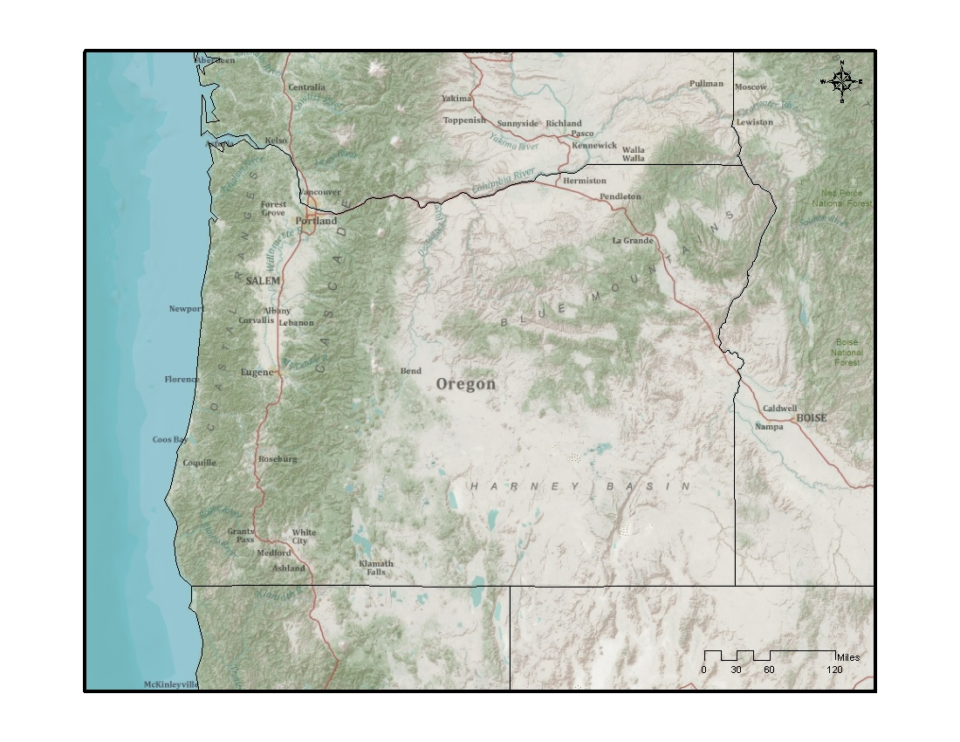

I. Introduction
The interstate transport provision in the CAA section 110(a)(2)(D)(i) (also called “ the good neighbor” provision) requires each state to submit a State Implementation Plan (SIP) that prohibits emissions that will have certain adverse air quality effects in other states. This SIP submittal is due within three years after the Environmental Protection Agency (EPA) adopts a new or revised NAAQS.

II. Background

EPA Promulgated NAAQS

- Nitrogen Dioxide (NO₂): EPA first set standards for NO₂ in 1971; setting both a primary standard (to protect health) and a secondary standard (to protect the public welfare) at 53 parts per billion (ppb), averaged annually. EPA reviewed the standards in 1985 and 1996, deciding to retain the standards at the conclusion of each review. In 2005, EPA began another review, resulting in the January 22, 2010, rulemaking to establish an additional primary NO₂ standard at 100 ppb, averaged over one hour (75 FR 6474).

- Sulfur Dioxide (SO₂): Primary standards for SO₂ were first set in 1971, at 0.14 parts per million (ppm) averaged over a 24-hour period, not to be exceeded more than once per year, and 0.030 ppm, annual arithmetic mean. EPA subsequently reviewed the primary standards and determined to retain them in 1996. More recently, on June 2, 2010, EPA adopted a revised primary SO₂ standard at 75 ppb, based on a three-year average of the annual 99th percentile of one-hour daily maximum concentrations (75 FR 35520).

- Lead (Pb): On October 15, 2008, the EPA revised the level of the primary and secondary Pb NAAQS from 1.5 micrograms per cubic meter (µg/m³) to 0.15 µg/m³.

- Fine Particulate Matter (PM 2.5): On December 14, 2012 EPA adopted a revised annual NAAQS for fine particulate matter (PM 2.5) from 15 µg/m³ to 12 µg/m³.

Section 110(a)(2)(D)(i) of the CAA identifies four distinct requirements related to the impacts of air pollutants transported across state lines. It requires that each SIP for a new or revised NAAQS contain adequate provisions prohibiting any source or other type of emissions activity within the state from emitting air pollutants that may:

- Contribute significantly to nonattainment of the applicable NAAQS in any other state;

- Interfere with maintenance of the applicable NAAQS in any other state;

- Interfere with measures required to be included in the applicable implementation plan for any other state to prevent significant deterioration of air quality; and

- Interfere with measures required to be included in the applicable implementation plan for any other state to protect visibility.

Section III below addresses elements 1 and 2 above, contributions to nonattainment of applicable NAAQS, and interference with maintenance of applicable NAAQS. Regarding elements 3 above (prevention of significant deterioration), DEQ’s air permitting rules for industrial sources require analysis for the PSD which ensures that air quality impacts from new or modified industrial sources will not cause or contribute to violations of a NAAQS in Oregon or neighboring states, or cause significant visibility impairment in federal Class-I areas. EPA most recently approved revisions to Oregon’s PSD program occurred on December 27, 2011 (76 FR 80747). Regarding element 4 above (visibility protection), Oregon’s federally approved regional haze plan provides the mechanism for ensuring emission reductions necessary to achieve visibility improvement in Oregon and in neighboring states. EPA approved the first element of the Oregon Regional Haze Plan (SIP) including the requirements for best available retrofit technology (BART) (76 FR 38997) on July 5, 2011. The EPA approved the remaining elements of the Oregon Regional Haze SIP on August 22, 2012 (77 FR 50611).

III. Air Quality Data and Attainment Status within Oregon and Surrounding States

  - Surrounding contiguous states: Oregon is bordered by Washington to the north, the Pacific Ocean to the west, California and Nevada to the south, and Idaho to the east. The Snake River separates the state from part of Idaho. The Columbia River forms most of the state's northern border. There are six major sources in Oregon within 5 km of contiguous Washington State and one major source within 5 km of Idaho. The sources are listed in Tables 5 and 6 below (page 29).

  - Designation of all areas within the state and in each surrounding state (attainment, nonattainment, and unclassifiable), including maintenance areas in adjacent states:
- Nitrogen Dioxide (NO₂): On January 20, 2012 EPA designated all areas of the country as “unclassifiable/attainment” for the 2010 NO₂ NAAQS, including all areas within the states of Idaho, California, Nevada, and Washington. The available air quality data show that all monitored areas in the country meet the 2010 NO2 NAAQS for 2008-2010. No state or tribe recommended an area be designated “nonattainment” during the federal designation process.

- Sulfur Dioxide (SO₂): According to EPA, designations for the entire state of Oregon, Washington, Idaho, California, and Nevada will be addressed in a future action. See proposed Consent Decree, Sierra Club v. McCarthy, No. 3:13-CV-3953-SI (N.D. Cal.), issued March 2, 2014, 70 Fed. Reg. 32,235, June 2, 2014 found at:

http://content.sierraclub.org/environmentallaw/sites/content.sierraclub.org.environmentallaw/files/SO2%20Consent%20Decree.pdf

EPA's review of the monitored air quality data from 2009-2011 showed no violations of 2010 1-hr SO₂ standard in any of these states. According to the latest available 2013 Oregon Air Quality Data Summaries Report, the downward trend in SO2 emissions continues with the highest 2012 and 2013 1-hr concentrations under 25 ppb.

- Lead (Pb): In 2008 EPA designated all areas in the states of Oregon, Idaho, Nevada, and Washington as “unclassifiable/attainment.” In California, Los Angeles County South Coast Air Basin is classified as “nonattainment.” The rest of the state is designated “unclassifiable/attainment.”

- Fine Particulate Matter (PM 2.5): Shoshone County in Idaho, and Imperial, Fresno, Kings, Madera, Merced, San Joaquin, Stanislaus, and Tulare counties in California are designated in nonattainment of the 2012 annual PM2.5 standard. There are no nonattainment areas for the annual PM 2.5 standard in Oregon, Washington, Idaho, or Nevada. There have been no annual PM 2.5 NAAQS violations in SW Washington during the most recent three-year period (2012-2014). The monitoring network for NO2 and SO2 is presented in Figure 2. The monitoring network for PM2.5 and Pb is presented in Figure 3.

  - Monitoring networks for pollutants within the state and surrounding states:
Figure 2: Monitoring network that includes for NO₂, and SO₂, in Oregon

Figure 3: Monitoring network that includes PM 2.5 and Lead in Oregon

Figure 4: Monitoring networks for NO₂ in Washington, Idaho, California and Nevada
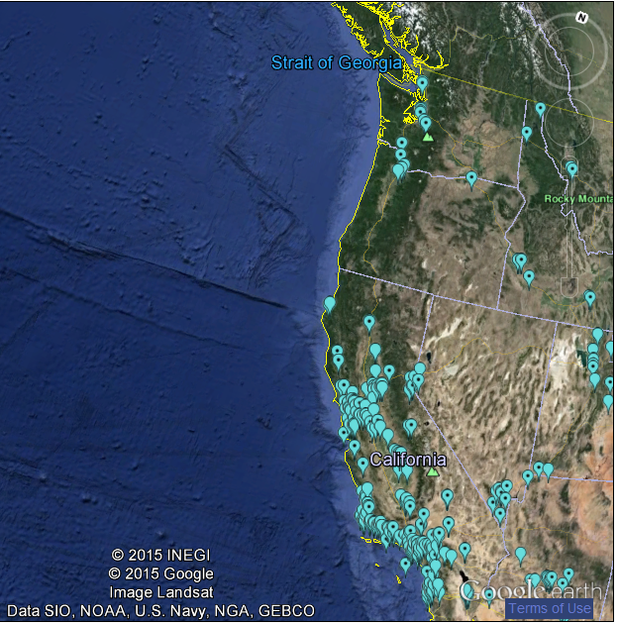

Figure 5: Monitoring networks for SO₂ in Washington, Idaho, California and Nevada
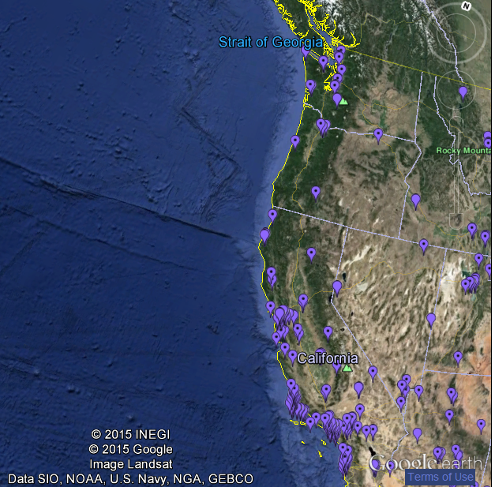

Figure 6: Monitoring networks for Pb in Washington, Idaho, California and Nevada
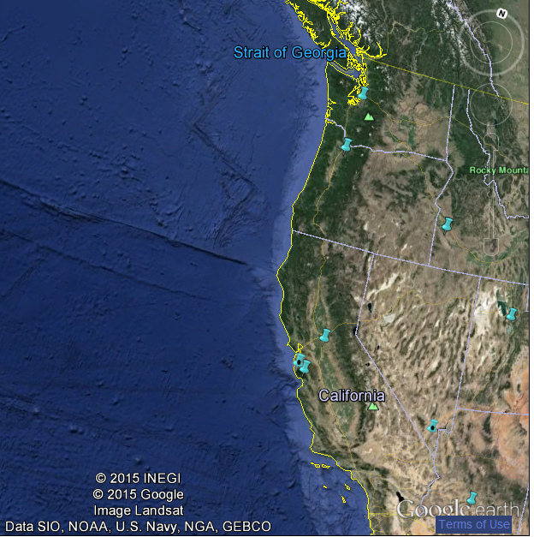

Figure 7: Monitoring networks for PM 2.5 in Washington, Idaho, California and Nevada
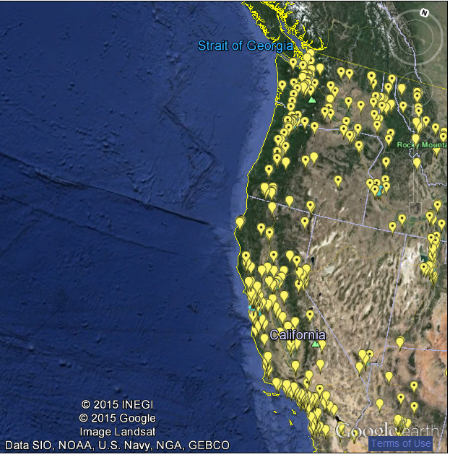

  - Ambient data, including the ‘design value’ for pollutants of interest, at each monitoring site and trends over the last 5-10 years.
Nitrogen Dioxide (NO₂):
The level of the hourly NAAQS for NO₂ is 100 ppb based on the 98th percentile value from three consecutive years of data. The design values shown here are computed for the latest design value period using Federal Reference Method or equivalent data reported to EPA by States, Tribes, and local agencies. The 2011-2013 design values for NO₂ are presented in Table 1. Daily maximum 1-hr NO2 2000-2013 trends at monitoring stations in Oregon, Washington, California, Idaho, and Nevada are in Figures 8-11.
Table 1: County-Level Design Value Concentrations for NO₂ 1-Hour NAAQS
State | County | Site | 2011-2013 1-hr Design Value (ppb)
California | Alameda | 060010011 | 50
California | Butte³ | 060070008 | 37
California | Contra Costa | 060131004 | 40
California | Imperial | 060250005 | 64
California | Kern | 060296001 | 46
California | Kings | 060311004 | 46
California | Los Angeles | 060371701 | 64
California | Marin | 060410001 | 45
California | Monterey | 060531003 | 35
California | Napa | 060550003 | 39
California | Placer | 060610006 | 50
California | Riverside | 060655001 | 39
California | Sacramento | 060670002 | 43
California | San Bernardino | 060712002 | 62
California | San Diego | 060732007 | 73
California | San Francisco | 060750005 | 68
California | San Joaquin | 060771002 | 53
California | San Luis Obispo | 060798001 | 38
California | San Mateo | 060811001 | 45
California | Santa Barbara | 060831008 | 36
California | Santa Clara | 060850005 | 51
California | Solano | 060950004 | 42
California | Sutter | 061010003 | 47
California | Tulare | 061072002 | 52
California | Ventura | 061112002 | 37
California | Yolo | 061130004 | 34
Oregon | Multnomah | 410510080 | 34
Nevada | Washoe | 320310016 | 56

Figure 8: Trends - Concentrations for NO₂ 1-Hour NAAQS - Washington
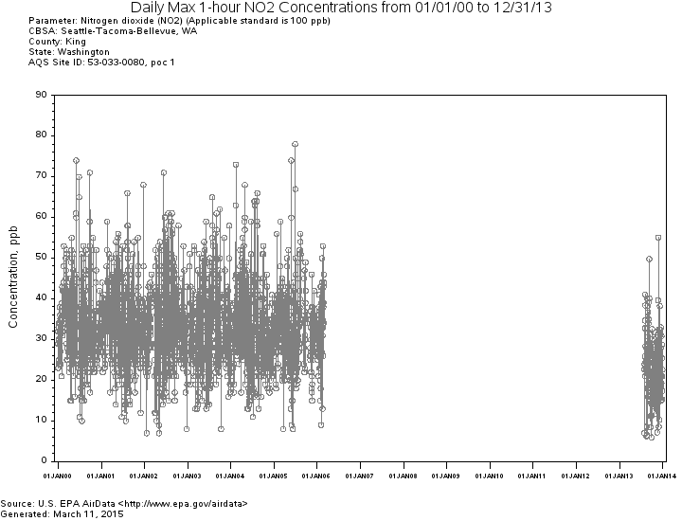

Figure 9: Trends - Concentrations for NO₂ 1-Hour NAAQS - California
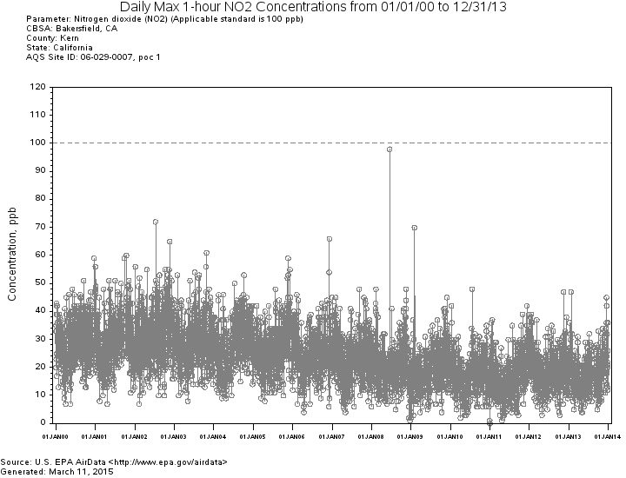

Figure 10: Trends - Concentrations for NO₂ 1-Hour NAAQS - Idaho
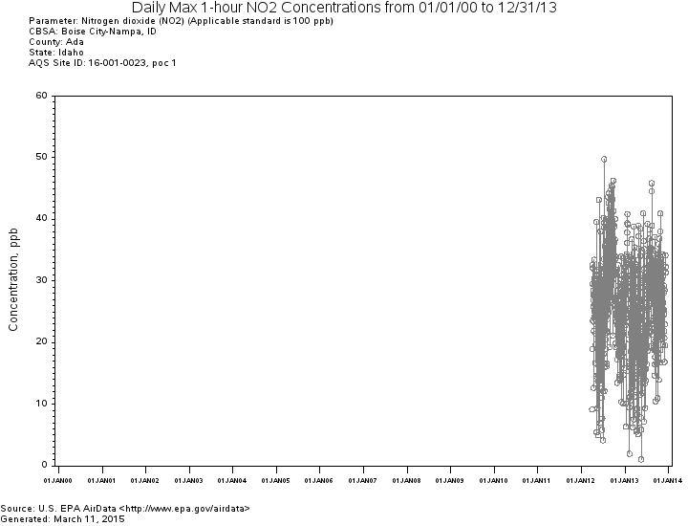

Figure 11: Trends – Concentrations for NO₂ 1-Hour NAAQS - Nevada
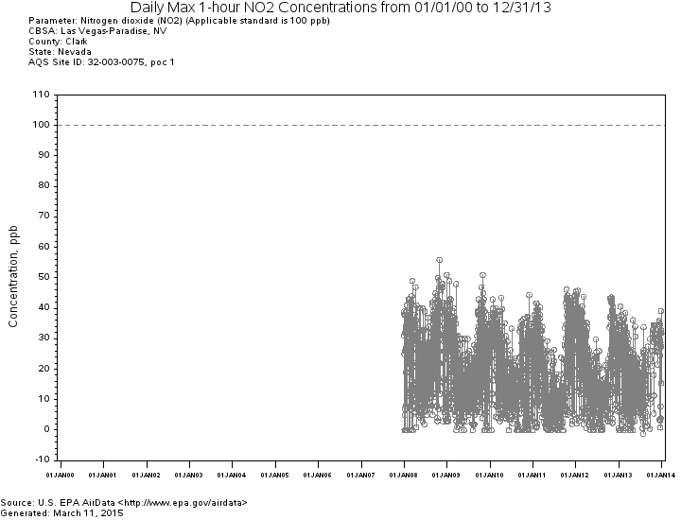

Sulfur Dioxide (SO₂)

The level of the 1-hour NAAQS for SO₂ is 75 ppb calculated as the 3-year average of the 99th percentile of the annual distribution of daily maximum 1-hour average concentrations. The 2011-2013 design values also calculated as the 3-year average of the annual distribution of daily maximum 1- hr average concentrations for SO₂ are presented in Table 2. Daily maximum 1-hr SO2 2000-2013 trends at monitoring stations in Oregon, Washington, California, Idaho, and Nevada are in Figures 12-16.

Table 2: County-Level Design Value Concentrations for SO₂ 1-Hour NAAQS
State | County | 2011-2013 1-Hour Design Value (ppb)
CA | Alameda | 15
CA | Contra Costa | 14
CA | Riverside | 3
CA | Sacramento | 2
CA | San Bernardino | 5
CA | San Diego | 1
CA | San Luis Obispo | 21
CA | Santa Barbara | 36
CA | Santa Clara | 13
CA | Solano | 4
ID | Caribou | 40
NV | Clark | 8
NV | Washoe | 6
OR | Multnomah | 6
WA | Clallam | 1

Figure 12: Trends – SO₂ 1-hour NAAQS concentrations – Umatilla County, Oregon
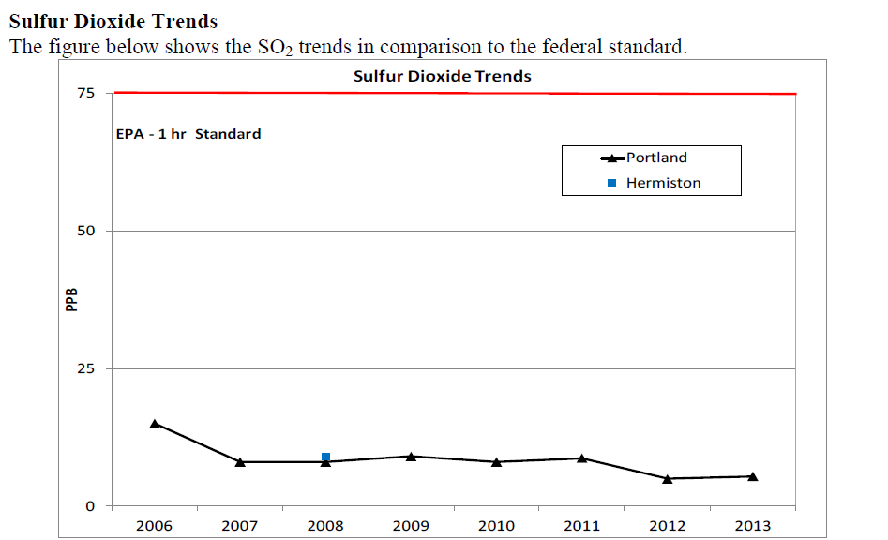

Figure 13: Trends – SO₂ 1-hour NAAQS concentrations - Washington
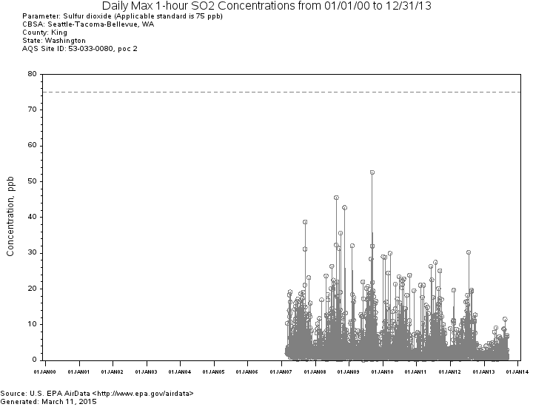

Figure 14: Trends – SO₂ 1-hour NAAQS concentrations - California
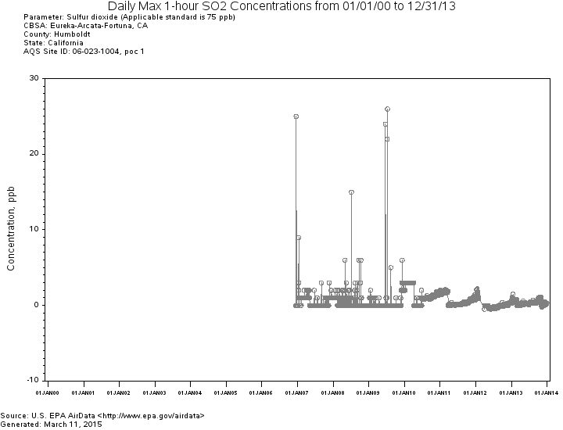

Figure 15: Trends – SO₂ 1-hour NAAQS concentrations - Idaho
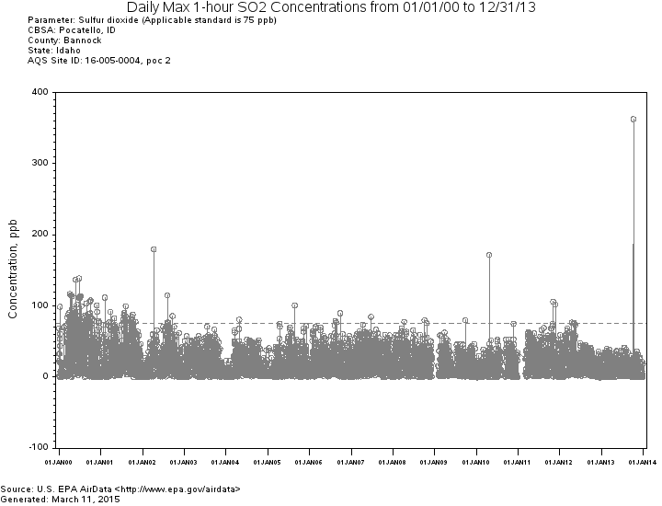

Figure 16: Trends – SO₂ 1-hour NAAQS concentrations - Nevada
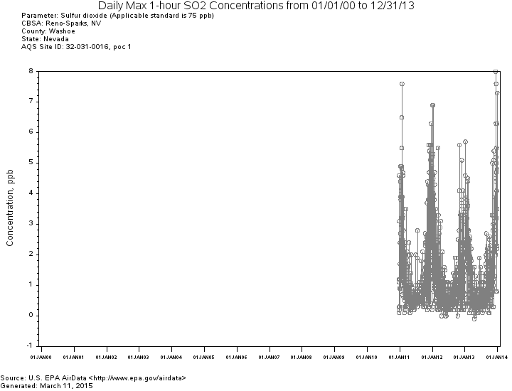

Lead (Pb):

The level of the 2008 NAAQS for lead is 0.15 µg/m3 not to be exceeded in any 3-month period. The 2011-2013 available design values for Pb are presented in Table 3. Daily maximum 1-hr Pb 1990-2013 trends at monitoring stations in Oregon, California, and Idaho are in Figures 17-19.

Table 3. Site-Level Maximum Design Value Concentrations for 2008 Lead NAAQS, 2011-2013
State | County | AQS Site ID | 2011-2013 Design Value (µg/m³)
California | Imperial | 060250005 | 0.03
California | Los Angeles | 060371103 | 0.01
California | Los Angeles | 060371403 | 0.11
California | Los Angeles | 060371405 | 0.46
California | Los Angeles | 060371406 | 0.07
California | Los Angeles | 060371602 | 0.01
California | Riverside | 060651003 | 0.01
California | Riverside | 060658001 | 0.01
California | San Bernardino | 060711004 | 0.01
California | San Diego | 060731020 | 0.17
California | San Mateo | 060812002 | 0.33
Oregon | Yamhill | 410711702 | 0.05

The design values in bold in Table 3 exceed the 2008 Pb NAAQS. The monitoring site in California is 800 miles from the Oregon border. Given the great distances involved and the nature of lead transport, Oregon emissions are not expected to have any effect on lead levels measured in California.

Figure 17 below shows local 2005-2013 Pb trends in Oregon. Figures 18-20 show Pb trends in Idaho, California and Washington. According to EPA requirements, the lead emissions monitoring threshold is 0.50 tons per year (tpy). Air quality monitoring agencies are advised to use this threshold to determine if an air quality monitor is required to be placed near a facility emitting lead. There are no Pb trends for Nevada because Nevada did not conduct ambient monitoring for Pb. The figures show Pb trends in Oregon and its neighboring states are going down.

Figure 17: Annual Maximum 3-Month Average Pb - Oregon
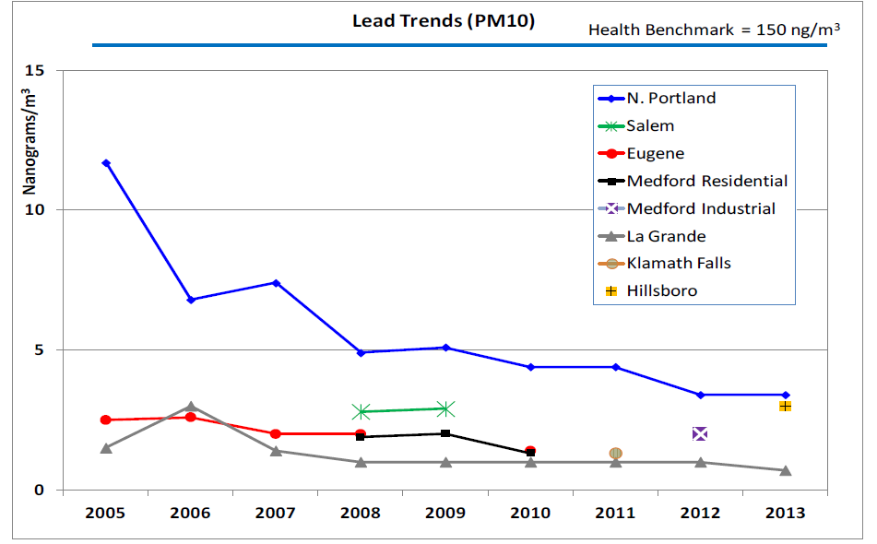
Lead NAAQS is 0.15 mg/m³ which equals 150 ng/m³

Figure 18: Annual Maximum 3-Month Average Pb - Idaho
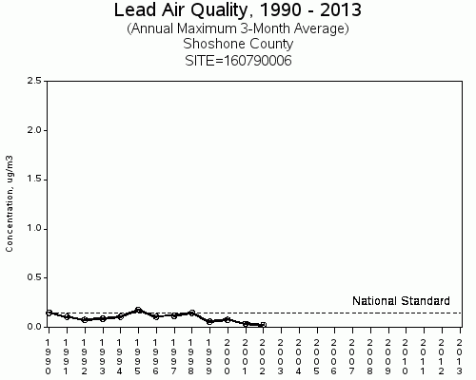

Figure 19: Annual Maximum 3-Month Average Pb - California
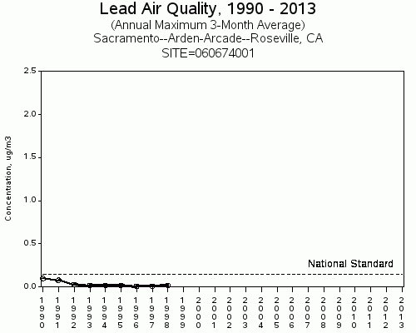

Figure 20: Quarterly Maximum Concentrations Pb – Washington

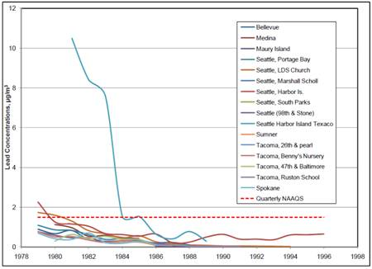

Fine Particulate Matter (PM 2.5):

The level of the 2012 NAAQS for PM 2.5 is 12 ug/m3 calculated as a 3-year average of the annual arithmetic mean. Table 4 presents the 2011-2013 design values for PM2.5. Figures 5-10 present annual PM2.5 2000-2013 trends at monitoring stations in Oregon, Washington, California, Idaho and Nevada.

Table 4 presents the 2011-2013design values for PM 2.5.

Table 4 PM2.5 Site Listing, 2011-2013
State | County | Site ID | 2011-2013 Annual Design Value (µg/m3)
California | Alameda | 060010007 | 7.6
California | Alameda | 060010009 | 10.0
California | Butte | 060070008 | 10.1
California | Calaveras | 060090001 | 8.4
California | Colusa | 060111002 | 7.1
California | Contra Costa | 060130002 | 7.4
California | Fresno | 060190011 | 15.4
California | Fresno | 060192009 | 7.8
California | Fresno | 060195001 | 16.4
California | Fresno | 060195025 | 14.7
California | Humboldt | 060231002 | 6.2
California | Imperial ⁴ | 60250005 | 14.3
California | Imperial | 060250007 | 7.5
California | Imperial | 060251003 | 7.4
California | Inyo | 060271003 | 7.5
California | Kern | 060290014 | 16.4
California | Kern | 060290016 | 17.3
California | Kings | 060311004 | 17.0
California | Lake | 060333001 | 3.8
California | Los Angeles | 060370002 | 11.2
California | Los Angeles | 060371002 | 12.8
California | Los Angeles | 060371103 | 13.0
California | Los Angeles | 060371201 | 10.2
California | Los Angeles | 060371302 | 12.2
California | Los Angeles | 060371602 | 12.0
California | Los Angeles | 060374002 | 11.1
California | Los Angeles | 060374004 | 11.0
California | Madera | 060392010 | 18.1
California | Marin | 060410001 | 9.5
California | Merced | 060470003 | 13.3
California | Merced | 060472510 | 11.1
California | Monterey | 060531003 | 6.1
California | Nevada | 060570005 | 4.6
California | Nevada | 060571001 | 7.0
California | Orange | 060590007 | 10.7
California | Orange | 060592022 | 8.2
California | Placer | 060610006 | 7.5
California | Plumas | 060631006 | 10.2
California | Plumas | 060631009 | 12.2
California | Plumas | 060631010 | 12.8
California | Riverside | 060650009 | 7.7
California | Riverside | 060651003 | 11.5
California | Riverside | 060652002 | 7.7
California | Riverside | 060655001 | 6.4
California | Riverside | 060658001 | 13.4
California | Riverside | 060658005 | 15.1
California | Sacramento | 060670006 | 10.4
California | Sacramento | 060670010 | 9.5
California | Sacramento | 060674001 | 9.3
California | San Benito | 060690002 | 5.5
California | San Bernardino | 060710025 | 12.6
California | San Bernardino | 060712002 | 12.6
California | San Bernardino | 060718001 | 8.7
California | San Bernardino | 060719004 | 11.8
California | San Diego | 060730001 | 9.9
California | San Diego | 060730003 | 10.6
California | San Diego | 060731002 | 10.7
California | San Diego | 060731010 | 10.8
California | San Diego | 060731016 | 8.7
California | San Francisco | 060750005 | 9.2
California | San Joaquin | 060771002 | 13.8
California | San Joaquin | 060772010 | 10.2
California | San Luis Obispo | 060792004 | 8.7
California | San Luis Obispo | 060792006 | 6.6
California | San Luis Obispo | 060792007 | 11.3
California | San Luis Obispo | 060798001 | 7.0
California | San Mateo | 060811001 | 9.3
California | Santa Barbara | 060830011 | 9.5
California | Santa Barbara | 060831008 | 7.6
California | Santa Clara | 060850002 | 8.0
California | Santa Clara | 060850005 | 10.3
California | Santa Cruz | 060870007 | 6.3
California | Shasta | 060890004 | 5.7
California | Shasta | 060893004 | 6.2
California | Siskiyou | 060932001 | 6.3
California | Solano | 060950004 | 9.6
California | Sonoma | 060970003 | 8.4
California | Stanislaus | 060990005 | 13.6
California | Stanislaus | 060990006 | 15.7
California | Sutter | 061010003 | 7.7
California | Tehama | 061030006 | 8.1
California | Tulare | 061072002 | 16.6
California | Ventura | 061110007 | 9.1
California | Ventura | 061110009 | 8.1
California | Ventura | 061112002 | 9.1
California | Ventura | 061113001 | 9.0
California | Yolo | 061131003 | 7.2
Idaho | Ada | 160010010 | 9.1
Idaho | Bannock | 160050020 | 7.7
Idaho | Benewah | 160090010 | 9.9
Idaho | Canyon | 160270002 | 10.8
Idaho | Franklin | 160410001 | 8.0
Idaho | Lemhi | 160590004 | 12.0
Idaho | Shoshone | 160790017 | 12.8
Nevada | Clark | 320030540 | 8.1
Nevada | Clark | 320030561 | 8.8
Nevada | Clark | 320031019 | 4.6
Nevada | Washoe | 320310016 | 7.6
Oregon | Crook | 410130100 | 9.8
Oregon | Harney | 410250003 | 9.5
Oregon | Jackson | 410290133 | 10.9
Oregon | Josephine | 410330114 | 8.8
Oregon | Klamath | 410350004 | 11.6
Oregon | Lake | 410370001 | 11.1
Oregon | Lane | 410390060 | 7.0
Oregon | Lane | 410391009 | 5.8
Oregon | Lane | 410392013 | 9.1
Oregon | Lane | 410399004 | 7.1
Oregon | Multnomah | 410510080 | 8.1
Oregon | Umatilla | 410590121 | 7.6
Oregon | Washington | 410670004 | 8.2
Washington | King | 530330057 | 10.1
Washington | King | 530330080 | 6.1
Washington | King | 530332004 | 7.1
Washington | Pierce | 530530029 | 7.8
Washington | Snohomish | 530610005 | 5.9
Washington | Snohomish | 530610020 | 6.9
Washington | Snohomish | 530611007 | 7.7
Washington | Spokane | 530630021 | 8.0
Washington | Yakima | 530770009 | 9.1

There are design values that exceed the annual PM 2.5 NAAQS in neighboring states at monitoring sites located hundreds of miles away from Oregon. Oregon’s PM 2.5 emissions are unlikely to significantly contribute to those levels.

Figure 20 shows annual PM 2.5 2000-2013 NW trends at monitoring stations in Oregon, Washington, California, Idaho, and Nevada. The trend shows an 11% regional decrease in PM 2.5 emissions across the NW region.

Figure 21 - Annual PM 2.5 2000-2013 NW Trend
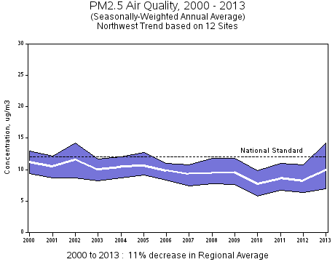

Consultation with Neighboring States: In March 2015, DEQ contacted the air quality agencies in neighboring states via email - Adele Malone (Nevada), Mike Edwards (Idaho), Sylvia Vanderspek (California), and Paul Mairose (Washington) - regarding the potential transport of air emissions (NO₂, SO₂, Pb and PM2.5) across state boundaries, and they informed DEQ that emissions from Oregon do not appear to be impacting their states in a significant way. Specifically, other than wildfires, California is not aware of any Oregon air emissions that affect Northern California. Washington’s recent interstate transport report indicates Oregon’s emissions are not significantly affecting Washington. Idaho reported that since they do not have a lead, NO₂ or SO₂ non-attainment area, they do not believe Oregon is affecting Idaho. Due to the lack of any nonattainment or maintenance areas for the listed pollutants, Nevada concludes that emissions from Oregon are not currently affecting air quality in any significant way.

IV. Nature and Extent of Expected Pollutant Transport

NO₂ and SO₂ and Pb normally do not transport over long distances. Both NO₂ and SO₂ will most likely either disperse in the atmosphere or chemically react to form a secondary pollutant within a few miles of the source. Pb would most likely be deposited within a few miles of a source. Based on monitoring data and DEQ’s discussion with other state air agencies, DEQ concludes that direct emissions of Pb, NO₂ and SO₂ do not cause or contribute to exceedances of the NAAQS. As NO₂ and SO₂ can also react in the atmosphere to become nitrate and sulfate particulate. Any impacts from those pollutants as well as PM _{2.5} are addressed though DEQ’s PSD rules and through the Regional Haze program.

Nitrogen Dioxide: NO₂ is one of a group of highly reactive gasses known as "oxides of nitrogen," or "nitrogen oxides (NOx)." Other nitrogen oxides include nitrous acid and nitric acid. EPA’s NAAQS uses NO₂ as the indicator for the larger group of nitrogen oxides. NO₂ forms quickly from emissions from cars, trucks and buses, power plants and off-road equipment. In addition to contributing to the formation of ground-level ozone, and fine particle pollution, NO₂ is linked with a number of adverse effects on the respiratory system.
EPA first set standards for NO₂ in 1971, setting both a primary standard (to protect health) and a secondary standard (to protect the public welfare) at 0.053 parts per billion (ppb), averaged annually. EPA has reviewed the standards twice since that time, but chose not to revise the annual standards at the conclusion of each review. In January 2010, EPA established an additional primary standard at 100 ppb, averaged over one hour. Concentrations of NO₂ emitted into the atmosphere will decrease during transport through three mechanisms: deposition, chemical transformation, and dispersion. Interstate transport of NO₂ is not a concern for Oregon due to the distances involved for large stationary sources and large concentrations of area source emissions in western Oregon.
Sulfur Dioxide: SO₂ is one of a group of highly reactive gasses known as “oxides of sulfur.” Generally the largest sources of SO₂ emissions are from fossil fuel combustion at power plants (73%) and other industrial facilities (20%). Smaller sources of SO₂ emissions include industrial processes such as extracting metal from ore, and burning high sulfur containing fuels in locomotives, large ships, and non-road equipment. SO₂ is linked with a number of adverse effects on the respiratory system. The emission inventory for Oregon demonstrates a similar source distribution.
EPA first set standards for SO₂ in 1971. EPA set a 24-hour primary standard at 140 ppb and an annual average standard at 30 ppb (to protect health). EPA also set a 3-hour average secondary standard at 500 ppb (to protect the public welfare). In 1996, EPA reviewed the SO₂ NAAQS and chose not to revise the standards.
In 2010, EPA revised the primary SO₂ NAAQS by establishing a new 1-hour standard at a level of 75 ppb. EPA revoked the two existing primary standards because they would not provide additional public health protection.
Concentrations of SO₂ emitted into the atmosphere decreases during transport through three mechanisms: deposition, chemical transformation, and dispersion. Interstate transport of SO₂ is not a concern for Oregon due to the distances involved for large stationary sources and large concentrations of area source emissions in western Oregon.
Lead: As noted in the EPA’s October 14, 2011 Pb infrastructure guidance, the physical properties of Pb prevent emissions from experiencing the same travel or formation phenomena as fine particulate matter or ozone. More specifically, there is a sharp decrease in Pb concentrations, at least in the coarse fraction, as the distance from a Pb source increases. Accordingly, while it may be possible for a source in a state to emit Pb in a location and in quantities that may contribute significantly to nonattainment in, or interfere with maintenance by, any other state, EPA anticipates that this would be a rare situation (e.g., where large sources are in close proximity to state boundaries). EPA’s experience with initial Pb designations suggests that sources that emit less than 0.5 tons per year or that are located more than two miles from a state border generally appear unlikely to contribute significantly to nonattainment in another state. All sources of Pb emissions in Oregon are below 0.5 tons per year and are located greater than two miles from the state border. Therefore, it is unlikely that sources in Oregon will significantly contribute to nonattainment or interfere with maintenance of the 2008 Pb NAAQS in any other state.

Fine Particulate Matter: DEQ’s consultation with air agencies in adjacent states suggests that high PM 2.5 levels in their respective communities are driven largely by local pollution sources during air stagnation events. Local air stagnation events would generally preclude interstate air pollution transport as a significant contributor to high PM2.5 levels jeopardizing NAAQS compliance.

V. Sources of Pollutant Emissions Near the State Boundary and Expected Impacts in Neighboring States.
This section addresses sources and emission for pollutants (specifically major point or area source emissions and their proximity to the state boundary) and the likelihood that emissions from these sources would transport across the state boundary to contribute significantly to nonattainment or interfere with maintenance of any applicable NAAQS in any other state.
There are six Title V Oregon sources (major industrial sources that have a potential to emit a 100 tons per year of any criteria pollutant) in close proximity to the Washington border and one source in close proximity to the Idaho border.

Georgia-Pacific Consumer Products LP, Cascades Tissue Group-Oregon, Portland General Electric Company Beaver Plant/Port Westward I Plant, and Portland General Electric Company Coyote Springs Plant all went through PSD analysis, were issued PSD permits and thus demonstrated that their emissions do not cause or contribute to a violation of any applicable NAAQS.

Owens-Brockway Glass Containers and Evraz were evaluated as part of the competing sources inventory during both Port Westward and Troutdale Energy Center’s PSD analyses and thus demonstrated that their emissions considered in conjunction with the emissions from other sources in the area do not cause or contribute to a violation of any applicable NAAQS.

A PSD permit applicant must conduct an air quality analysis of the ambient impacts associated with the construction and operation of a proposed new source or modification. The purpose of the air quality analysis is to demonstrate that new emissions from a proposed major stationary source or major modification, in conjunction with other applicable emissions from existing sources (including secondary emissions), will not cause or contribute to a violation of any applicable NAAQS.
Portland General Electric’s coal-fired power plant is located in Boardman, Oregon, 14 km south of Washington’s boarder. It is the only coal fired power plant in Oregon. In December 2010, the Environmental Quality Commission approved DEQ's proposed revisions to air pollution control rules for the PGE Boardman coal-fired power plant. Based on the adopted rules, Boardman has a federally enforceable shutdown date of December 31, 2020. The rules also require PGE Boardman to use dry sorbent injection controls to meet federal regulations for sulfur dioxide control and a more stringent sulfur dioxide limit from 2018-2020. DEQ concluded that the proposed BART controls, when combined with the permanent closure of plant no later than December 31, 2020, meet federal requirements and provide a significant environmental and public health benefit.
Based on the analysis discussed above, it is reasonable to conclude that emissions from sources in Oregon do not significantly contribute to PM2.5 and NO₂ concentrations in any other state.
Regional Work with Western Regional Air Partnership (WRAP): In late 2010, WRAP initiated the West-wide Jump-start Air Quality Modeling Study (WestJumpAQMS). The goal of the study was to develop the next generation of regional air quality modeling databases for ozone, PM2.5, visibility and deposition planning in the western U.S and to provide information on the role of interstate and international transport to ozone and PM2.5 under current and potential future NAAQS. The study looked at PM2.5 annual source apportionment but did not look at the transport of lead, NO₂ or SO₂. DEQ reviewed Appendix E, State Contributions to Modeled Annual PM 2.5 Concentrations in 2008 by Monitoring Site, and the total annual PM2.5 modeled concentrations in all the counties in the state of Washington, California, Idaho, Nevada, and as far away as Wyoming. Clark and Skamania counties in Washington may be impacted by Oregon’s PM2.5 emissions from Georgia Pacific Consumer Products located in Clatskanie. However, Washington does not have an annual PM2.5 nonattainment area and has not had any violations of the PM2.5 NAAQS in the past 3 years. Any potential impact does not result in Oregon’s contribution to nonattainment or violations of annual PM2.5 standard in the state of Washington. The impacts by Oregon to other neighboring states were insignificant.

VI. Conclusion
In general air pollution from all sources transport across state boundaries. Based on the information described above (Oregon’s emissions inventory, air monitoring data and consultation with neighboring state air agencies), DEQ finds no evidence to suggest that Oregon emission of NO₂, SO₂, Pb and PM2.5 significantly contribute o exeedances or violations of NAAQS, or cause adverse effects in the neighboring states. Additionally, Oregon’s PSD program requires NAAQS and visibility analysis for any new or modified industrial sources.
In conclusion, in accordance with section 110(a)(2)(D)(i)(I), the current Oregon SIP contains adequate provisions prohibiting any source or other type of emissions activity within the State from emitting any air pollutant in amounts which will contribute significantly to nonattainment in, or interfere with maintenance by, any other State with respect to any such national primary or secondary ambient air quality standard.

