***DRAFT***

**Oregon State Implementation Plan Revision Addressing the Interstate Transport of Lead (Pb), Nitrogen Dioxide (NO2), Sulfur Dioxide (SO2) and Fine Particulate Matter (PM 2.5)**

**Clean Air Act Section 110(a)(2)(D)**

**Oregon Department of Environmental Quality**

**April 13, 2015**

Contents

Addressing Interstate Pollutant Impacts under the Clean Air Act3

1. Introduction5
2. Background 5
3. Air Quality Data and Attainment Status within the State and Surrounding States 6
4. Nature of Pollutant Transport 29
5. Sources of Pollutant Emissions Near the State Boundary and Expected Impacts in Neighboring States 31

VI. Conclusion 32

**Contact:**

Nancy Cardwell

Air Planning

(503) 229-6610

# Addressing Interstate Pollutant Impacts under the Clean Air Act

**Overview**

Some amount of air pollution routinely moves across all state borders and across all regions of the country. This document addresses the effect of Oregon air emissions moving to neighboring states. Based on the information summarized in the sections that follow, Oregon DEQ concludes that air emissions (Pb, NO2, SO2 and PM 2.5) from Oregon sources do not significantly contribute to violations of national ambient air quality standards in other states, or interfere with other states’ efforts to meet air quality standards, prevent significant air quality degradation, or protect visibility. DEQ’s conclusions are based on its understanding of air pollution problems in adjacent states, and the emission sources, meteorology (weather patterns), and topographic features (mountain ranges, etc.) that influence air quality problems in these states.

DEQ will collaborate with air agencies in Washington, Idaho, Nevada, California and other states whenever necessary to evaluate case-specific air quality problems that may involve regional movement of air pollution. DEQ’s Section 110 infrastructure SIP provides the framework and legal mechanism for DEQ to act as needed to reduce any Oregon emissions found to significantly contribute to air quality problems in other states.

The map below (Figure 1) illustrates the significant distances and mountain ranges that in many areas separate Oregon from communities in Washington, California, Idaho, and Nevada and that can help limit the long range transport of air pollution.

**Figure 1: Map of Oregon and major mountain ranges** 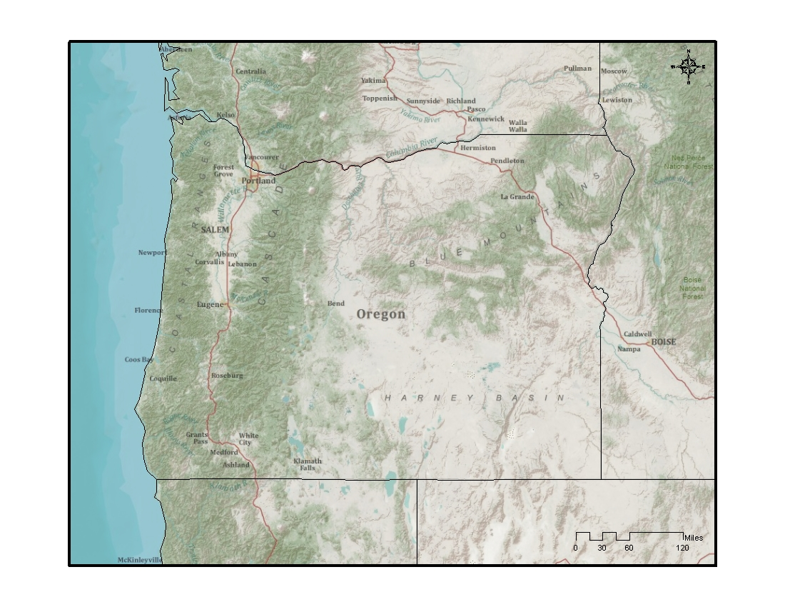

**I. Introduction**

The interstate transport provision in Clean Air Act (CAA) section 110(a)(2)(D)(i) (also called “ the good neighbor” provision) requires each state to submit a State Implementation Plan (SIP) that prohibits emissions that will have certain adverse air quality effects in other states. This SIP submittal is due within three years after the Environmental Protection Agency adopts a new or revised National Ambient Air Quality Standard (NAAQS).

II. Background

**EPA Promulgated NAAQS**

* Lead (Pb): On October 15, 2008, the EPA revised the level of the primary and secondary Pb NAAQS from 1.5 micrograms per cubic meter (µg/m3) to 0.15 µg/m3.
* Nitrogen Dioxide (NO2): EPA first set standards for NO2 in 1971; setting both a primary standard (to protect health) and a secondary standard (to protect the public welfare) at 53 parts per billion( ppb), averaged annually. EPA reviewed the standards in 1985 and 1996, deciding to retain the standards at the conclusion of each review. In 2005, EPA began another review, resulting in the January 22, 2010, rulemaking to establish an additional primary NO2 standard at 100 ppb, averaged over one hour (75 FR 6474).
* Sulfur Dioxide (SO2): Primary standards for SO2 were first set in 1971, at 0.14 parts per million (ppm) averaged over a 24-hour period, not to be exceeded more than once per year, and 0.030 ppm, annual arithmetic mean. EPA subsequently reviewed the primary standards and determined to retain them in 1996. More recently, on June 2, 2010, EPA adopted a revised primary SO2 standard at 75 ppb, based on a three-year average of the annual 99th percentile of one-hour daily maximum concentrations (75 FR 35520).
* Fine Particulate Matter (PM 2.5): On December 14, 2012 EPA adopted a revised annual NAAQS for fine particulate matter (PM 2.5) from 15 µg/m3 to 12 µg/m3.

Section 110(a)(2)(D)(i) identifies four distinct requirements related to the impacts of air pollutants transported across state lines. It requires that each SIP for a new or revised NAAQS contain adequate provisions prohibiting any source or other type of emissions activity within the state from emitting air pollutants that may:

1. contribute significantly to nonattainment of the applicable NAAQS in any other state;
2. interfere with maintenance of the applicable NAAQS in any other state;
3. interfere with measures required to be included in the applicable implementation plan for any other state to prevent significant deterioration of air quality; and
4. interfere with measures required to be included in the applicable implementation plan for any other state to protect visibility.

The federally approved SIP for the State of Oregon currently addresses elements 3 and 4 above. (Q for EPA: Why include 3 and 4 if they are approved?) This SIP submittal addresses the requirements of CAA section 110(a)(2)(D)(i)(I) for the new/revised NAAQS for Pb, NO2, SO2 and PM 2.5 for elements 1 and 2 listed above.

III. Air Quality Data and Attainment Status within Oregon and Surrounding States

* 1. **Surrounding contiguous states**: Oregon is bordered by Washington to the north, the Pacific Ocean to the west, California and Nevada to the south, and Idaho to the east. The Snake River separates the state from part of Idaho. The Columbia River forms most of the state's northern border. There are six major sources in Oregon within 5 km of contiguous Washington State and one major source within 5 km of Idaho.
  2. **Designation of all areas within the state and in each surrounding state (attainment, nonattainment, and unclassifiable), including maintenance areas in adjacent states:**
* Lead (Pb): In 2008 EPA designated all areas in the states of Oregon, Idaho, Nevada, and Washington as “unclassifiable/attainment.” In California, Los Angeles County South Coast Air Basin is classified as “nonattainment.” The rest of the state is designated “unclassifiable/attainment.”
* Nitrogen Dioxide (NO2): On January 20, 2012 EPA designated all areas of the country as “unclassifiable/attainment” for the 2010 NO2 NAAQS. The available air quality data show that all monitored areas in the country meet the 2010 NO2 NAAQS for 2008-2010. No state or tribe recommended an area be designated “nonattainment.”
* Sulfur Dioxide (SO2): According to EPA, designations for the entire states of Oregon, Washington, Idaho, California, and Nevada will be addressed in a future action. EPA's review of the monitored air quality data from 2009-2011 showed no violations of 2010 1-hr SO2 standard in any of these states.
* Fine Particulate Matter (PM 2.5): Shoshone county in Idaho, and Imperial, Fresno, Kings, Madera, Merced, San Joaquin, Stanislaus, and Tulare counties in California are designated in nonattainment of 2012 annual PM2.5 standard.

There are no nonattainment areas for the annual PM 2.5 standard in Oregon, Washington, Idaho, or Nevada. There have been no annual PM 2.5 NAAQS violations in SW Washington during the most recent three-year period (2012-2014).

* 1. **Monitoring networks for pollutants within the state and surrounding states:**

**Figure 2: Monitoring network that includes for NO2, and SO2, in Oregon**



**Figure 3: Monitoring network that includes PM 2.5 and Lead in Oregon**



**Figure 4: Monitoring networks for NO2 in Washington, Idaho, California and Nevada**

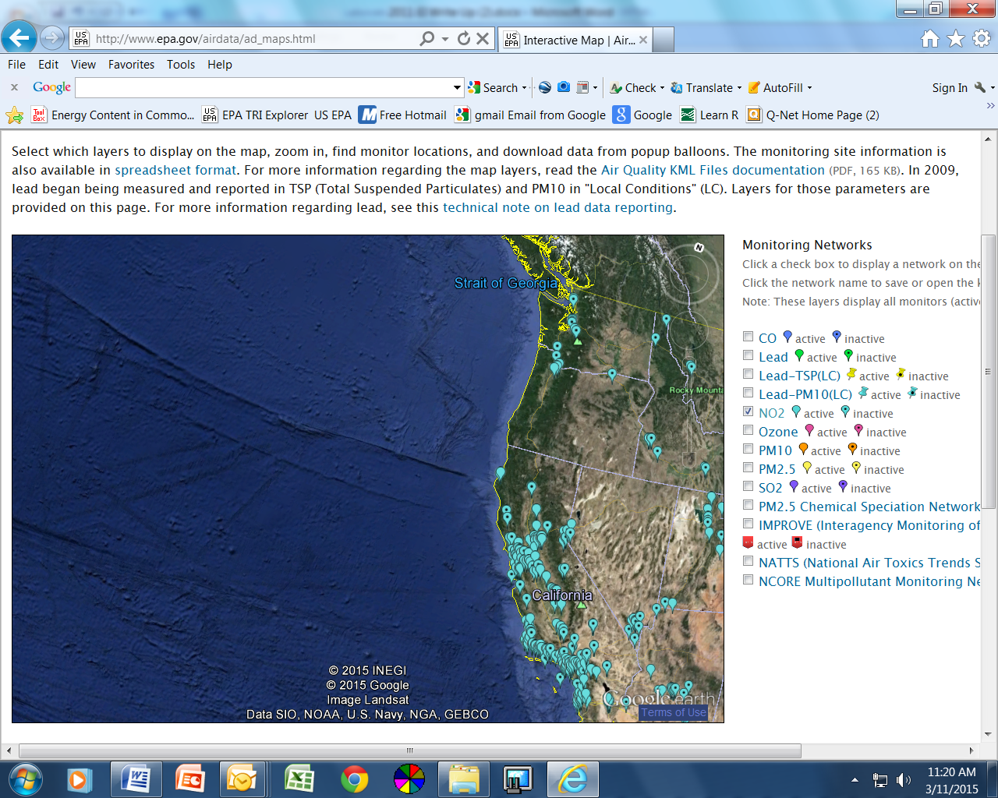

**Figure 5: Monitoring networks for SO2 in Washington, Idaho, California and Nevada**

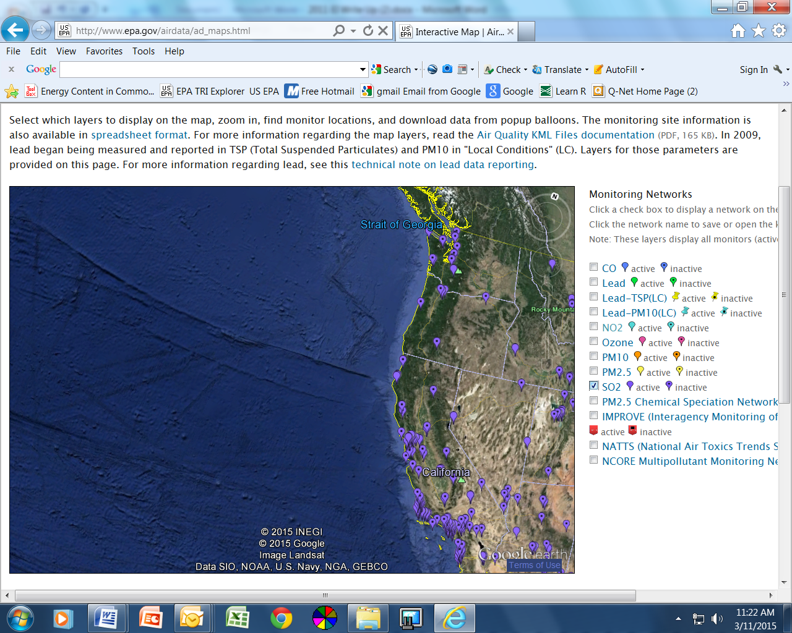

**Figure 6: Monitoring networks for Pbin Washington, Idaho, California and Nevada**

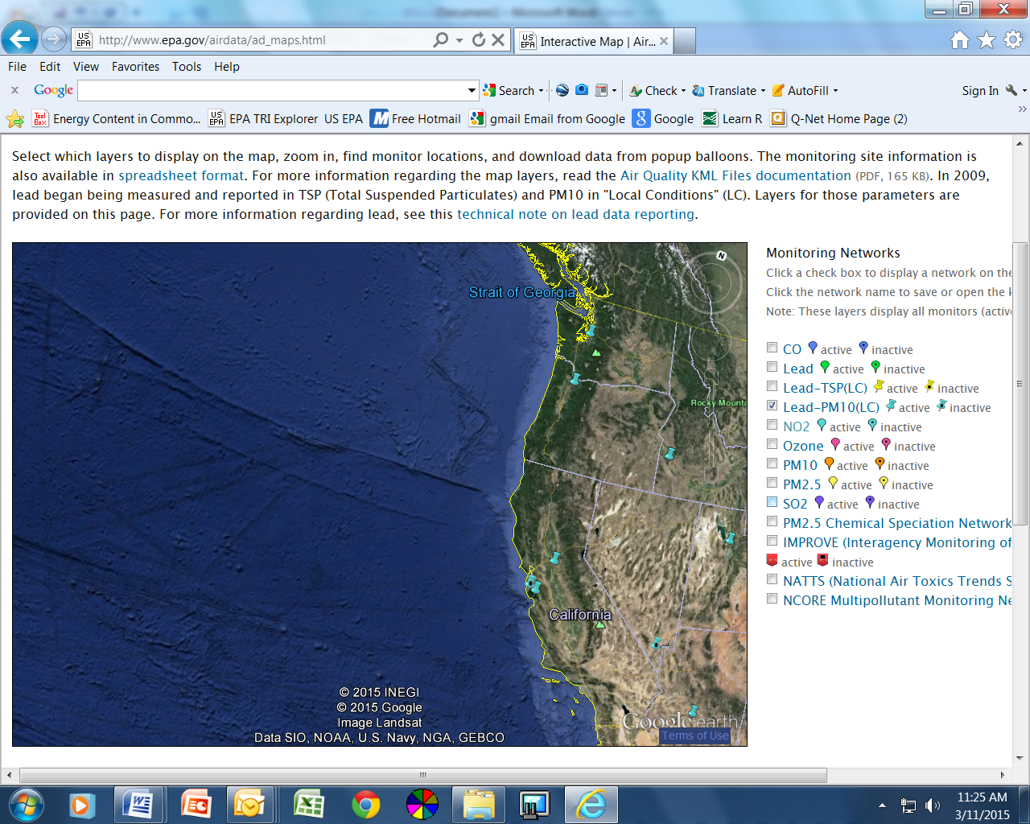

**Figure 7: Monitoring networks for PM 2.5 in Washington, Idaho, California and Nevada**

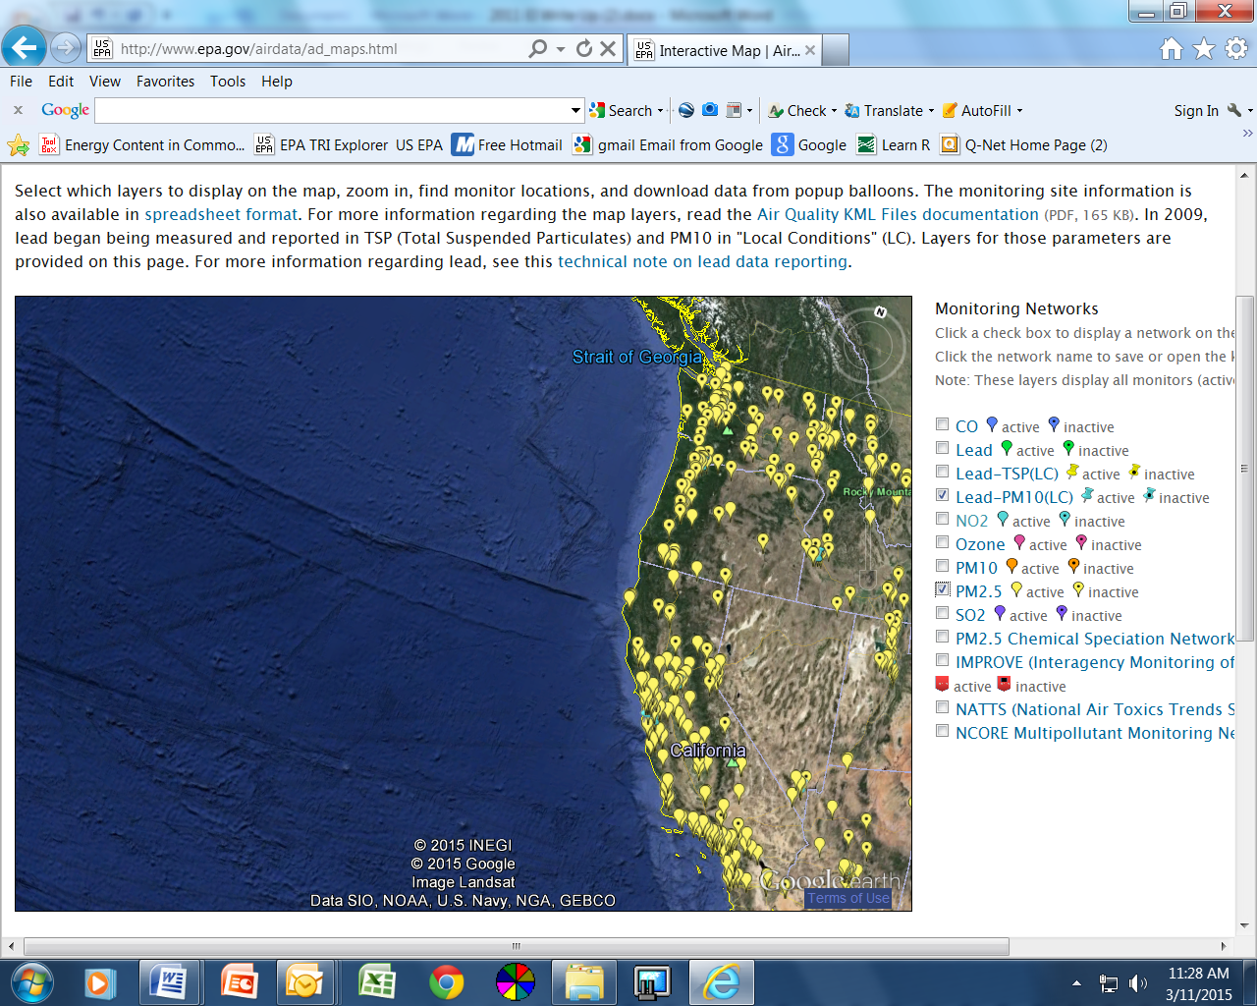

* 1. **Ambient data, including the ‘design value’ for pollutants of interest, at each monitoring site and trends over the last 5-10 years.**

NO2: The level of the hourly NAAQS for nitrogen dioxide is 100 ppb based on the 98th percentile value from three consecutive years of data. The design values shown here are computed for the latest design value period using Federal Reference Method or equivalent data reported to EPA by States, Tribes, and local agencies. The 2011-2013 design values for NO2 are presented in Table 1. Daily maximum 1-hr NO2 2000-2013 trends at monitoring stations in Oregon, Washington, California, Idaho, and Nevada are in Figures 1-4.

|  |  |  |  |
| --- | --- | --- | --- |
| Table 1: County-Level Design Value Concentrations for NO2 1-Hour NAAQS | | | |
| State | **County** | **Site** | **2011-2013 1-hr Design Value (ppb)** |
| California | Alameda | 060010011 | 50 |
| California | Butte3 | 060070008 | 37 |
| California | Contra Costa | 060131004 | 40 |
| California | Imperial | 060250005 | 64 |
| California | Kern | 060296001 | 46 |
| California | Kings | 060311004 | 46 |
| California | Los Angeles | 060371701 | 64 |
| California | Marin | 060410001 | 45 |
| California | Monterey | 060531003 | 35 |
| California | Napa | 060550003 | 39 |
| California | Placer | 060610006 | 50 |
| California | Riverside | 060655001 | 39 |
| California | Sacramento | 060670002 | 43 |
| California | San Bernardino | 060712002 | 62 |
| California | San Diego | 060732007 | 73 |
| California | San Francisco | 060750005 | 68 |
| California | San Joaquin | 060771002 | 53 |
| California | San Luis Obispo | 060798001 | 38 |
| California | San Mateo | 060811001 | 45 |
| California | Santa Barbara | 060831008 | 36 |
| California | Santa Clara | 060850005 | 51 |
| California | Solano | 060950004 | 42 |
| California | Sutter | 061010003 | 47 |
| California | Tulare | 061072002 | 52 |
| California | Ventura | 061112002 | 37 |
| California | Yolo | 061130004 | 34 |
| Oregon | Multnomah | 410510080 | 34 |
| Nevada | Washoe | 320310016 | 56 |

**Figure 1: Trends - Concentrations for NO2 1-Hour NAAQS - Washington**

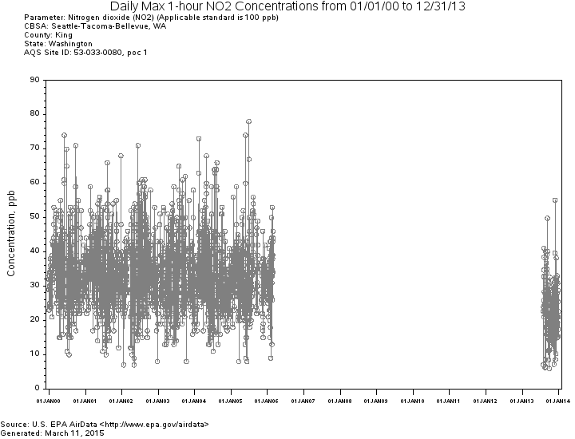

**Figure 2: Trends - Concentrations for NO2 1-Hour NAAQS - California**

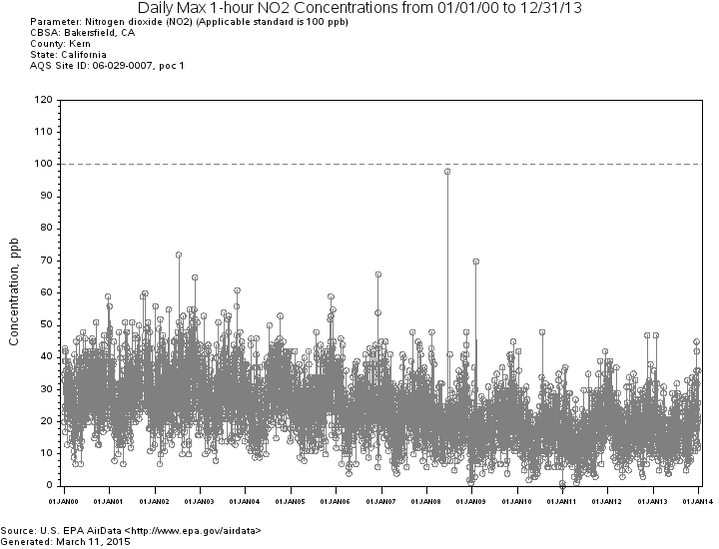

**Figure 3: Trends - Concentrations for NO2 1-Hour NAAQS - Idaho**

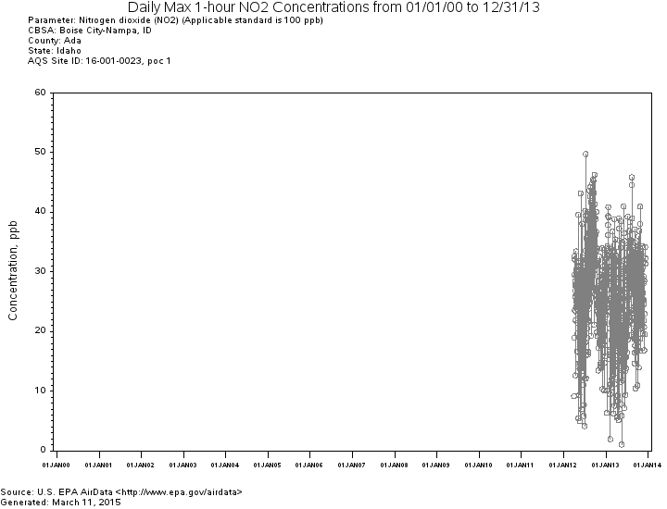

**Figure 4: Trends – Concentrations for NO2 1-Hour NAAQS - Nevada**

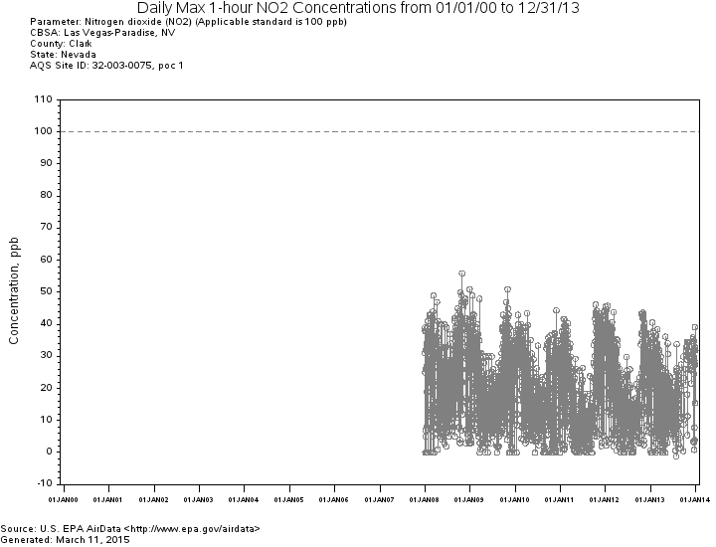

SO2: The level of the 1-hour NAAQS for sulfur dioxide is 75 ppb calculated as the 3-year average of the 99th percentile of the annual distribution of daily maximum 1-hour average concentrations. The 2011-2013 Design values for SO2  are presented in Table 2. .Daily maximum 1-hr SO2 2000-2013 trends at monitoring stations in Oregon, Washington, California, Idaho, and Nevada are in Figures 5-10.

|  |  |  |
| --- | --- | --- |
| Table 2: County-Level Design Value Concentrations for SO2 1-Hour NAAQS | | |
| State | **County** | **2011-2013 1-Hour Design Value (ppb)** |
| CA | Alameda | 15 |
| CA | Contra Costa | 14 |
| CA | Riverside | 3 |
| CA | Sacramento | 2 |
| CA | San Bernardino | 5 |
| CA | San Diego | 1 |
| CA | San Luis Obispo | 21 |
| CA | Santa Barbara | 36 |
| CA | Santa Clara | 13 |
| CA | Solano | 4 |
| ID | Caribou | 40 |
| NV | Clark | 8 |
| NV | Washoe | 6 |
| OR | Multnomah | 6 |
| WA | Clallam | 1 |

|  |
| --- |
| **Figure 5: Trends – SO2 1-hour NAAQS concentrations – Umatilla County, Oregon** |

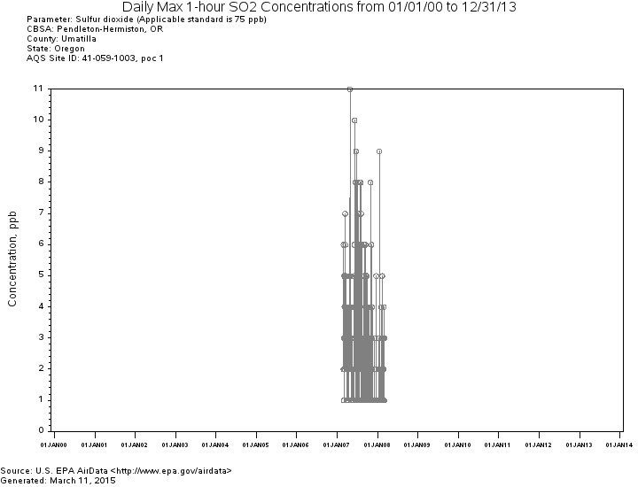

**Figure 6: Trends – SO2 1-hour NAAQS concentrations, Multnomah County, Oregon**

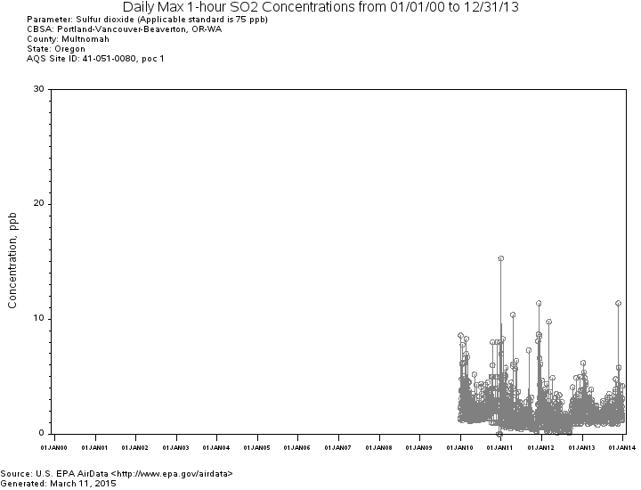

**Figure 7: Trends – SO2 1-hour NAAQS concentrations - Washington**

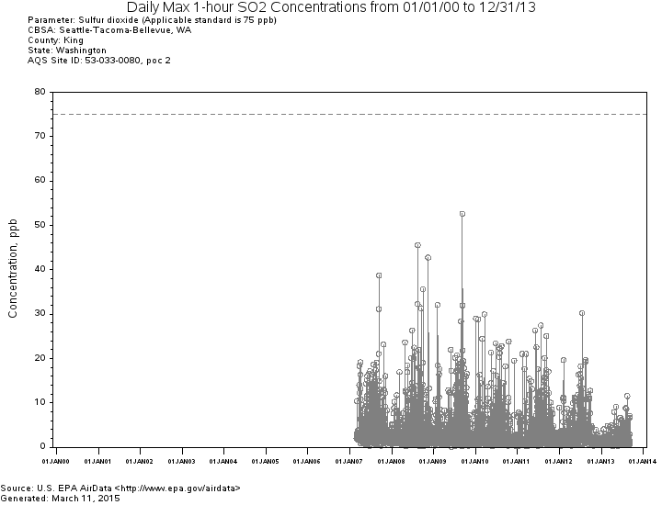

**Figure 8: Trends – SO2 1-hour NAAQS concentrations - California**

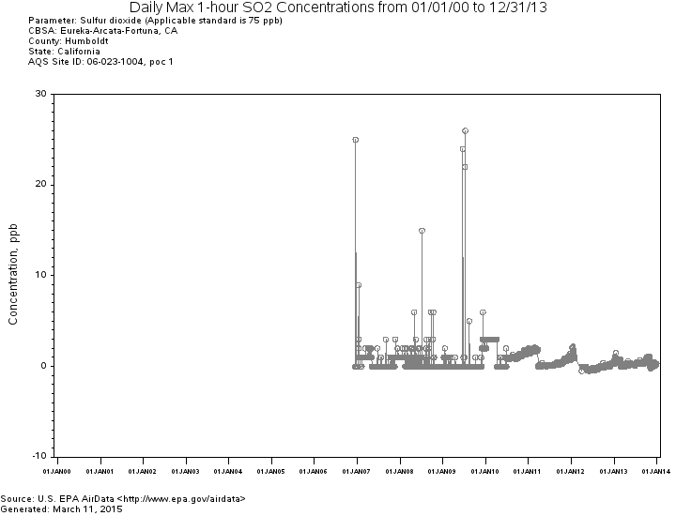

**Figure 9: Trends – SO2 1-hour NAAQS concentrations - Idaho**

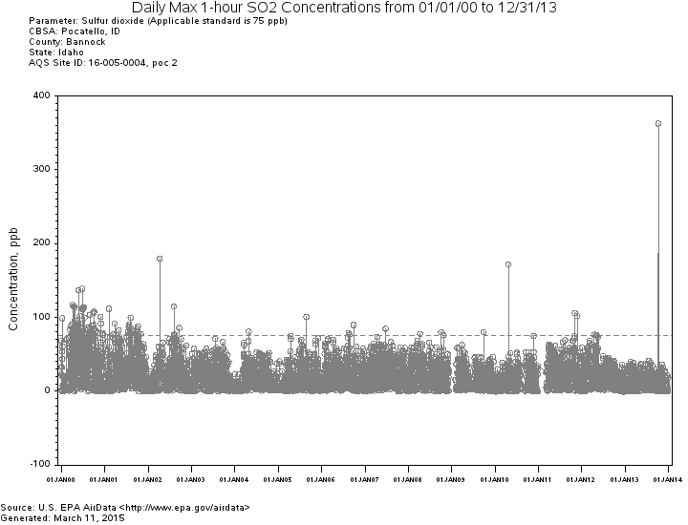

**Figure 10: Trends – SO2 1-hour NAAQS concentrations - Nevada**

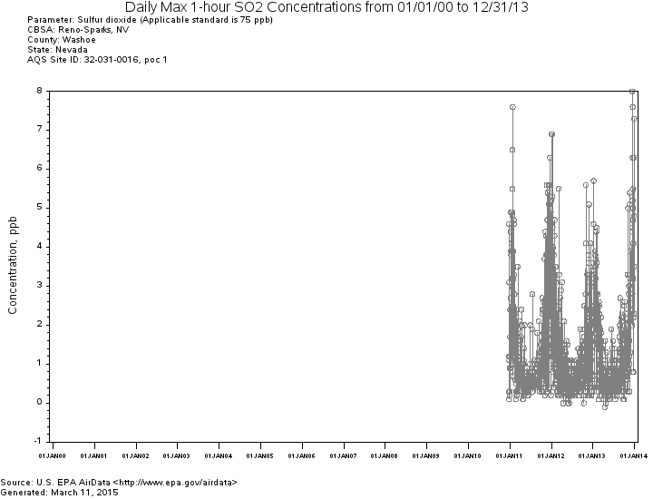

Pb: The level of the 2008 NAAQS for lead is 0.15 µg/m3 not to be exceeded in any 3-month period. The 2011-2013 available Design values for Pb are presented in Table 3. Daily maximum 1-hr Pb 1990-2013 trends at monitoring stations in Oregon, California, and Idaho are in Figures 11-13.

|  |  |  |  |
| --- | --- | --- | --- |
| Table 3. Site-Level Maximum Design Value Concentrations for 2008 Lead NAAQS, 2011-2013 | | | |
| State | **County** | **AQS Site ID** | **2011-2013 Design Value (µg/m3)** |
| California | Fresno | 060190011 |  |
| California | Imperial | 060250005 | 0.03 |
| California | Los Angeles | 060371302 |  |
| California | Los Angeles | 060371402 |  |
| California | Los Angeles | 060371404 |  |
| California | Los Angeles | 060374002 |  |
| California | Los Angeles | 060374004 |  |
| California | Los Angeles | 060375005 |  |
| California | Los Angeles | 060371103 | 0.01 |
| California | Los Angeles | 060371403 | 0.11 |
| California | Los Angeles | 060371405 | **0.46** |
| California | Los Angeles | 060371406 | 0.07 |
| California | Los Angeles | 060371602 | 0.01 |
| California | Riverside | 060651003 | 0.01 |
| California | Riverside | 060658001 | 0.01 |
| California | San Bernardino | 060719004 |  |
| California | San Bernardino | 060711004 | 0.01 |
| California | San Diego | 060730003 |  |
| California | San Diego | 060731021 |  |
| California | San Diego | 060731020 | **0.17** |
| California | San Mateo | 060812002 | **0.33** |
| California | Santa Clara | 060852010 |  |
| California | Santa Clara | 060852011 |  |
| Oregon | Yamhill | 410711702 | 0.05 |
| Nevada | Clark | 320030540 |  |
| Washington | King | 530330029 |  |
| Washington | Snohomish | 530610013 |  |

The Design values in bold in Table 3 exceed the 2008 Lead NAAQS. The monitoring site in California is 800 miles from the Oregon border. It is not possible for lead emissions from Oregon to move to and be measured at the California monitoring site.

Figures 11-13 show local 1990-2013 Pb trends in Oregon, Washington, Idaho and California. Note: There are no Pb trends for Nevada and Washington.

**Figure 11: Annual Maximum 3-Month Average Pb - Oregon**

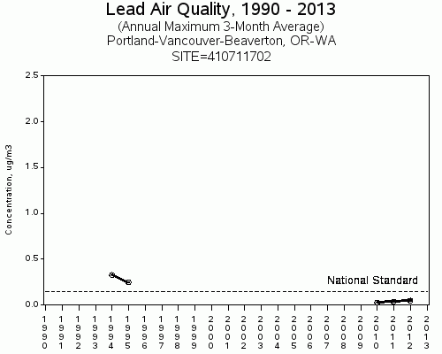

**Figure 12: Annual Maximum 3-Month Average Pb - Idaho**

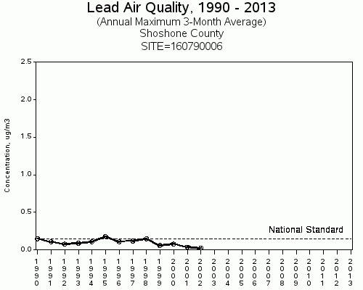

**Figure 13: Annual Maximum 3-Month Average Pb - California**

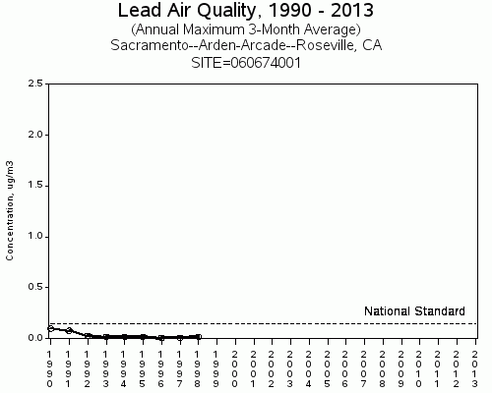

PM 2.5: The level of the 2012 NAAQS for PM 2.5 is 12 ug/m3 calculated as a 3-year average of the annual arithmetic mean. Table 4 presents the 2011-2013 Design values for PM2.5. Figures 5-10 present annual PM2.5 2000-2013 trends at monitoring stations in Oregon, Washington, California, Idaho and Nevada.

Table 4 presents the 2011-2013 design values for PM 2.5. Figure 13 shows annual PM 2.5 2000-2013 NW trend at monitoring stations in Oregon, Washington, California, Idaho, and Nevada. The trend shows an 11% regional decrease in PM 2.5 emissions across the NW region.

|  |  |  |  |
| --- | --- | --- | --- |
| Table 4 PM2.5 Site Listing, 2011-2013 | | | |
| State | **County** | **Site ID** | **2011-2013 Annual Design Value (µg/m3)** |
| California | Alameda | 060010007 | 7.6 |
| California | Alameda | 060010009 | 10.0 |
| California | Butte | 060070008 | 10.1 |
| California | Calaveras | 060090001 | 8.4 |
| California | Colusa | 060111002 | 7.1 |
| California | Contra Costa | 060130002 | 7.4 |
| California | Fresno | 060190011 | **15.4** |
| California | Fresno | 060192009 | 7.8 |
| California | Fresno | 060195001 | **16.4** |
| California | Fresno | 060195025 | **14.7** |
| California | Humboldt | 060231002 | 6.2 |
| California | Imperial 4 | 60250005 | **14.3** |
| California | Imperial | 060250007 | 7.5 |
| California | Imperial | 060251003 | 7.4 |
| California | Inyo | 060271003 | 7.5 |
| California | Kern | 060290014 | **16.4** |
| California | Kern | 060290016 | **17.3** |
| California | Kings | 060311004 | **17.0** |
| California | Lake | 060333001 | 3.8 |
| California | Los Angeles | 060370002 | 11.2 |
| California | Los Angeles | 060371002 | **12.8** |
| California | Los Angeles | 060371103 | **13.0** |
| California | Los Angeles | 060371201 | 10.2 |
| California | Los Angeles | 060371302 | **12.2** |
| California | Los Angeles | 060371602 | 12.0 |
| California | Los Angeles | 060374002 | 11.1 |
| California | Los Angeles | 060374004 | 11.0 |
| California | Madera | 060392010 | **18.1** |
| California | Marin | 060410001 | 9.5 |
| California | Merced | 060470003 | **13.3** |
| California | Merced | 060472510 | 11.1 |
| California | Monterey | 060531003 | 6.1 |
| California | Nevada | 060570005 | 4.6 |
| California | Nevada | 060571001 | 7.0 |
| California | Orange | 060590007 | 10.7 |
| California | Orange | 060592022 | 8.2 |
| California | Placer | 060610006 | 7.5 |
| California | Plumas | 060631006 | 10.2 |
| California | Plumas | 060631009 | **12.2** |
| California | Plumas | 060631010 | **12.8** |
| California | Riverside | 060650009 | 7.7 |
| California | Riverside | 060651003 | 11.5 |
| California | Riverside | 060652002 | 7.7 |
| California | Riverside | 060655001 | 6.4 |
| California | Riverside | 060658001 | **13.4** |
| California | Riverside | 060658005 | **15.1** |
| California | Sacramento | 060670006 | 10.4 |
| California | Sacramento | 060670010 | 9.5 |
| California | Sacramento | 060674001 | 9.3 |
| California | San Benito | 060690002 | 5.5 |
| California | San Bernardino | 060710025 | **12.6** |
| California | San Bernardino | 060712002 | **12.6** |
| California | San Bernardino | 060718001 | 8.7 |
| California | San Bernardino | 060719004 | 11.8 |
| California | San Diego | 060730001 | 9.9 |
| California | San Diego | 060730003 | 10.6 |
| California | San Diego | 060731002 | 10.7 |
| California | San Diego | 060731010 | 10.8 |
| California | San Diego | 060731016 | 8.7 |
| California | San Francisco | 060750005 | 9.2 |
| California | San Joaquin | 060771002 | 13.8 |
| California | San Joaquin | 060772010 | 10.2 |
| California | San Luis Obispo | 060792004 | 8.7 |
| California | San Luis Obispo | 060792006 | 6.6 |
| California | San Luis Obispo | 060792007 | 11.3 |
| California | San Luis Obispo | 060798001 | 7.0 |
| California | San Mateo | 060811001 | 9.3 |
| California | Santa Barbara | 060830011 | 9.5 |
| California | Santa Barbara | 060831008 | 7.6 |
| California | Santa Clara | 060850002 | 8.0 |
| California | Santa Clara | 060850005 | 10.3 |
| California | Santa Cruz | 060870007 | 6.3 |
| California | Shasta | 060890004 | 5.7 |
| California | Shasta | 060893004 | 6.2 |
| California | Siskiyou | 060932001 | 6.3 |
| California | Solano | 060950004 | 9.6 |
| California | Sonoma | 060970003 | 8.4 |
| California | Stanislaus | 060990005 | **13.6** |
| California | Stanislaus | 060990006 | **15.7** |
| California | Sutter | 061010003 | 7.7 |
| California | Tehama | 061030006 | 8.1 |
| California | Tulare | 061072002 | **16.6** |
| California | Ventura | 061110007 | 9.1 |
| California | Ventura | 061110009 | 8.1 |
| California | Ventura | 061112002 | 9.1 |
| California | Ventura | 061113001 | 9.0 |
| California | Yolo | 061131003 | 7.2 |
| Idaho | Ada | 160010010 | 9.1 |
| Idaho | Bannock | 160050020 | 7.7 |
| Idaho | Benewah | 160090010 | 9.9 |
| Idaho | Canyon | 160270002 | 10.8 |
| Idaho | Franklin | 160410001 | 8.0 |
| Idaho | Lemhi | 160590004 | 12.0 |
| Idaho | Shoshone | 160790017 | **12.8** |
| Nevada | Clark | 320030540 | 8.1 |
| Nevada | Clark | 320030561 | 8.8 |
| Nevada | Clark | 320031019 | 4.6 |
| Nevada | Washoe | 320310016 | 7.6 |
| Oregon | Crook | 410130100 | 9.8 |
| Oregon | Harney | 410250003 | 9.5 |
| Oregon | Jackson | 410290133 | 10.9 |
| Oregon | Josephine | 410330114 | 8.8 |
| Oregon | Klamath | 410350004 | 11.6 |
| Oregon | Lake | 410370001 | 11.1 |
| Oregon | Lane | 410390060 | 7.0 |
| Oregon | Lane | 410391009 | 5.8 |
| Oregon | Lane | 410392013 | 9.1 |
| Oregon | Lane | 410399004 | 7.1 |
| Oregon | Multnomah | 410510080 | 8.1 |
| Oregon | Umatilla | 410590121 | 7.6 |
| Oregon | Washington | 410670004 | 8.2 |
| Washington | King | 530330057 | 10.1 |
| Washington | King | 530330080 | 6.1 |
| Washington | King | 530332004 | 7.1 |
| Washington | Pierce | 530530029 | 7.8 |
| Washington | Snohomish | 530610005 | 5.9 |
| Washington | Snohomish | 530610020 | 6.9 |
| Washington | Snohomish | 530611007 | 7.7 |
| Washington | Spokane | 530630021 | 8.0 |
| Washington | Yakima | 530770009 | 9.1 |

There are design values that exceed the annual PM 2.5 NAAQS in neighboring states at monitoring sites located hundreds of miles away from Oregon. It is unlikely Oregon’s PM 2.5 emissions contribute to those levels.

**Figure 13**

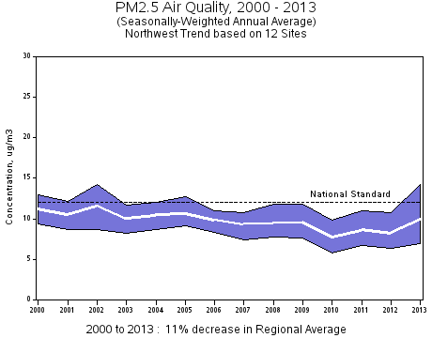

IV. Nature and Extent of Expected Pollutant Transport

*Summary*: Lead, Nitrogen Dioxide and Sulfur Dioxide normally do not move over long distances. Pb would most likely be deposited within a few miles of a source. Both NO2 and SO2 will most likely either disperse in the atmosphere or chemically react to form a secondary pollutant within a few miles of the source. The only transport of PM 2.5 is related to regional haze and is not sufficient to contribute to exceeding NAAQS in neighboring states. Oregon receives a lot of PM 2.5 from forest fire smoke, exceptional events and residential wood burning. Thus, only large pollutant sources in proximity to the State boundaries would be expected to significantly contribute to nonattainment or interfere with maintenance of a NAAQS in another state.

*Nitrogen Dioxide* : NO2 is one of a group of highly reactive gasses known as "oxides of nitrogen," or "nitrogen oxides (NOx)." Other nitrogen oxides include nitrous acid and nitric acid. EPA’s NAAQS uses NO2 as the indicator for the larger group of nitrogen oxides. NO2 forms quickly from emissions from cars, trucks and buses, power plants and off-road equipment. In addition to contributing to the formation of ground-level ozone, and fine particle pollution, NO2 is linked with a number of adverse effects on the respiratory system.

EPA first set standards for NO2 in 1971, setting both a primary standard (to protect health) and a secondary standard (to protect the public welfare) at 0.053 parts per billion (ppb), averaged annually. The Agency has reviewed the standards twice since that time, but chose not to revise the annual standards at the conclusion of each review. In January 2010, EPA established an additional primary standard at 100 ppb, averaged over one hour. Concentrations of NO2 emitted into the atmosphere will decrease during transport through three mechanisms: deposition, chemical transformation, and dispersion. Interstate transport of NO2 is not a concern for Oregon.

*Sulfur Dioxide (SO2)*: SO2 is one of a group of highly reactive gasses known as “oxides of sulfur.” Generally the largest sources of SO2 emissions are from fossil fuel combustion at power plants (73%) and other industrial facilities (20%). Smaller sources of SO2 emissions include industrial processes such as extracting metal from ore, and burning high sulfur containing fuels in locomotives, large ships, and non-road equipment. SO2 is linked with a number of adverse effects on the respiratory system. The emission inventory for Oregon demonstrates a similar source distribution.

EPA first set standards for SO2 in 1971. EPA set a 24-hour primary standard at 140 ppb and an annual average standard at 30 ppb (to protect health). EPA also set a 3-hour average secondary standard at 500 ppb (to protect the public welfare). In 1996, EPA reviewed the SO2 NAAQS and chose not to revise the standards.

In 2010, EPA revised the primary SO2 NAAQS by establishing a new 1-hour standard at a level of 75 ppb. EPA revoked the two existing primary standards because they would not provide additional public health protection.

Concentrations of SO2 emitted into the atmosphere decreases during transport through three mechanisms: deposition, chemical transformation, and dispersion. Interstate transport of SO2 is not a concern for Oregon.

*Lead (Pb)*: As noted in the EPA’s October 14, 2011 Pb infrastructure guidance, the physical properties of Pb prevent Pb emissions from experiencing the same travel or formation phenomena as fine particulate matter or ozone. More specifically, there is a sharp decrease in Pb concentrations, at least in the coarse fraction, as the distance from a Pb source increases. Accordingly, while it may be possible for a source in a state to emit Pb in a location and in quantities that may contribute significantly to nonattainment in, or interfere with maintenance by, any other state, EPA anticipates that this would be a rare situation (e.g., where large sources are in close proximity to state boundaries). EPA’s experience with initial Pb designations suggests that sources that emit less than 0.5 tons per year or that are located more than two miles from a state border generally appear unlikely to contribute significantly to nonattainment in another state. All sources of Pb emissions in the Oregon are below 0.5 tons per year and are located greater than two miles from the state border. Therefore, it is unlikely that sources in Oregon will significantly contribute to nonattainment or interfere with maintenance of the 2008 Pb NAAQS in any other state.

*Fine Particulate Matter (PM 2.5):* DEQ’s consultation with air agencies in adjacent states suggests that high PM 2.5 levels in their respective communities are driven largely by local pollution sources during air stagnation events. Local air stagnation events would generally preclude interstate air pollution transport as a significant contributor to high PM2.5 levels jeopardizing NAAQS compliance.

**V. Sources of Pollutant Emissions Near the State Boundary and Expected Impacts in Neighboring States.**

This section addresses the emission inventory of sources and emission for pollutants (specifically major point or area source emissions and their proximity to the state boundary) and the likelihood that emissions from these sources would transport across the state boundary to contribute significant to nonattainment or interfere with maintenance of any applicable NAAQS in any other state.

There are six Title V Oregon sources in close proximity to the Washington border and one source in close proximity to the Idaho border. The 2011 emission inventories of these sources are in the tables below.



Georgia-Pacific Consumer Products LP, Cascades Tissue Group-Oregon, Portland General Electric Company Beaver Plant/Port Westward I Plant, and Portland General Electric Company Coyote Springs Plant all went through PSD analysis.

Owens-Brockway Glass Containers and Evraz were evaluated as part of the competing sources inventory during both Port Westward and Troutdale Energy Center’s PSD analyses.

A PSD permit applicant must conduct an air quality analysis of the ambient impacts associated with the construction and operation of a proposed new source or modification. The purpose of the air quality analysis is to demonstrate that new emissions from a proposed major stationary source or major modification, in conjunction with other applicable emissions from existing sources (including secondary emissions), will not cause or contribute to a violation of any applicable NAAQS.

Portland General Electric’s only coal-fired power plant in the state is located in Boardman, Oregon, 14 km south of Washington’s boarder. PGE Boardman has a federally enforceable shutdown date of 2020.

Based on our analysis, we believe it is reasonable to conclude that emissions from sources in Oregon do not significantly contribute to PM 2.5 and NO2 concentrations in any other state.

Regional Work with Western Regional Air Partnership (WRAP):  In late 2010, WRAP initiated the West-wide Jump-start Air Quality Modeling Study (WestJumpAQMS). The study’s goals were to develop the next generation of regional air quality modeling databases for ozone, PM 2.5, visibility and deposition planning in the western U.S and to provide information on the role of interstate and international transport to ozone and PM 2.5 under current and potential future NAAQS. The study looked at PM 2.5 annual source apportionment but did not look at the transport of lead, NO2 or SO2.  We looked at Appendix E of the study (State Contributions to Modeled Annual PM 2.5 concentrations in 2008 by Monitoring Site).  We reviewed the total annual PM 2.5 modeled concentrations in all the counties in the state of Washington, California, Idaho, Nevada, and as far away as Wyoming.  While Clark and Skamania counties in Washington may be impacted by Oregon’s PM2.5 emissions, since Washington does not have annual PM2.5 nonattainment area and has not had any violations of the standard in the past 3 years, those impacts do not result in Oregon’s contribution to nonattainment or violations of annual PM2.5 standard in the state of Washington. The impacts by Oregon to other neighboring states were insignificant.

Consultation with Neighboring States:  In March 2015, DEQ contacted its neighboring states (Nevada, Idaho, Washington, Nevada and California) regarding the potential transport of air emissions across state boundaries. Other than wildfires, California is not aware or any Oregon air emissions that affect Northern California. Based on Washington’s recent interstate transport report, Oregon’s emissions are not significantly affecting Washington.  Idaho reported that since they do not have a lead, NO2 or SO2 non-attainment area, they do not believe Oregon is affecting Idaho. Due to the lack of any nonattainment or maintenance areas for the listed pollutants, Nevada concludes that emissions from Oregon are not currently affecting air quality in any significant way.

**VI. Conclusion**

Based upon the Oregon 2011 emissions inventory, 2011-2013 design values, long-term trends,  2010 WRAP study, and consultation with neighboring states, DEQ finds no evidence to suggest that Oregon emissions of NO2, SO2, Pb and PM2.5 significantly contribute to exceedances or violations of NAAQS, or cause adverse effects in the neighboring states.

In conclusion, in accordance with section 110(a)(2)(D)(i)(I), the current SIP contains adequate provisions prohibiting any source or other type of emissions activity within Oregon from emitting air pollutants that will contribute significantly to nonattainment of the applicable NAAQS in any other state or interfere with maintenance of the applicable NAAQS in any other state.