**Oregon SIP Infrastructure Addressing the Interstate Transport Pollutant Impacts of Lead (Pb), Nitrogen Dioxide (NO2), Sulfur Dioxide (SO2) and Fine Particulate Matter (PM 2.5)**

**(NLC draft 3/12/15)**

**Clean Air Act Section 110(a)(2)(D)**

**Oregon Department of Environmental Quality**

**<Date>**

Contents

Addressing Interstate Pollutant Impacts under the Clean Air Act 18

1. Introduction 18
2. Background 18
3. Air Quality Data and Attainment Status within the State and Surrounding States 18
4. Nature of Pollutant Transport 18
5. Sources of Pollutant Emissions Near the State Boundary and Expected Impacts in Neighboring States 18

VI. Conclusion 18

**Contact:**

Nancy Cardwell

Environmental Solutions

Air Planning

(503) 229-6610

# Addressing Interstate Pollutant Impacts under the Clean Air Act

**Overview** (from 2009 DEQ submittal)

Some amount of air pollution transport occurs routinely across all state borders and across all regions of the country. This document discusses Oregon’s ability to address interstate air pollution transport. Based on the information summarized in the sections that follow, DEQ concludes that air emissions (Pb, NO2, SO2 and PM 2.5) from Oregon sources do not significantly contribute to violations of national ambient air quality standards in other states, or interfere with other states efforts to meet air quality standards, prevent significant air quality degradation, or protect visibility. DEQ’s conclusions are based on its understanding of air pollution problems in adjacent states, and the emission sources, meteorology (weather patterns), and topographic features (mountain ranges, etc.) that influence air quality problems in these states.

DEQ will collaborate with Washington, Idaho, Nevada, California and other state air agencies whenever necessary to evaluate case-specific air quality problems that may involve regional transport of air pollution. DEQ’s Section 110 infrastructure SIP provides the framework and legal mechanism for DEQ to act as needed to reduce any Oregon emissions found to significantly contribute to air quality problems in other states.

The map below (Figure 1) illustrates the significant distances and mountain ranges that in many areas separate Oregon from communities in Washington, California, Idaho, and Nevada, and can help limit the long range transport of air pollution.

**Figure 1: Map of Oregon and major mountain ranges** 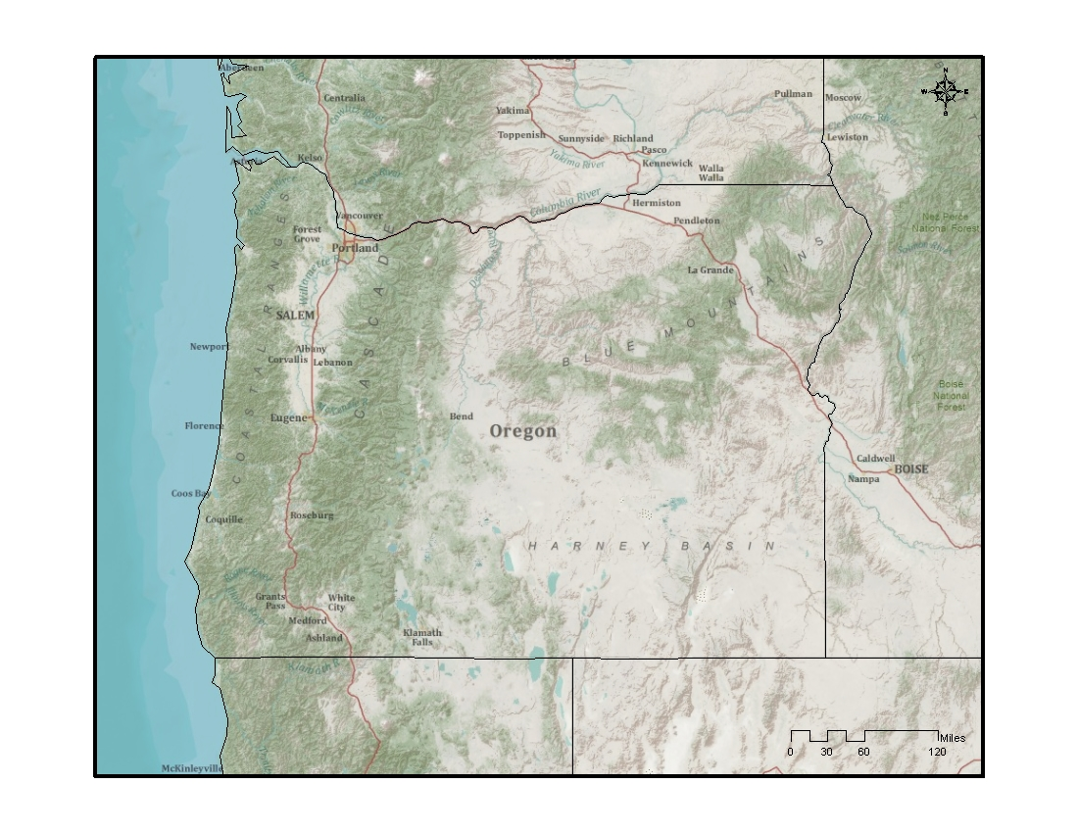

**I. Introduction**

The interstate transport provision in Clean Air Act (CAA) section 110(a)(2)(D)(i) (also called “ the good neighbor” provision) requires each state to submit a State Implementation Plan (SIP) that prohibits emissions that will have certain adverse air quality effects in other states. This SIP submittal is due within three years of the Environmental Protection Agency (EPA) promulgating a new or revised National Ambient Air Quality Standard (NAAQS).

II. Background

**EPA Promulgated NAAQS**

* Lead (Pb): On October 15, 2008, the EPA revised the level of the primary and secondary Pb NAAQS from 1.5 micrograms per cubic meter (µg/m3) to 0.15 µg/m3.
* Nitrogen Dioxide (NO2): The EPA first set standards for NO2 in 1971, setting both a primary standard (to protect health) and a secondary standard (to protect the public welfare) at 53 parts per billion (53 ppb), averaged annually. The EPA reviewed the standards in 1985 and 1996, deciding to retain the standards at the conclusion of each review. In 2005, the EPA began another review, resulting in the January 22, 2010, rulemaking to establish an additional primary NO2 standard at 100 ppb, averaged over one hour (75 FR 6474).
* Sulfur Dioxide (SO2): Primary standards for SO2 were first set in 1971, at 0.14 parts per million (ppm) averaged over a 24-hour period, not to be exceeded more than once per year, and 0.030 ppm, annual arithmetic mean. The EPA subsequently reviewed the primary standards and determined to retain them in 1996 at the conclusion of the review. More recently, on June 2, 2010, the EPA promulgated a revised primary SO2 standard at 75 ppb, based on a three-year average of the annual 99th percentile of one-hour daily maximum concentrations (75 FR 35520).
* Fine Particulate Matter (PM 2.5): On December 14, 2012 the EPA promulgated a revised NAAQS for fine particulate matter (PM 2.5) from 15 µg/m3 to 0.12 µg/m3.

Section 110(a)(2)(D)(i) identifies four distinct requirements related to the impacts of air pollutants transported across state lines. It requires that each SIP for a new or revised NAAQS contain adequate provisions prohibiting any source or other type of emissions activity within the state from emitting air pollutants may:

1. contribute significantly to nonattainment of the applicable NAAQS in any other state;
2. interfere with maintenance of the applicable NAAQS in any other state;
3. interfere with measures required to be included in the applicable implementation plan for any other state to prevent significant deterioration of air quality; and
4. interfere with measures required to be included in the applicable implementation plan for any other state to protect visibility

The federally approved SIP for the State of Oregon currently addresses elements 3 and 4 above. (Q: Why include 3 and 4 if they are approved?) This SIP submittal addresses the requirements of CAA section 110(a)(2)(D)(i)(I) for the new/revised NAAQS for Pb, NO2, SO2 and PM 2.5 for elements 1 and 2 listed above.

III. Air Quality Data and Attainment Status within Oregon and Surrounding States

* 1. **Surrounding contiguous states**: Oregon is bordered by Washington to the north, the Pacific Ocean to the west, California and Nevada to the south, and Idaho to the east. The Snake River separates the state from part of Idaho. The Columbia River forms most of the state's northern border. The only sources in Oregon within 5 km of a contiguous state is Washington and Idaho.
  2. **Designation of all areas within the state and in each surrounding state (attainment, nonattainment, and unclassifiable), including maintenance areas in adjacent states:**
* Lead (Pb): All areas in the states of Oregon, Idaho, Nevada, and Washington were designated by EPA in 2008 as “unclassifiable/attainment”. In California, Los Angeles County South Coast Air Basin is classified as “nonattainement”. The rest of the state is designated “ unclassifiable/attainment”
* Nitrogen Dioxide (NO2): On January 20, 2012 EPA designated all areas of the country as “unclassifiable/attainment” for the 2010 NO2 NAAQS. The available air quality data show that all monitored areas in the country meet the 2010 NO2 NAAQS for 2008-2010. No state or tribe recommended an area be designated “nonattainment.”
* Sulfur Dioxide (SO2): According to EPA, designations for entire states of Oregon, Washington, Idaho, California, Nevada will be addressed in a future action. The EPA's review of the monitored air quality data from 2009-2011 showed no violations of 2010 1-hr SO2 standard in any of these states.
* Fine Particulate Matter (PM 2.5): Shoshone county in Idaho, Imperial, Fresno, Kings, Madera, Merced, San Joaquin, Stanislaus, and Tulare counties in California are designated in nonattainment of 2012 annual PM2.5 standard.

There are no nonattainment areas for the annual PM 2.5 standard in Oregon, Washington, Idaho, and Nevada. There have been no annual PM 2.5 NAAQS violations in SW Washington during the most recent three-year period (2012-2014).

* 1. **Monitoring network for pollutants within the state and surrounding states:**

*Oregon Monitoring Network for NO2, SO2, Pb and PM 2.5*:





*NO2 Monitoring Networks (Oregon, Washington, Idaho, California, Nevada)*

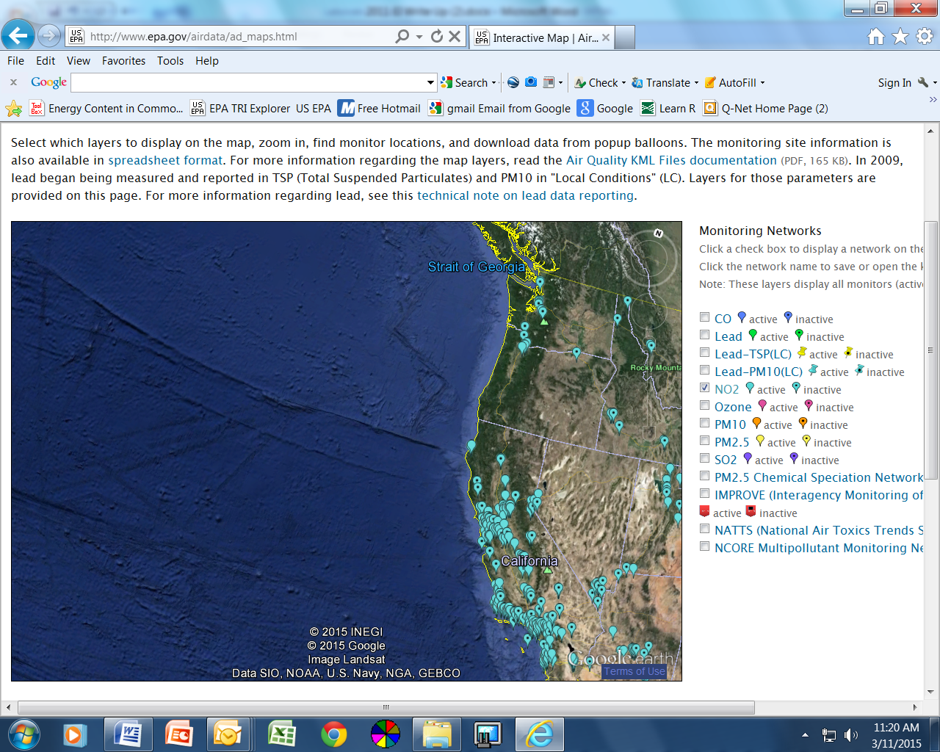

*SO2 Monitoring Networks (Oregon, Washington, Idaho, California, Nevada*

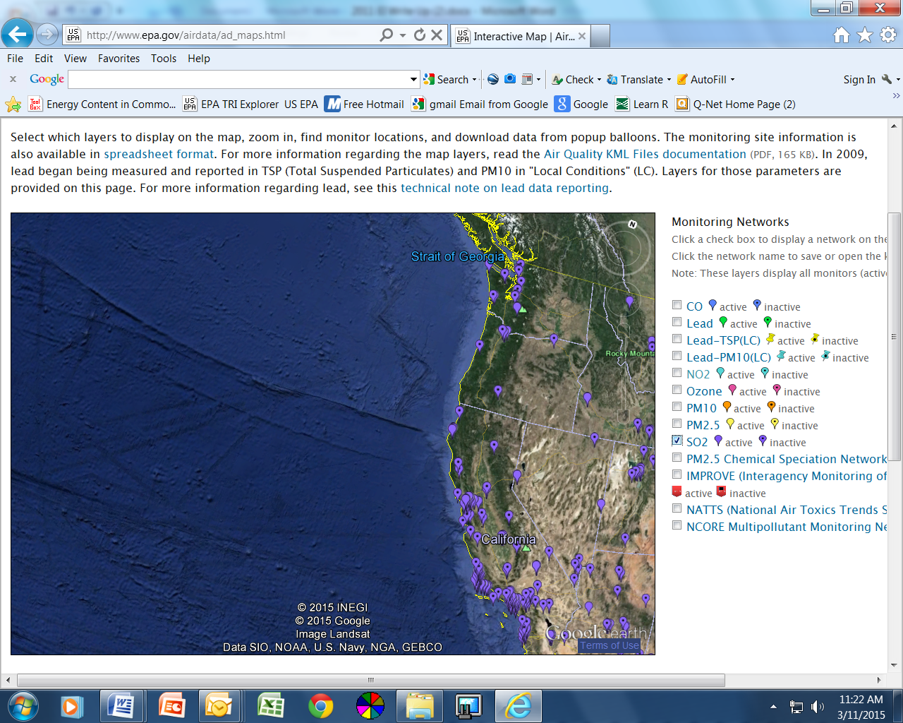

Pb *SO2 Monitoring Networks (Oregon, Washington, Idaho, California, Nevada)*

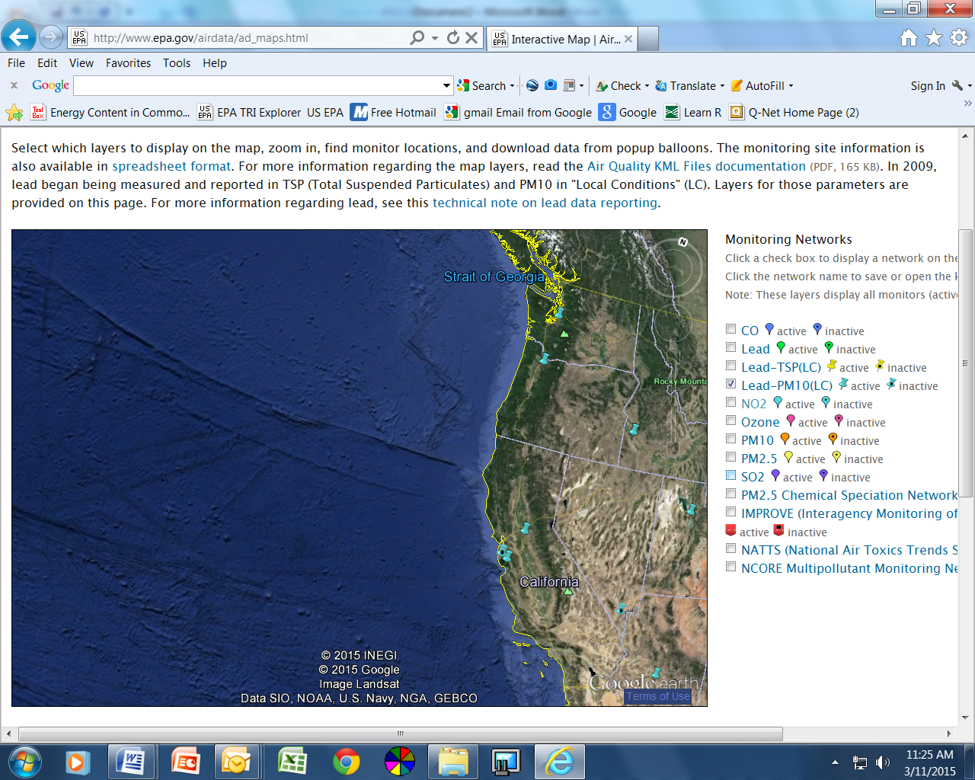

PM2.5 *Monitoring Networks (Oregon, Washington, Idaho, California, Nevada)*

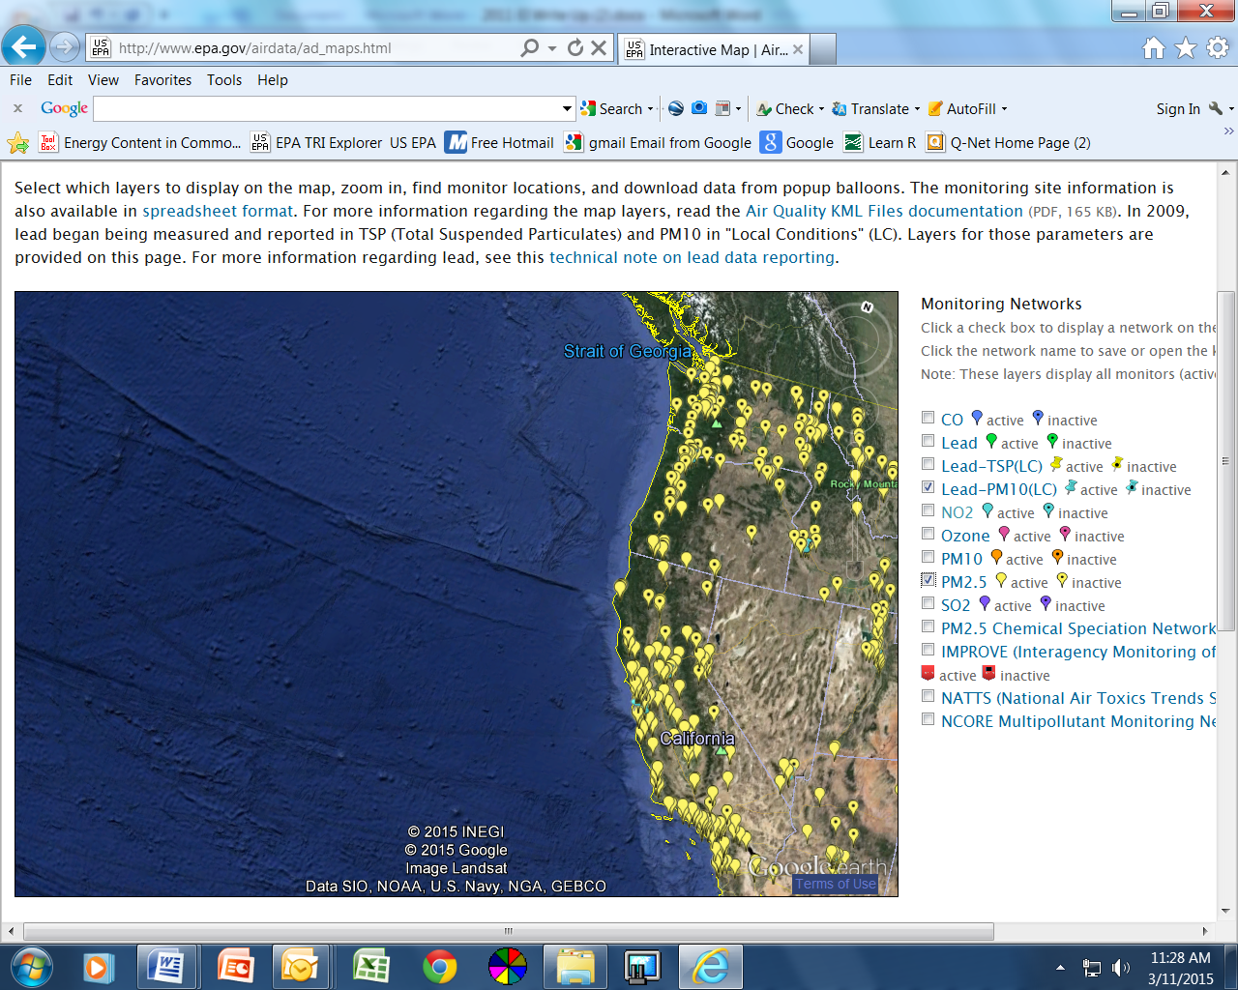

* 1. **Ambient data, including the ‘design value’ for pollutants of interest at each monitoring site and trends over the last 5-10 years.**

NO2: The level of the hourly NAAQS for nitrogen dioxide is 100 parts per billion (ppb) based on the 98th percentile value from three consecutive years of data. The design values shown here are computed for the latest design value period using Federal Reference Method or equivalent data reported to EPA by States, Tribes, and local agencies. Daily maximum 2000-02013 1-hr NO2 trends in Oregon, Washington, California, Idaho, and Nevada are in Figures x –y.

|  |  |  |  |
| --- | --- | --- | --- |
| Table 1 County-Level Design Value Concentrations for Nitrogen Dioxide 1-Hour NAAQS | | | |
| **State** | **County** | **Site** | **2011-2013 1-hr Design Value** |
| California | Alameda | 060010011 | 50 |
| California | Butte3 | 060070008 | 37 |
| California | Contra Costa | 060131004 | 40 |
| California | Imperial | 060250005 | 64 |
| California | Kern | 060296001 | 46 |
| California | Kings | 060311004 | 46 |
| California | Los Angeles | 060371701 | 64 |
| California | Marin | 060410001 | 45 |
| California | Monterey | 060531003 | 35 |
| California | Napa | 060550003 | 39 |
| California | Placer | 060610006 | 50 |
| California | Riverside | 060655001 | 39 |
| California | Sacramento | 060670002 | 43 |
| California | San Bernardino | 060712002 | 62 |
| California | San Diego | 060732007 | 73 |
| California | San Francisco | 060750005 | 68 |
| California | San Joaquin | 060771002 | 53 |
| California | San Luis Obispo | 060798001 | 38 |
| California | San Mateo | 060811001 | 45 |
| California | Santa Barbara | 060831008 | 36 |
| California | Santa Clara | 060850005 | 51 |
| California | Solano | 060950004 | 42 |
| California | Sutter | 061010003 | 47 |
| California | Tulare | 061072002 | 52 |
| California | Ventura | 061112002 | 37 |
| California | Yolo | 061130004 | 34 |
| Oregon | Multnomah | 410510080 | 34 |
| Nevada | Washoe | 320310016 | 56 |

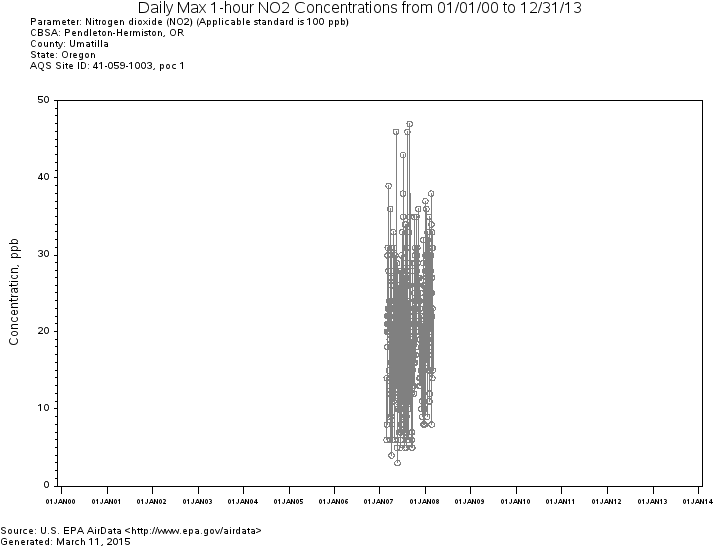

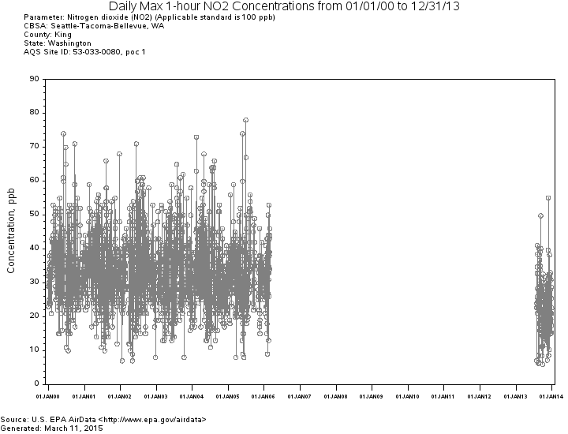

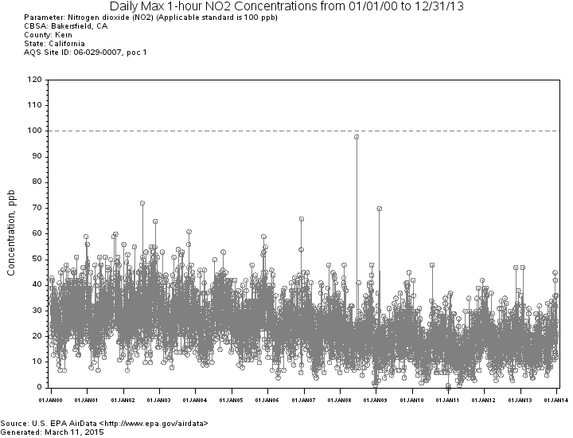

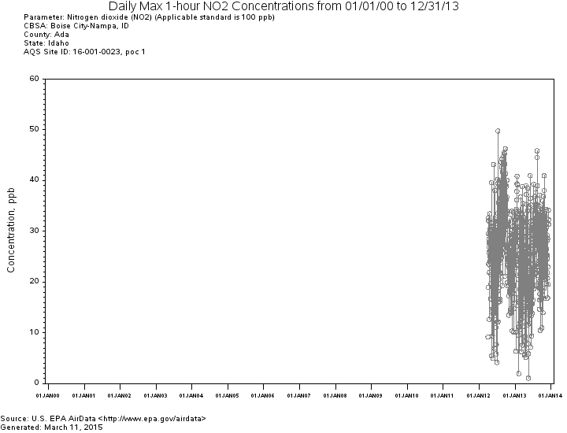

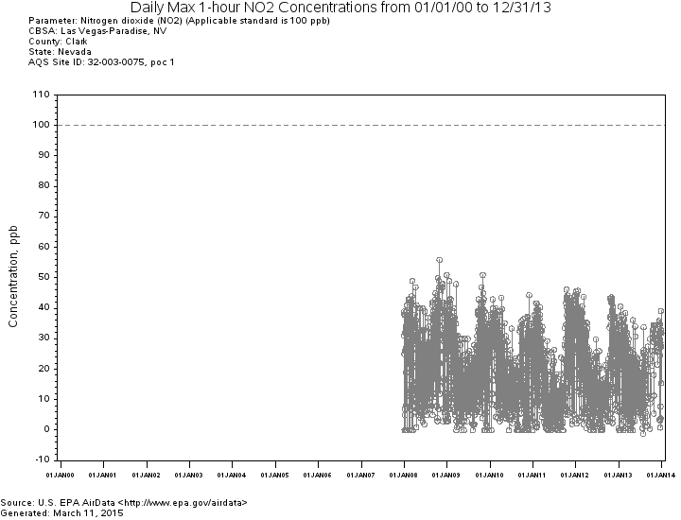

SO2: The level of the 1-hour NAAQS for sulfur dioxide is 75 parts per billion (ppb) calculated as the 3-year average of the 99th percentile of the annual distribution of daily maximum 1-hour average concentrations. Daily maximum 2000-02013 1-hr SO2 trends in Oregon, Washington, California, Idaho, and Nevada are in Figures x –y.

|  |  |  |
| --- | --- | --- |
| Table 4c. County-Level Design Values for Sulfur Dioxide 1-Hour NAAQS | | |
| **State** | **County** | **2011-2013 1-Hour Design Value (ppb)** |
| CA | Alameda | 15 |
| CA | Contra Costa | 14 |
| CA | Riverside | 3 |
| CA | Sacramento | 2 |
| CA | San Bernardino | 5 |
| CA | San Diego | 1 |
| CA | San Luis Obispo | 21 |
| CA | Santa Barbara | 36 |
| CA | Santa Clara | 13 |
| CA | Solano | 4 |
| ID | Caribou | 40 |
| NV | Clark | 8 |
| NV | Washoe | 6 |
| OR | Multnomah | 6 |
| WA | Clallam | 1 |

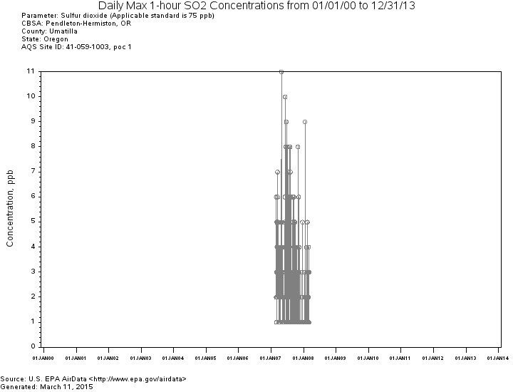

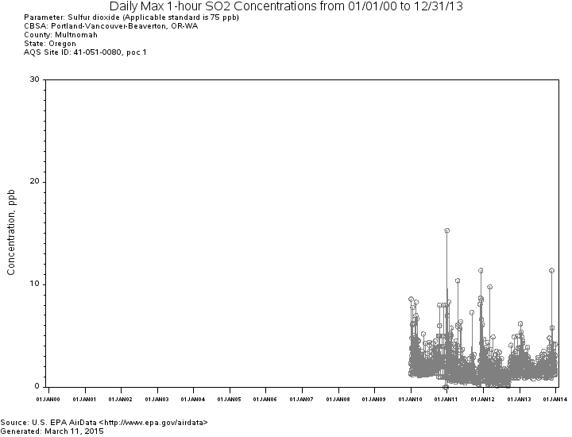

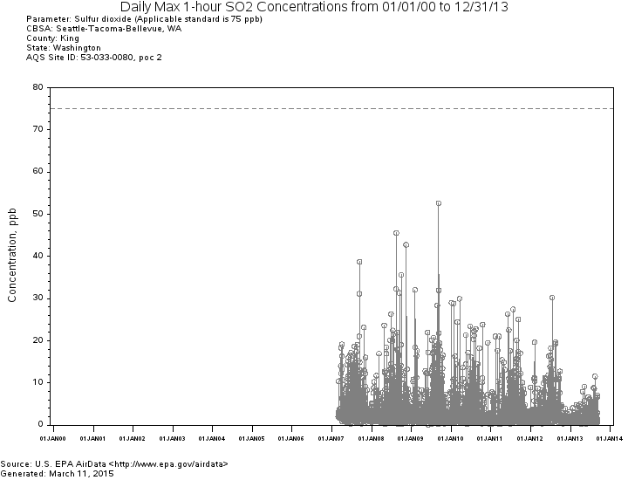

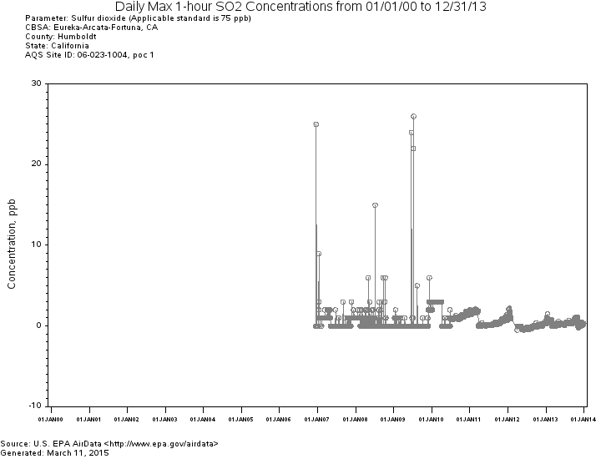

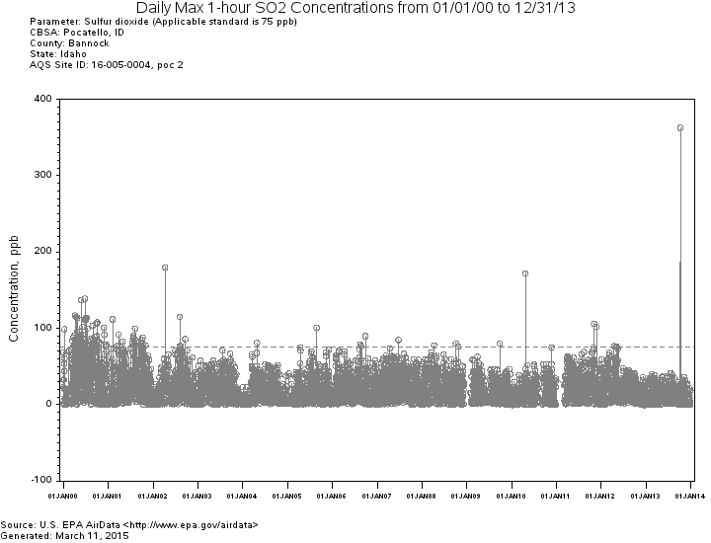

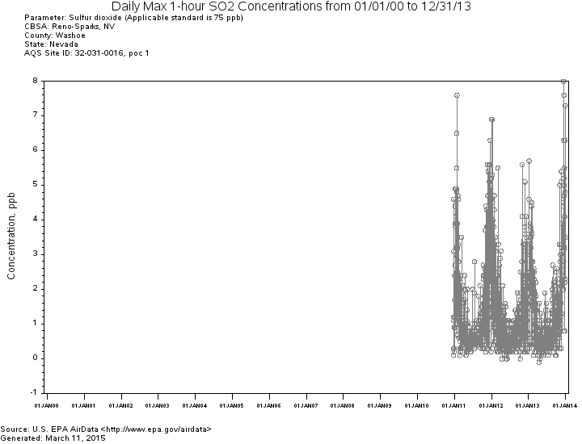

Pb: The level of the 2008 NAAQS for lead is 0.15 micrograms per cubic meter (µg/m3) not to be exceeded in any 3-month period.

|  |  |  |  |
| --- | --- | --- | --- |
| **Table 3. Site-Level Maximum Design Value Concentrations for 2008 Lead NAAQS, 2011-2013** | | | |
| **State** | **County** | **AQS Site ID** | **2011-2013 Design Value (µg/m3)** |
| California | Imperial | 060250005 | 0.03 |
| California | Los Angeles | 060371103 | 0.01 |
| California | Los Angeles | 060371403 | 0.11 |
| California | Los Angeles | 060371405 | 0.46 |
| California | Los Angeles | 060371406 | 0.07 |
| California | Los Angeles | 060371602 | 0.01 |
| California | Riverside | 060651003 | 0.01 |
| California | Riverside | 060658001 | 0.01 |
| California | San Bernardino | 060711004 | 0.01 |
| California | San Diego | 060731020 | 0.17 |
| California | San Mateo | 060812002 | 0.33 |

Local 1990-2013 trends in Oregon, Washington, Idaho, and California are shown in Figures x - y

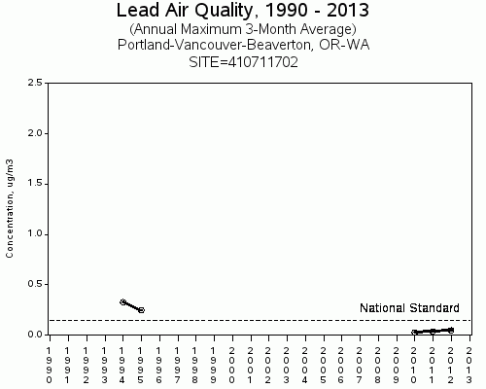

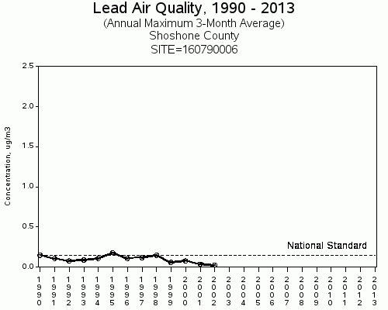

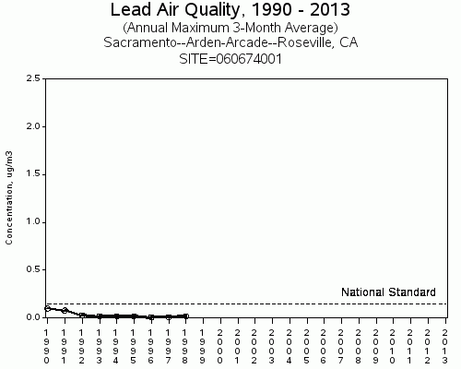

PM2.5: The level of the 2012 NAAQS for PM2.5 is 15 ug/m3 calculated as a 3-year average of the annual arithmetic mean.

|  |  |  |  |
| --- | --- | --- | --- |
| **Table 4 PM2.5 Site Listing, 2011-2013** | | | |
| **State** | **County** | **Site ID** | **2011-2013 Annual Design Value (µg/m3)** |
| California | Alameda | 060010007 | 7.6 |
| California | Alameda | 060010009 | 10.0 |
| California | Butte | 060070008 | 10.1 |
| California | Calaveras | 060090001 | 8.4 |
| California | Colusa | 060111002 | 7.1 |
| California | Contra Costa | 060130002 | 7.4 |
| California | Fresno | 060190011 | 15.4 |
| California | Fresno | 060192009 | 7.8 |
| California | Fresno | 060195001 | 16.4 |
| California | Fresno | 060195025 | 14.7 |
| California | Humboldt | 060231002 | 6.2 |
| California | Imperial 4 | 60250005 | 14.3 |
| California | Imperial | 060250007 | 7.5 |
| California | Imperial | 060251003 | 7.4 |
| California | Inyo | 060271003 | 7.5 |
| California | Kern | 060290014 | 16.4 |
| California | Kern | 060290016 | 17.3 |
| California | Kings | 060311004 | 17.0 |
| California | Lake | 060333001 | 3.8 |
| California | Los Angeles | 060370002 | 11.2 |
| California | Los Angeles | 060371002 | 12.8 |
| California | Los Angeles | 060371103 | 13.0 |
| California | Los Angeles | 060371201 | 10.2 |
| California | Los Angeles | 060371302 | 12.2 |
| California | Los Angeles | 060371602 | 12.0 |
| California | Los Angeles | 060374002 | 11.1 |
| California | Los Angeles | 060374004 | 11.0 |
| California | Madera | 060392010 | 18.1 |
| California | Marin | 060410001 | 9.5 |
| California | Merced | 060470003 | 13.3 |
| California | Merced | 060472510 | 11.1 |
| California | Monterey | 060531003 | 6.1 |
| California | Nevada | 060570005 | 4.6 |
| California | Nevada | 060571001 | 7.0 |
| California | Orange | 060590007 | 10.7 |
| California | Orange | 060592022 | 8.2 |
| California | Placer | 060610006 | 7.5 |
| California | Plumas | 060631006 | 10.2 |
| California | Plumas | 060631009 | 12.2 |
| California | Plumas | 060631010 | 12.8 |
| California | Riverside | 060650009 | 7.7 |
| California | Riverside | 060651003 | 11.5 |
| California | Riverside | 060652002 | 7.7 |
| California | Riverside | 060655001 | 6.4 |
| California | Riverside | 060658001 | 13.4 |
| California | Riverside | 060658005 | 15.1 |
| California | Sacramento | 060670006 | 10.4 |
| California | Sacramento | 060670010 | 9.5 |
| California | Sacramento | 060674001 | 9.3 |
| California | San Benito | 060690002 | 5.5 |
| California | San Bernardino | 060710025 | 12.6 |
| California | San Bernardino | 060712002 | 12.6 |
| California | San Bernardino | 060718001 | 8.7 |
| California | San Bernardino | 060719004 | 11.8 |
| California | San Diego | 060730001 | 9.9 |
| California | San Diego | 060730003 | 10.6 |
| California | San Diego | 060731002 | 10.7 |
| California | San Diego | 060731010 | 10.8 |
| California | San Diego | 060731016 | 8.7 |
| California | San Francisco | 060750005 | 9.2 |
| California | San Joaquin | 060771002 | 13.8 |
| California | San Joaquin | 060772010 | 10.2 |
| California | San Luis Obispo | 060792004 | 8.7 |
| California | San Luis Obispo | 060792006 | 6.6 |
| California | San Luis Obispo | 060792007 | 11.3 |
| California | San Luis Obispo | 060798001 | 7.0 |
| California | San Mateo | 060811001 | 9.3 |
| California | Santa Barbara | 060830011 | 9.5 |
| California | Santa Barbara | 060831008 | 7.6 |
| California | Santa Clara | 060850002 | 8.0 |
| California | Santa Clara | 060850005 | 10.3 |
| California | Santa Cruz | 060870007 | 6.3 |
| California | Shasta | 060890004 | 5.7 |
| California | Shasta | 060893004 | 6.2 |
| California | Siskiyou | 060932001 | 6.3 |
| California | Solano | 060950004 | 9.6 |
| California | Sonoma | 060970003 | 8.4 |
| California | Stanislaus | 060990005 | 13.6 |
| California | Stanislaus | 060990006 | 15.7 |
| California | Sutter | 061010003 | 7.7 |
| California | Tehama | 061030006 | 8.1 |
| California | Tulare | 061072002 | 16.6 |
| California | Ventura | 061110007 | 9.1 |
| California | Ventura | 061110009 | 8.1 |
| California | Ventura | 061112002 | 9.1 |
| California | Ventura | 061113001 | 9.0 |
| California | Yolo | 061131003 | 7.2 |
| Idaho | Ada | 160010010 | 9.1 |
| Idaho | Bannock | 160050020 | 7.7 |
| Idaho | Benewah | 160090010 | 9.9 |
| Idaho | Canyon | 160270002 | 10.8 |
| Idaho | Franklin | 160410001 | 8.0 |
| Idaho | Lemhi | 160590004 | 12.0 |
| Idaho | Shoshone | 160790017 | 12.8 |
| Nevada | Clark | 320030540 | 8.1 |
| Nevada | Clark | 320030561 | 8.8 |
| Nevada | Clark | 320031019 | 4.6 |
| Nevada | Washoe | 320310016 | 7.6 |
| Oregon | Crook | 410130100 | 9.8 |
| Oregon | Harney | 410250003 | 9.5 |
| Oregon | Jackson | 410290133 | 10.9 |
| Oregon | Josephine | 410330114 | 8.8 |
| Oregon | Klamath | 410350004 | 11.6 |
| Oregon | Lake | 410370001 | 11.1 |
| Oregon | Lane | 410390060 | 7.0 |
| Oregon | Lane | 410391009 | 5.8 |
| Oregon | Lane | 410392013 | 9.1 |
| Oregon | Lane | 410399004 | 7.1 |
| Oregon | Multnomah | 410510080 | 8.1 |
| Oregon | Umatilla | 410590121 | 7.6 |
| Oregon | Washington | 410670004 | 8.2 |
| Washington | King | 530330057 | 10.1 |
| Washington | King | 530330080 | 6.1 |
| Washington | King | 530332004 | 7.1 |
| Washington | Pierce | 530530029 | 7.8 |
| Washington | Snohomish | 530610005 | 5.9 |
| Washington | Snohomish | 530610020 | 6.9 |
| Washington | Snohomish | 530611007 | 7.7 |
| Washington | Spokane | 530630021 | 8.0 |
| Washington | Yakima | 530770009 | 9.1 |

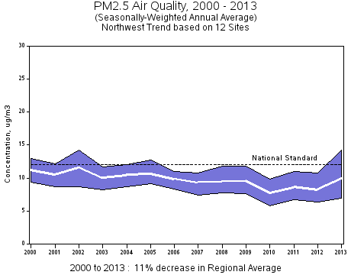

IV. Nature and Extent of Expected Pollutant Transport

Lead (Pb), Nitrogen Dioxide (NO2) and Sulfur Dioxide (SO2) are not expected to be transported for long distances. Pb would most likely be deposited within a few miles of a source. Both NO2 and SO2 will most likely either disperse in the atmosphere or chemically react to form a secondary pollutant within a few miles of the source. The only transport of Fine Particulate Matter (PM 2.5) is related to regional haze and is not enough to contribute to exceedances to the NAAQS. Oregon receives a lot of PM 2.5 from forest fire smoke, exceptional events and wood burning. Thus only large pollutant sources in proximity to the State boundaries would be expected to significantly contribute or interfere in adjacent states.

*Lead (Pb)*: As noted in the EPA’s October 14, 2011 Pb infrastructure guidance, the physical properties of Pb prevent Pb emissions from experiencing the same travel or formation phenomena as fine particulate matter or ozone. More specifically, there is a sharp decrease in Pb concentrations, at least in the coarse fraction, as the distance from a Pb source increases. Accordingly, while it may be possible for a source in a state to emit Pb in a location and in quantities that may contribute significantly to nonattainment in, or interfere with maintenance by, any other state, the EPA anticipates that this would be a rare situation (e.g., where large sources are in close proximity to state boundaries). The EPA’s experience with initial Pb designations suggests that sources that emit less than 0.5 tons per year or that are located more than two miles from a state border generally appear unlikely to contribute significantly to nonattainment in another state. All sources of Pb emissions in the Oregon are below 0.5 tons per year and are located greater than two miles from the state border. Therefore, it is reasonable to conclude that sources in the Oregon will not significantly contribute to nonattainment or interfere with maintenance of the 2008 Pb NAAQS in any other state.

*Nitrogen Dioxide (NO2)*: NO2 is one of a group of highly reactive gasses known as "oxides of nitrogen," or "nitrogen oxides (NOx)." Other nitrogen oxides include nitrous acid and nitric acid. EPA’s NAAQS uses NO2 as the indicator for the larger group of nitrogen oxides. NO2 forms quickly from emissions from cars, trucks and buses, power plants, and off-road equipment. In addition to contributing to the formation of ground-level ozone, and fine particle pollution, NO2 is linked with a number of adverse effects on the respiratory system. EPA first set standards for NO2 in 1971, setting both a primary standard (to protect health) and a secondary standard (to protect the public welfare) at 0.053 parts per million (53 ppb), averaged annually. The Agency has reviewed the standards twice since that time, but chose not to revise the annual standards at the conclusion of each review. In January 2010, EPA established an additional primary standard at 100 ppb, averaged over one hour. Closing statement? Therefore NO2 is not of concern…..

*Sulfur Dioxide (SO2)*: SO2 is one of a group of highly reactive gasses known as “oxides of sulfur.” Generally the largest sources of SO2 emissions are from fossil fuel combustion at power plants (73%) and other industrial facilities (20%). Smaller sources of SO2 emissions include industrial processes such as extracting metal from ore, and the burning of high sulfur containing fuels by locomotives, large ships, and non-road equipment. SO2 is linked with a number of adverse effects on the respiratory system. The emission inventory for Oregon demonstrates a similar source distribution.

EPA first set standards for SO2 in 1971. EPA set a 24-hour primary standard at 140 ppb and an annual average standard at 30 ppb (to protect health). EPA also set a 3-hour average secondary standard at 500 ppb (to protect the public welfare). In 1996, EPA reviewed the SO2 NAAQS and chose not to revise the standards.

In 2010, EPA revised the primary SO2 NAAQS by establishing a new 1-hour standard at a level of 75 parts per billion (ppb). EPA revoked the two existing primary standards because they would not provide additional public health protection.

Thus, concentrations of SO2 emitted into the atmosphere will decrease during transport through three mechanisms: deposition, chemical transformation, and dispersion. Interstate transport of SO2 is not a concern for Oregon.

*Fine Particulate Matter (PM 2.5:* DEQ’s consultation with air agencies in adjacent states suggests that high PM2.5 levels in their respective communities are driven largely by local pollution sources during events of air stagnation. Local air stagnation events would generally preclude interstate air pollution transport as a significant contributor to high PM2.5 levels jeopardizing NAAQS compliance. Say more?

**V. Sources of Pollutant Emissions Near the State Boundary and Expected Impacts in Neighboring States** (Emission inventory of sources and emission for pollutants, specifically major point or area source emissions and their proximity to the state boundary. Likelihood that emissions from these sources would transport across the state boundary to significantly contribute or interfere with other states).

There are six Title V Oregon sources in close proximity to the Washington border and one source in close proximity to the Idaho border. The 2011 emission inventories of these sources are in the tables below.



Georgia-Pacific Consumer Products LP, Cascades Tissue Group-Oregon, Portland General Electric Company Beaver Plant/Port Westward I Plant, and Portland General Electric Company Coyote Springs Plant all went through PSD analysis.

Owens-Brockway Glass Containers and Evraz were evaluated as part of the competing sources inventory during both Port Westward and Troutdale Energy Center’s PSD analyses.

An applicant for a PSD permit is required to conduct an air quality analysis of the ambient impacts associated with the construction and operation of a proposed new source or modification. The purpose of the air quality analysis is to demonstrate that new emissions emitted from a proposed major stationary source or major modification, in conjunction with other applicable emissions from existing sources (including secondary emissions), will not cause or contribute to a violation of any applicable NAAQS.

Based on our analysis, we believe it is reasonable to conclude that emissions from sources in Oregon do not significantly contribute to PM 2.5 and NO2 concentrations in any other state.

**VI. Conclusion**

Based on the rationale provided above, the current SIP contains adequate provisions prohibiting any source or other type of emissions activity within the state from emitting air pollutants which will:

1. contribute significantly to nonattainment of the applicable NAAQS in any other state
2. interfere with maintenance of the applicable NAAQS in any other state

Insert conversation with other states confirming we are not significantly contributing or interfering….

E:\winword\rulemaking\Interstate Transport Submittal for Pb, NO2, SO2, PM 2.5