

**Submit written comments**

**Online**

<http://www.oregon.gov/deq/RulesandRegulations/Pages/comments/Cpm2.5standardupdate.aspx>

**Protected email** for public university and OHSU students

<mailto:Comment-pm2.5standardupdate@DEQ.state.or.us>

**By mail**

Oregon DEQ

Attn: Program Lead

Office address

Portland, OR 97204-1390

**By fax**

(###) ###-####

Contact phone number

Attn: Contact name

**At hearing**

July 18, 2015

5-6 p.m. Example: Thursday, Nov. 6, 2014

at 1:30 p.m.

Hearing address

Comment deadline

**4 p.m., July 20, 2015**

Comment form

http:/www.oregon.gov/deq/RulesandRegulations/Pages/comments/CEnterCodeName.aspx

**Protected email** for public university and OHSU students

[Comment-enter CodeName@DEQ.state.or.us](mailto:Comment-WQNH3@DEQ.state.or.us)

**By mail**

Oregon DEQ

Attn: Contact name

Street address

City, OR Zip

**By fax**

5##-###-####

Attn: Contact name

**At hearing**

Enter day of week, date and time. EXAMPLE: Wednesday, Oct. 15, 2014 at 6 p.m.

Street address

City, State Zip

OPTIONAL: See additional hearing on the reverse.

**Comment deadline**

Enter day of week, date and time. EXAMPLE: Thursday, Oct. 30, 2014 at 5 p.m.

# Invitation to Comment

**Show/hide instructions and examples**

All cobalt blue text and EXAMPLES are in the Font Effects | Hidden. Word identifies hidden text by underlining it with dots. You may use one of the following methods to show/hide hidden text:

1. Press paragraph symbol displayed in Paragraph grouping.

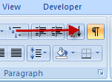

1. Press [Ctrl] [Shift] [8] keys simultaneously

To find and delete all hidden text before publishing, press [Ctrl] [F] keys, press Format button, and select the Font | Effects | Hidden box and press OK button. On the Replace tab, place cursor in Replace with: box and press Delete key then press Replace All button.

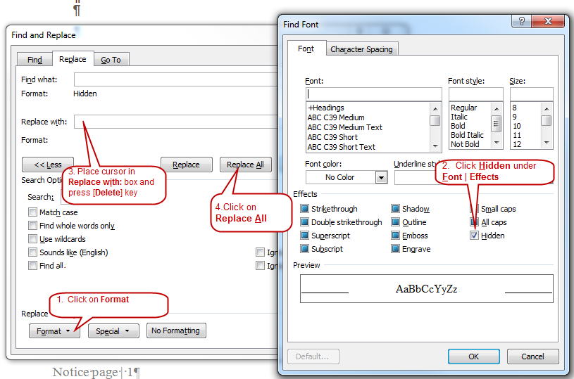

Administrative Procedures Act Requirements

All DEQ public writing for rulemaking must be clear and simple to meet requirements of the Administrative Procedures Act.

ORS 183.750 Readability of Public Writingshttp://www.oregon.gov/DAS/Images/spacer.gif

Article Content

183.750 State agency required to prepare public writings in readable form.

(1) Every state agency shall prepare its public writings in language that is as clear and simple as possible.

(2) As used in this section:

(a) “Public writing” means any rule, form, license or notice prepared by a state agency.

(b) “State agency” means any officer, board, commission, department, division or institution in the executive or administrative branch of state government. [Formerly 183.025]

Note: 183.750 was enacted into law by the Legislative Assembly but was not added to or made a part of ORS chapter 183 or any series therein by legislative action. See Preface to Oregon Revised Statutes for further explanation.

Limit this invitation to two pages. Point to the Notice and other supporting documents rather than You do not need to cover everything in the notice. Do include major changes that affect the public.

WARNING:Links developed in Word sometimes break with conversion from Word to Adobe.

* The problem occurs after editing an existing hyperlink in Word. After this edit, Word hangs onto some residual information from the initial hyperlink that seems to confuse Adobe.
* To remedy the problem, delete hyperlinked text rather than remove the hyperlink from the text then adding the new hyperlink. Start all over with new text and the new hyperlink.

Always test hyperlinks in Adobe.

**Infrastructure SIP PM 2.5**

The Administrative Procedures Act, Oregon Revised Statute 183, limits the rulemaking caption to 15 words or less. DEQ prefers shorter captions. It must reasonably identify the subject of the rule and it must be identical on all public documents such as the notice and the staff report.

DEQ invites input on proposed permanent or temporaryrule or rules amendments Use singular or plural and applicable action such as amendment adoption or repealto chapter 340 of the Oregon Administrative Rules.

DEQ proposal

See far right column to learn how to comment on this proposal. DEQ proposes the following changes to OAR 340, division number or numbers. Enter primary division numbers. Omit any lading zeros. for Enter short title or short descriptor for primary division

* Enter rulemaking action word: amend, adopt, or repeal Amend 340-200-004 to update the Oregon Clean Air Act State Implementation Plan Enter rulemaking action word: amend, adopt, or repeal
* Amend 340-202-0060(3) to incorporate the annual primary ambient air quality standard for PM 2.55 Add one or two sentences about this change.
* Enter rulemaking action word: amend, adopt, or repeal Add one or two sentences about this change.Amend 340-250-0030(22) to include PM 2.5 in the definition of National Ambient Air Quality Standard (NAAQS)

Rulemaking goal

The goal of this rulemaking is to update its Clean Air Act State Implementation Plan to ensure DEQ has the authority to implement the current NAAQS for PM 2.5. DEQ will meet this goal by (briefly describe rule changes)Provide brief description of the purpose of this rulemaking.

DEQ requests public comment through Enter comment deadline using style guide format EXAMPLE: Wednesday, Feb. 28, 2013 by 5 p.m.on whether to consider other options for achieving these rules’ substantive goals while reducing negative economic impact of the rule on business. DEQ’s statement of fiscal and economic impact is in the notice at: [http://www.oregon.gov/deq/RulesandRegulations/Pages/201x Enter year/Renter CodeName.aspx](http://www.oregon.gov/deq/RulesandRegulations/Pages/201x/Renter%20CodeName.aspx).

Who does this affect?

The proposed amendment of Oregon Administrative Rule 340-200-0040 to incorporate the latest NAAQS for PM 2.5 into the State of Oregon Clean Air Act Implementation Plan does not add or remove any parties regulated by DEQ. However, it does reflect meeting a more restrictive test. Describe parties may need or want to kno

Attend a hearing

DEQ invites you to attend one of the public hearings listed below. The presiding officer will provide a brief overview of the proposal before inviting your spoken or written comment.

**More information**

The proposed rules and notice [LinkAdd link to the rulemaking site to the word “Link” and provide the address]for this rulemaking are on DEQ rules and regulations web page. [http://www.oregon.gov/deq/RulesandRegulations/Pages/201x Enter year/Rpm2.5standardupdate.enter CodeName.aspx](http://www.oregon.gov/deq/RulesandRegulations/Pages/201x%20Enter%20year/Rpm2.5standardupdate.aspx)

Sign up for rulemaking notices

Get email updates about future DEQ proposed rule by signing through [GovDelivery](https://public.govdelivery.com/accounts/ORDEQ/subscriber/new?pop=t&topic_id=ORDEQ_548)Add link to the rulemaking site to the word “Link” and provide the addre.

**What has happened so far?**

Documents used to develop proposal

OPTION 1 DEQ relied on the following documents to consider the need for the proposed rules and to prepare the rulemaking documents.

These should all be links to web documents – I can help you if you don’t know how to do this

* Enter title and link to web page or document if available. 2011 Oregon Title V Emissions Inventory (DEQ)
* Enter title and link to web page or document if available. TRAACS database query for large businesses (DEQ)
* 2013 Oregon Annual Ambient Air Monitoring Network Plan (DEQ)
* Infrastructure and Interstate Transport SIPS (EPA)
* Interstate Transport Technical Support Documents (EPA)

OPTION 2The notice [LinkAdd link to the rulemaking site to the word “Link” and provide the address]lists documents that DEQ relied on to consider the need for the proposed rules and prepare the rulemaking documents. [http://www.oregon.gov/deq/RulesandRegulations/Pages/201x/Rpm2.5standardupdate.aspx](http://www.oregon.gov/deq/RulesandRegulations/Pages/201x%20Enter%20year/Renter%20CodeName.aspx).

Rulemaking dates

Use this OPTION for more than on hearing. Otherwise, use the right column on front page.

Hearing locations

1. EnterThursday, July 16, 2015

5:00-6:00 p.m.

DEQ Headquarters, Room EQC B

811 SW 6th Avenue

Portland, OR 972045:00-dEnter street address, building number/nameEnter room name or number Enter time in style guide format EXAMPLE: 5 p.m.Enter day of week, month, day and year in style guide format. EXAMPLE: Wednesday, Feb. 28, 2013, following DEQ style guide

Presiding Officer: DEQ staff

1. Enter City: Enter time in style guide format EXAMPLE: 5 p.m.

Date: Enter day of week, month, day and year in style guide format. EXAMPLE: Wednesday, Feb. 28, 2013, following DEQ style guide

Comment deadline

To consider comments on the proposed rules, DEQ must receive the comment by 4 p.m. on July 20, 2015 Enter time, day of week, month, day and year in Style guide format. EXAMPLE: 5 p.m. Thursday, Oct. 30, 2014

**What will happen next?**

DEQ will prepare a written response to each comment or summary of similar comments received by the comment deadline. DEQ may modify the rule proposal based on the comments.

Comments or summary of comments and responses will become part of the DEQ staff report that will go to the Oregon [Environmental Quality Commission](http://www.oregon.gov/DEQ/EQC/index.shtml) for final decision.

Present proposal to the EQC

The Environmental Quality Commission is the board that reviews all proposed changes to division 340 of the Oregon Administrative Rules. The commission adopts, rejects, or adopts with changes, any proposed rule.

DEQ plans to take the completed draft proposal, including any modifications made in response to public comments to the commission for decision at its Enter date using style guide format meeting in and include city that will host the EQC. EXAMPLE: “at its Jan 7-8, 2015 meeting in Portland.

OPTION FOR SIPS If EQC approves the proposed rules and incorporating the amendments into the Oregon Clean Air Act State Implementation Plan under OAR 340-200-0040, DEQ will submit the revised state implementation plan to EPA.

Accessibility information

You may review copies of all websites and documents referenced in this announcement at:

DEQ Headquarters

811 SW 6th Ave,

Portland, OR 97204

To schedule a review, call Enter contact name and phone number or toll-free in Oregon at 1-800-452.4011, extension Enter extension number.

Please notify DEQ of any special physical or language accommodations or if you need information in large print, Braille or another format. To make these arrangements, contact DEQ, Portland, at 503-229-5696 or call toll-free in Oregon at 1-800-452-4011, ext. 5696; fax to 503-229-6762; or email to [deqinfo@deq.state.or.us](mailto:deqinfo@deq.state.or.us). Hearing impaired persons may call 711.