

Submit written comments

Online
http://www.oregon.gov/deq/RulesandRegulations/Pages/comments/CCodeName.aspx

Protected email for public university and OHSU students
mailto:Comment-CodeName@DEQ.state.or.us

By mail
Oregon DEQ
Attn: Program Lead
Office address
Portland, OR 97204-1390

By fax
(###) ###-####
Contact phone number
Attn: Contact name

At hearing
Date and time Example: Thursday, Nov. 6, 2014
at 1:30 p.m.

Text Hearing address

Comment deadline
Friday, Nov. 7, 2014
at 5 p.m.
Comment form
http:/www.oregon.gov/deq/RulesandRegulations/Pages/comments/CEnterCodeName.aspx

Protected email for public university and OHSU students
Comment-enter CodeName@DEQ.state.or.us

By mail
Oregon DEQ
Attn: Contact name
Street address
City, OR Zip

By fax
5##-###-####
Attn: Contact name

At hearing
Enter day of week, date and time. EXAMPLE: Wednesday, Oct. 15, 2014 at 6 p.m.

Street address
City, State Zip

OPTIONAL: See additional hearing on the reverse.

Comment deadline
Enter day of week, date and time. EXAMPLE: Thursday, Oct. 30, 2014 at 5 p.m.

Invitation to Comment

Show/hide instructions and examples

All cobalt blue text and EXAMPLES are in the Font Effects | Hidden. Word identifies hidden text by underlining it with dots. You may use one of the following methods to show/hide hidden text:

- Press paragraph symbol displayed in Paragraph grouping.

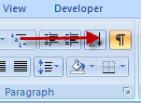

- Press [Ctrl] [Shift] [8] keys simultaneously

To find and delete all hidden text before publishing, press [Ctrl] [F] keys, press Format button, and select the Font | Effects | Hidden box and press OK button. On the Replace tab, place cursor in Replace with: box and press Delete key then press Replace All button.

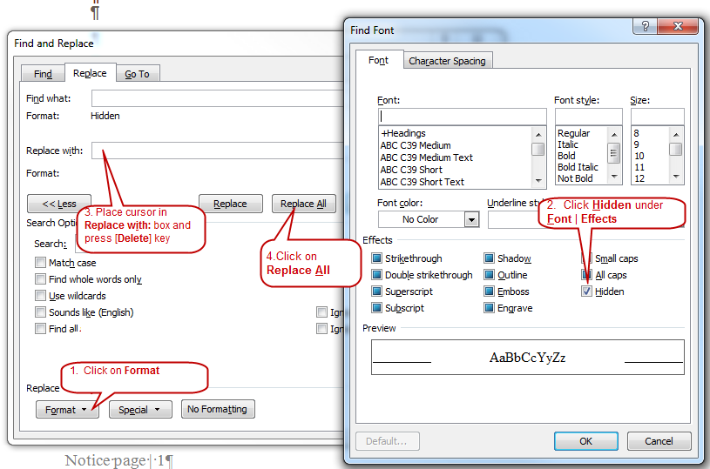

Administrative Procedures Act Requirements

All DEQ public writing for rulemaking must be clear and simple to meet requirements of the Administrative Procedures Act.

ORS 183.750 Readability of Public Writings
Article Content

183.750 State agency required to prepare public writings in readable form.
(1) Every state agency shall prepare its public writings in language that is as clear and simple as possible.
(2) As used in this section:
(a) “Public writing” means any rule, form, license or notice prepared by a state agency.
(b) “State agency” means any officer, board, commission, department, division or institution in the executive or administrative branch of state government. [Formerly 183.025]
Note: 183.750 was enacted into law by the Legislative Assembly but was not added to or made a part of ORS chapter 183 or any series therein by legislative action. See Preface to Oregon Revised Statutes for further explanation.

Enter the rule caption (title)

DEQ invites input on proposed permanent rule amendments to chapter 340 of the Oregon Administrative Rules.

DEQ proposal

See far right column to learn how to comment on this proposal. DEQ proposes the following changes to OAR 340, division number for
- Enter text
- Enter text
- Enter text

Rulemaking goal
The goal of this rulemaking is

DEQ requests public comment through on whether to consider other options for achieving these rules’ substantive goals while reducing negative economic impact of the rule on business. DEQ’s statement of fiscal and economic impact is in the notice at: http://www.oregon.gov/deq/RulesandRegulations/Pages/201x Enter year/R.aspx.

Who does this affect?

Parties affected by this proposal include

Attend a hearing
DEQ invites you to attend one of the public hearings listed below. The presiding officer will provide a brief overview of the proposal before inviting your spoken or written comment.

More information
The proposed rules and notice [Link]for this rulemaking are on DEQ rules and regulations web page. http://www.oregon.gov/deq/RulesandRegulations/Pages/201x/Raspx

Sign up for rulemaking notices

Get email updates about future DEQ proposed rule by signing through GovDelivery.

What has happened so far?

Advisory committee

DEQ convened the Enter name advisory committee. Information about the committee is on http://www.oregon.gov/deq/RulesandRegulations/Pages/Advisory/A.aspx.

Documents used to develop proposal
DEQ relied on the following documents to consider the need for the proposed rules and to prepare the rulemaking documents.

- Enter text
- Enter text
The notice [Link]lists documents that DEQ relied on to consider the need for the proposed rules and prepare the rulemaking documents. http://www.oregon.gov/deq/RulesandRegulations/Pages/201x/Raspx.

Rulemaking dates

Hearing locations
- Text

Text

Text

Time:

Date:

Presiding Officer: DEQ staff

- Text

Text

Text

Time:

Date:

Presiding Officer: DEQ staff

Comment deadline

To consider comments on the proposed rules, DEQ must receive the comment by .

What will happen next?

DEQ will prepare a written response to each comment or summary of similar comments received by the comment deadline. DEQ may modify the rule proposal based on the comments.

Comments or summary of comments and responses will become part of the DEQ staff report that will go to the Oregon Environmental Quality Commission for final decision.

Present proposal to the EQC

The Environmental Quality Commission is the board that reviews all proposed changes to division 340 of the Oregon Administrative Rules. The commission adopts, rejects, or adopts with changes, any proposed rule.

DEQ plans to take the completed draft proposal, including any modifications made in response to public comments to the commission for decision at its meeting in

If EQC approves the proposed rules and incorporating the amendments into the Oregon Clean Air Act State Implementation Plan under OAR 340-200-0040, DEQ will submit the revised state implementation plan to EPA.

Accessibility information
You may review copies of all websites and documents referenced in this announcement at:

Text

Text

Text

Text

To schedule a review, call or toll-free in Oregon at 1-800-452.4011, extension .

Please notify DEQ of any special physical or language accommodations or if you need information in large print, Braille or another format. To make these arrangements, contact DEQ, Portland, at 503-229-5696 or call toll-free in Oregon at 1-800-452-4011, ext. 5696; fax to 503-229-6762; or email to deqinfo@deq.state.or.us. Hearing impaired persons may call 711.

