**WASHINGTON**

**WAC 173-400-050 Emission standards for combustion and**

**incineration units.** (1) Combustion and incineration emissions

units must meet all requirements of WAC 173-400-040 and, in

addition, no person shall cause or allow emissions of particulate

matter in excess of 0.23 gram per dry cubic meter at standard

conditions (0.1 grain/dscf), except, for an emissions unit

combusting wood derived fuels for the production of steam. No

person shall allow the emission of particulate matter in excess of

0.46 gram per dry cubic meter at standard conditions (0.2

grain/dscf), as measured by EPA method 5 in Appendix A to 40 C.F.R.

Part 60, (in effect on July 1, ((2010)) 2012) or approved

procedures contained in "*Source Test Manual - Procedures For*

*Compliance Testing*," state of Washington, department of ecology, as

of September 20, 2004, on file at ecology.

(5) **Catalytic cracking units.**

(a) All existing catalytic cracking units shall meet all

provisions of WAC 173-400-040 (2), (3), (4), (5), (6), and (7) and:

(i) No person shall cause or allow the emission for more than

three minutes, in any one hour, of an air contaminant from any

catalytic cracking unit which at the emission point, or within a

reasonable distance of the emission point, exceeds forty percent

opacity.

(ii) No person shall cause or allow the emission of

particulate material in excess of 0.46 grams per dry cubic meter at

standard conditions (0.20 grains/dscf) of exhaust gas.

(b) All new catalytic cracking units shall meet all provisions

of WAC 173-400-115.

(2) **Hog fuel boilers.**

(a) Hog fuel boilers shall meet all provisions of WAC 173-400-

040 and 173-400-050(1), except that emissions may exceed twenty

percent opacity for up to fifteen consecutive minutes once in any

eight hours. The intent of this provision is to allow soot blowing

and grate cleaning necessary to the operation of these units. This

practice is to be scheduled for the same specific times each day

and the permitting authority shall be notified of the schedule or

any changes

(3) **Orchard heating.**

(a) Burning of rubber materials, asphaltic products, crankcase

oil or petroleum wastes, plastic, or garbage is prohibited.

(b) It is unlawful to burn any material or operate any

orchard-heating device that causes a visible emission exceeding

twenty percent opacity, except during the first thirty minutes

after such device or material is ignited.

**IDAPA 58 - DEPARTMENT OF ENVIRONMENTAL QUALITY 58.01.01 - Rules for the Control of Air Pollution in Idaho**

**02. Heating Device Opacity**. Orchard heating device with visible emissions exceeding forty percent (40%) opacity at normal operating conditions shall not be used. Opacity shall be determined by the procedures contained in Section 625.

**625.VISIBLE EMISSIONS.**

A person shall not discharge any air pollutant into the atmosphere from any point of emission for a period or periods aggregating more than three (3) minutes in any sixty (60) minute period which is greater than twenty percent (20%) opacity as determined by this section. (4-5-00)

**01. Exemptions**. The provisions of this section shall not apply to: (4-5-00) **a.** Kraft Process Lime Kilns, if operating prior to January 24, 1969; or (5-1-94) **b.** Carbon Monoxide Flare Pits on Elemental Phosphorous Furnaces, if operating prior to January 24, 1969; or (5-1-94) **c.** Liquid Phosphorous Loading Operations, if operating prior to January 24, 1969; or (5-1-94) **d.** Wigwam Burners; or (5-1-94) **e.** Kraft Process Recovery Furnaces. (5-1-94) **f.** Calcining Operations Utilizing an Electrostatic Precipitator to Control Emissions, if operating prior to January 24, 1969. (5-1-94)

**02. Standards for Exempted Sources**. Except as provided in Section 626, for sources exempted from the provisions of this section, a person shall not discharge into the atmosphere from any point of emission, for any air pollutant for a period or periods aggregating more than three (3) minutes in any sixty (60) minute period which is greater than forty percent (40%) opacity as determined by this section.

**626.GENERAL RESTRICTIONS ON VISIBLE EMISSIONS FROM WIGWAM BURNERS.**

Except for a period of one (1) hour following start up a person shall not discharge into the atmosphere from any wigwam burner any air pollutant for a period or periods aggregating more than three (3) minutes in any sixty (60) minute period which is greater than twenty percent (20%) opacity as determined by the procedures contained in Section 625.

**04. Visible Emissions Standards for Roads and Stockpiles**. Visible fugitive emissions from vehicle traffic on an affected paved public roadway; vehicle traffic on, or wind erosion of, an unpaved haul road; and wind erosion of any stockpile shall not exceed twenty percent (20%) opacity for a period or periods aggregating more than three (3) minutes in any sixty (60) minute period. Opacity shall be determined using the test methods and procedures contained in Section 625. The plant is not required to have a certified opacity reader.

**798.ELECTRICAL GENERATORS.**

The following requirements apply to all electrical generators used to provide electrical power to any nonmetallic mineral processing plant. The requirements apply to each site of operations. (3-15-02)

**01. Fuel Type**. Only ASTM (American Society of Testing and Materials) Grade 1 or 2 fuel oil shall be used. The sulfur content of the fuel used shall not exceed the percentages of sulfur given in Section 725. (5-8-09)

**02. Generator Operating Requirements**. For the purposes of Sections 790 through 799, the following apply to all electrical generators. kW = kilowatts hr/day = hours per day hr/yr = hours per year (3-15-02)

**03. Generator Opacity Limit**. Visible emissions from any generator stack, vent, or other functionally equivalent opening shall not exceed twenty percent (20%) opacity for a period or periods aggregating more than three (3) minutes in any sixty (60) minute period. Opacity shall be determined using the test methods and procedures contained in Section 625.

**02. Requirements for Paved Public Roadways**. (3-15-02) **a.** Definitions. (3-15-02) i. Paved public roadway. A paved public roadway means a roadway accessible to the general public having a surface of asphalt or concrete. (3-15-02) ii. Track-out. Track-out means the deposition of mud, dirt, or similar debris onto the surface of a paved public roadway from the tires and/or undercarriage of any vehicle associated with the operation of a nonmetallic mineral processing plant. (3-15-02) **b.** Control strategy triggers. Triggers that require initiation of a strategy or strategies to control fugitive dust emissions from track-out include, but are not limited to: (3-15-02) i. Visible deposition of mud, dirt, or similar debris on the surface of a paved public roadway. (3-15-02) ii. Visible fugitive emissions from vehicle traffic on an affected paved public roadway that approach twenty percent (20%) opacity for a period or periods aggregating more than one (1) minute in any sixty (60) minute period.

**03. Requirements for Unpaved Haul Roads**. (3-15-02) **a.** Definition of “unpaved haul roads.” Any unsurfaced roadway within the physical boundary of a nonmetallic mineral processing facility that is used as a haul road, access road, or similar. (3-15-02) **b.** Control strategy triggers. Triggers that require initiation of a strategy or strategies to control fugitive dust emissions from unpaved haul roads include, but are not limited to: (3-15-02) i. Visible fugitive emissions from vehicle traffic on an affected paved public roadway that approach twenty percent (20%) opacity for a period or periods aggregating more than one (1) minute in any sixty (60) minute period.

**676.STANDARDS FOR NEW SOURCES.**

A person shall not discharge into the atmosphere from any fuel burning equipment with a maximum rated input of ten (10) million BTU's per hour or more, and commencing operation on or after October 1, 1979, particulate matter in excess of the concentrations shown in the following table:

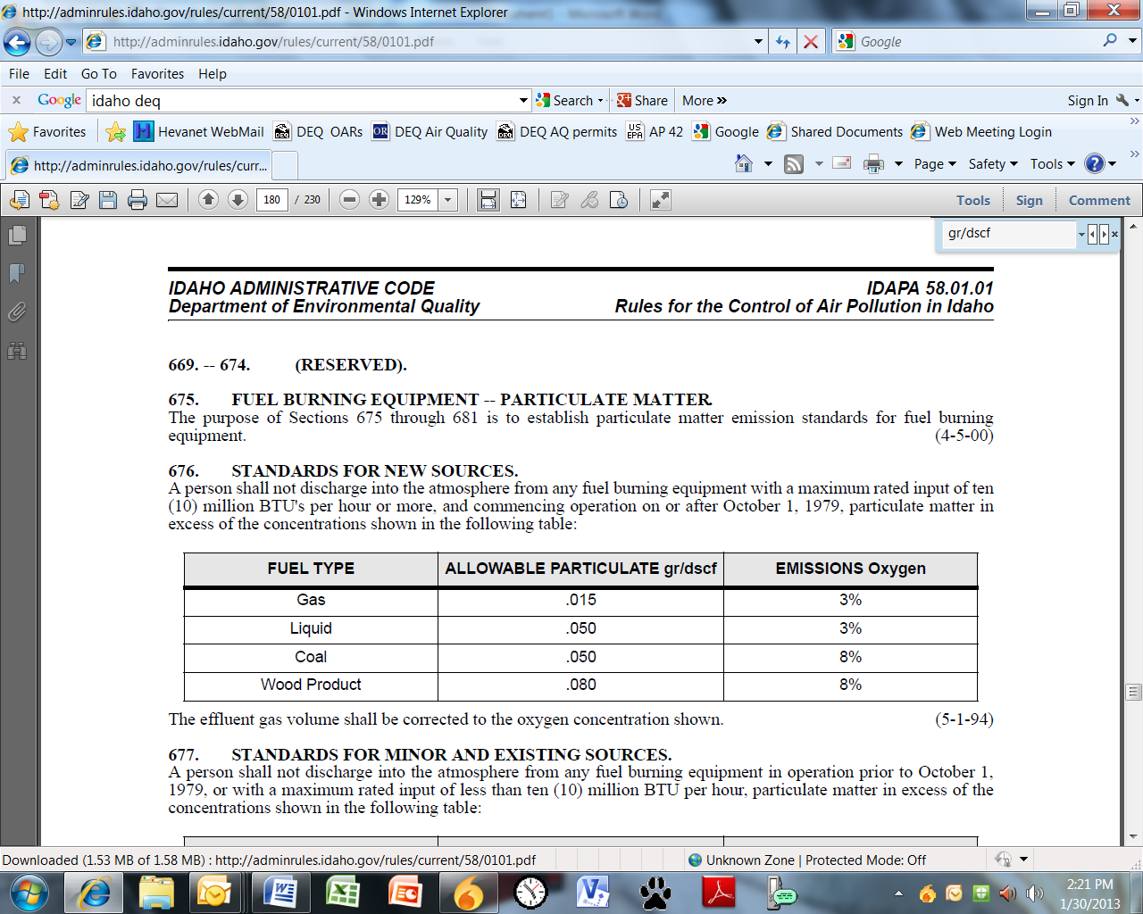

The effluent gas volume shall be corrected to the oxygen concentration shown.

**677.STANDARDS FOR MINOR AND EXISTING SOURCES.**

A person shall not discharge into the atmosphere from any fuel burning equipment in operation prior to October 1, 1979, or with a maximum rated input of less than ten (10) million BTU per hour, particulate matter in excess of the concentrations shown in the following table:

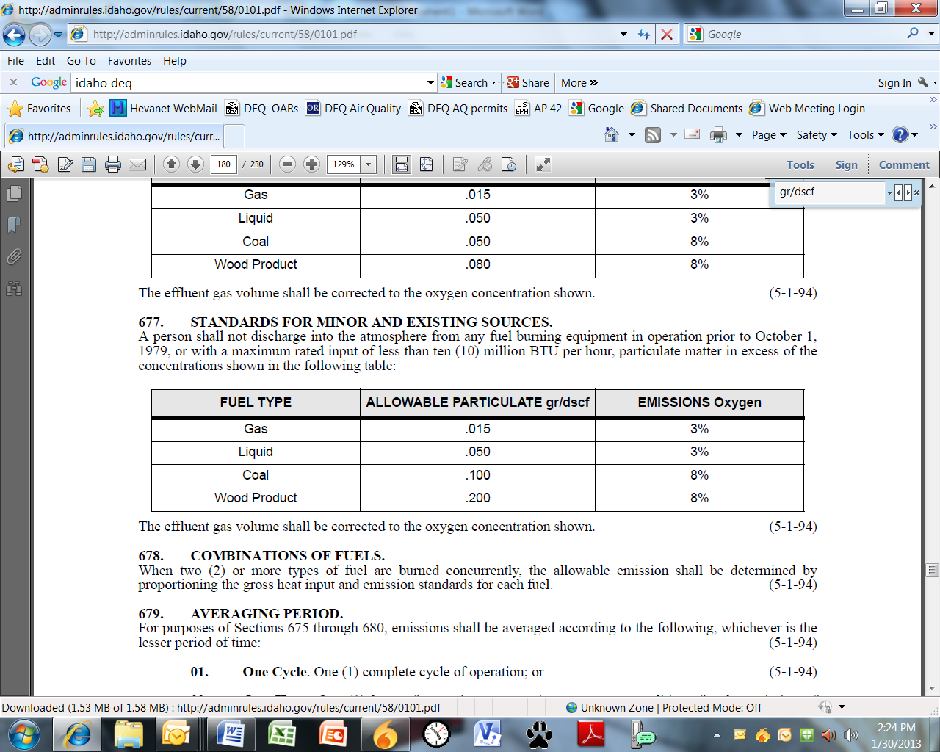

The effluent gas volume shall be corrected to the oxygen concentration shown.