Other Agency Grain Loading and Opacity Limits

AGENCY | EQUIPMENT | GRAIN LOADING | OPACITY
SWCAA (Vancouver WA) | Old HFB | 0.07 gr/dscf | 15%
 | New HFB | 0.01 gr/dscf | 10%
Benton Clean Air Agency (WA) | All | 0.1 gr/dscf | 20%
Siskiyou County (CA) | Non combustion | 0.30 gr/dscf | Ringlemann No. 2
 | combustion
North Coast Unified AQMD (CA) | General combustion | 0.20 gr/dscf | Ringlemann No. 2
 | Steam generating units | 0.10 gr/dscf
 | Non combustion | 0.20 gr/dscf
Modoc County APCD (CA) | Non combustion | 0.30 gr/dscf | Ringlemann No. 2
 | combustion
Shasta County (CA) | Combustion – post 7-1-86 | 0.10 gr/dscf | 40% or Ringlemann No. 2
 | Combustion – pre 7-1-86 | 0.15 gr/dscf
 | <10μ in Size post 7-1-86 | 0.05 gr/dscf
 | <10μ in Size pre 7-1-86 | 0.10 gr/dscf
 | All other PM post 7-1-86 | 0.15 gr/dscf
 | All other PM pre 7-1-86 | 0.15 gr/dscf
Idaho DEQ | Fuel Burning Wood > 10 MMBtu/hr and > 10-1-79 | 0.080 gr/dscf | 20%
 | Fuel Burning Wood < 10 MMBtu/hr or < 10-1-79 | 0.200 gr/dscf
Alaska | Fuel burning | 0.05 gr/dscf except | 20% except
 |  | 0.15 < 11-1-82 & >20% woodwaste | 30% < 11-1-82 and >20% woodwaste
Montana | 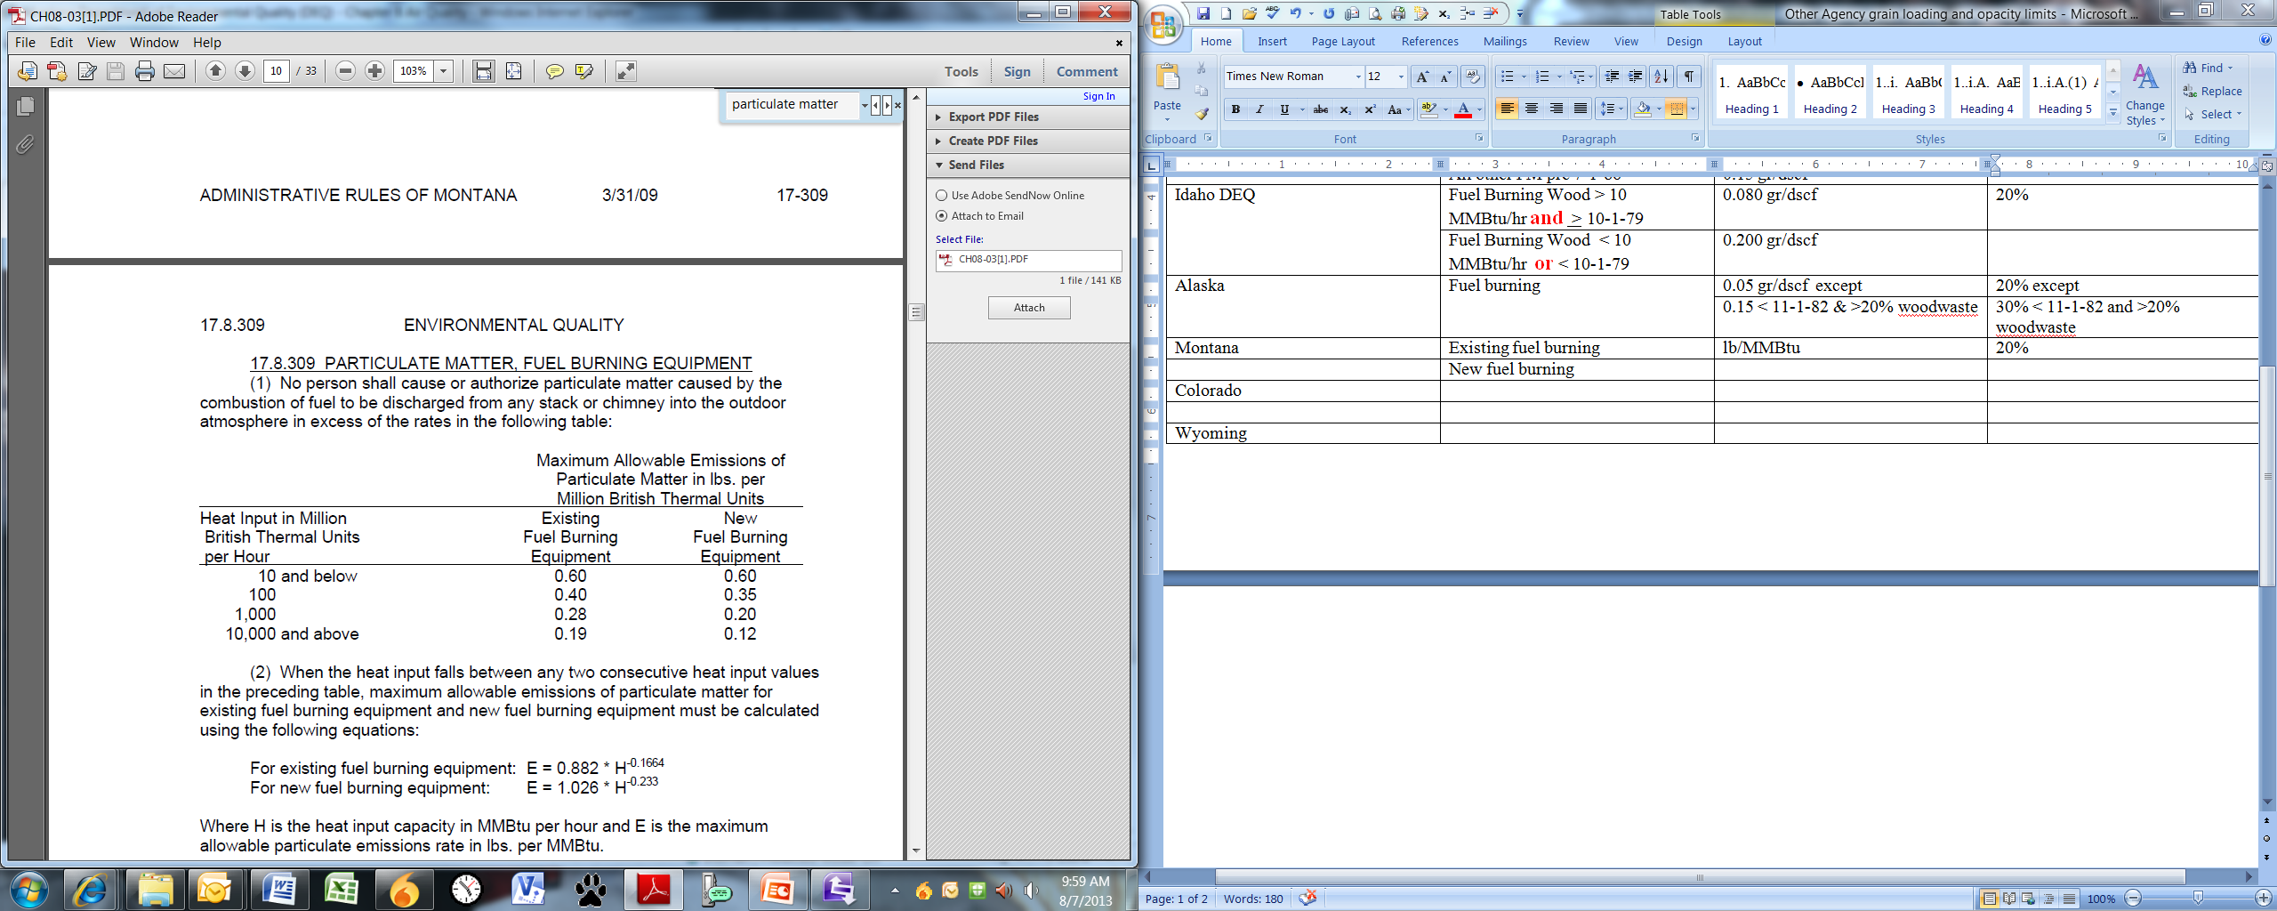 |  | 20%
Colorado | - fuel burning equipment < 1x106 BTU/hr total heat input design capacity.  - fuel burning equipment with designed heat inputs > 1x106 BTU per hour, but < 500x106 BTU per hour, the following equation will be used to determine the allowable particulate emission limitation.  - fuel burning equipment of > 500x10⁶ BTU per hour or more. | - 0.5 lbs. per 106 BTU heat input  - PE=0.5(FI)^{-0.26}  Where:  PE = Particulate Emission in Pounds per million BTU heat input.  FI = Fuel Input in Million BTU per hour.  - 0.1 lbs. per 10⁶ BTU heat input | 20%
Wyoming |  |  | 20% after effective date of rule (?)
 |  |  | 40% before effective date of rule (?)

