

Steam Engineering Inc.

December 10, 2013

Jill Inahara

Oregon DEQ

**WOOD FIRED BOILER EXPERIENCE**

Thank you for your interest in Steam Engineering. When I founded the company in 1987 I anticipated that most of our clients would be burning oil or natural gas as boiler fuel. In 1987 the home of the wood products industry was Portland, Oregon in my opinion the center of wood products is now Atlanta, Georgia. In the late seventies and early eighties companies burning wood as a boiler fuel were being capped in the amount of wood they could burn by air emission limits. The majority of Steam Engineering Inc. clients were operators of wood fired boilers instead of oil and gas fired boilers. The reasons were the need to meet environmental limits and the only way a plant with a wood fired boiler operation could increase plant production was to improve the steam system efficiency to increase steam output without increasing the fuel firing rate. It is very challenging for wood fired boilers to meet more stringent emission limits without incurring the cost of backend cleanup technology, usually ESP electrostatic precipitators.

# 1.0 MULTICLONE PERFORMANCE

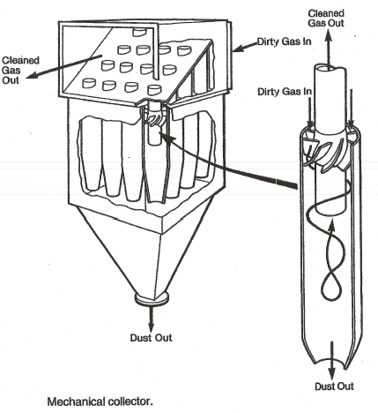There are a few boilers in Oregon that continue to operate with only a multiclone for emission control. In my experience many clients (wood fired boiler operators) are not familiar and do not know how to inspect or how to optimize multiclone performance. If the client is boarder line in meeting emissions the optimization of the multiclone might enable them to operate without exceeding emission limits. Most multiclone installations will have an inspection door on the ash hopper but many do not provide access to the clean air side of the collector. Every part of the collector is important to its performance. Missing vanes, a hole in the inner or outer tube of each cone will cause bypassing of dirty gas to the clean side of the collector.

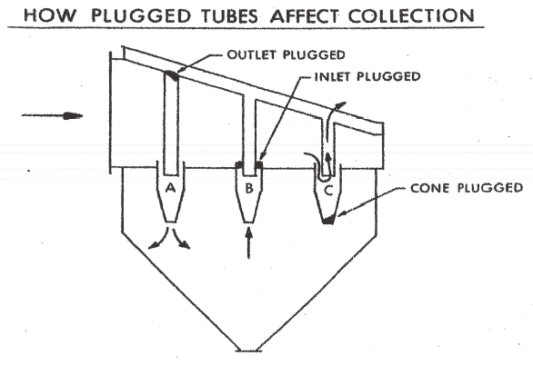

The above sketch demonstrates the need for a thorough inspection of all parts of the collector. Plugging of the clean tube outlet, the dirty tube outlet, or the turning vanes (dirty tube inlet) will cause short circuiting and reduced collector performance.

Each multiclone manufacturer should provide a multiclone efficiency curve that charts expected efficiency versus pressure drop across the multiclone and particle size. I have seldom come in contact with a client that has such a curve. Shown on the following page is a performance curve for a Clarage Inc. multiclone.

In my experience best performance is achieved with a pressure drop of 3 inches of water column and that pressure drop only occurs at one flow rate. The actual flue gas flow rate for a wood fired boiler varies and it is important to try and tune the multiclone for normal operation. Tuning often involves plugging tubes top and bottom to optimize the pressure drop across the multiclone at the normal boiler firing rate. Anytime the firing rate varies the efficiency of the multiclone also varies because the flow rate and pressure drop across the multiclone changes with firing rate. It is possible to optimize multiclone performance with varying firing rates with the use of flue gas recirculation.



# 2.0 FLUE GAS RECIRCULATION

Flue gas can be collected after the multiclone and before the induced draft fan. The FGR is returned to and mixed with fresh combustion air to control excess combustion air and to optimize the performance of the boiler and multiclone.

When the firing rate on the boiler decreases the amount of recirculated flue gas is increased and the amount of fresh combustion air is decreased. The result is the flow of flue gas through the boiler and the multiclone is nearly constant. Constant flue gas volume will result in consistent pressure drop across the multiclone and consistent performance of both the multiclone and the boiler. An additional benefit of FGR is a cooling of flame temperature and a reduction NOx emissions from the boiler.

# 3.0 MULTICLONE INSPECTIONS

To properly inspect a multiclone it needs to be observed while operating and then it needs to be shut down allowed to cool and then inspected from the ash hopper and from the clean tube discharge side of the collector. When operating, a draft gage must be correctly installed to accurately measure the pressure drop across the collector. Inspection must include clean side and dirty side and access panels will need to be installed if they do not exist.

If Steam Engineering were completing the inspection at least two days would have to be budgeted for the inspection and the client would have to provide mechanics to install a draft gage and to provide access panels if they do not exist. A budget of $3,000 to $4,000 plus expenses at cost would have to be allowed. I have worked with technicians from companies like Northwest Industrial Mechanics. They are qualified to complete the inspection and they also are cable of completing any of the necessary mechanical work like the installation of a draft gage or the installation of access panels, the budget would need to be increased $1,000 to $2,000 for a qualified boiler repair company to complete the same work. It is also possible that a company like Wellons would be willing to give you a budget for inspections.

# 4.0 BOILER MACT TUNE-UP

I have completed several Boiler MACT tune-ups around the country and Steam Engineering is especially qualified for this work. Frequently an older wood fired boiler has no specific air to fuel ratio control. It is important when tuning a wood fired boiler to identify best operating practices so the tuning and observable parameters are repeatable to the operators when they face changes is fuel quality and changes in boiler load. The tune-up should include a list of opportunities for improvement, the fuel savings should be quantified but budgets and paybacks for the improvements are beyond the scope of the tune-up.

The boiler tune-ups that I have completed take approximately 1 and ½ days. One day for tuning and half day for report writing. A budget would be $2,000 plus expenses at cost. A Boiler MACT or Boiler GACT assessment for a Boiler MACT area source will most often take 2 ½ to 3 days plus expenses at cost.

# 5.0 CONTINUOUS OPACITY MONITORING

The technology has improved but it is expensive. Less expensive opacity monitors are available but they require extensive maintenance and calibration. I already mentioned that many of the wood fired boilers without expensive emission controls cannot currently meet the three minute window for opacity excursions when grate cleaning. Continuous monitoring of opacity with this existing rule will record frequent violations. I do not favor continuous opacity monitoring but primarily because the grate cleaning rule is not currently practical for most wood fired boilers.

# 6.0 ESP BUDGETS

The cost of an ESP depends on the size of the boiler, the volume and grain loading of the flue gas to be cleaned. There are several manufacturers that offer ESP’s with options, that should not be options for a wood fired boiler. Some of my experiences are listed below:

* Do not attempt to use a single ESP for multiple wood fired boilers. Each boiler should have a separate ESP.
* Stiffeners for the plates in a wood fired boiler should not be an option they are required to extend the life of the unit and to prevent warping of the plates.
* Two field ESP’s have been successful on wood fired boilers but I much prefer three fields if the budget will allow.
* Always operate all of the fields of the ESP all of the time.

To my knowledge there is still a company in Texas called PPC Industries that builds a satisfactory ESP for the size boilers I think you are considering for an installed budget of $850,000 to $1,300,000. Locally I believe the Wellons company built ESP’s at one time and they just copied another companies design.

# 7.0 FISCAL ADVISORY COMMITTEE

You are working with rules regarding a family of boilers that I know well and while I am interested in participating on the committee it is important to realize that my emphasis will always be on practical emission standards for wood fired boilers. That emphasis would tend to favor the operating perspective over the emission goals if they do not coincide.

Steam Engineering Inc. is a consulting engineering and water treatment company we do not represent any equipment lines but we have and will continue to recommend specific equipment to our clients for steam system efficiency improvement. While consulting engineering is our primary business we have done small turkey improvement projects. The design build portion of the business happened because when I work with a client I am selling the result, an increase in production a decrease in fuel use. Our engineering capability statement is shown below.

Bill Moir

Engineering Manager

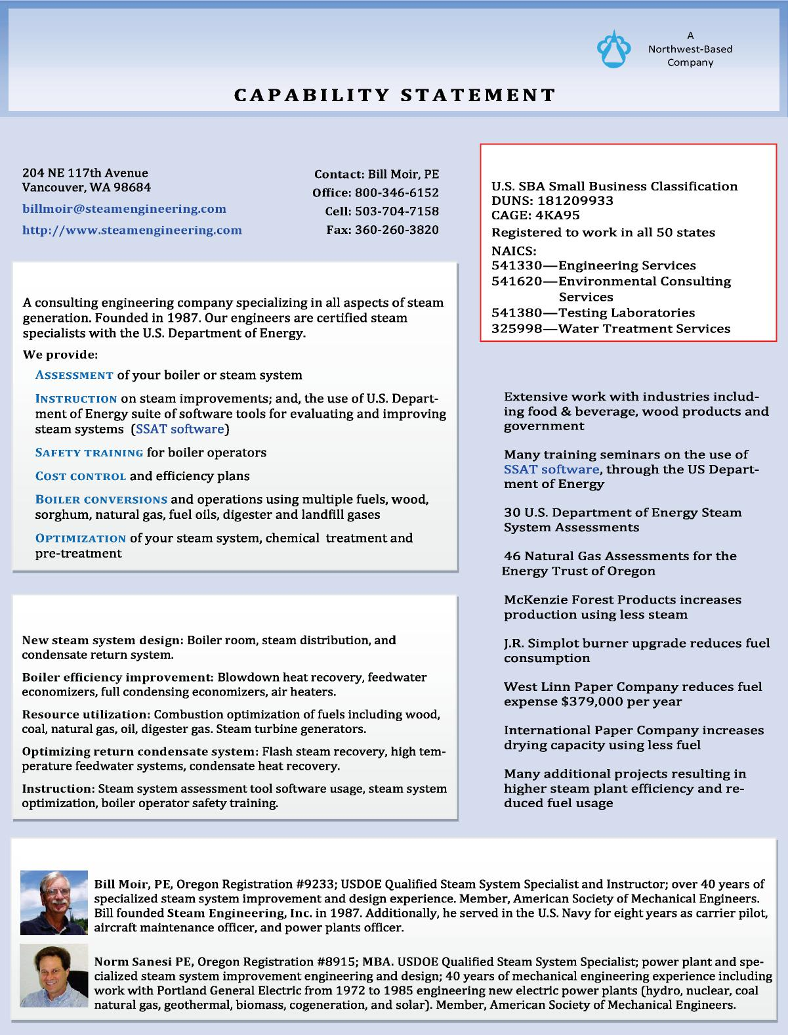

Steam Engineering, Inc. **.**

STEAM ENGINEERING, INC.

COMPANY DESIGNATIONS

COMPANY OVERVIEW

PAST PERFORMANCE

•

•

•

•

•

AREAS OF EXPERIENCE

•

•

•

•

KEY PERSONNEL