Dates? | 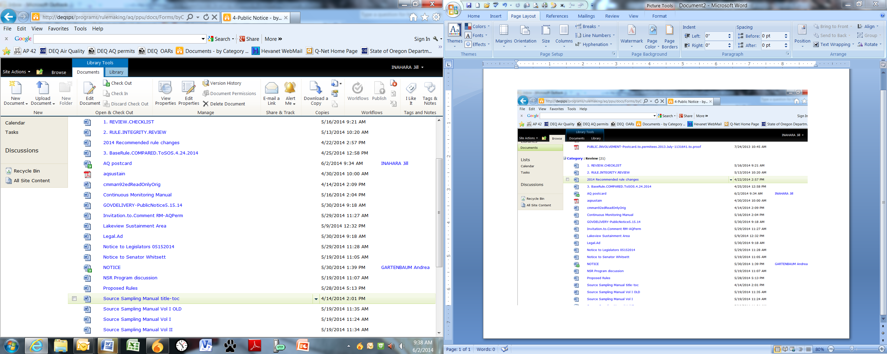  Ready to post? | File Name | File Explanation
NA | NA |  | Maggie’s checklist
NA | NA |  | Maggie’s comparison to SOS rules w/comments
NA |  |  | Crosswalk
NA | NA |  | Maggie’s comparison to SOS rules
√ | Links? |  | postcard
NA | NA |  | Letter from Lakeview requesting sustainment area
NA | √ |  | Redline of old CMM
√ | √ |  | CMM PDF
√ | Links? |  | GovDelivery notice
√ | Links? |  | Invitation
√ | √ |  | Lakeview Sustainment Area Document - PDF
√ | NA |  | NSR Program Discussion PDF

