**Greenhouse Gas Emissions Control Review**

**Intel Oregon Site**

The semiconductor manufacturing process is an extremely complex one involving a large number of individual pieces of manufacturing equipment, many of which may contribute to the overall emissions. A large semiconductor fabrication plant (or “fab”) may have hundreds of individual pieces of manufacturing equipment (or “tools”) and a typical product may require hundreds of process steps to manufacture. The manufacturing process uses nitrous oxide (N2O), perfluorocompounds (PFCs) and fluorinated heat transfer fluids, all of which are regulated as greenhouse gases. These materials are used as etchants and to clean quartz reaction chambers after the process step. As many as 200 tools may be sources of PFC and/or N2O emissions. The mix of tools on the factory floor is ever changing as manufacturing processes are in a constant state of evolution over the multiyear ramp-up to full production. In addition, factories are sometimes expanded or otherwise changed during the installation and ramp-up process in response to changing market conditions, or to resolve problems in the manufacturing process. These changes could involve additions or replacements of manufacturing tools, or changes to process chemical “recipes”. In short, a semiconductor fab is rarely a static, unchanging manufacturing operation. Semiconductor operations also rely on natural gas boilers for temperature and humidity control, which results in combustion generated greenhouse gas emissions. Fluorinated gases that are used at the Intel Oregon site are shown below:

|  |  |
| --- | --- |
| Formula | Name |
| CHF3 | Trifluoromethane |
| CH2F2 | Difluoromethane |
| SF6 | Sulfur Hexafluoride |
| NF3 | Nitrogen Trifluoride |
| CF4 | Carbon Tetrafluoride |
| C4F8 | Halocarbon 318, (perfluorocyclobutane) |
| CH3F | HFC 41, Methyl Fluoride |
|  | HFE 7100 |
|  | HFE 7200 |

Nitrogen trifluoride (NF3) emissions must be reported under the federal greenhouse gas reporting rule, but is not considered a “greenhouse gas” under either EPA’s recently promulgated “Tailoring Rule” or the greenhouse gas major new source review rules proposed for adoption by the Oregon Department of Environmental Quality on October 15, 2010. Therefore, while emissions of NF3 will be included in emission reports filed under the federal reporting rule, they are not taken into account when determining requirements under the PSD Tailoring Rule. HFE 7100 and HFE 7200 are used as a heat transfer fluid in some manufacturing tools. The remaining materials in this table are used directly in the manufacturing process.

Intel has long had programs in place to reduce perfluorocompound (PFC) emissions. As far back as 1996, Intel and the U.S. Semiconductor Industry Association (SIA) formalized an early voluntary commitment for PFC reduction in a memorandum of understanding (MOU) with EPA. This is believed to be the first voluntary industry action in the world aimed at reducing GHG emissions. That commitment entailed data gathering and emissions reduction efforts. This was followed by a second MOU whereby SIA member companies agreed to a hard target to reduce absolute PFC emissions 10% below 1995 levels by the year 2010. This second MOU has been embraced in other regions around the world as part of an international semiconductor industry voluntary agreement through the World Semiconductor Council (WSC). Intel is on track to meeting this reduction goal in spite of the fact that manufacturing volumes have increased roughly fourfold since 1995. This means that on a production basis, Intel has reduced its greenhouse gas emissions by nearly 80 percent as compared to 1995 levels. These emission reductions have come as a result of substantial investments of both time and money. As a result of Intel’s efforts to meet these voluntary agreements, current processes have already incorporated many steps to reduce emissions of global warming compounds. These actions include a mix of chemical substitution, process optimization and add on controls.

Description of Emission Reduction Actions

One of the key emission reduction actions taken was to convert many of the quartz chamber cleaning steps to use nitrogen trifluoride (NF3). In the past, it was common to use other PFCs such as hexafluoroethane (C2F6) for this step. While NF3 is still considered a global warming compound (though not one regulated by the Tailoring Rule), this conversion still resulted in a significant drop in global warming emissions because NF3 is much more easily broken down and more fully consumed in the manufacturing process than C2F6. Data from old manufacturing processes showed that 60-70% of C2F6 used in the process passed through unreacted and since there was no effective C2F6 abatement method it was ultimately emitted. NF3 in contrast is much less stable and is therefore largely consumed or broken down into byproducts in the process. The remaining NF3 and byproduct emissions are then abated with a combination of thermal oxidation and wet scrubbing. A diagram of a typical NF3 exhaust and treatment system is shown in attachment 1. As a result, typically 5% or less of the NF3 used is ultimately emitted and the net result of converting from C2F6 to NF3 is a substantial emissions reduction. The figures below show the PFC emissions from the Oregon site for the last two years, along with an estimate of what they may have been if Intel had not made the conversion from C2F6 to NF3 many years ago as part of its voluntary PFC reduction efforts.

**Intel Oregon PFC Emissions, mtCO2e**

|  |  |  |
| --- | --- | --- |
| PFC emissions (excluding NF3) | 2008 | 2009 |
| Ronler Acres | 49,327 | 41,376 |
| Aloha | 4620 | 2,554 |
| Total | 53,947 | 43,930 |

**Emissions avoided due to NF3 Use**

|  |  |  |
| --- | --- | --- |
| Projected emissions, without NF3 conversion | 2008 | 2009 |
| NF3 used, lbs. | 110,000 | 54,000 |
| % emitted | 5% | 3.5% |
| NF3 emissions, mtCO2e | 48,000 mtCO2e | 16,000 |
| Emissions (lbs.) if C2F6 used (60% emitted) | 65,500 | 32,400 |
| GWP C2F6 | 9200 |  |
| Emissions (mtCO2e) if C2F6 used | 301,000 | 149,000 |
| % reduction in GHG emissions | 84% | 89% |

Intel has also installed abatement on some of the largest emitting tools using PFCs other than NF3. The abatement device is a thermal oxidation unit capable of removing 95% or more of the PFC emissions. These units have been installed at Intel fabs to enable meeting the voluntary PFC reduction goal mentioned above. At a typical fab, $3-5M worth of these devices will be installed. A picture of the abatement unit is included in attachment 2. There is also significant work done during the development of new technologies to optimize manufacturing processes, thereby minimizing chemical use and emissions.

As a result of these actions, Intel’s global PFC emissions have declined significantly, despite the fact that the total level of manufacturing has increased roughly fourfold since the original PFC reduction agreement was signed. Emissions per unit of production have declined by about 80% over that time. Figure 1 below shows the company wide PFC emissions trend (both absolute and production normalized) since 1995, which is the baseline year for the voluntary agreement.

**Fig. 1 Total PFC Emission Trend**

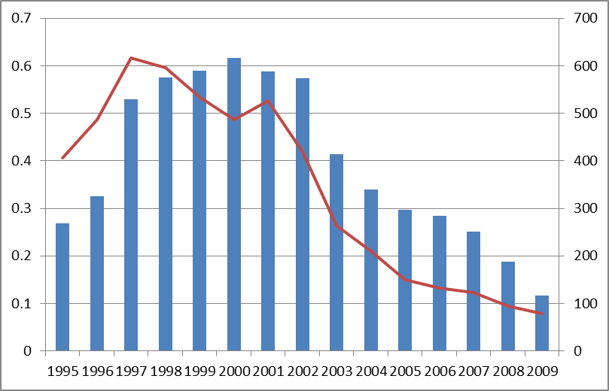

**Total Emissions, mmtce**

**Lbs.CE per unit production**

While PFC emission reductions have been an important focus for Intel, other actions have also been taken to reduce total greenhouse gas emissions. The existing D1D facility in Hillsboro, Oregon was constructed with a heat recovery system on the boilers that reduces their natural gas consumption (and subsequent CO2 emissions) by more than 50% from a similar size fab without heat recovery. Intel has dedicated funds to energy conservation and the site has implemented a number of other energy conservation projects that have helped reduce natural gas consumption. As a result of these actions, total greenhouse gas emissions at the Oregon campus have seen a decline similar to the one seen for Intel-wide PFC emissions (see figure 2). This has occurred despite an increase in manufacturing activity at the Oregon site of more than 3X since 2000.

Future Plans

Intel intends to continue its greenhouse gas reduction efforts and is currently working with the WSC to develop an extension to the initial voluntary agreement that addressed emissions through 2010. Intel is currently a world leader in the development and implementation of greenhouse gas reduction techniques for the semiconductor industry.

Intel will employ state-of-the-art technologies to minimize the greenhouse gas emissions from the new facility proposed to be constructed in Oregon. As described above, Intel has invested extensive resources in developing the leading technologies for minimizing both process and combustion greenhouse gas emissions. The new Intel facility proposed for Hillsboro, Oregon will include the emission reduction steps described above, including both PFC controls, PFC use reduction and boiler heat recovery systems to reduce fuel consumption. This investment of millions of dollars into greenhouse gas emission prevention and emission control is part of Intel’s commitment to the community to employ the best available control technology. In addition to employing these proven technologies, we continue to evaluate new technologies that may provide further greenhouse gas reductions. At present, trials are being conducted on a new type of emissions control device that may be utilized to further reduce PFCs in future manufacturing processes. Intel will continue to look for new opportunities to reduce greenhouse gas emissions and we welcome the opportunity to discuss these efforts with the Oregon Department of Environmental Quality and the community.

**Attachment 1**

**Diagram of NF3 treatment**

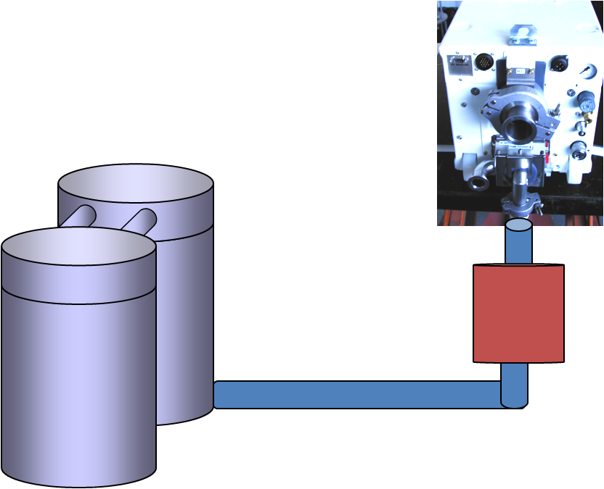

To house scrubber exhaust

Fab tool exhaust

Thermal oxidizer/wet scrubber

**Attachment 2**

**PFC Abatement Unit**

