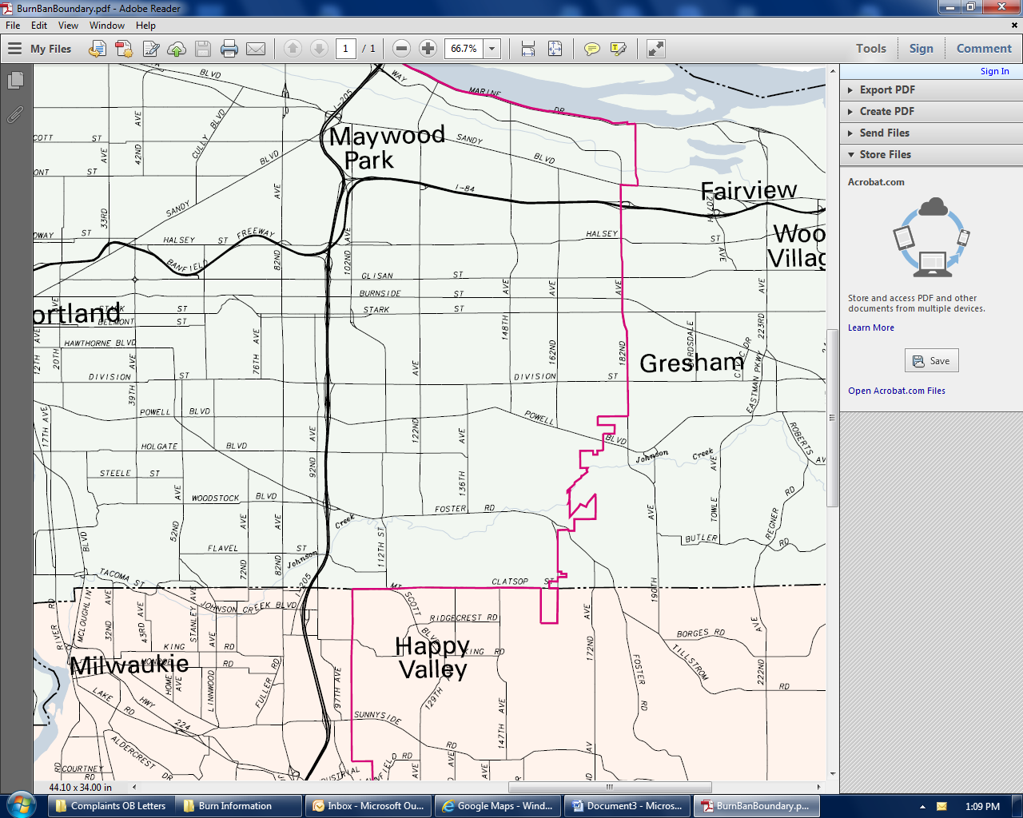

False boundary. This is the boundary map I have been giving out. I believe DEQ took the lines from a Metro map for city limits boundaries

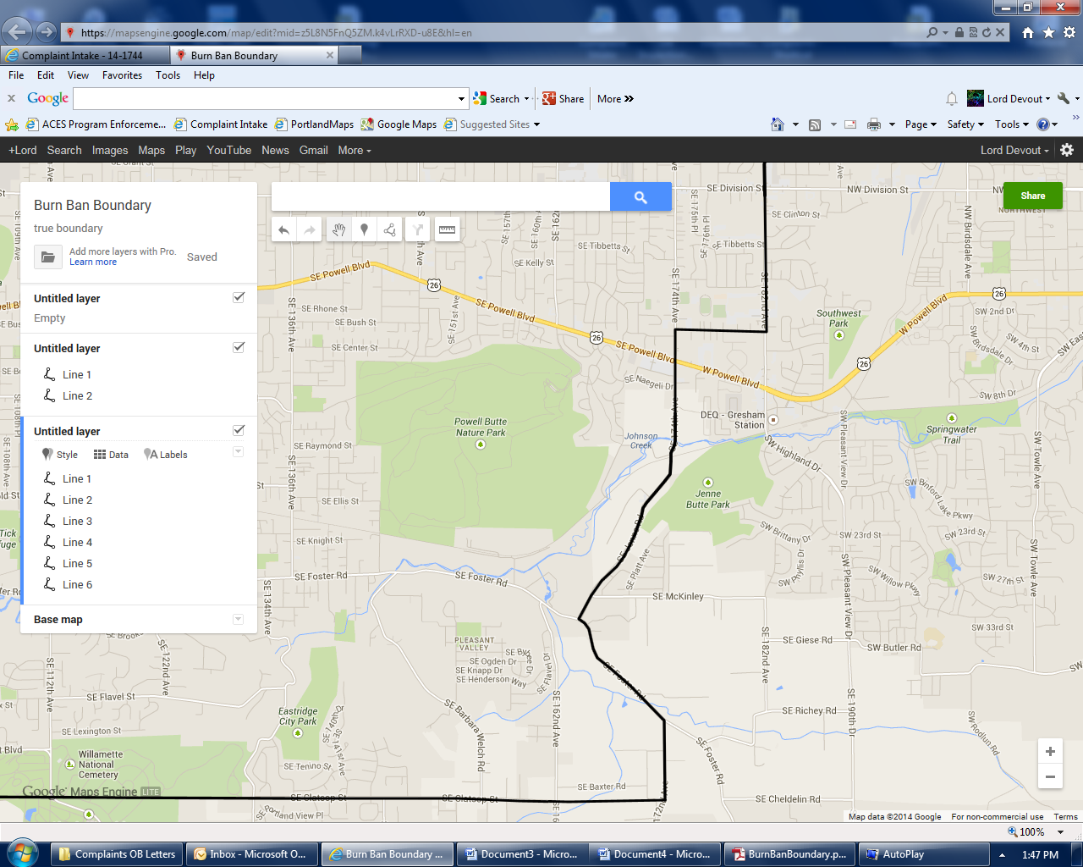

This is the true burn boundary as worded in DEQ OAR 340-264-0130(A). That is if “southeasterly” is the typo and meant to be northwesterly. If the typo is “172nd” and meant to be 162nd then the red line is the true burn boundary.