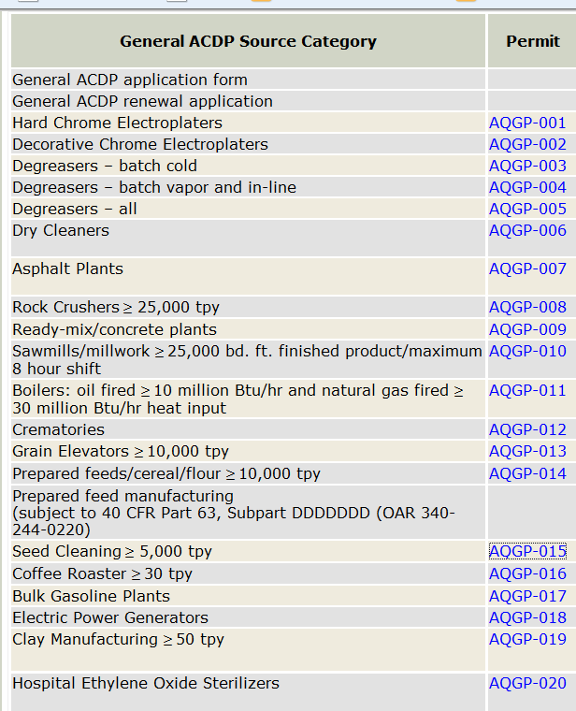
Issued by EQC? Expiration Date

No | 08/01/21
No | 08/01/21
Yes | 08/01/11
Yes | 12/01/18
Yes | 12/01/18
No? No sig but no EQC | 03/01/20
Yes | 10/01/17
Yes | 10/01/17
Yes | 10/01/17
Yes | 10/01/17
Yes | 10/01/17
Yes | 10/01/17
No | 08/01/21
No | 08/01/21
No | 08/01/21
No | 08/01/21
Yes | 12/01/18
Yes | 12/01/18
No | 08/01/21
Yes | 12/01/18
No? No sig but no EQC | 03/01/20
No? No sig but no EQC | 03/01/20
No? No sig but no EQC | 03/01/20
Yes | 12/01/18
No | 04/01/21
No | 04/01/21
No | 04/01/21
No | 04/01/21
No | 04/01/21
No | 10/01/23
