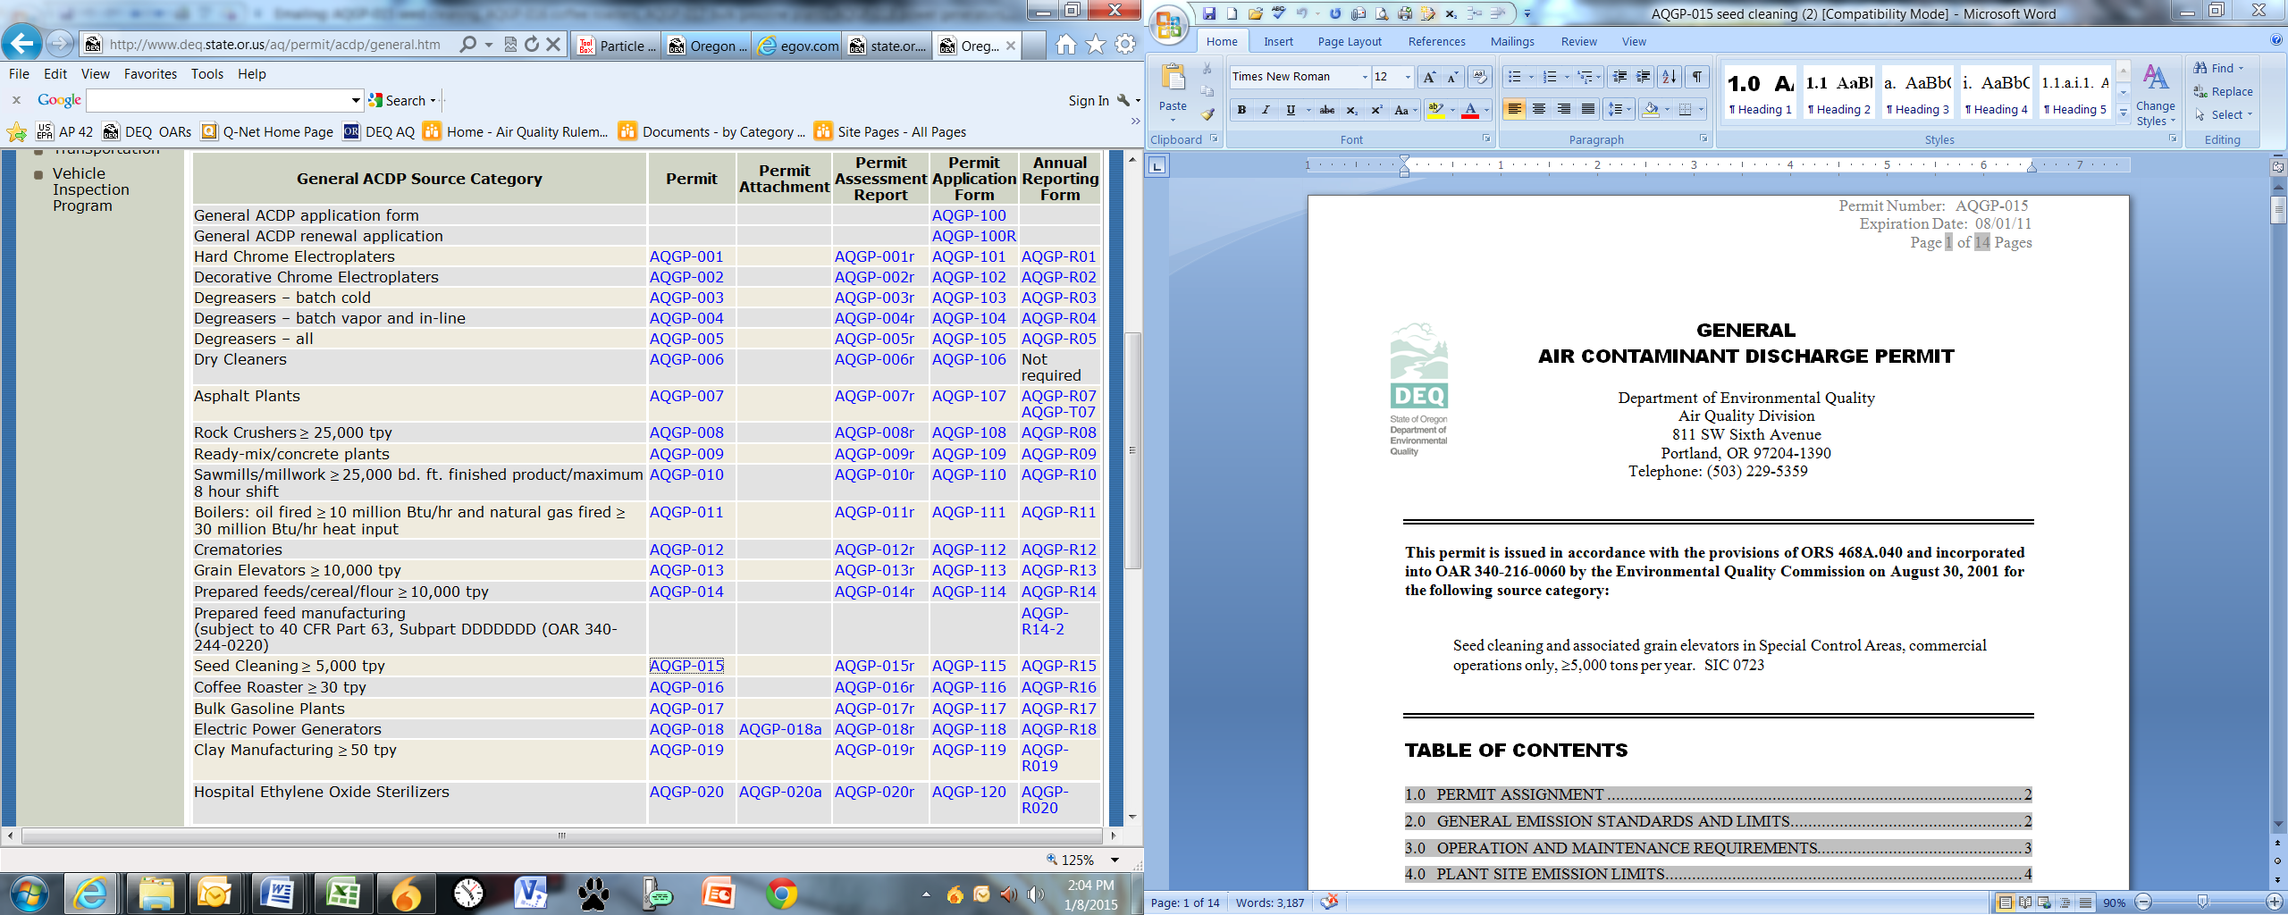 **Issued by EQC? Expiration Date**

|  |  |
| --- | --- |
| No | 08/01/21 |
| No | 08/01/21 |
| Yes | 08/01/11 |
| Yes | 12/01/18 |
| Yes | 12/01/18 |
| No? No sig but no EQC | 03/01/20 |
| Yes | 10/01/17 |
| Yes | 10/01/17 |
| Yes | 10/01/17 |
| Yes | 10/01/17 |
| Yes | 10/01/17 |
| Yes | 10/01/17 |
| No | 08/01/21 |
| No | 08/01/21 |
| No | 08/01/21 |
| No | 08/01/21 |
| Yes | 12/01/18 |
| Yes | 12/01/18 |
| No | 08/01/21 |
| Yes | 12/01/18 |
| No? No sig but no EQC | 03/01/20 |
| No? No sig but no EQC | 03/01/20 |
| No? No sig but no EQC | 03/01/20 |
| Yes | 12/01/18 |
|  |  |
| No | 04/01/21 |
| No | 04/01/21 |
| No | 04/01/21 |
| No | 04/01/21 |
| No | 04/01/21 |
| No | 10/01/23 |

