1. Natural Gas Hog Fuel Boiler Conversion For Macmillan Bloedel Harmac Division In Nanaimo, BC
2. PROJECT OVERVIEW

In 1991, Inproheat converted a tangentially fired 450,000 lb/hr 625 psig CE hog fuel boiler in a pulp mill to natural gas. Before the conversion, the boiler burned Bunker-C oil along with bark and other wood residue. For an integrated mill such as Harmac, wood waste is an important energy source and provides a considerable contribution to total energy requirements. In a hog fuel boiler, natural gas or some other fuel is used to sustain load when moisture of the wood is high or when steam demand exceeds the capacity of the boiler fired on wood alone. Heating value of wood waste decreases sharply as moisture (which can run as high as 63% by weight) increases. At Nanaimo, the hog fuel is derived from sea borne logs and thus it has a relatively high moisture level. The boiler typically runs 80% to 85% on hog fuel with the remainder provided by gas or oil burners. If the hog fuel supply is interrupted, gas or oil burners are capable of sustaining the entire boiler load. Steam from the boiler drives a steam turbine for electricity generation and provides heat for various pulping processes at the mill. The boiler had a history of unstable combustion and was subject to secondary combustion "puffs" caused by delayed ignition of combustible gases generated at the grate level due to a sudden increase in hog fuel moisture content. The gases wouldn't ignite until they flowed upward about 15 to 20 feet in the furnace and reached the vicinity of the oil burner. Once they ignited, they produced a large, heavy furnace pressurization of "puff". The objective of the conversion was to add natural gas firing capability (lower cost and cleaner fuel compared to Bunker C oil) and to stabilize boiler operation and improve boiler control.

1. THE CHALLENGE

To eliminate the "puffs" and stabilize operations, an ignition source closer to the grate was needed. That way, the gases would ignite sooner and at a point at which the air supply was adequate. In addition, the air distribution throughout the boiler needed improvement. These objectives plus the addition of natural gas firing with fuel oil standby capability became very challenging due to a very tight boiler design and already crowded area surrounding it. A special consideration had to be given to the materials of construction of the burners, which were subject to accelerated corrosion in the presence of chlorides originating from the sea salt entrapped in the hog fuel.

The higher temperatures and lower luminosity of natural gas products of combustion created a concern of excessive temperatures over the boiler superheater section.

1. THE SOLUTION

The boiler conversion was a joint project. Inproheat Industries teamed up with Coen Company of Burlingame, CA and Coen Burners Canada of Montreal. Coen Burlingame carried out an elaborate computer modeling of combustion air velocities in the windbox and gas velocities and temperatures throughout the boiler and prepared the preliminary burner design. Coen Canada worked on fabrication details and fabricated final burner components. Inproheat designed and supplied the gas headers and local fuel train racks as well as modifications to the existing burner control system. The installation and startup were supervised by both Coen and Inproheat.

A total of sixteen overfire gas burners and eight new oil burners were provided. The computer modeling led to a development of venturi inserts and flow distributor plates which were added to the existing windbox.

To address the concern about high superheater temperatures the gas burners were set to fire slightly sub-stochiometrically and utilized a portion of the under-fire combustion air rising from the grates. This method produces a radiant, yellow gas flame which is completely oxidized and yet allows the furnace to absorb the amount of radiant energy similar to an oil flame.

To control high temperature salt corrosion, special corrosion-resistant alloys were used in the high temperature windbox discharge zones.

To stabilize combustion and eliminate the "puffs", Coen and Inproheat designed a special 30 MM BTU/hr gas hearth burner that could fire downward at about a 30 degree angle and sideways at a 22 degree angle. The burner produces a long sharp flame which reaches almost 20 feet and sweeps over the grate providing an ignition source at grate level.

1. THE RESULT

Natural gas hog fuel boiler conversion stabilized combustion and eliminated any secondary combustion, reduced acid dew-point corrosion of boiler components and improved air distribution through special computer modeling. When the gas conversion components were put to the test, a near perfect air balance to all burners was achieved.

The superheater temperature rise was insignificant thanks to the setup of the gas burners.

The utilization of special corrosion-resistant alloys prevented deterioration of burner components. Also, because natural gas does not contain sulfur, as oil does, cold-end acid dew-point corrosion was naturally eliminated.

After a few months of operation, a problem was discovered with the chloride corrosion of 316 stainless steel gas flexible hoses. Chlorides would enter the hoses through the gas burner nozzles while the gas burners were off line. The problem was solved by replacing stainless steel hoses with special Teflon-lined flexible hoses. The gas conversion was put to the test when the main hog fuel conveyor failed during boiler startup and was out of service for several days. The burners worked as they were supposed to and even exceeded performance expectations for turndown and control. Operators were able to get enough turndown on all burners to avoid taking them individually off line.

Along the stabilized boiler operation, the hearth burner made it easier to bring the grate fire back into service after grate cleaning. With high moisture hog fuel, it took in the past a considerable amount of time to re-establish load on the grate. With the hearth burner the time required dropped to 15 minutes. According to Fred Williamson, Chief Power Engineer at Harmac: "...The burner has stabilized operation to the point that there are virtually no combustion puffs. Before, we really didn't dare to push the boiler. Now because the combustion process is secure, we can operate the boiler on a more automatic basis... The results of the conversion have been excellent. It allowed us to automate and put the boiler under computer control. Our only problem is that the system operates so well, it's tempting for the operators to keep running on gas more than necessary..."

<http://inproheat.com/natural-gas-hog-fuel-boiler-conversion-macmillan-bloedel-harmac-division-nanaimo-bc>

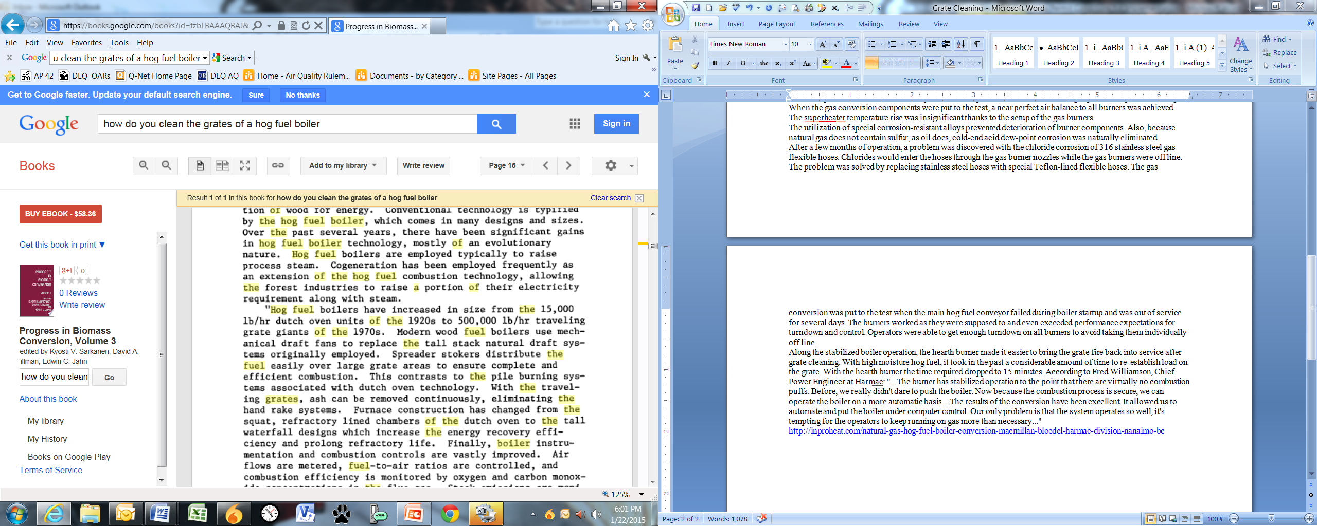

<https://books.google.com/books?id=tzbLBAAAQBAJ&pg=PA15&lpg=PA15&dq=how+do+you+clean+the+grates+of+a+hog+fuel+boiler&source=bl&ots=vFOLxyMkvk&sig=bzkWS7yufgR8bnjPb_8omID87-Y&hl=en&sa=X&ei=8qrBVNZm2LeiBML2gIAP&ved=0CCIQ6AEwATgK#v=onepage&q=how%20do%20you%20clean%20the%20grates%20of%20a%20hog%20fuel%20boiler&f=false>

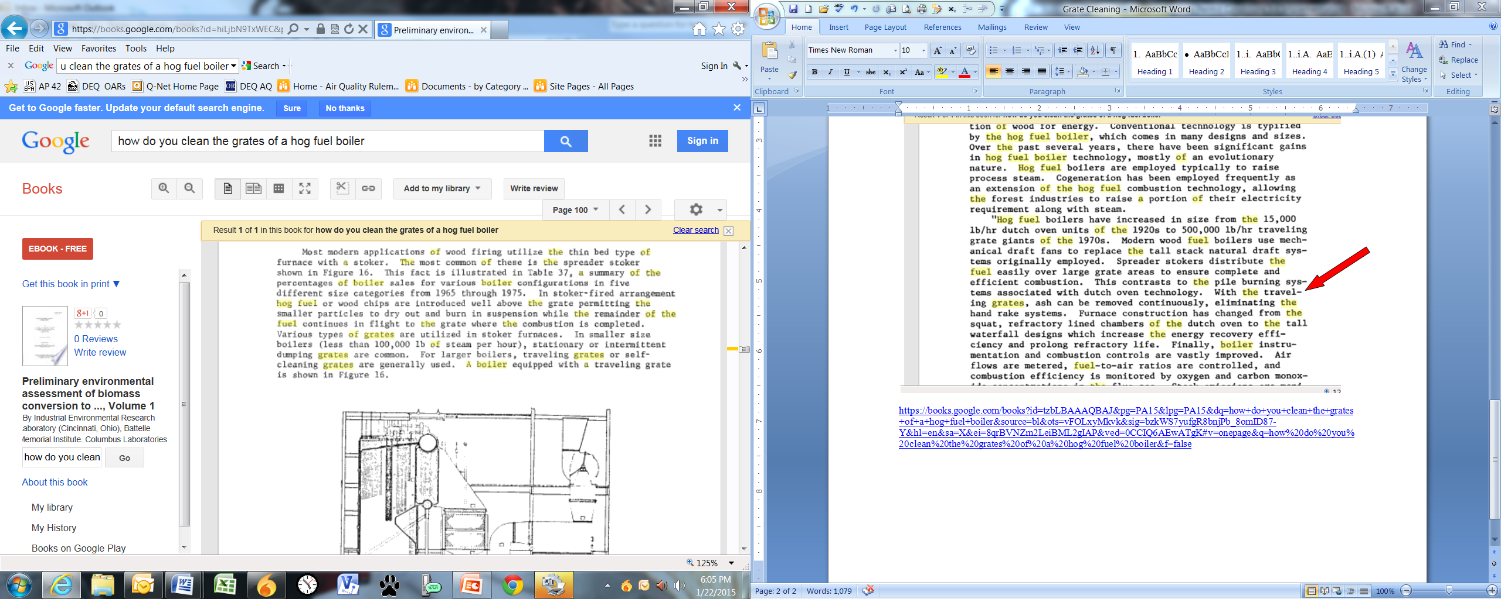

<https://books.google.com/books?id=hiLjbN9TxWEC&pg=PA100&lpg=PA100&dq=how+do+you+clean+the+grates+of+a+hog+fuel+boiler&source=bl&ots=Lo3Hnv_CY0&sig=kSuBw1so9f2iqqF2elUEjILjZSk&hl=en&sa=X&ei=DKzBVIWQNZW3ogSHroLQCQ&ved=0CCkQ6AEwBDgK#v=onepage&q=how%20do%20you%20clean%20the%20grates%20of%20a%20hog%20fuel%20boiler&f=false>