340-264-0078

Figure 2

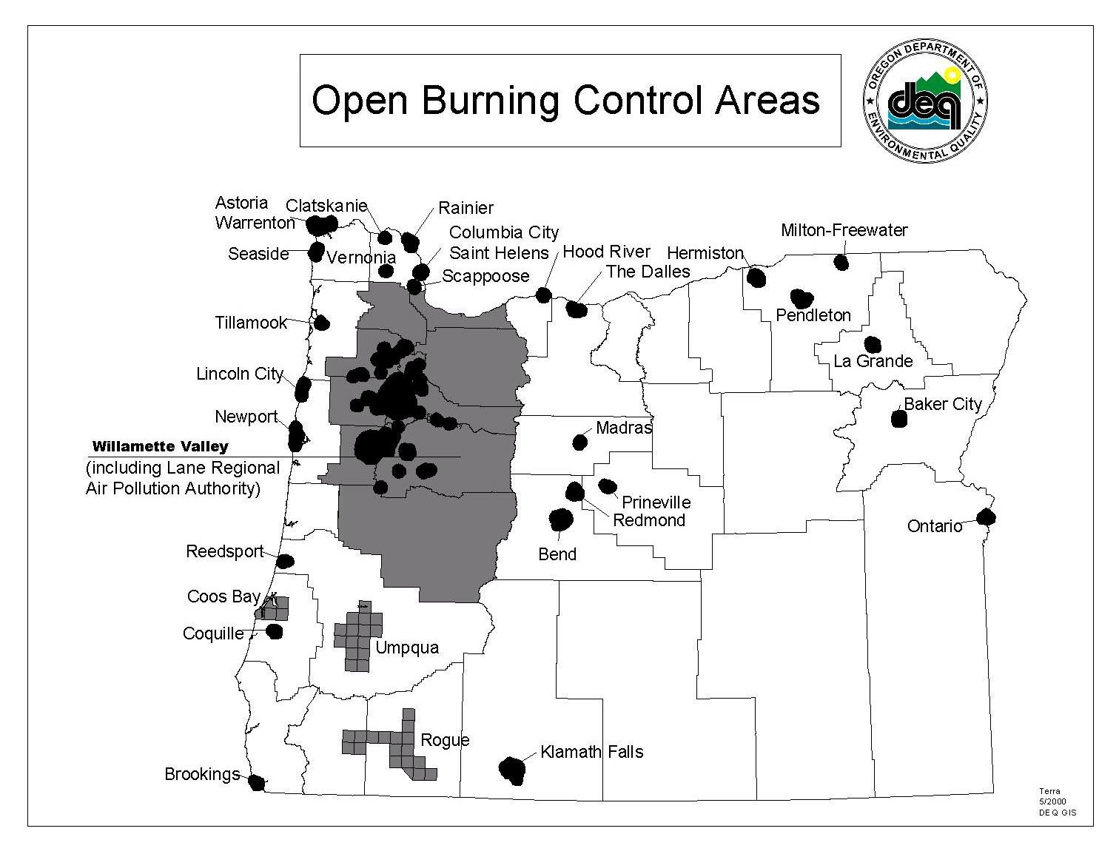

OPEN BURNING OUTSIDE OF WILLAMETTE VALLEY,

CONTROL AREAS CITIES EXCEEDING POPULATION OF 4,000