June 1, 2015

Dennis McLerran
Regional Administrator
U.S. Environmental Protection Agency, Region 10
1200 Sixth Avenue, RA-140
Seattle, WA 98101

Dear Mr. McLerran:
This submittal is to update Oregon’s Title V Program with rules adopted by the Environmental Quality Commission on April 16, 2015. The Oregon Administrative Rules for Oregon’s air quality permitting program were reorganized and updated. The Source Sampling Manual Volumes I and II and Continuous Monitoring Manual were also updated. DEQ also changed the following:

- statewide particulate matter emission standards;
- preconstruction permitting program;
- greenhouse gas permitting requirements to align with the June 23, 2014 Supreme Court decision;
- public meeting procedures to allow DEQ to use technology such as teleconferencing to improve community outreach;
- woodstove replacement program called Heat Smart; and
- gasoline dispensing facility rules.

Attachments including a cover memo to the EQC, redline version of the rule, public notice, and Secretary of State filing have been forwarded to Lucita Valiere. This submittal implements Item IV, Operating Permit program Updates, of the Title V Implementation Agreement between Oregon and EPA. The table that highlights the rule changes relied upon to implement our Title V program is attached.

The staff contacts for this submittal are Jill Inahara, Program Operations, at 503-229-5001, and Emil Hnidey, SIP Coordinator, at (503) 229-5946.

Sincerely,

Dick Pedersen
Director

cc w/attachments: Lucita Valiere, EPA, Region 10

cc w/o attachments: Emil Hnidey, DEQ AQ SIP Coordinator
Lydia Emer, DEQ Operations Administrator
Paul Koprowski, EPA Oregon Operations office

Attachments:

Attachment 1: Rule Change Crosswalk
Summary of Title V Program Rule Changes

Attachment 2: Oregon Department of Environmental Quality
April 15-16, 2015
Oregon Environmental Quality Commission meeting
Rulemaking, Action Item: J

Air quality permitting, Heat Smart and gasoline dispensing facility updates

Attachment 3: Provisions Submitted for Approval

Attachment 4: Public Notice and Adoption Documents
Public notice in the Secretary of State’s Oregon Bulletin July 1, 2014
Certificate and Order for Filing Permanent Administrative Rules, filed November
08, 2007.

Attachment 5: Presiding Officer’s Report for Rulemaking Hearings dated May 01, 2007

Attachment 1

Rule Change Crosswalk
Summary of April 16, 2015 Rulemaking

(separate attachment – page Item J 000925)

Attachment 2

Oregon Department of Environmental Quality
April 15-16, 2015
Oregon Environmental Quality Commission meeting
Rulemaking, Action Item: J

Air quality permitting, Heat Smart and gasoline dispensing facility updates

(separate attachment)

Attachment 3

Provisions Submitted for Approval
(separate attachment)

Adopt OAR:

340-200-0035, 340-202-0225, 340-204-0300, 340-204-0310, 340-204-0320, 340-206-8010, 340-206-8020, 340-206-8030, 340-206-8040, 340-208-0005, 340-212-0005, 340-214-0005, 340-222-0046, 340-222-0048, 340-222-0051, 340-224-0025, 340-224-0045, 340-224-0055, 340-224-0245, 340-224-0250, 340-224-0255, 340-224-0260, 340-224-0270, 340-224-0500, 340-224-0510, 340-224-0520, 340-224-0530, 340-224-0540, 340-226-0005, 340-226-8010, 340-234-0005, 340-234-0540, 340-236-0005, 340-236-8010, 340-240-0050

Amend OAR:

340-200-0010, 340-200-0020, 340-200-0025, 340-200-0030, 340-200-0040, 340-200-0050, 340-200-0100, 340-200-0110, 340-200-0120, 340-202-0010, 340-202-0020, 340-202-0050, 340-202-0070, 340-202-0100, 340-202-0110, 340-202-0130, 340-202-0200, 340-202-0210, 340-202-0220, 340-204-0010, 340-204-0020, 340-204-0030, 340-204-0040, 340-204-0050, 340-204-0060, 340-204-0070, 340-204-0080, 340-204-0090, 340-206-0010, 340-206-0020, 340-206-0030, 340-206-0040, 340-206-0050, 340-206-0060, 340-206-0070, 340-208-0010, 340-208-0110, 340-208-0210, 340-208-0300, 340-208-0310, 340-208-0320, 340-208-0450, 340-209-0010, 340-209-0020, 340-209-0030, 340-209-0040, 340-209-0050, 340-209-0060, 340-209-0070, 340-209-0080, 340-210-0010, 340-210-0020, 340-210-0100, 340-210-0110, 340-210-0120, 340-210-0205, 340-210-0215, 340-210-0225, 340-210-0230, 340-210-0240, 340-210-0250, 340-212-0010, 340-212-0110, 340-212-0120, 340-212-0130, 340-212-0140, 340-212-0150, 340-212-0200, 340-212-0210, 340-212-0220, 340-212-0230, 340-212-0240, 340-212-0250, 340-212-0260, 340-212-0270, 340-212-0280, 340-214-0010, 340-214-0100, 340-214-0110, 340-214-0114, 340-214-0130, 340-214-0200, 340-214-0210, 340-214-0220, 340-214-0300, 340-214-0310, 340-214-0320, 340-214-0330, 340-214-0340, 340-214-0350, 340-214-0360, 340-216-0010, 340-216-0020, 340-216-0025, 340-216-0030, 340-216-0040, 340-216-0052, 340-216-0054, 340-216-0056, 340-216-0060, 340-216-0062, 340-216-0064, 340-216-0066, 340-216-0068, 340-216-0070, 340-216-0082, 340-216-0084, 340-216-0090, 340-216-0094, 340-216-8010, 340-216-8020, 340-218-0010, 340-218-0020, 340-218-0030, 340-218-0040, 340-218-0050, 340-218-0060, 340-218-0070, 340-218-0080, 340-218-0090, 340-218-0100, 340-218-0110, 340-218-0120, 340-218-0140, 340-218-0150, 340-218-0160, 340-218-0170, 340-218-0180, 340-218-0190, 340-218-0200, 340-218-0210, 340-218-0220, 340-218-0230, 340-218-0240, 340-220-0010, 340-220-0020, 340-220-0060, 340-220-0070, 340-220-0080, 340-220-0090, 340-220-0100, 340-220-0110, 340-220-0120, 340-220-0130, 340-220-0140, 340-220-0150, 340-220-0160, 340-220-0170, 340-220-0180, 340-220-0190, 340-222-0010, 340-222-0020, 340-222-0030, 340-222-0040, 340-222-0041, 340-222-0042, 340-222-0060, 340-222-0080, 340-222-0090, 340-224-0010, 340-224-0020, 340-224-0030, 340-224-0040, 340-224-0050, 340-224-0060, 340-224-0070, 340-225-0010, 340-225-0020, 340-225-0030, 340-225-0040, 340-225-0045, 340-225-0050, 340-225-0060, 340-225-0070, 340-226-0010, 340-226-0100, 340-226-0110, 340-226-0120, 340-226-0130, 340-226-0140, 340-226-0210, 340-226-0310, 340-226-0320, 340-226-0400, 340-228-0010, 340-228-0020, 340-228-0100, 340-228-0110, 340-228-0120, 340-228-0130, 340-228-0200, 340-228-0210, 340-228-0300, 340-232-0010, 340-232-0020, 340-232-0030, 340-232-0040, 340-232-0050, 340-232-0060, 340-232-0080, 340-232-0085, 340-232-0090, 340-232-0100, 340-232-0110, 340-232-0120, 340-232-0130, 340-232-0140, 340-232-0150, 340-232-0160, 340-232-0170, 340-232-0180, 340-232-0190, 340-232-0200, 340-232-0210, 340-232-0220, 340-232-0230, 340-234-0010, 340-234-0100, 340-234-0140, 340-234-0200, 340-234-0210, 340-234-0220,
340-234-0240, 340-234-0250, 340-234-0270, 340-234-0500, 340-234-0510, 340-234-0520, 340-234-0530, 340-236-0010, 340-236-0310, 340-236-0320, 340-236-0330, 340-236-0400, 340-236-0410, 340-236-0420, 340-236-0440, 340-236-0500, 340-240-0010, 340-240-0020, 340-240-0030, 340-240-0100, 340-240-0110, 340-240-0120, 340-240-0130, 340-240-0140, 340-240-0150, 340-240-0160, 340-240-0180, 340-240-0190, 340-240-0210, 340-240-0220, 340-240-0250, 340-240-0300, 340-240-0320, 340-240-0330, 340-240-0340, 340-240-0350, 340-240-0360, 340-240-0400, 340-240-0410, 340-240-0420, 340-240-0430, 340-240-0440, 340-240-0510, 340-240-0550, 340-240-0560, 340-240-0610, 340-242-0400, 340-242-0410, 340-242-0420, 340-242-0430, 340-242-0440, 340-242-0500, 340-242-0510, 340-242-0520, 340-242-0600, 340-242-0610, 340-242-0620, 340-242-0630, 340-244-0040, 340-244-0232, 340-244-0234, 340-244-0236, 340-244-0238, 340-244-0239, 340-244-0240, 340-244-0242, 340-244-0244, 340-244-0246, 340-244-0248, 340-244-0250, 340-246-0230, 340-262-0450, 340-264-0010, 340-264-0020, 340-264-0030, 340-264-0040, 340-264-0050, 340-264-0060, 340-264-0070, 340-264-0075, 340-264-0078, 340-264-0080, 340-264-0100, 340-264-0110, 340-264-0120, 340-264-0130, 340-264-0140, 340-264-0150, 340-264-0160, 340-264-0170, 340-264-0175, 340-264-0180, 340-268-0010, 340-268-0020, 340-268-0030

Amend and Renumber OAR:
340-222-0043 renumbered to 340-222-0035,
340-222-0045 renumbered to 340-222-0055,
340-224-0080 renumbered to 340-224-0034,
340-224-0100 renumbered to 340-224-0038

Repeal OAR:
340-208-0100, 340-208-0200, 340-208-0600, 340-214-0400, 340-214-0410, 340-214-0420, 340-214-0430, 340-218-0250, 340-222-0070, 340-225-0090, 340-226-0200, 340-228-0400, 340-228-0410, 340-228-0420, 340-228-0430, 340-228-0440, 340-228-0450, 340-228-0460, 340-228-0470, 340-228-0480, 340-228-0490, 340-228-0500, 340-228-0510, 340-228-0520, 340-228-0530, 340-234-0300, 340-234-0310, 340-234-0320, 340-234-0330, 340-234-0340, 340-234-0350, 340-234-0360, 340-234-0400, 340-234-0410, 340-234-0420, 340-234-0430, 340-236-0100, 340-236-0110, 340-236-0120, 340-236-0130, 340-236-0140, 340-236-0150, 340-236-0200, 340-236-0210, 340-236-0220, 340-236-0230, 340-236-0430, 340-240-0170, 340-240-0230, 340-240-0310, 340-242-0700, 340-242-0710, 340-242-0720, 340-242-0730, 340-242-0740, 340-242-0750, 340-242-0760, 340-242-0770, 340-242-0780, 340-242-0790, 340-264-0190
Attachment 4

Public Notice and Adoption Documents

Public notice in the Secretary of State’s Oregon Bulletin July 1, 2014
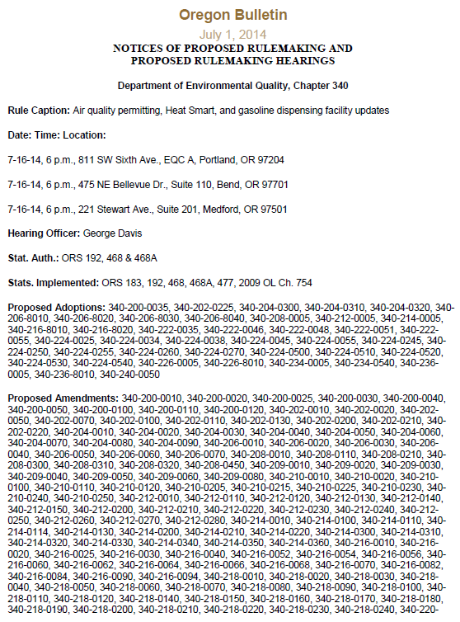
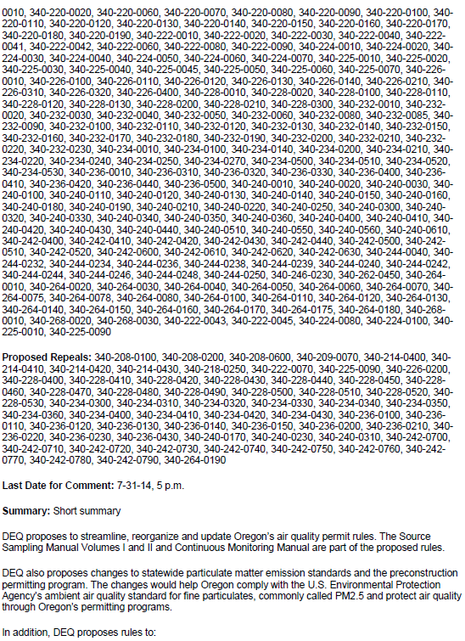
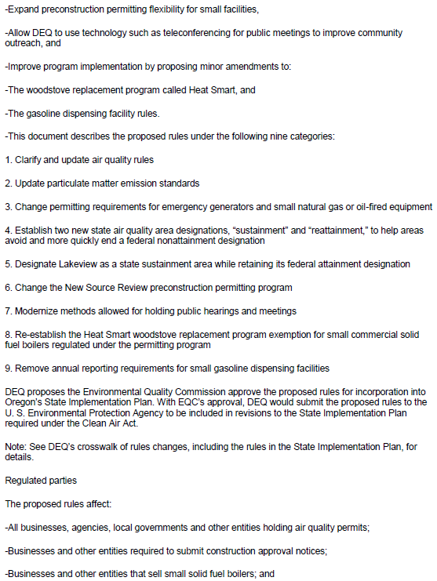
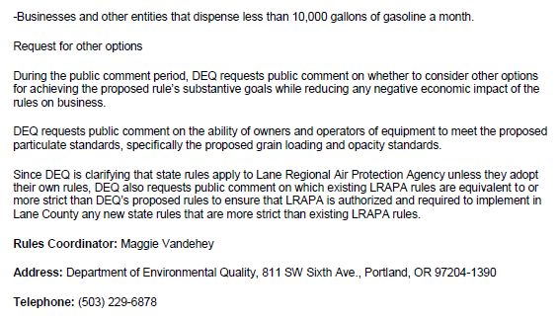

Certificate and Order for Filing Permanent Administrative Rules, filed April 29, 2011

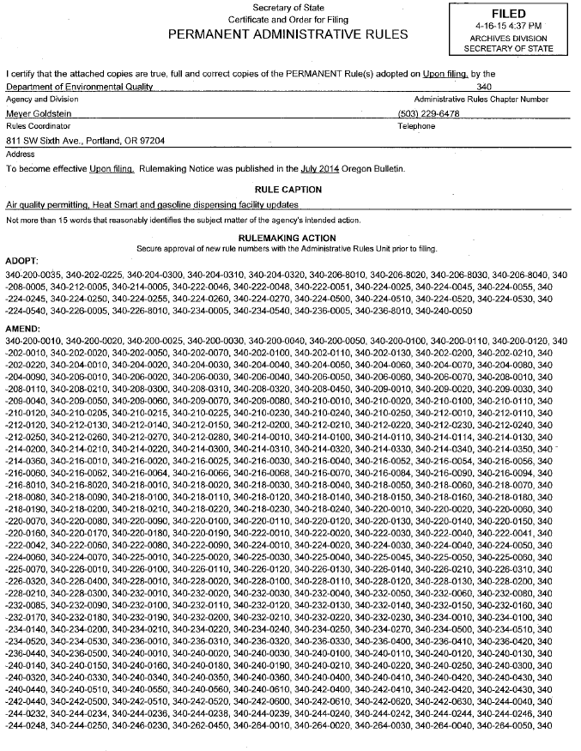

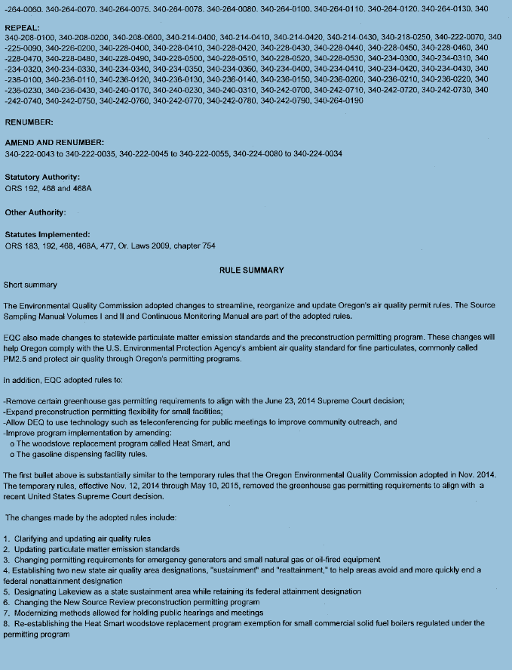

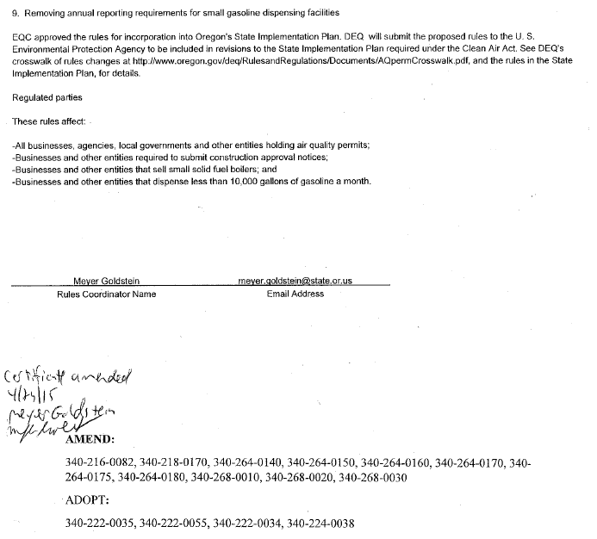

Attachment 5

Presiding Officer’s Report for Rulemaking Hearings dated July 18, 2014

