

Oregon Department of Environmental Quality

Enter EQC DATE mmm dd, yyyy

Oregon Environmental Quality Commission Meeting

Rulemaking Action Item Enter L

**Enter caption**

How to hide instructions and examples

All cobalt blue text and EXAMPLES are in the Font Effects | Hidden. Word identifies hidden text by underlining it with dots. You may use one of the following methods to show/hide hidden text:

1. Press paragraph symbol displayed in Paragraph grouping.

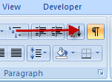

1. Press [Ctrl] [Shift] [8] keys simultaneously

To find and delete all hidden text before publishing, press [Ctrl] [F] keys, press Format button, and select the Font | Effects | Hidden box and press OK button. On the Replace tab, place cursor in Replace with: box and press Delete key then press Replace All button.

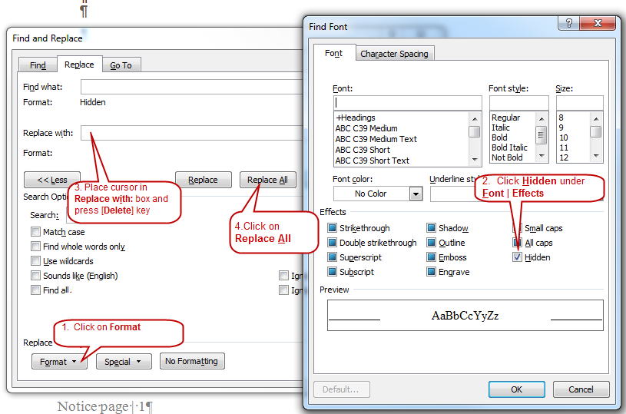

Administrative Procedures Act Requirements

All DEQ public writing for rulemaking must be clear and simple to meet requirements of the Administrative Procedures Act.

ORS 183.750 Readability of Public Writingshttp://www.oregon.gov/DAS/Images/spacer.gif

Article Content

183.750 State agency required to prepare public writings in readable form.

(1) Every state agency shall prepare its public writings in language that is as clear and simple as possible.

(2) As used in this section:

(a) “Public writing” means any rule, form, license or notice prepared by a state agency.

(b) “State agency” means any officer, board, commission, department, division or institution in the executive or administrative branch of state government. [Formerly 183.025]

Note: 183.750 was enacted into law by the Legislative Assembly but was not added to or made a part of ORS chapter 183 or any series therein by legislative action. See Preface to Oregon Revised Statutes for further explanation.

What DEQ says in the staff report is important. This report becomes part of the administrative history of the rule and the court may look at it for guidance when deciding how to interpret an ambiguous rule section. Be thorough and accurate when discussing the potential scope of the rule.

Plain Language

When you write this document, and all other public rulemaking documents, your publication reviewers will follow plain language guidelines. We, your reviewers recommend the following resources for anyone who has not taken a plain language course or who needs a refresher.

FAA Plain Language Course. [[LINK](http://www.faa.gov/about/initiatives/plain_language/basic_course/)] It will take about an hour. It has some quirkiness and a few shots of humor.

For more details in an online or printable format, use the Federal Plain Language Guidelines. [[LINK](http://www.plainlanguage.gov/howto/guidelines/FederalPLGuidelines/TOC.cfm)]

Agency Communications on Q-Net offers the DEQ-centric Style and writing resources [[LINK]](http://deq05/intranet/communication/index.htm)

|  |
| --- |
| DEQ recommendation to the EQC |

## DEQ recommends that the Environmental Quality Commission:

Select recommendation from list

Adopt the proposed rules in Attachment A as part of chapter 340 of the Oregon Administrative Rules. Approve incorporating these rule amendments into the Oregon Clean Air Act State Implementation Plan under OAR 340-200-0040.

SMOKE MANAGEMENT PLAN RECOMMENDATION

DEQ recommends that the Environmental Quality Commission:

1. Approve the Oregon Smoke Management Plan under ORS 477.013 as part of chapter 340 of the Oregon Administrative Rules;
2. Adopt the proposed amendment to OAR 340-200-0040 in Attachment A to incorporate the proposed rules into the Oregon Clean Air Act State Implementation Plan; and
3. Direct DEQ to submit the SIP revision to the U.S. Environmental Protection Agency for approval

|  |
| --- |
| Overview |

## Request for other options

During the public comment period, DEQ requested public comment on whether to consider other options for achieving the rules’ substantive goals while reducing negative economic impact of the rule on business. This document includes a summary of comments and DEQ responses.

Insert the following sections from published NOTICE after the Recommendation section. Also, add a message box to each section of these sections similar to the grey message box below.

* Overview – include *Request for Other Options.* May include a message box if there were no changes
* Statement of need – may have a message box if no changes as a result of public comment
* Freeform title –may have a message box if there were no changes
* Federal relationships– needs a message box
* Rules affected, authorities, supporting documents - may have a message box if no changes
* Statement of fiscal and economic impact – may have a message box if no changes as a result of public comment
* Fees – needs a message box
* Land use – needs a message box

MESSAGE BOX

**REVIEWERS do not edit or modify this section**

[LIST KEY REVIEWERS such as program staff and managers, OCO, EPA, DOJ, the advisory committee, DAS, division and agency rules coordinators] reviewed this section prior to publishing it in the public notice. Do not modify it except to correct typographical errors. The program manager and the division administrator reviewed and approved this section at that time.

|  |
| --- |
| Stakeholder and public involvement |

Insert information from NOTICE here

* Advisory committee
* EQC involvement
* Public notice

CHANGE FROM FUTURE TO PAST TENSE

## Public hearings and comment

DEQ held ## public hearing(s). DEQ received ## public comments. The following is a summary of comments DEQ received during the public comment period with cross reference to commenter number. DEQ’s response follows the summary. Original comments are on file with DEQ.

## Presiding Officers’ Record

### Hearing 1

Meeting location:

Meeting date and time: DEQ headquarters.10th floor, Conference Room EQC A

811 SW 6th Ave. Portland OR 97204-1390

Time convened:

Time adjourned:

Presiding Officer: Name presiding officer

The presiding officer convened the hearing and summarized procedures for the hearing including notification that DEQ was recording the hearing. The presiding officer asked people who wanted to present verbal comments to complete, sign and submit a registration form or, if attending by Web conference to use the “chat” feature to indicate their intent to present comments.

According to [Oregon Administrative Rule 137-001-0030](http://arcweb.sos.state.or.us/pages/rules/oars_100/oar_137/137_001.html), the presiding officer summarized the content of the notice given under [Oregon Revised Statute 183.335](http://www.leg.state.or.us/ors/183.html).

Hearing2

Meeting location:

Meeting date and time: DEQ headquarters.10th floor, Conference Room EQC A

811 SW 6th Ave. Portland OR 97204-1390

Time convened:

Time adjourned:

Presiding Officer: Name presiding officer

The presiding officer convened the hearing and summarized procedures for the hearing including notification that DEQ was recording the hearing. The presiding officer asked people who wanted to present verbal comments to complete, sign and submit a registration form or, if attending by Web conference to use the “chat” feature to indicate their intent to present comments.

According to [Oregon Administrative Rule 137-001-0030](http://arcweb.sos.state.or.us/pages/rules/oars_100/oar_137/137_001.html), the presiding officer summarized the content of the notice given under [Oregon Revised Statute 183.335](http://www.leg.state.or.us/ors/183.html).

DEQ added all names, addresses and affiliations provided on the registration form and attendee list to DEQ interested parties list for this rule and to the commenter section of this staff report. The commenter list includes a cross reference to the hearing number. DEQ added all written and oral comments presented at each hearing to the summary of comments and agency responses section of this staff report.

[OPTION]

Describe information meeting.

Insert ‘Summary of comments and DEQ responses’ and ‘ Commenters’ sections from folder 5 here.

|  |
| --- |
| Implementation |

## Notification

The proposed rules would become effective on mmm, dd, yyyy. DEQ will notify affected parties by Describe Notification TEXT.

Include information about the application of the rule. Be thorough and accurate. Without speculation, describe the implementation elements that DEQ has already decided to do. Use the example elements below as an example of how to develop elements that apply to this proposal. Delete them if they do not apply. Remember, this staff report becomes part of the administrative history of the rules and the court may look to it for guidance on deciding how to interpret an ambiguous section of the rule.

## Compliance and enforcement

* Affected parties -Text
* DEQ staff - Text

## Measuring, sampling, monitoring and reporting

* Affected parties - Text
* DEQ staff - Text

## Systems

* Website - Text
* Database - Text
* Invoicing - Text

Training

* Affected parties - Text
* DEQ staff - Text

|  |
| --- |
| Five-year review ORS 183.405 |

Requirement

The state Administrative Procedures Act requires DEQ to review **new** rules within five years of the date the EQC adopts the proposed rules. Though the review will align with any changes to the law in the intervening years, DEQ based its analysis on current law.

## Exemption from five-year rule review

OPTION 1 The Administrative Procedures Act exempts Choose an item. of the proposed rules from the five-year rule review because the proposed rules would:

* Choose an item.
* Choose an item.
* Choose an item.

OPTION 2 Exemption from the five-year rule review under ORS 183.405(4) and 183.405 (5) of the Administrative Procedures Act do not apply to these proposed rules.

Delete the following if all proposed rules are exempt .

## Five-year rule review required

No later than Enter the date that that is 5 years from EQC meeting date in Mmm dd, yyyy format. Example Sept. 6, 2012. DEQ will review the newly adopted rules required under ORS 183.405 (1) to determine whether:

* The rule has had the intended effect
* The anticipated fiscal impact of the rule was underestimated or overestimated
* Subsequent changes in the law require that the rule be repealed or amended
* There is continued need for the rule.

DEQ will use “available information” to comply with the review requirement allowed under ORS 183.405 (2).

DEQ will provide the five-year rule review report to the advisory committee to comply with ORS 183.405 (3).

|  |
| --- |
| Formats used in this document Arial 14 bold, Text RGB 0-73-79, Box RGB 226-221-219 |

Subsection title Ariel 11

Level 1 text -- Times Roman 12 Level 2 text

1. Level 2 text

a. Level 3 text

b. Level 3 text

c. Last text

1. Level 2 text

* Level 1 bullet 1
  + Level 2 bullet
  + Level 2 bullet
  + Last bullet
* Level 1 bullet

| Table # (Arial 11)  **Table Title – (RGB 0-130-114 Bold Arial 13)** | | | | |
| --- | --- | --- | --- | --- |
| Column header (RGB 177-221-205 Arial 11) | | Column header (RGB 177-221-205) | | |
| RGB 223-241-235 Arial 10 | RGB 223-241-235 Arial 10 | RGB 223-241-235 Arial 10 | RGB 223-241-235 Arial 10 |  |
| Times Roman 121 | OR Times Roman 11 | OR Times Roman 10 |  |  |
|  |  |  |  |  |
| 1.5 pt | 1.5 pt 3 pt | 3 pt 1.5 pt | 1.5 pt |  |
|  |  |  |  |  |
|  |  |  |  |  |

1 Footnote Times Roman 12

**WORD PROBLEM**

The extra column on the right corrects a Word error that prevents vertical alignment in last column of a Word table.

Maggie 5/1/2012

2 Footnote Times Roman 12