Oregon Department of Environmental Quality

Air Quality Division – Technical Services Section

Inventory Preparation

and Quality Assurance Plan

for the

Grants Pass Urban Growth Boundary

Limited PM10 Maintenance Plan

**March 2014**

Oregon Department of the Environmental Quality

Inventory Preparation Plan/Quality Assurance Plan

for the

Grants Pass Urban Growth Boundary

Limited PM10 Maintenance Plan

© Oregon Department of the Environmental Quality

Environmental Solutions Division, Technical Services Section

811 SW Sixth Avenue

Portland, Oregon 97204

Phone 503.229.5359 • Fax 503.229.5675

# TABLE OF CONTENTS

TABLE OF CONTENTS i

TABLE OF FIGURES ii

TABLE OF TABLES ii

1 INTRODUCTION 1

1.1 Geographic Area 1

1.2 Temporal Resolution 2

2 INVENTORY DEVELOPMENT 2

2.1 Data Categories 3

2.2 Emission Sectors 3

3 SPATIAL ALLOCATION METHODS 4

4 TEMPORAL ALLOCATION METHODS 6

4.1 Permitted Point 6

4.2 Aircraft and Locomotives 6

4.3 Nonpoint (area) and Nonroad Vehicles & Equipment 6

4.3.1 Open Burning 6

4.3.2 Small Stationary Fossil Fuel Combustion 6

4.3.3 Residential Wood Combustion 6

4.3.4 Wildfires and Prescribed Burning 7

4.3.5 Structure Fires 7

4.3.6 Commercial Food Preparation 7

4.3.7 Fugitive Dust 7

4.3.8 Nonroad Vehicles & Equipment Excluding Aircraft and Locomotives 7

4.4 On-Road Mobile 7

5 QUALITY ASSURANCE AND QUALITY CONTROL 7

6 EXTERNAL AUDITS 8

7 PERSONNEL 8

8 SCHEDULE 8

# TABLE OF FIGURES

Figure 1‑1. Grants Pass UGB and Location of the Air Quality Monitoring Station 2

# TABLE OF TABLES

Table 2.1. 1993 PM10 Seasonal Worst-Case Day Emissions by Category 3

Table 2.2. 1993 PM10 Seasonal Worst-Case Daily Emissions by Source Category 4

Table 3.1. Data Sources, Spatial Surrogates and Boundaries 5

Table 8.1. Draft Project Schedule: Grants Pass Limited Maintenance Plans for CO and PM10 9

# INTRODUCTION

The Grants Pass PM10 maintenance area was classified as a “Group 1 Planning Area” in 1987 by the Environmental Protection Agency (EPA) for violating the 24-hour PM10 standard. In 1990, EPA formally designated Grants Pass as a moderate nonattainment area for the 24-hour standard, 150µg/m3.

Monitoring data shows that Grants Pass area has been in attainment of the standard since 1989. Full compliance for the area was achieved by 1990 with no exceedances recorded at the PM10 monitor for three consecutive years. The area was reclassified to attainment for the 24-hour PM10 standard in December 2003 when EPA approved the first maintenance plan designed to maintain compliance with the 24-hour PM10 standard through the year 2015. The second maintenance plan is due in 2015. Once approved by EPA, the second maintenance plan will fulfill the final maintenance planning requirements of the Clean Air Act. This Inventory Preparation Plan is in support of the development of the required second PM10 maintenance plan.

The Grants Pass Urban Growth Boundary (UGB) is the maintenance area for PM10. A PM10 monitor was located at 11th and K Streets in downtown Grants Pass from 1985 until 1999. Due to loss of property access in 1999, the monitor was relocated to the sewage treatment plant within the UGB. Measured PM10 levels were so low that the monitor was removed with EPA approval at the end of 2008. Since then, both continuous, non-reference method monitoring and Federal Reference Method (FRM) monitoring of PM2.5 has been conducted in Grants Pass, which has been correlated with a co-located PM10 monitor to provide estimated PM10 values. Figure 1-1 shows the Grants Pass UGB and the present location of the monitor.

The Grants Pass UGB qualifies for the Limited Maintenance Plan (LMP) approach because the area satisfies all criteria outlined in the Limited Maintenance Plan Option for Moderate PM10 Nonattainment Areas (Wegman memo, 2001). The design value for 2004-2008 was 49 µg/m3, and the risk to the community of exceeding the PM10 standard is low. According to the LMP guidance, EPA will consider the maintenance demonstration satisfied if the monitoring data show the design value to be at or below 98 µg/m3 for the 24-hr PM10 NAAQS, and if the area expects only limited growth in on-road motor vehicle emissions. The Grants Pass UGB passes the Motor Vehicle Regional Analysis outlined in Appendix B of the Wegman memo (Appendix B attached).

Oregon DEQ proposes using existing information from the EPA 2011 National Emission Inventory (NEI) to create the emissions inventory for PM10 sources in Grants Pass. This document describes the planned approach to the LMP EI and the basis for selecting that approach.

## Geographic Area

The city of Grants Pass is located in the Rogue Valley, northwest of Medford and along the Rogue River. The city is approximately 11 sq. miles in area, and the US Census 2011 population was 34,533. The Grants Pass Parkside School Air Quality Monitoring Station is located at the corner of SW Wagner and M streets, at an elevation of 277 meters (801 ft). Figure 1-1 shows the geographic area of the Grants Pass UGB, along with the location of the monitor.

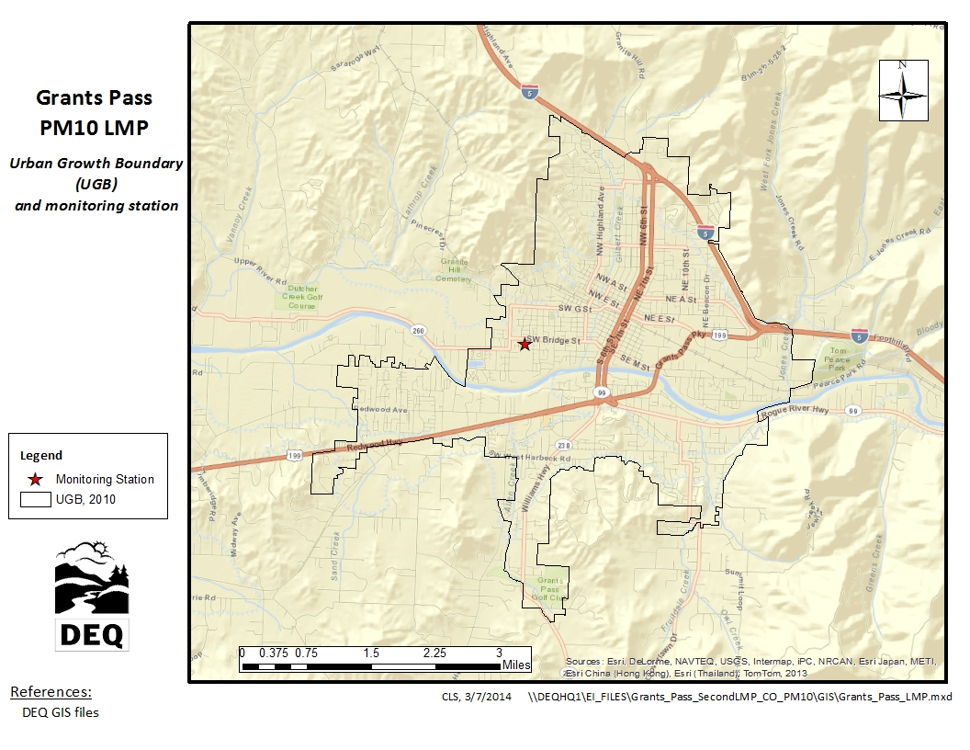

Figure 1‑1. Grants Pass UGB and Location of the Air Quality Monitoring Station

## Temporal Resolution

Historical exceedences of the 24-hr PM10 standard have occurred during the PM season, which is defined as four consecutive months, November 1st through the end of February. As such, in addition to annual emissions typical season day and worst-case season day emissions will be included in the inventory. The term “worst-case day” describes the maximum activity/emissions that have occurred or could occur on a season day, for each emissions source. Worst-case day emissions are summed for all sources/categories, i.e. assumed to occur on the same day. The assumption: A “perfect storm” of emissions that could cause an exceedence. The unit of measure for annual emissions will be tons per year (tpy), and the unit of measure for season day emissions will be pounds per day (lb/day).

# INVENTORY DEVELOPMENT

The DEQ will develop an emission inventory using EPA 2011 National Emissions Inventory (NEI) data for Josephine County. We will temporally allocate the EI data to PM season, and spatially allocate the county-wide NEI data to the Grants Pass UGB, or to buffers around the UGB or monitor, depending on emissions category. All data sources and allocation methods will be documented. The emission inventory will be consistent with the 1993 inventory.

## Data Categories

From the base year (1993) emission inventory for the maintenance plan, the most significant categories of PM10 emissions in the Grants Pass UGB are re-entrained road dust, residential wood combustion, small stationary fossil fuel combustion, and permitted point source fossil fuel combustion. Table 2.1 shows the breakdown by category for worst-case day PM10 emissions in 1993.

Table 2.1. 1993 PM10 Seasonal Worst-Case Day Emissions by Category

|  |  |  |
| --- | --- | --- |
| **Emission Inventory Category** | **Emissions per Day (lb/day)** | **Percent of Worst-Case Day Emissions** |
| Re-Entrained Road Dust | 4,512 | 42% |
| Residential Wood Combustion | 4,064 | 38% |
| Small Stationary Fossil Fuel Combustion(a) | 1,064 | 10% |
| Permitted Point Sources | 591 | 6% |
| All other sources | 470 | 4% |
|  | ------- | ------- |
| Total | 10,701 | 100% |

1. Non-permitted stationary residential, industrial, commercial, and institutional fuel use

## Emission Sectors

We propose 14 emission inventory sources be included in this LMP for the Grants Pass maintenance area. The sectors are based on a review of emission sectors listed in the 1993 maintenance plan, and an analysis of 2011 NEI data. Table 2.2 shows the breakdown by source category of average daily PM10 emissions in 1993 inventory; DEQ will use the same emission source categories as in the 1993 inventory.

Table 2.2. 1993 PM10 Seasonal Worst-Case Daily Emissions by Source Category

|  |  |  |
| --- | --- | --- |
| **Emission Source Category** | **Emissions per Day (lb/day)** | **Percent of Worst-Case Day Emissions** |
| Permitted Point Sources | 591 | 5.52% |
| Open Burning | 101 | 0.95% |
| Small Stationary Fossil Fuel Combustion(a) | 736 | 9.94% |
| Residential Wood Combustion | 4,064 | 37.98% |
| Wildfires & Prescribed Burning | 45 | 0.42% |
| Commercial Food Preparation(b) | 46 | 0.43% |
| Fugitive Dust | 58 | 0.54% |
| Structure Fires | 12 | 0.12% |
| Aircraft & Airport Related | 0(c) | 0% |
| Locomotives | 2 | 0.02% |
| Recreational Marine | 1 | 0.01% |
| Nonroad Vehicles & Equipment | 53 | 0.50% |
| Onroad Mobile: Exhaust + Brake + Tire | 148 | 1.40% |
| Re-Entrained Road Dust | 4,512 | 42.16% |
|  | ------- | -------- |
| Total | 10,701 | 100% |

1. Non-permitted stationary residential, industrial, commercial, and institutional fuel use
2. Particulate emissions from the cooking process only; fuel used by restaurants is covered under small stationary fossil fuel combustion.
3. Grants Pass Airport located outside the Grants Pass UGB, so emissions are not included. However, DEQ staff will verify that no additional airports/heliports are located within the UGB for the 2011 EI.

# SPATIAL ALLOCATION METHODS

For emissions sources with specific coordinates, emissions will be mapped to either the UGB or to a buffer zone around the monitor or other boundary, depending on emissions source category. For sources without specific coordinates, spatial surrogates will be used to approximate both the location and magnitude of emissions. Spatial surrogates are typically used to approximate emissions inside smaller boundaries from larger boundaries. For sources without specific coordinates, county-wide emissions will be spatially allocated to UGB using the formula:

*EUGB = ECOUNTY * SurrogateUGB / SurrogateCOUNTY*

Where *EUGB* = emissions in UGB,

*ECOUNTY* = county-wide emissions

*SurrogateUGB* = surrogate activity in UGB

*SurrogateCOUNTY* = surrogate activity in county

Data sources, spatial surrogates or boundaries used for each category of emissions are detailed in Table 3-1.

Table 3.1. Data Sources, Spatial Surrogates and Boundaries



# TEMPORAL ALLOCATION METHODS

Annual emissions will be adjusted from tons per year to lbs per typical season and worst-case season day for each source category. Methods for each category are described below, and all methods are consistent with the 1993 EI.

## Permitted Point

Typical day emissions estimates will be calculated from annual emissions utilizing facility operating schedules taken from source permits. Worst-case day emissions will be actual emissions calculated from permits, source annual reports, and DEQ point source emissions estimation reports.

## Aircraft and Locomotives

Aircraft and locomotive activity will be considered uniform throughout the year. Annual emissions will be divided by 365 days to estimate typical season day and worst-case day emissions.

## Nonpoint (area) and Nonroad Vehicles & Equipment

For nonpoint (area) and nonroad vehicles and equipment (excluding aircraft and locomotive), temporal allocation to season will follow the formula:

***Annual to Typical Season Day = (Annual Emissions * SAF) / (weekly activity * 52 weeks/yr)***

Where SAF = Seasonal Adjustment Factor =

= *(Season Activity * 12 months) / (Annual Activity * Season Months)*

(Reference: EPA-450/4-91-016, p. 5-22)

### Open Burning

Open burning will be temporally allocated using SAF values and activity in days per week taken from the 1993 EI. Open burning is prohibited during low-ventilation days; however a worst-case scenario will be calculated using estimates for illegal open burning activity as determined in the 1993 EI.

### Small Stationary Fossil Fuel Combustion

Annual emissions from small stationary fossil fuel combustion will be temporally allocated using SAF values and activity in days per week taken from the 1993 EI. However, the residential heating SAF will be developed from base year (2011) heating degree day (HDD) data. Worst-case day for industrial/commercial/institutional fuel use will be assumed equal to typical season day. However, worst-case day for residential heating will be allocated from typical season day using a “multiplier” (scalar) calculated from HDD data.

### Residential Wood Combustion

Residential wood combustion annual emissions will be allocated to season using SAF values calculated from 2011 heating degree day (HDD) data. A worst-case “multiplier” (scalar) based on 2011 HDD data will be used to estimate worst-case day emissions. Activity in days per week will be taken from the 1993 EI.

### Wildfires and Prescribed Burning

As wildfires and prescribed burning are date-specific events, DEQ will temporally allocate emissions from these sources using fire date data, available in the EPA National Emission Inventory (NEI). SAF values will be calculated using annual and seasonal fire dates. Worst-case day emissions will be assumed to be equal to typical season day emissions.

### Structure Fires

As structure fires are date-specific events, DEQ will temporally allocate emissions from these sources using fire date data. Fire data used by DEQ to estimate structure fire emissions for the NEI is supplied by the state fire marshal. A seasonal adjustment factor (SAF) will be estimated using annual and seasonal fire dates. Worst-case day emissions will be assumed equal to typical season day emissions.

### Commercial Food Preparation

Emissions from commercial food preparation will be temporally allocated using SAF values and weekly activity taken from the 1993 EI. The SAF and weekly activity in the 1993 EI were estimated from a Commercial Food Preparation Survey conducted in Grants Pass specifically for the emission inventory.

### Fugitive Dust

Fugitive dust emissions will be temporally allocated using SAF values and activity in days per week taken from the 1993 EI. Fugitive dust within the UGB was determined to come from road sanding and aggregate storage piles. The 1993 SAF and weekly data is based on aggregate storage pile disturbance by month, obtained from municipal records.

### Nonroad Vehicles & Equipment Excluding Aircraft and Locomotives

Sources of emissions covered by the Nonroad model include the following categories:

* Recreational marine • Railway maintenance
* Agricultural • Lawn & garden
* Construction • Industrial
* Light commercial • Logging
* Airport Ground Support Equipment (GSE)

Emissions from these categories will be temporally allocated to season using SAFs and weekly activity taken from the 1993 emission inventory.

## On-Road Mobile

Emissions from on-road mobile, including re-entrained road dust, will be temporally allocated to season using SAF data and weekly activity taken from the 1993 emission inventory.

# QUALITY ASSURANCE AND QUALITY CONTROL

DEQ will be using existing data that has already been quality checked. DEQ staff will perform quality assurance for accuracy, completeness, and representativeness on the spatial and temporal allocation of emissions from the existing inventory.

# EXTERNAL AUDITS

DEQ is willing to be audited by the EPA, and make changes to this inventory preparation and quality assurance plan if warranted.

# PERSONNEL

DEQ personnel responsible for the Grants Pass PM10 Limited Maintenance Plan inventory include:

Wendy Wiles, DEQ Environmental Solutions Division Administrator

Jeffrey Stocum, Air Quality Technical Services Section Manager

*Emission Inventory and Air Quality Information Systems*

Christopher Swab, Senior Emission Inventory Analyst

Brandy Albertson, Emission Inventory Analyst

Wesley Risher, Emission Inventory Analyst

Miyoung Park, Emission Inventory Specialist

*Quality Assurance*

Anthony Barnack, Air Monitoring Coordinator

David Collier, Air Quality Planning & Development Manager

Aida Biberic, Air Quality Planner

# SCHEDULE

Table 8.1 shows the draft schedule for document submittal to EPA Region 10 and other tasks to be completed. DEQ will submit a draft inventory to EPA upon their request, and will submit a final inventory to EPA according to this Inventory Preparation and Quality Assurance Plan.

Table 8.1. Draft Project Schedule: Grants Pass Limited Maintenance Plans for CO and PM10