Oregon Department of Environmental Quality

Air Quality Division – Technical Services Section

Inventory Preparation and

Quality Assurance Plan

for the

Grants Pass Urban Growth Boundary

Limited Carbon Monoxide Maintenance Plan

**March 2014**

Oregon Department of the Environmental Quality

Inventory Preparation Plan/Quality Assurance Plan

for the

Grants Pass Urban Growth Boundary

Limited CO Maintenance Plan

© Oregon Department of the Environmental Quality

Environmental Solutions Division, Technical Services Section

811 SW Sixth Avenue

Portland, Oregon 97204

Phone 503.229.5359 • Fax 503.229.5675

# TABLE OF CONTENTS

TABLE OF CONTENTS i

TABLE OF FIGURES ii

TABLE OF TABLES ii

1 INTRODUCTION 1

1.1 Geographic Area 1

1.2 Temporal Resolution 2

2 INVENTORY DEVELOPMENT 2

2.1 Data Categories 3

2.2 Emission Sectors 3

3 SPATIAL ALLOCATION METHODS 4

4 TEMPORAL ALLOCATION METHODS 6

4.1 Permitted Point 6

4.2 Aircraft and Locomotives 6

4.3 Nonpoint (area) and Nonroad Vehicles & Equipment 6

4.3.1 Open Burning 6

4.3.2 Small Stationary Fossil Fuel Combustion 6

4.3.3 Residential Wood Combustion 6

4.3.4 Wildfires and Prescribed Burning 6

4.3.5 Structure Fires 6

4.3.6 Nonroad Vehicles & Equipment Excluding Aircraft and Locomotives 7

4.4 On-Road Mobile: Vehicle Exhaust 7

5 QUALITY ASSURANCE AND QUALITY CONTROL 7

6 EXTERNAL AUDITS 7

7 PERSONNEL 7

8 SCHEDULE 8

# TABLE OF FIGURES

Figure 1‑1. Grants Pass UGB and CO Maintenance Area 2

# TABLE OF TABLES

Table 2.1. 1993 CO Season Day Emissions by Category 3

Table 2.2. 1993 CO Season Day Emissions by Source Category 4

Table 3.1. Data Sources, Spatial Surrogates and Boundaries 5

Table 8.1. Draft Project Schedule: Grants Pass Limited Maintenance Plans for CO 9

# INTRODUCTION

Grants Pass was designated a nonattainment area for carbon monoxide (CO) on December 15, 1985 and classified as moderate upon enactment of the Clean Air Act Amendments in 1990. The highest 8-hour carbon monoxide concentration recorded in Grants Pass occurred in 1982 at level of 14.4 ppm. In that same year, Grants Pass exceeded the federal 8-hour standard of 9 ppm on 28 days. The 1-hour standard has never been exceeded in Grants Pass. By the late 1980’s, maximum levels were closer to the standard level, and the last exceedances of the standard was in 1990.

The area was reclassified to attainment for the 8-hour CO standard in August 2000 when EPA approved the first maintenance plan designed to maintain compliance with the 8-hour CO standard through the year 2015. The second maintenance plan is due in 2015. Once approved by EPA, the second maintenance plan will fulfill the final maintenance planning requirements of the Clean Air Act. This Inventory Preparation Plan is in support of the development of the required second CO maintenance plan.

The maintenance area is the Central Business District in downtown Grants Pass (Figure 1.1). However, EPA considered the Urban Growth Boundary to be a more representative are of influence for CO emissions and the 1993 emission inventory was prepared for UGB. Similar approach is recommended for the second maintenance plan. CO monitor was located at 215 SE Sixth Street, known as the Wing Building. Measured CO levels were so low that the monitor was removed with EPA approval at the end of 2005. Because on-road mobile vehicle emissions are the primary source of CO in Grants Pass (over 70%), Oregon DEQ will track any increase in emissions as reported every three years through the Statewide Emission Inventory which is submitted to EPA for inclusion in the National Emission Inventory (NEI). Significant increase in emissions inventory that is not due to a change of emissions factor or computer models will prompt DEQ to resume monitoring for CO in Grants Pass.

The Grants Pass second maintenance plan qualifies for the Limited Maintenance Plan (LMP) approach because it satisfies all the requirements outlined in the Limited Maintenance Plant Option for Nonclassifiable CO Nonattainment Areas (Paisie memo, 1995). For the 8-hour CO, in the most recent two years of data, the maximum value of 4.0 ppm was recorded on November 3, 2004 and the second maximum value of 3.9 was recorded on March 22, 2005. The risk to the community of exceeding the CO standard is low.

Oregon DEQ proposes using existing information from the EPA 2005 National Emission Inventory (NEl) to create the emissions inventory for CO sources in Grants Pass. The exception will be on-road emission estimates, which will be obtained from Sierra Research Inc., working under contract for the Rogue Valley Council of Governments (RVCOG). This document describes the planned approach to the LMP EI and the basis for selecting that approach.

## Geographic Area

The city of Grants Pass is located in the Rogue Valley, northwest of Medford and along the Rogue River. The city is approximately 11 sq. miles in area, and the US Census 2011 population was 34,533. The elevation of the city is approximately 277 meters (801 ft). Figure 1-1 shows the geographic area of the Grants Pass UGB.

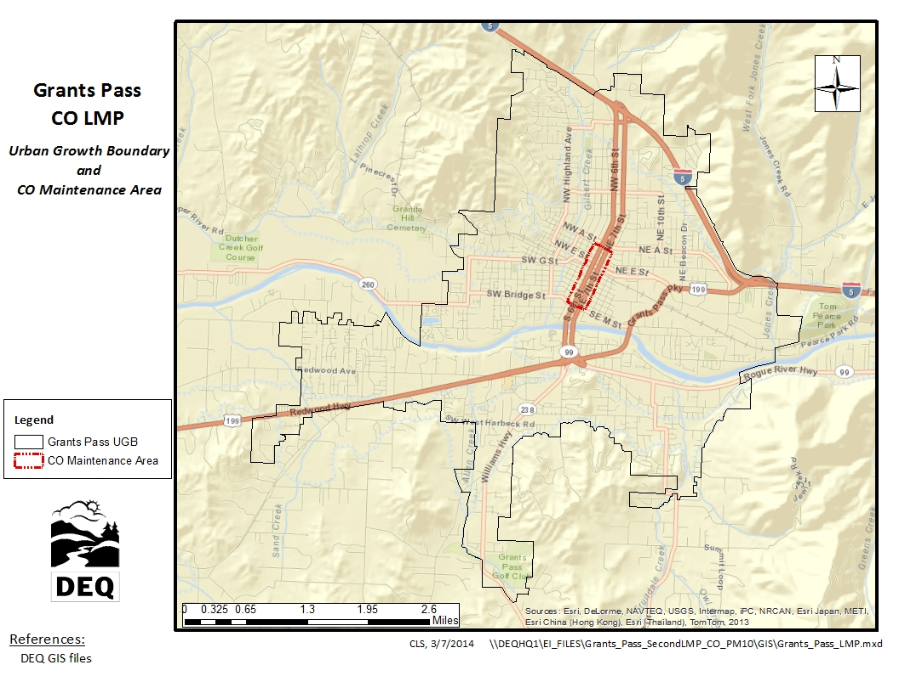

Figure 1‑1. Grants Pass UGB and CO Maintenance Area

## Temporal Resolution

The CO season is defined as three consecutive months, December 1st through the end of February. As such, season day emissions in addition to annual emissions will be included in the inventory. The unit of measure for annual emissions will be tons per year (tpy), and the unit of measure for season day emissions will be pounds per day (lb/day).

# INVENTORY DEVELOPMENT

The DEQ will develop an emission inventory using EPA 2005 National Emissions Inventory (NEI) data for Josephine County. We will temporally allocate the EI data to CO season, and spatially allocate the county-wide NEI data to the Grants Pass UGB, or to buffers around the UGB, depending on emissions category. All data sources and allocation methods will be documented. The emission inventory will be consistent with the 1993 inventory.

The exception will be on-road mobile sources; for the 2005 on-road mobile emission inventory, emissions will be estimated by Sierra Research as contracted by the Rogue Valley Council of Governments (RVCOG) and in coordination with the Oregon Department of Transportation (ODOT). Sierra Research will generate emissions estimates through activity in the form of 2005 VMT data provided by ODOT in conjunction with emission factors generated by the EPA MOVES2010b model. DEQ staff will review the MOVES model inputs for appropriateness.

## Data Categories

From the base year (1993) emission inventory for the maintenance plan, the most significant categories of CO emissions in the Grants Pass UGB are on-road mobile vehicle exhaust, residential wood combustion, permitted point sources, and nonroad vehicles and equipment. Table 2.1 shows the breakdown by category for worst-case day COemissions in 1993.

Table 2.1. 1993 CO Season Day Emissions by Category

|  |  |  |
| --- | --- | --- |
| **Emission Inventory Category** | **Emissions per Day (lb/day)** | **Percent of Daily Emissions** |
| On-Road Mobile Vehicle Exhaust | 48,104 | 76% |
| Residential Wood Combustion | 10,094 | 16% |
| Permitted Point Sources | 2,386 | 4% |
| Nonroad Vehicles & Equipment | 1,684 | 3% |
| All other sources | 1,285 | 2% |
|  | ------- | ------- |
| Total | 63,553 | 100% |

## Emission Sectors

We propose 14 emission inventory sources be included in this LMP for the Grants Pass maintenance area. The sectors are based on a review of emission sectors listed in the 1993 maintenance plan, and an analysis of 2005 NEI data. Table 2.2 shows the breakdown by source category of average daily COemissions in 1993 inventory; DEQ will use the same source categories as in the 1993 inventory.

Table 2.2. 1993 CO Season Day Emissions by Source Category

|  |  |  |
| --- | --- | --- |
| **Emission Source Category** | **Emissions per Day (lb/day)** | **Percent of Worst-Case Day Emissions** |
| Permitted Point Sources | 2,386 | 3.75% |
| Open Burning | 825 | 1.30% |
| Small Stationary Fossil Fuel Combustion(a) | 258 | 0.41% |
| Residential Wood Combustion | 10,094 | 15.88% |
| Wildfires & Prescribed Burning | 64 | 0.10% |
| Structure Fires | 138 | 0.22% |
| Aircraft & Airport Related | 0(b) | 0% |
| Locomotives | 9 | 0.01% |
| Recreational Marine | 34 | 0.05% |
| Nonroad Vehicles & Equipment | 1,641 | 2.58% |
| Onroad Mobile: Exhaust | 48,104 | 75.69% |
|  | ------- | -------- |
| Total | 63,553 | 100% |

1. Non-permitted stationary residential, industrial, commercial, and institutional fuel use
2. Grants Pass Airport located outside the Grants Pass UGB, so emissions are not included. However, DEQ staff will verify that no additional airports/heliports are located within the UGB for the 2011 EI.

# SPATIAL ALLOCATION METHODS

For emissions sources with specific coordinates, emissions will be mapped to either the UGB or other boundary, depending on emissions source category. For sources without specific coordinates, spatial surrogates will be used to approximate both the location and magnitude of emissions. Spatial surrogates are typically used to approximate emissions inside smaller boundaries from larger boundaries. For sources without specific coordinates, county-wide emissions will be spatially allocated to UGB using the formula:

*EUGB = ECOUNTY * SurrogateUGB / SurrogateCOUNTY*

Where *EUGB* = emissions in UGB,

*ECOUNTY* = county-wide emissions

*SurrogateUGB* = surrogate activity in UGB

*SurrogateCOUNTY* = surrogate activity in county

Data sources, spatial surrogates or boundaries used for each category of emissions are detailed in Table 3-1.

Table 3.1. Data Sources, Spatial Surrogates and Boundaries



# TEMPORAL ALLOCATION METHODS

Annual emissions will be adjusted from tons per year to lbs per season day for each source category. Methods for each category are described below, and all methods are consistent with the 1993 EI.

## Permitted Point

Typical day emissions estimates will be calculated from annual emissions utilizing facility operating schedules taken from source permits. Seasonal adjustment may also be estimated from source annual reports, and DEQ point source emissions estimation reports.

## Aircraft and Locomotives

Aircraft and locomotive activity will be considered uniform throughout the year. Annual emissions will be divided by 365 days to estimate season day emissions.

## Nonpoint (area) and Nonroad Vehicles & Equipment

For nonpoint (area) and nonroad vehicles and equipment (excluding aircraft and locomotive), temporal allocation to season will follow the formula:

***Annual to Typical Season Day = (Annual Emissions * SAF) / (weekly activity * 52 weeks/yr)***

Where SAF = Seasonal Adjustment Factor =

= *(Season Activity * 12 months) / (Annual Activity * Season Months)*

(Reference: EPA-450/4-91-016, p. 5-22)

### Open Burning

Open burning will be temporally allocated using SAF values and activity in days per week; using 2005 permit and complaint data, DEQ may either verify the SAF values used in the 1993 EI or develop new SAF values based on the 2005 data. Regardless, the method will be consistent with the 1993 EI.

### Small Stationary Fossil Fuel Combustion

Annual emissions from small stationary fossil fuel combustion will be temporally allocated using SAF values and activity in days per week taken from the 1993 EI. SAF values for these sources in the 1993 EI were taken directly from EPA-450/4-91-016, Table 5.8-1, p. 5-18.

### Residential Wood Combustion

Annual emissions from residential wood combustion will be temporally allocated using SAF values and activity in days per week taken from the 1993 EI. SAF values for these sources in the 1993 EI were taken directly from EPA-450/4-91-016, Table 5.8-1, p. 5-18.

### Wildfires and Prescribed Burning

As wildfires and prescribed burning are date-specific events, DEQ will temporally allocate emissions from these sources using fire date data, available from the EPA National Emission Inventory (NEI). SAF values will be calculated using annual and seasonal fire dates.

### Structure Fires

As structure fires are date-specific events, DEQ will temporally allocate emissions from these sources using fire date data. Fire data used by DEQ to estimate structure fire emissions for the NEI is supplied by the state fire marshal. A seasonal adjustment factor (SAF) will be estimated using annual and seasonal fire dates.

### Nonroad Vehicles & Equipment Excluding Aircraft and Locomotives

Sources of emissions covered by the Nonroad model include the following categories:

* Recreational marine • Railway maintenance
* Agricultural • Lawn & garden
* Construction • Industrial
* Light commercial • Logging
* Airport Ground Support Equipment (GSE)

Emissions from these categories will be temporally allocated to season using SAFs and weekly activity taken from the 1993 emission inventory.

## On-Road Mobile: Vehicle Exhaust

ODOT will develop on-road temporal allocation profiles (monthly and hourly) from available traffic count station volumes within UGB/Josephine County. The ultimate source of the profiles may be seasonal adjustment calculations performed by DEQ staff for the 1993 EI; however ODOT has the discretion of making changes or revisions to the factors.

# QUALITY ASSURANCE AND QUALITY CONTROL

DEQ will be using existing data that has already been quality checked. DEQ staff will perform quality assurance for accuracy, completeness, and representativeness on the spatial and temporal allocation of emissions from the existing inventory. DEQ staff will review MOVES (on-road EF model) inputs for appropriateness.

# EXTERNAL AUDITS

DEQ is willing to be audited by the EPA, and make changes to this inventory preparation and quality assurance plan if warranted.

# PERSONNEL

DEQ personnel responsible for the Grants Pass CO Limited Maintenance Plan inventory include:

Wendy Wiles, DEQ Environmental Solutions Division Administrator

Jeffrey Stocum, Air Quality Technical Services Section Manager

*Emission Inventory and Air Quality Information Systems*

Christopher Swab, Senior Emission Inventory Analyst

Brandy Albertson, Emission Inventory Analyst

Wesley Risher, Emission Inventory Analyst

Miyoung Park, Emission Inventory Specialist

*Quality Assurance*

Anthony Barnack, Air Monitoring Coordinator

David Collier, Air Quality Planning & Development Manager

Aida Biberic, Air Quality Planner

# SCHEDULE

Table 8.1 shows the draft schedule for document submittal to EPA Region 10 and other tasks to be completed. DEQ will submit a draft inventory to EPA upon their request, and will submit a final inventory to EPA according to this Inventory Preparation and Quality Assurance Plan.

Table 8.1. Draft Project Schedule: Grants Pass Limited Maintenance Plans for CO