Grants Pass Carbon Monoxide Limited Maintenance Plan

Submitted to: U.S. Environmental Protection Agency
DRAFT

By: State of Oregon Department of Environmental Quality

March 2015

Last Updated: 12/16/14

By: Jane Doe

DEQ 03-??-###


DEQ Environmental Solutions
Air Quality Program
811 SW 6th Avenue
Portland, OR 97204
Phone: (503) 229-5696
(800) 452-4011
Fax: (503) 229-6762
Contact: Brian Finneran
www.oregon.gov/DEQ

DEQ is a leader in restoring, maintaining and enhancing the quality of Oregon’s air, land and water.

State Implementation Plan Revision

Grants Pass Carbon Monoxide Limited Maintenance Plan

A Limited Maintenance Plan
for Carbon Monoxide
The Grants Pass Urban Growth Boundary

State of Oregon Clean Air Act Implementation Plan

Adopted by the Environmental Quality Commission on
March XX, 2015

State of Oregon
Department of Environmental Quality
811 SW Sixth Avenue
Portland, OR 97204-1390

Table of Contents

Acknowledgments i
Executive Summary ii
Plan Structure iii
1. Introduction 1
2. Geographic Area 1
3. History of CO Problem in Grants Pass 2
4. Limited Maintenance Plan Option 4
5. Emission Inventory 4
6. Continuing Control Measures 6
7. Contingency Plan 8
8. Verification of Continued Attainment 9

Table of Figures

Figure 1. Grants Pass UGB and location of the CO Monitoring Station 2
Figure 2. Grants Pass Carbon Monoxide Trend 2nd highest 8-hour average, 1980-2005 4
Figure 3. 2005 Grants Pass Annual CO Emissions 6
Figure 4. 2005 Grants Pass Season CO Emissions 6

Table of Tables

Table 1. Grants Pass Carbon Monoxide Concentrations 1980-2005 3
Table 2. 2005 Grants Pass UGB CO Annual and Seasonal Emission Inventory 5

Appendices

Appendix A: EPA 1995 Paisie Memo
Appendix B: Grants Pass 2005 Emission Inventory
Appendix C: EPA 2006 Approval Letter for removal of the CO monitor
Appendix D: Inventory Preparation and Quality Assurance Plan

Acknowledgments

Principal Author: Brian Finneran, DEQ Air Quality Planning

Principal Contributors:

Oregon Department of Environmental Quality

David Collier Air Quality Planning Manager
Aida Biberic Air Quality Planning
Anthony Barnack Air Quality Planning
Wes Risher Air Quality Technical Services
Chris Swab Air Quality Technical Services

Environmental Protection Agency

Lucy Edmondson EPA Region X

Claudia Vaupel EPA Region X

Bob Kotchenruther EPA Region X

Grants Pass

Dan Moore Rogue Valley Council of Governments
Jonathan David Rogue Valley Council of Governments

Other support:

Tom Carlson Sierra Research, Inc

Executive Summary

The City of Grants Pass and surrounding area currently meets the federal standard for Carbon Monoxide (CO). This State Implementation Plan (SIP) revision explains how this area will continue to meet this standard through 2025. EPA set the national ambient air quality standard for carbon monoxide at 35 parts per million (ppm) for a 1-hour average and 9 ppm for an 8-hour average. Like most areas of the country that failed to meet the carbon monoxide standard, Grants Pass did not meet the 8-hour portion of the standard.

Grants Pass was designated a nonattainment area for carbon monoxide on December 15, 1985 and classified as moderate upon enactment of the Clean Air Act Amendments in 1990. The downtown central business district represented the nonattainment area. The highest 8-hour CO concentration recorded in Grants Pass occurred in 1982 at level of 14.4 ppm. In that same year, Grants Pass exceeded the federal 8-hour standard of 9 ppm on 28 days. The 1-hour standard has never been exceeded in Grants Pass. By the late 1980’s, maximum levels were closer to the level of the standard, and the last exceedance was in 1990.

The area was reclassified to attainment for the 8-hour CO standard in August 2000 when EPA approved the first maintenance plan designed to maintain compliance with the 8-hour CO standard through the year 2015 (see 65 FR 52932). While the central business district represented the maintenance area, EPA considered the Urban Growth Boundary to be a more representative area of influence for carbon monoxide emissions, and the 1993 emission inventory was prepared for UGB. The carbon monoxide monitor was located at 215 SE Sixth Street, known as the Wing Building. Measured CO levels were so low that the monitor was removed (with EPA approval) in 2006. A second maintenance plan is now required, and once approved by EPA, will apply until 2025, and fulfill the final maintenance planning requirements under the Clean Air Act.

Grants Pass qualifies for a Limited Maintenance Plan (LMP), which is an option EPA provides for areas at low risk of exceeding the CO standard (see EPA 1995 Paisie Memo in Appendix A). The current 8-hour CO design value for the Grants Pass area is 4.0 ppm based on the two most recent years of data (2004-2005), which is well below the standard. According to the LMP guidance, EPA will consider the maintenance demonstration satisfied if the monitoring data show the design value is at or below 7.65 ppm, or 85 percent of the level of the 8-hour CO standard.

To qualify for the LMP approach, the control and contingency measures from the first Grants Pass CO maintenance plan must remain in place. The primary control measure has been the emission standards for new motor vehicles under the Federal Motor Vehicle Control Program. Another measure has been the New Source Review Program with Best Available Control Technology (BACT).

To quantify carbon monoxide emission sources in Grants Pass, DEQ used the EPA 2005 National Emission Inventory (NEI) for this plan. Since that the Grants Pass CO monitor was removed in 2006, to verify continued attainment with the CO standard, DEQ will track CO emissions every three years as part of the Statewide Emission Inventory, which is submitted to EPA for inclusion in the NEI. DEQ will review the NEI estimates to identify any increases, focusing on on-road mobile sources, which represent about 70% of the CO emissions in Grants Pass. Any emissions increase will be evaluated by DEQ to verify it is not due to a change in emission calculation methodology or other factors not representative of an actual emissions increase. For the purposes of triggering the Contingency Plan, an increase of 5 percent in either the total annual or season emissions, or the on-road mobile source category, will be considered as “significant” for triggering the contingency measures. These include resuming ambient CO monitoring in Grants Pass, and if needed, forming an advisory committee to develop new strategies to prevent or correct any violation of the CO standard, and replacing BACT with LAER control technology for industrial sources.

Plan Structure

This SIP revision includes the compliance history for Grants Pass and describes how the
area met and will continue to meet the standard.

This document is organized as follows:

Section 1 – Introduction. Describes the purpose of this second maintenance plan, and summary on the CO standard.

Section 2 – Geographic Area. Describes the geographic area covered by the maintenance plan,

Section 3 – History of the Carbon Monoxide Problem. Summarizes Grants Pass CO compliance history and past CO monitoring data and trends.

Section 4 – Limited Maintenance Plan Option. Describes the criteria an area must meet to qualify for this option and how Grants Pass qualifies.

Section 5 – Emission Inventory. Includes historical information on the most significant CO emission categories from the original maintenance plan and an updated inventory on these categories.

Section 6 – Continuing Control Measures. Lists the measures that were in the original CO maintenance plan, and how these measures will be continued under this LMP.

Section 7 – Contingency Plan. Describes the contingency measures that apply should a violation occur in the future.

Section 8 – Verification of Continued Attainment. Describes how compliance will be tracked and confirmed.

Appendices – Supporting documentation for this LMP.

1. Introduction

This State Implementation Plan revision explains how the Grants Pass carbon monoxide (CO) maintenance area, as defined in OAR 340-204-0010 (the Grants Pass UGB) will continue to meet the National Ambient Air Quality Standard (NAAQS) for CO through 2025. This plan represents a “limited” maintenance plan, developed in accordance with the federal Clean Air Act and the policies of the U.S. Environmental Protection Agency (EPA) (see Appendix A 1995 Paisie Memo).

The Clean Air Act requires EPA to set air quality standards to protect public health for six common air pollutants, including carbon monoxide. In 1971 EPA set the national ambient air quality standard for carbon monoxide. Carbon monoxide is a colorless, odorless gas that decreases the oxygen carrying capacity of the blood. High concentrations can severely impair the function of oxygen-dependent tissues, including the brain, heart, and muscle. Prolonged exposure to even low levels can aggravate existing conditions in people with heart disease or circulatory disorders. Motor vehicles are the primary source of CO in Oregon.

EPA established the national ambient air quality standard for CO at 35 parts per million (ppm) for a 1-hour average and 9 ppm for an 8-hour average. Two exceedances within one calendar year constitute a violation. Like most areas of the country that failed to meet the CO standard, Grants Pass did not meet the 8-hour portion of the standard.

2. Geographic Area

The City of Grants Pass is located in southwestern Oregon, on the western side of the Cascade Mountains, in the Rogue Valley, northwest of Medford and along the Rogue River. The city is approximately 11 sq. miles in area, and the US Census 2013 population was 35,076. The surrounding hills can trap air pollution under stable meteorological conditions (inversions). These conditions exist most frequently during the winter and are associated with the majority of carbon monoxide violations.

Figure 1 shows the Grants Pass central business district, which is the maintenance area, and the Grants Pass UGB, which is the geographic area subject to this limited maintenance plan. Inside the central business district is the location of the monitoring station, at 215 SE Sixth Street. This district is defined by “B street” to the north, 8th street to the east, “M” street to the south, and 5th street to the west.

Figure 1. Grants Pass UGB and location of the CO Monitoring Station
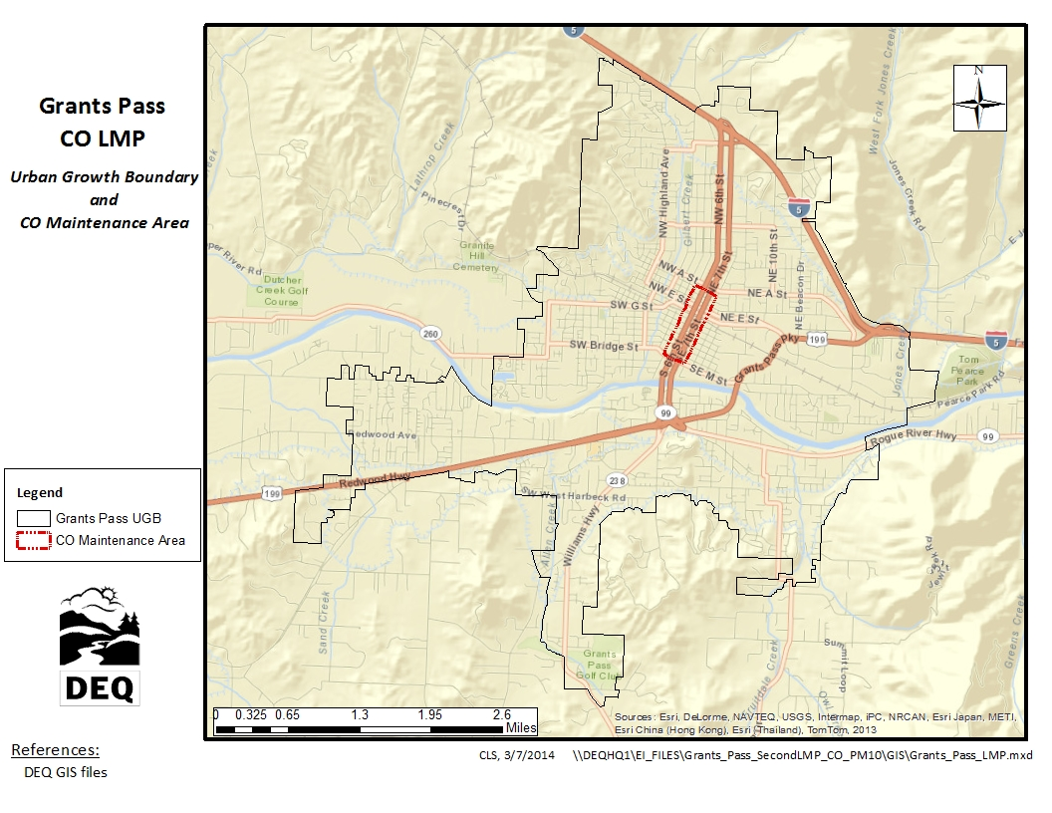

3. History of CO Problem in Grants Pass

DEQ began monitoring carbon monoxide in Grants Pass in 1980. The monitor was located at 215 SE 6th Street, known as the Wing Building, and has remained at that location until it was removed in 2006. A saturation survey conducted during the winter of 1993-1994 confirmed this location to be the best location for monitoring “worst case” CO concentrations.
A violation of the carbon monoxide standard occurs when there are two exceedances within one calendar year. The highest 8-hour CO concentration recorded in Grants Pass occurred in 1982 at level of 14.4 ppm. In that same year, Grants Pass exceeded the federal 8-hour standard of 9 ppm on 28 days. The 1-hour standard has never been exceeded in Grants Pass.

In 1985, the Grants Pass Central Business District was designated by EPA as a nonattainment area for carbon monoxide. By the late 1980’s, maximum levels were closer to the standard level, and the last exceedance was in 1990.

DEQ submitted a CO maintenance plan in November 1999, which EPA approved on August 2000 (65 FR 52932), and resulted in Grants Pass being reclassified to attainment with the carbon monoxide standard. The maintenance plan was to maintain compliance with the 8-hour carbon monoxide standard through the year 2015. While the central business district represented the maintenance area, EPA considered the Urban Growth Boundary to be a more representative of the area of influence for carbon monoxide emissions, and the 1993 emission inventory was prepared for UGB.
The trend in carbon monoxide levels, as recorded at the Wing Building monitor in downtown Grants Pass, is shown below in Table 1 and Figure 2. Since a violation is triggered by two exceedances in a calendar year, Figure 2 shows only the second highest concentration trend. Measured CO levels were so low that the monitor was removed with EPA approval in 2006 (the last full year of data is 2005).

Table 1. Grants Pass Carbon Monoxide Concentrations 1980-2005

 | 8-hour CO Averages
Year | Maximum | 2nd Highest
1980 | 13.3 | 12.7
1981 | 11.6 | 11.5
1982 | 14.4 | 13
1983 | 12.3 | 11.3
1984 | 12.9 | 11.2
1995 | 11.7 | 11.4
1996 | 10.4 | 10.2
1987 | 10.1 | 9.7
1988 | 10.8 | 10.4
1989 | 9.6 | 9.2
1990 | 9.9 | 8.5
1991 | 9.2 | 9.1
1992 | 8.3 | 7.4
1993 | 7.7 | 7.1
1994 | 6.6 | 6
1995 | 7.2 | 6.3
1996 | 6.4 | 6
1997 | 5.3 | 5
1998 | 4.7 | 4.7
1999 | 5 | 4.6
2000 | 4.5 | 4.3
2001 | 5.5 | 4.7
2002 | 4.6 | 4.5
2003 | 3.9 | 3.9
2004 | 4 | 3.5
2005 | 3.9 | 3.6

Figure 2. Grants Pass Carbon Monoxide Trend 2nd highest 8-hour average, 1980-2005

4. Limited Maintenance Plan Option

EPA developed the Limited Maintenance Plan (LMP) option for areas with little risk of re-violating the carbon monoxide standard (see 1995 Paisie Memo, Appendix A). EPA allows states to use this policy to prepare the required second 10-year maintenance plans, if the monitoring data show the design value is at or below 85 percent of the 8-hour CO standard, or 7.65 ppm. Determining the design value in this case is based on the higher of the two annual second highs in a two year calendar period. The Grants Pass 8-hour design value is 4.0 ppm, based on the two most recent years of data (2004-2005). This is well below both the 8-hour standard and the 85 percent level, so the area is eligible for the LMP option.

The LMP approach does not require future year emission projections or a maintenance demonstration. A LMP must include an attainment inventory, provisions for verification of continued attainment, a contingency plan and a statement regarding conformity determinations. Due to the low measured CO values in Grants Pass over the past 20 years, DEQ does not anticipate that CO levels will approach levels that would violate or exceed the 8-hour CO standard, and as noted above, has never exceeded the 1-hour CO standard.

5. Emission Inventory

This section presents the emissions inventory for the second 10-year maintenance plan and briefly describes its development. The LMP Guidance requires that the maintenance plan include an inventory with emission levels consistent with attainment of the CO standard. An inventory preparation and quality assurance plan (IPP) for the Grants Pass UGB was submitted to EPA in March 2014, and is provided in Appendix D. EPA reviewed the plan and agreed that the inventory be developed using EPA’s 2005 National Emission Inventory (NEI) data for Josephine County. In accordance with requirements for the LMP option, no emission projections were calculated.

Historically, exceedences of the CO 8-hour standard in Grants Pass have occurred during the winter months, when cooler temperatures contribute to incomplete combustion, and when CO emissions are trapped near the ground by atmospheric inversions. As noted in Section 3, the UGB was used for the initial 1993 emission inventory since it was more representative of the area of influence for carbon monoxide emissions, and used again for the 2005 emission inventory in this LMP. Sources of carbon monoxide in Grants Pass include industry, motor vehicles, non-road mobile sources, (e.g., construction equipment, recreational vehicles, lawn and garden equipment, and area sources (e.g., outdoor burning, woodstoves, fireplaces, and wildfires). The CO season is defined as three consecutive months - December 1 through the end of February. As such, season day emissions in addition to annual emissions are included in the inventory. The unit of measure for annual emissions is in tons per year (tpy), while the unit of measure for season emissions is in pounds per day (lb/day). In addition, the county-wide EI data is spatially allocated to the Grants Pass UGB, and to buffers around the UGB, depending on emissions category.

The 2005 carbon monoxide emission inventory for Grants Pass is summarized in Table 2 and Figures 3 and 4 below. The largest category of CO emissions is onroad mobile sources (primarily passenger cars and trucks). Considerably less are area sources (mostly residential wood combustion) and non-road engine sources (highest of these being commercial, industrial, and construction equipment, and lawn and garden equipment). The most significant difference between annual and seasonal emissions is that area sources during the winter season are higher (due to increased residential woodstove use), yet still much less than onroad mobile sources. While vehicle emission rates have declined steadily over preceding decades, the fact that cars and trucks tend to be operated close together and can create areas of traffic congestion, makes this source category the most likely to produce the highest CO concentrations.

A detailed breakdown of the 2005 CO emission inventory is provided in Appendix B.

Table 2. 2005 Grants Pass UGB CO Annual and Seasonal Emission Inventory

Source Category | CO Emissions
Source Category | Annual Tons / Year | Annual percent | Season Lbs / Day | Season percent
Stationary Point Sources | 207 | 1% | 1,202 | 1%
Stationary Area Sources | 2,461.3 | 16% | 22,244 | 25%
Non-Road Engine Sources | 1,718.2 | 11% | 6,289 | 7%
On-Road Mobile Sources | 10,603.3 | 71% | 58,120 | 66%
Total | 14,989.7 | 100% | 4,826 | 100%

Figure 3. 2005 Grants Pass Annual CO Emissions

Figure 4. 2005 Grants Pass Season CO Emissions

6. Continuing Control Measures

To qualify for the LMP option, the control measures from the first CO maintenance plan must remain in place and unchanged. The primary control measure has been the emission standards for new motor vehicles under the Federal Motor Vehicle Control Program. Other control measures have been the New Source Review Program, and several residential woodsmoke emission reduction efforts.

Federal Motor Vehicle Emission Control Program

This limited maintenance plan continues to rely on federal emission standards for new motor vehicles. These requirements include the federal Tier II emission standards for new light and medium duty cars and trucks as well as standards for heavy duty on-road and non-road vehicles.

As noted in Table 2 above, on-road mobile sources are responsible for the highest CO concentrations in Grants Pass. That is because cars and trucks moving through an area can assemble in significant numbers at areas of heavy traffic. High CO concentrations typically occur over a small area close to a congested intersection; CO dissipates quickly over distance from a source.

Emission reductions mandated by the Federal Motor Vehicle Emission Control Program have been primarily responsible for the large decrease in ambient CO concentrations in the past. Before CO emissions were regulated, a typical car of the 1950s emitted approximately 87 grams of CO per mile. Since then, federal rules have lowered CO emissions to the point where today’s federal Tier II requirements limit cars to no more than 3.4 grams CO per mile - a 95% reduction of CO. This program will continue to be an effective control for on-road mobile source emissions in the future.

Major New Source Review

Under this limited maintenance plan, the emission control requirement for new or expanding major industry in Grants Pass area will continue to require Best Available Control Technology (BACT). BACT technology provides a high level of control while allowing some flexibility and consideration of the cost effectiveness of different control options.

It should be noted that very few new or expanding industrial sources are expected in the Grants Pass area, and as shown in Table 2, stationary point sources are only about 1 percent of the CO emissions.

Woodsmoke Curtailment

As noted in the previous section, residential wood combustion emissions make up most of the stationary area source emissions, and as shown in Table 2, represent 16 percent of the total annual and 25 percent of season CO emissions in Grants Pass. The woodsmoke emission control efforts have significantly reduced particulate emissions through emission certification standards for new stoves, change-out programs to encourage removal of non-certified stoves, and a local voluntary curtailment program to reduce wood burning during stagnant weather periods. These efforts will be continued under this limited maintenance plan, and are expected to provide modest reductions in CO emissions in Grants Pass.

Conformity requirements

Federal transportation conformity rules (40 CFR parts 51 and 93) and general conformity rules (58 FR 63214) continue to apply under a limited maintenance plan. However, as noted in the Paisie Memo, these requirements are greatly simplified. An area under a LMP can demonstrate conformity without submitting an emissions budget, and as a result emissions do not need be capped nor a regional emissions analysis (including modeling) conducted.

7. Contingency Plan

Section 175(A) of the Clean Air Act requires a maintenance plan include contingency measures necessary to ensure prompt correction of any violation of the standard that may occur. The first Grants Pass maintenance plan contained contingency measures that would be implemented based on monitoring data – if CO concentrations exceeded 90 percent of the 8-hour standard (8.1 ppm) or if a violation of the standard were to occur. Since the Grants Pass CO monitor was removed in 2006, these contingency measures are no longer are applicable, other contingency measures are needed, which reflect an area like Grants Pass that is eligible for the LMP option and at low risk of re-violating the CO standard.

Contingency measures typically have several steps for action depending on the severity of air quality conditions. The following apply to this limited maintenance plan:

1. If DEQ’s three-year periodic review of CO emissions shows a significant increase in emissions, as described in Section 8 of this plan, DEQ will then reestablish ambient CO monitoring in Grants Pass.

2. If the highest measured 8-hour CO concentration in a given year in Grants Pass exceeds the LMP eligibility level of 7.65 ppm (85 percent of the 8-hr standard), DEQ will evaluate the cause of the CO increase, and consider forming an advisory committee to recommend strategies. Within 6 months of the validated 7.65 ppm CO concentration, DEQ will determine a schedule of selected strategies to either prevent or correct any violation of the 8-hour CO standard. This will allow as choice to be made before or after an actual violation has occurred.

The contingency strategies that will be considered include, but are not limited to:

- Improvements to parking and traffic circulation
- Aggressive signal retiming program
- Funding for transit
- Implementation of bicycle and pedestrian networks

DEQ (and the advisory group if needed) may also choose to conduct further evaluation, to determine if other strategies are necessary, or to take no further action if the problem was caused by an exceptional event.

3. If a violation of the CO standard occurs, and is validated by DEQ, in addition to step 2 above, DEQ will replace the BACT requirement for new and expanding industries listed in Section 6, with the Lowest Achievable Emission Rate (LAER) technology, and reinstate the requirement to offset any new CO emissions. Additional CO emission reduction measures will be considered as may be identified in the evaluation in step 2. Committing to further study in this way gives DEQ flexibility in choosing an appropriate approach should the need arise.

8. Verification of Continued Attainment

As described in this plan, CO levels in the Grants Pass UGB have steadily declined over the last 15 years, and are not expected to increase or threaten compliance with the CO standard. Given that the Grants Pass CO monitor was removed in 2006, another method of verifying continued attainment with the CO standard is needed.

DEQ will calculate CO emissions every three years as part of the Statewide Emission Inventory, which is submitted to EPA for inclusion in the NEI. DEQ will review the NEI estimates to identify any increases over the 2005 emission levels and source categories shown in Table 2 of this plan, and report on them in the annual network plan for the applicable year. Since on-road motor vehicles are the predominant source of carbon monoxide in Grants Pass (about 70%), this source category will be the primary focus of this review. Any increase in CO emissions will be evaluated by DEQ to verify it is not due to a change in emission calculation methodology, an exceptional event, or other factor not representative of an actual emissions increase. Recognizing there could be a minor, insignificant emissions increase, for the purposes of triggering the Contingency Plan described in Section 7, DEQ will consider an increase of 5 percent in either the total annual or season emissions, or in the on-road mobile source category, as representing a “significant” emission increase.
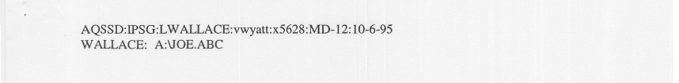

Appendix A

EPA 1995 Paisie Memo
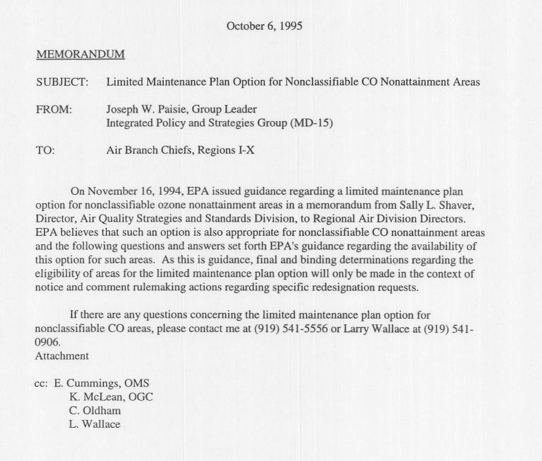

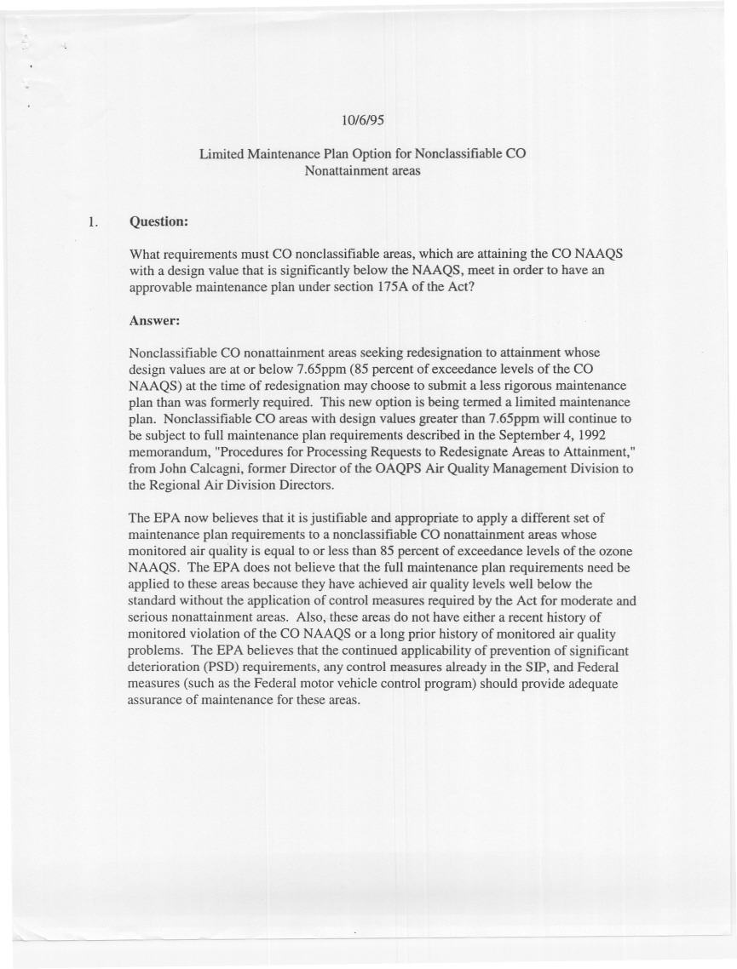

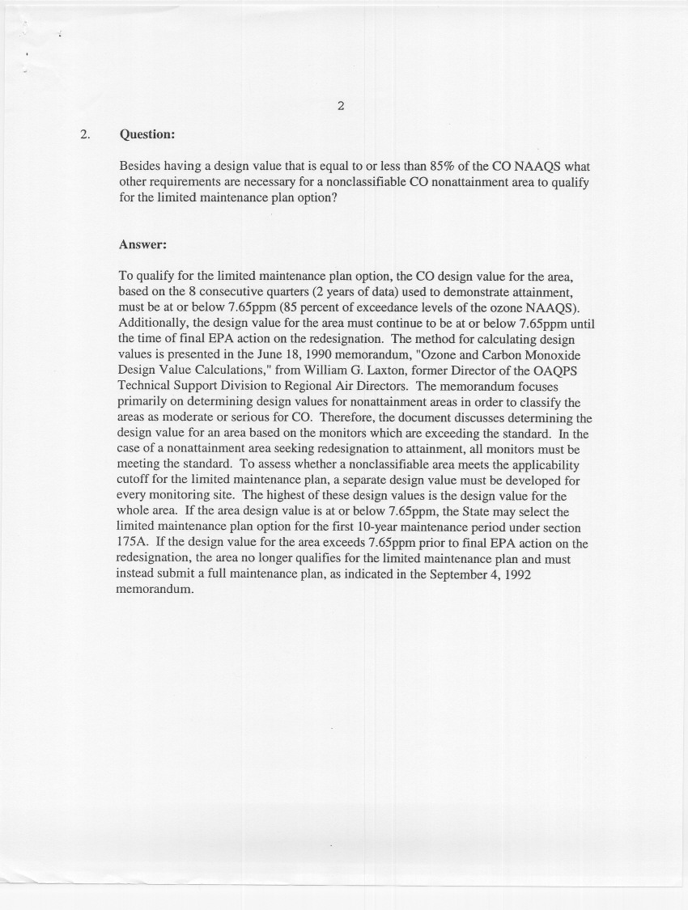
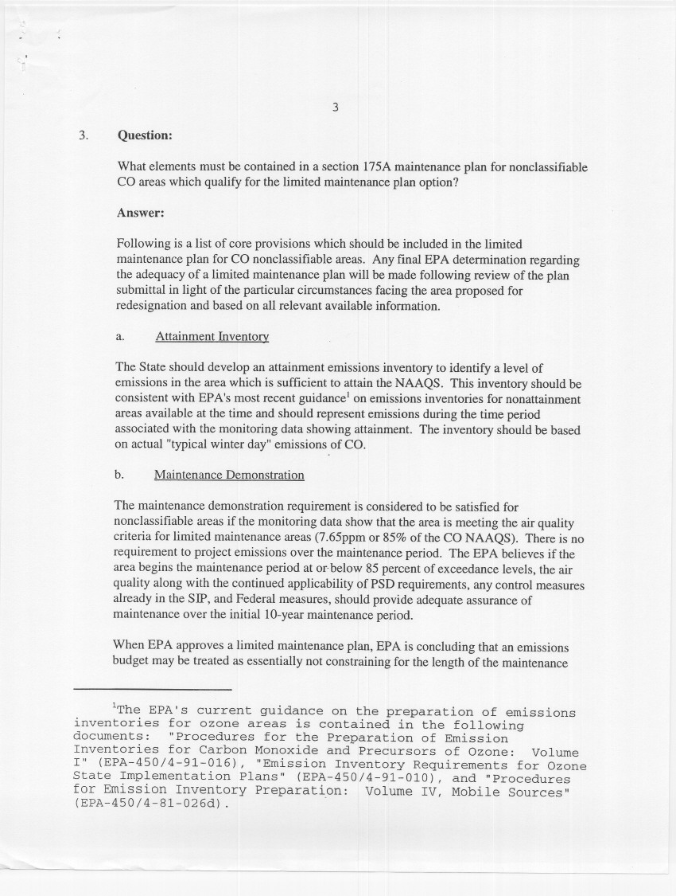

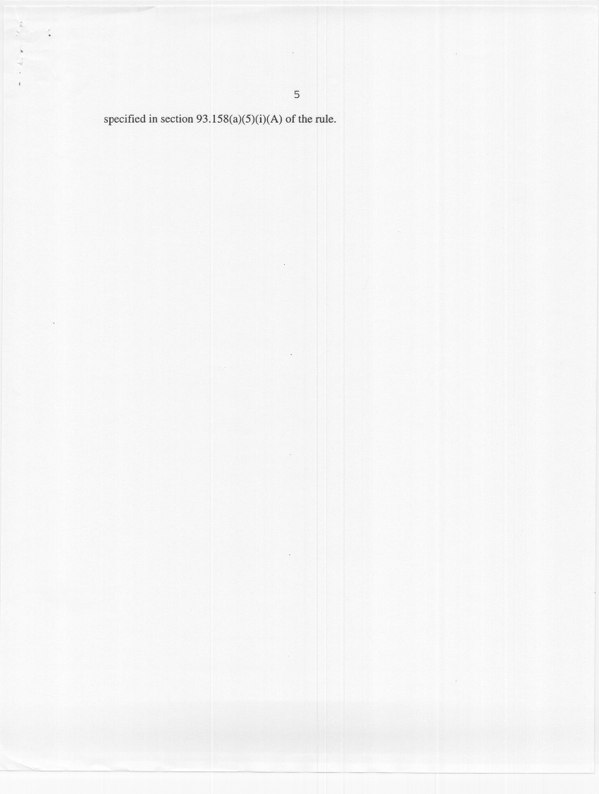
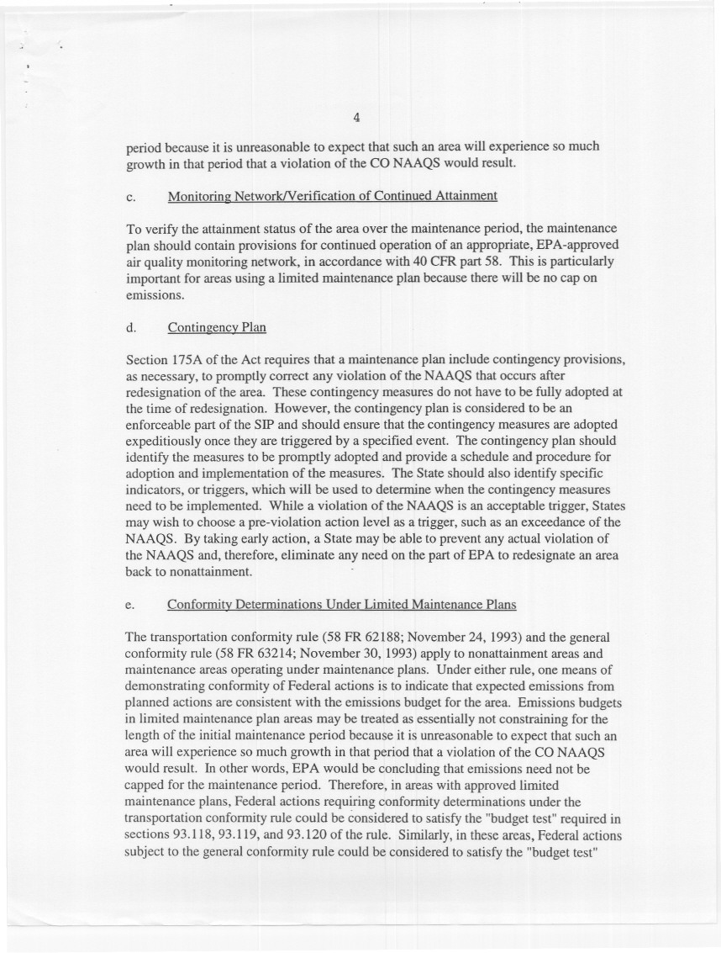

Appendix B

Grants Pass 2005 Carbon Monoxide Emission Inventory

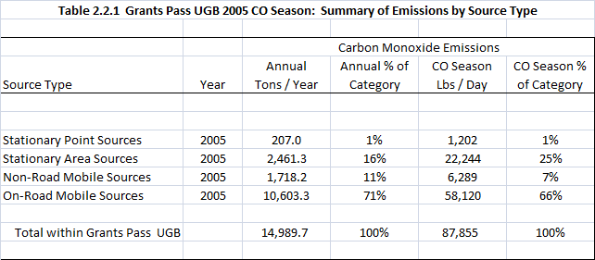
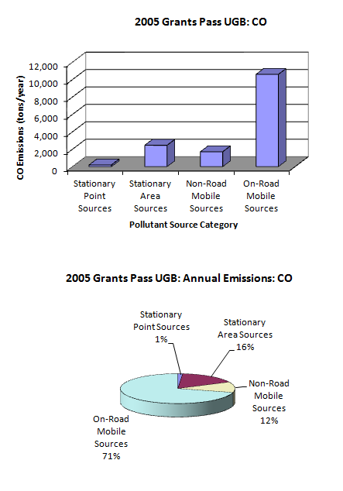
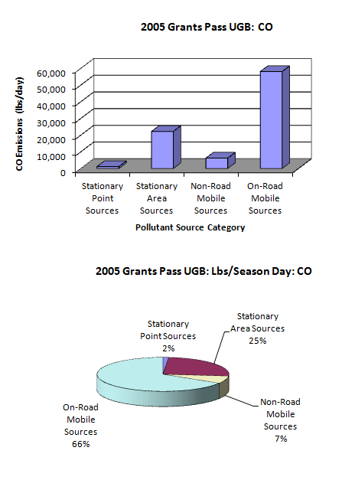
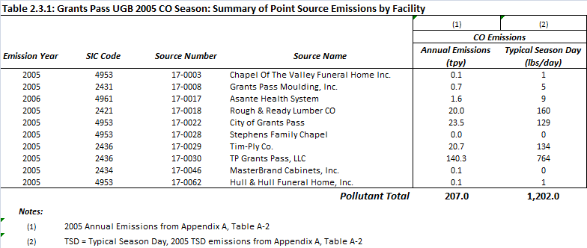
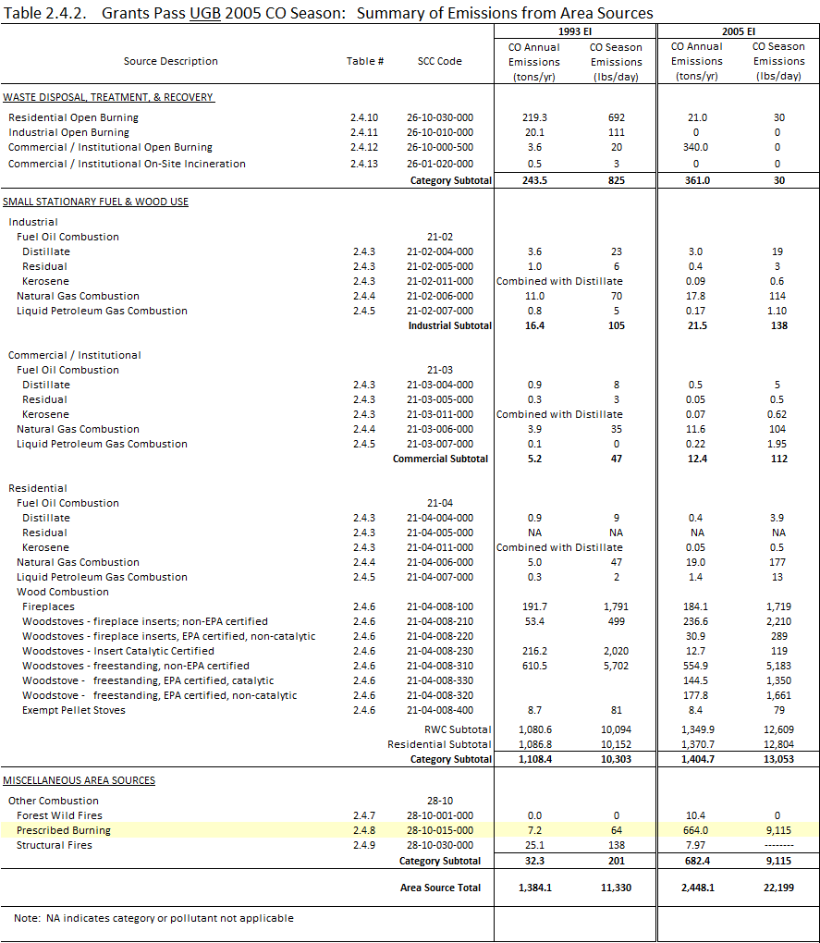

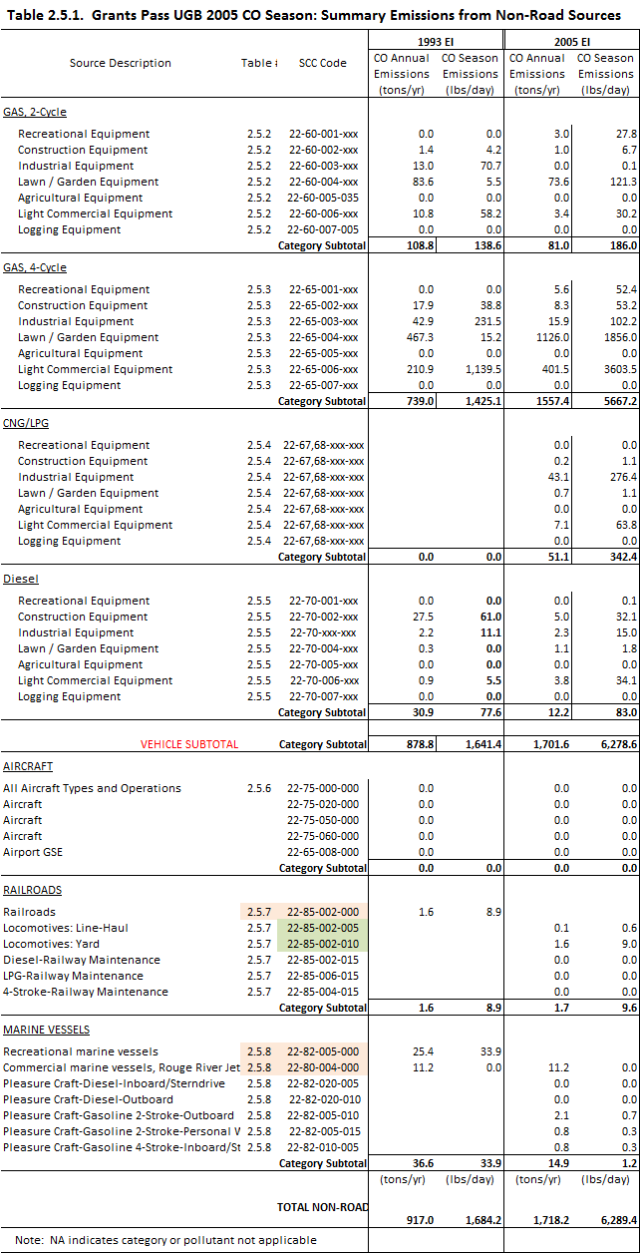

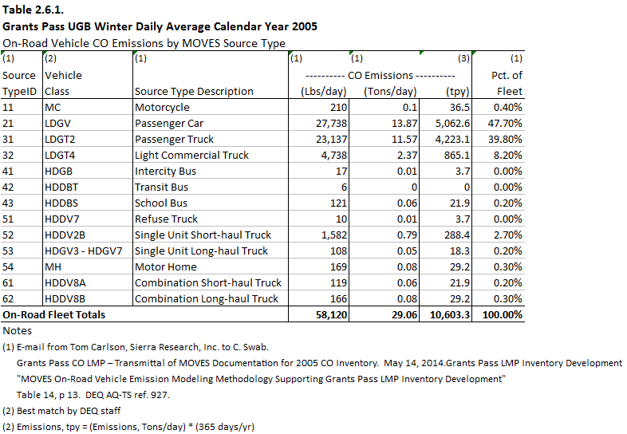

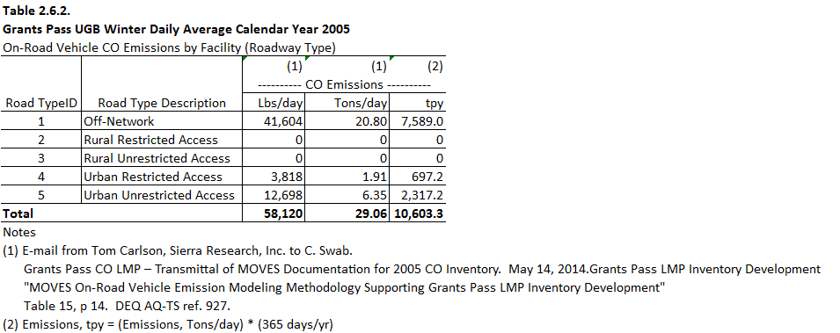

Appendix C

EPA October 16, 2006 Approval Letter for removing the carbon monoxide FRM monitor Grants Pass

Appendix D

Inventory Preparation and Quality Assurance Plan

for the

Grants Pass Urban Growth Boundary Limited CO Maintenance Plan
Oregon Department of Environmental Quality

Air Quality Division – Technical Services Section

Inventory Preparation and
Quality Assurance Plan
for the
Grants Pass Urban Growth Boundary
Limited Carbon Monoxide Maintenance Plan

March 2014

TABLE OF CONTENTS
TABLE OF CONTENTS Error! Bookmark not defined.
TABLE OF FIGURES 3
TABLE OF TABLES 3
1 INTRODUCTION 4
1.1 Geographic Area 4
1.2 Temporal Resolution 5
2 INVENTORY DEVELOPMENT 5
2.1 Data Categories 6
2.2 Emission Sectors 6
3 SPATIAL ALLOCATION METHODS 7
4 TEMPORAL ALLOCATION METHODS 9
4.1 Permitted Point 9
4.2 Aircraft and Locomotives 9
4.3 Nonpoint (area) and Nonroad Vehicles & Equipment 9
4.3.1 Open Burning 9
4.3.2 Small Stationary Fossil Fuel Combustion 9
4.3.3 Residential Wood Combustion 9
4.3.4 Wildfires and Prescribed Burning 9
4.3.5 Structure Fires 9
4.3.6 Nonroad Vehicles & Equipment Excluding Aircraft and Locomotives 10
4.4 On-Road Mobile: Vehicle Exhaust 10
5 QUALITY ASSURANCE AND QUALITY CONTROL 10
6 EXTERNAL AUDITS 10
7 PERSONNEL 10
8 SCHEDULE 11

TABLE OF FIGURES
Figure 1-1. Grants Pass UGB and CO Maintenance Area 5

TABLE OF TABLES
Table 2.1. 1993 CO Season Day Emissions by Category 6
Table 2.2. 1993 CO Season Day Emissions by Source Category 7
Table 3.1. Data Sources, Spatial Surrogates and Boundaries 8
Table 8.1. Draft Project Schedule: Grants Pass Limited Maintenance Plans for CO 12

- INTRODUCTION
Grants Pass was designated a nonattainment area for carbon monoxide (CO) on December 15, 1985 and classified as moderate upon enactment of the Clean Air Act Amendments in 1990. The highest 8-hour carbon monoxide concentration recorded in Grants Pass occurred in 1982 at level of 14.4 ppm. In that same year, Grants Pass exceeded the federal 8-hour standard of 9 ppm on 28 days. The 1-hour standard has never been exceeded in Grants Pass. By the late 1980’s, maximum levels were closer to the standard level, and the last exceedances of the standard was in 1990.

The area was reclassified to attainment for the 8-hour CO standard in August 2000 when EPA approved the first maintenance plan designed to maintain compliance with the 8-hour CO standard through the year 2015. The second maintenance plan is due in 2015. Once approved by EPA, the second maintenance plan will fulfill the final maintenance planning requirements of the Clean Air Act. This Inventory Preparation Plan is in support of the development of the required second CO maintenance plan.

The maintenance area is the Central Business District in downtown Grants Pass (Figure 1.1). However, EPA considered the Urban Growth Boundary to be a more representative are of influence for CO emissions and the 1993 emission inventory was prepared for UGB. Similar approach is recommended for the second maintenance plan. CO monitor was located at 215 SE Sixth Street, known as the Wing Building. Measured CO levels were so low that the monitor was removed with EPA approval at the end of 2005. Because on-road mobile vehicle emissions are the primary source of CO in Grants Pass (over 70%), Oregon DEQ will track any increase in emissions as reported every three years through the Statewide Emission Inventory which is submitted to EPA for inclusion in the National Emission Inventory (NEI). Significant increase in emissions inventory that is not due to a change of emissions factor or computer models will prompt DEQ to resume monitoring for CO in Grants Pass.

The Grants Pass second maintenance plan qualifies for the Limited Maintenance Plan (LMP) approach because it satisfies all the requirements outlined in the Limited Maintenance Plant Option for Nonclassifiable CO Nonattainment Areas (Paisie memo, 1995). For the 8-hour CO, in the most recent two years of data, the maximum value of 4.0 ppm was recorded on November 3, 2004 and the second maximum value of 3.9 was recorded on March 22, 2005. The risk to the community of exceeding the CO standard is low.

Oregon DEQ proposes using existing information from the EPA 2005 National Emission Inventory (NEl) to create the emissions inventory for CO sources in Grants Pass. The exception will be on-road emission estimates, which will be obtained from Sierra Research Inc., working under contract for the Rogue Valley Council of Governments (RVCOG). This document describes the planned approach to the LMP EI and the basis for selecting that approach.
  - Geographic Area
The city of Grants Pass is located in the Rogue Valley, northwest of Medford and along the Rogue River. The city is approximately 11 sq. miles in area, and the US Census 2011 population was 34,533. The elevation of the city is approximately 277 meters (801 ft). Figure 1-1 shows the geographic area of the Grants Pass UGB.
Figure 0-1. Grants Pass UGB and CO Maintenance Area

1.2 Temporal Resolution
The CO season is defined as three consecutive months, December 1st through the end of February. As such, season day emissions in addition to annual emissions will be included in the inventory. The unit of measure for annual emissions will be tons per year (tpy), and the unit of measure for season day emissions will be pounds per day (lb/day).
- INVENTORY DEVELOPMENT
The DEQ will develop an emission inventory using EPA 2005 National Emissions Inventory (NEI) data for Josephine County. We will temporally allocate the EI data to CO season, and spatially allocate the county-wide NEI data to the Grants Pass UGB, or to buffers around the UGB, depending on emissions category. All data sources and allocation methods will be documented. The emission inventory will be consistent with the 1993 inventory.

The exception will be on-road mobile sources; for the 2005 on-road mobile emission inventory, emissions will be estimated by Sierra Research as contracted by the Rogue Valley Council of Governments (RVCOG) and in coordination with the Oregon Department of Transportation (ODOT). Sierra Research will generate emissions estimates through activity in the form of 2005 VMT data provided by ODOT in conjunction with emission factors generated by the EPA MOVES2010b model. DEQ staff will review the MOVES model inputs for appropriateness.

2.1 Data Categories
From the base year (1993) emission inventory for the maintenance plan, the most significant categories of CO emissions in the Grants Pass UGB are on-road mobile vehicle exhaust, residential wood combustion, permitted point sources, and nonroad vehicles and equipment. Table 2.1 shows the breakdown by category for worst-case day CO emissions in 1993.

Table 0.1. 1993 CO Season Day Emissions by Category
Emission Inventory Category | Emissions per Day (lb/day) | Percent of Daily Emissions
On-Road Mobile Vehicle Exhaust | 48,104 | 76%
Residential Wood Combustion | 10,094 | 16%
Permitted Point Sources | 2,386 | 4%
Nonroad Vehicles & Equipment | 1,684 | 3%
All other sources | 1,285 | 2%
 | ------- | -------
Total | 63,553 | 100%

2.2 Emission Sectors

We propose 14 emission inventory sources be included in this LMP for the Grants Pass maintenance area. The sectors are based on a review of emission sectors listed in the 1993 maintenance plan, and an analysis of 2005 NEI data. Table 2.2 shows the breakdown by source category of average daily CO emissions in 1993 inventory; DEQ will use the same source categories as in the 1993 inventory.

Table 0.2. 1993 CO Season Day Emissions by Source Category

Emission Source Category | Emissions per Day (lb/day) | Percent of Worst-Case Day Emissions
Permitted Point Sources | 2,386 | 3.75%
Open Burning | 825 | 1.30%
Small Stationary Fossil Fuel Combustion^{(a)} | 258 | 0.41%
Residential Wood Combustion | 10,094 | 15.88%
Wildfires & Prescribed Burning | 64 | 0.10%
Structure Fires | 138 | 0.22%
Aircraft & Airport Related | 0^{(b)} | 0%
Locomotives | 9 | 0.01%
Recreational Marine | 34 | 0.05%
Nonroad Vehicles & Equipment | 1,641 | 2.58%
Onroad Mobile: Exhaust | 48,104 | 75.69%
 | ------- | --------
Total | 63,553 | 100%
- Non-permitted stationary residential, industrial, commercial, and institutional fuel use
- Grants Pass Airport located outside the Grants Pass UGB, so emissions are not included. However, DEQ staff will verify that no additional airports/heliports are located within the UGB for the 2011 EI.

3. SPATIAL ALLOCATION METHODS
For emissions sources with specific coordinates, emissions will be mapped to either the UGB or other boundary, depending on emissions source category. For sources without specific coordinates, spatial surrogates will be used to approximate both the location and magnitude of emissions. Spatial surrogates are typically used to approximate emissions inside smaller boundaries from larger boundaries. For sources without specific coordinates, county-wide emissions will be spatially allocated to UGB using the formula:

E_{UGB} = E_{COUNTY} * Surrogate_{UGB} / Surrogate_{COUNTY}

Where E_{UGB} = emissions in UGB,
E_{COUNTY} = county-wide emissions
Surrogate_{UGB} = surrogate activity in UGB
Surrogate_{COUNTY} = surrogate activity in county

Data sources, spatial surrogates or boundaries used for each category of emissions are detailed in Table 3-1.

Table 0.3. Data Sources, Spatial Surrogates and Boundaries

4. TEMPORAL ALLOCATION METHODS
Annual emissions will be adjusted from tons per year to lbs per season day for each source category. Methods for each category are described below, and all methods are consistent with the 1993 EI.

4.1 Permitted Point
Typical day emissions estimates will be calculated from annual emissions utilizing facility operating schedules taken from source permits. Seasonal adjustment may also be estimated from source annual reports, and DEQ point source emissions estimation reports.

4.2 Aircraft and Locomotives
Aircraft and locomotive activity will be considered uniform throughout the year. Annual emissions will be divided by 365 days to estimate season day emissions.

4.3 Nonpoint (area) and Nonroad Vehicles & Equipment
For nonpoint (area) and nonroad vehicles and equipment (excluding aircraft and locomotive), temporal allocation to season will follow the formula:

Annual to Typical Season Day = (Annual Emissions * SAF) / (weekly activity * 52 weeks/yr)
Where SAF = Seasonal Adjustment Factor =
= (Season Activity * 12 months) / (Annual Activity * Season Months)
(Reference: EPA-450/4-91-016, p. 5-22)

4.3.1 Open Burning
Open burning will be temporally allocated using SAF values and activity in days per week; using 2005 permit and complaint data, DEQ may either verify the SAF values used in the 1993 EI or develop new SAF values based on the 2005 data. Regardless, the method will be consistent with the 1993 EI.

4.3.2 Small Stationary Fossil Fuel Combustion
Annual emissions from small stationary fossil fuel combustion will be temporally allocated using SAF values and activity in days per week taken from the 1993 EI. SAF values for these sources in the 1993 EI were taken directly from EPA-450/4-91-016, Table 5.8-1, p. 5-18.

4.3.3 Residential Wood Combustion
Annual emissions from residential wood combustion will be temporally allocated using SAF values and activity in days per week taken from the 1993 EI. SAF values for these sources in the 1993 EI were taken directly from EPA-450/4-91-016, Table 5.8-1, p. 5-18.

4.3.4 Wildfires and Prescribed Burning
As wildfires and prescribed burning are date-specific events, DEQ will temporally allocate emissions from these sources using fire date data, available from the EPA National Emission Inventory (NEI). SAF values will be calculated using annual and seasonal fire dates.

4.3.5 Structure Fires
As structure fires are date-specific events, DEQ will temporally allocate emissions from these sources using fire date data. Fire data used by DEQ to estimate structure fire emissions for the NEI is supplied by the state fire marshal. A seasonal adjustment factor (SAF) will be estimated using annual and seasonal fire dates.

4.3.6 Nonroad Vehicles & Equipment Excluding Aircraft and Locomotives
Sources of emissions covered by the Nonroad model include the following categories:
- Recreational marine • Railway maintenance
- Agricultural • Lawn & garden
- Construction • Industrial
- Light commercial • Logging
- Airport Ground Support Equipment (GSE)
Emissions from these categories will be temporally allocated to season using SAFs and weekly activity taken from the 1993 emission inventory.

4.4 On-Road Mobile: Vehicle Exhaust
ODOT will develop on-road temporal allocation profiles (monthly and hourly) from available traffic count station volumes within UGB/Josephine County. The ultimate source of the profiles may be seasonal adjustment calculations performed by DEQ staff for the 1993 EI; however ODOT has the discretion of making changes or revisions to the factors.

5. QUALITY ASSURANCE AND QUALITY CONTROL
DEQ will be using existing data that has already been quality checked. DEQ staff will perform quality assurance for accuracy, completeness, and representativeness on the spatial and temporal allocation of emissions from the existing inventory. DEQ staff will review MOVES (on-road EF model) inputs for appropriateness.

6. EXTERNAL AUDITS
DEQ is willing to be audited by the EPA, and make changes to this inventory preparation and quality assurance plan if warranted.

7. PERSONNEL
DEQ personnel responsible for the Grants Pass CO Limited Maintenance Plan inventory include:

Wendy Wiles, DEQ Environmental Solutions Division Administrator
Jeffrey Stocum, Air Quality Technical Services Section Manager
Emission Inventory and Air Quality Information Systems
Christopher Swab, Senior Emission Inventory Analyst
Brandy Albertson, Emission Inventory Analyst
Wesley Risher, Emission Inventory Analyst
Miyoung Park, Emission Inventory Specialist
Quality Assurance
Anthony Barnack, Air Monitoring Coordinator
David Collier, Air Quality Planning & Development Manager
Aida Biberic, Air Quality Planner

8. SCHEDULE
Table 8.1 shows the draft schedule for document submittal to EPA Region 10 and other tasks to be completed. DEQ will submit a draft inventory to EPA upon their request, and will submit a final inventory to EPA according to this Inventory Preparation and Quality Assurance Plan.

Table 0.4. Draft Project Schedule: Grants Pass Limited Maintenance Plans for CO

See Appendix C: EPA approval letter dated October 19, 2006, to Anthony Barnack, DEQ Air Monitoring Program, on discontinuing the Grants Pass CO monitor.
40CFR part 50.8 states that standards defined in parts per million should be compared “in terms of integers with fractional parts of 0.5 or greater rounding”. This led to an interpretation by EPA that any 8-hour CO concentration of less than 9.5 ppm would be equivalent to attainment. Therefore, concentrations at or above 9.5 ppm represent an exceedance of the standard. Two exceedances in one calendar year constitute a violation.
See Appendix C: EPA approval letter dated October 19, 2006, to Anthony Barnack, DEQ Air Monitoring Program, on discontinuing the Grants Pass CO monitor in 2006.
See Paise Memo in Appendix A for additional information on conformity requirements.

