Grants Pass PM10 Limited Maintenance Plan

DRAFT

**Submitted to: U.S. Environmental Protection Agency**

**By: State of Oregon Department of Environmental Quality**

**March 2015**



Last Updated: 12/16/14

By: Jane Doe

DEQ 03-??-###



**DEQ Environmental Solutions**

**Air Quality Program**

811 SW 6th Avenue

Portland, OR 97204

Phone: (503) 229-5696

(800) 452-4011

Fax: (503) 229-6762

Contact: Brian Finneran

www.oregon.gov/DEQ

DEQ is a leader in restoring, maintaining and enhancing the quality of Oregon’s air, land and water.

State Implementation Plan Revision

Grants Pass PM10 Limited Maintenance Plan

**A Limited Maintenance Plan**

**for Particulate Matter (PM10)**

**The Grants Pass Urban Growth Boundary**

**State of Oregon Clean Air Act Implementation Plan**

**Adopted by the Environmental Quality Commission on**

**March XX, 2015**

State of Oregon

Department of Environmental Quality

811 SW Sixth Avenue

Portland, OR 97204-1390

**Table of Contents**

Acknowledgments i

Executive Summary ii

Plan Structure iii

1. Introduction 1

2. Geographic Area 1

3. History of PM10 Problem in Grants Pass 2

4. Tracking Current PM10 Levels in Grants Pass 4

5. Limited Maintenance Plan Option 5

6. Emission Inventory 6

7. Continuing Control Measures 8

8. Contingency Measures 9

9. Commitment to Continued Monitoring and Verification of Continued Attainment 10

**Table of Figures**

Figure 1. Grants Pass UGB and location of the Parkside School PM10 Monitor 2

Figure 2. Grants Pass PM10 Trend 1987-2013 4

Figure 3. Grants Pass Parkside School PM10/PM2.5 Correlation 5

Figure 4. 2011 Grants Pass Annual PM10 Emissions 7

Figure 5. 2011 Grants Pass Worst Case Day PM10 Emissions 7

**Table of Tables**

Table 1. Grants Pass Maximum 24-hour PM10 Highest Values 1987-2008 3

Table 2. 2011 Grants Pass UGB PM10 Daily and Annual Emission Inventory 7

Table 3. Grants Pass PM10 Continuing Control Measures 8

**Appendices**

Appendix A: EPA 2001 Wegman Memo

Appendix B: Grants Pass 2011 Emission Inventory

Appendix C: Motor Vehicle Regional Analysis Test

Appendix D: DEQ Report: Justification for Discontinuation of Monitoring in Carbon Monoxide and PM10 Maintenance Areas, 2011

# Appendix E: Inventory Preparation and Quality Assurance Plan

# Acknowledgments

**Principal Author:** Brian Finneran, DEQ Air Quality Planning

**Principal Contributors:**

Oregon Department of Environmental Quality

David Collier Air Quality Planning Manager

Aida Biberic Air Quality Planning

Anthony Barnack Air Quality Planning

Wes Risher Air Quality Technical Services

Chris Swab Air Quality Technical Services

Environmental Protection Agency

Lucy Edmondson EPA Region X

Claudia Vaupel EPA Region X

Bob Kotchenruther EPA Region X

Grants Pass

Dan Moore Rogue Valley Council of Governments

Jonathan David Rogue Valley Council of Governments

Other support:

Tom Carlson Sierra Research, Inc

# Executive Summary

The City of Grants Pass and surrounding area currently meets the federal standard for Particulate Matter 10 microns and smaller (PM10). This State Implementation Plan (SIP) revision explains how this area will continue to meet this standard through 2025. EPA sets standards for particle pollution because smaller particles such as soot, dust, and unburned fuel can penetrate deeply into the lungs and cause health problems. The current 24-hour federal health standard for PM10, set in 1987, is 150 micrograms per cubic meter (μg/m3). To maintain compliance with the standard, monitored levels should not exceed the daily standard more than once a year over three consecutive years.

The Grants Pass area, defined as the Urban Growth Boundary (UGB), last violated the daily standard in 1988. Smoke from woodstoves and fireplaces were the major contributing sources. As a result of this violation, EPA formally designated Grants Pass as a moderate nonattainment area in 1990, and an attainment plan was adopted, containing PM10 control measures for woodstoves, open burning, forestry burning, industrial growth, and others. The area was reclassified to attainment after DEQ adopted the PM10 maintenance plan in 2002 (see 68 FR 61111). This plan was designed to maintain compliance with the daily PM10 standard through the year 2015. A second maintenance plan is now required, and once approved by EPA, will fulfill the final maintenance planning requirements under the Clean Air Act.

The 2002 PM10 maintenance plan allowed for some future growth while ensuring continued protection of public health. It replaced the most stringent emission control requirements for new or expanding major industry with some flexibility for industrial growth, established a PM10 emissions budget for future transportation projects, and a contingency plan in case of an exceedance or violation of the PM10 standard.

Grants Pass qualifies for a Limited Maintenance Plan (LMP), which is an option EPA provides for areas at low risk of exceeding the PM10 standard (see EPA’s 2001 Wegman Memo, Appendix A). The design value is 49 µg/m3 (2004-2008) for the most recent 5-year average of PM10 monitoring data, and is the same value for most recent 5 years (2009-2013) based on estimated PM10 levels, which is well below the daily standard. According to the LMP guidance, EPA will consider the maintenance demonstration satisfied if the monitoring data shows the design value is at or below 98 µg/m3 for the 24-hour PM10 standard, and if the area expects only limited growth in on-road motor vehicle emissions. The Grants Pass UGB passes the Motor Vehicle Regional Analysis outlined in the Wegman Memo.

PM10 monitoring began in Grants Pass in 1987, and was removed in 2008 (with EPA approval) due to measured PM10 levels being well below the 24-hour federal health standard for over 10 years.[1] Since then a surrogate method for estimating PM10 levels has been used based on PM2.5 monitoring and applying an established correlation between PM10 and PM2.5. Under the Grants Pass LMP, DEQ has committed to continue operating the PM2.5 monitor and estimating PM10 levels in order to to demonstrate continued compliance with the PM10 NAAQS. Should it become necessary to remove the PM2.5 monitor during the period of the LMP, DEQ will estimate PM10 levels using a beta attenuation mass (BAM) monitor, approved by EPA as a Federal Equivalent Method for measuring PM10, in order to track PM10 levels for the remainder of the limited maintenance plan. EPA approval will be obtained prior to this change. To quantify PM10 emission sources in Grants Pass, the EPA 2011 National Emission Inventory (NEI) was used for this plan.

The control and contingency measures from the first Grants Pass PM10 maintenance plan remain in place. To qualify for the LMP approach, these measures must remain unchanged. The control strategies include a residential woodstove curtailment program, ban on the use of uncertified woodstoves, BACT controls for large new or expanding industrial sources, outdoor open burning restrictions, and prescribed forestry burning smoke management protection. As noted in the Wegman Memo, while federal conformity rules still apply, an emissions budget and regional emissions analysis will no longer be needed.

# Plan Structure

This SIP revision includes the compliance history for Grants Pass and describes how the

area met and will continue to meet the standard.

This document is organized as follows:

**Section 1** – Introduction. Describes the purpose of this second maintenance plan, and summary on the PM10 standard.

**Section 2** – Geographic Area. Describes the geographic area covered by the maintenance plan,

**Section 3** – History of the PM10 Problem. Summarizes Grants Pass PM10 compliance history and past monitoring PM10 data and trends.

**Section 4** – Tracking Current PM10 Levels in Grants Pass. Shows how future PM10 monitoring will take place, using the correlation of PM10 to PM2.5, and justification for using this surrogate monitoring method.

**Section 5** – Limited Maintenance Plan Option. Describes the criteria an area must meet to qualify for this option and how Grants Pass qualifies.

**Section 6** – Emission Inventory. Includes historical information on the most significant PM10

emission categories from the original maintenance plan and an updated inventory on these

categories.

**Section 7** – Continuing Control Measures. Lists the measures that were in the original maintenance plan, and how these measures will be continued under this LMP.

**Section 8** – Contingency Plan. Describes the contingency plan should a violation occur in the future.

**Section 9** – Commitment to Continued Monitoring and Verification of Continued Attainment. Describes how monitoring will be continued and how compliance will be confirmed.

**Appendices –** Supporting documentation for this LMP.

# 1. Introduction

This State Implementation Plan revision explains how the Grants Pass PM10 maintenance area, as defined in OAR 340-204-0010 (the Grants Pass UGB) will continue to meet the National Ambient Air Quality Standard (NAAQS) for particulate matter ten microns or smaller (PM10) through 2025. This plan represents a “limited” maintenance plan, developed in accordance with the federal Clean Air Act and the policies of the U.S. Environmental Protection Agency (EPA) (see Appendix A “Wegman Memo”).

The Clean Air Act requires EPA to set air quality standards to protect public health for six common air pollutants, including particulate matter. On July 1, 1987, EPA revised the particulate matter NAAQS from total suspended particulate (TSP) to PM10, or particulate matter that is ten microns is size or less. Particulate in this size range can be inhaled deeply into the lungs where they can remain for weeks to years and aggravate respiratory conditions, such as bronchitis, asthma, emphysema, and similar diseases. Health effects caused by particulate matter vary based upon the size, concentration, and chemical composition of the particles. In addition, there may be several potential carcinogens present on particulate matter. Of particular concern are the condensed organic compounds released from low temperature combustion processes such as wood stoves. Sensitive groups that appear to be at greatest risk to these effects include the elderly, individuals with cardiopulmonary disease, and children.

EPA established the PM10 standard at 150 micrograms per cubic meter (µg/m3) for the 24-hour average and 50µg/m3 for the annual average. If an area is in violation of the standard, EPA designates it as a nonattainment area. State and federal restrictions are placed on nonattainment areas as needed to improve air quality and meet standards.

In addition to the PM10 standard, EPA adopted the PM2.5 standard in 1997, for smaller or fine particulate matter 2.5 microns in size or less, since the smaller inhalable particles have been found to pose a greater health risk. This standard is set at 35 µg/m3 for the 24-hour average and 12µg/m3 for the annual average. Grants Pass has never violated the PM2.5 standard.

# 2. Geographic Area

The City of Grants Pass is located in southwestern Oregon, on the western side of the Cascade Mountains, in the Rogue Valley, northwest of Medford and along the Rogue River. The city is approximately 11 sq. miles in area, and the US Census 2013 population was 35,076. The surrounding hills can trap air pollution under stable meteorological conditions (inversions). These conditions exist most frequently during the late fall and winter and are associated with the majority of the particulate matter violations.

Figure 1 depicts the Grants Pass UGB, which is the geographic area subject to this limited maintenance plan. The map also shows the location of the Grants Pass Parkside School Air Quality Monitoring Station (2002-2008), located at the corner of SW Wagner and M streets, at an elevation of 277 meters (801 ft).

Figure 1. Grants Pass UGB and location of the Parkside School PM10 Monitor

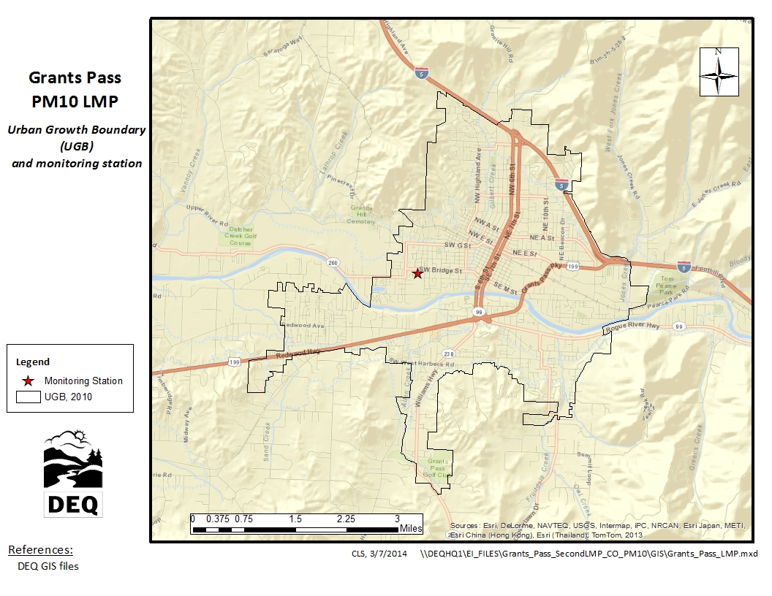

# 3. History of PM10 Problem in Grants Pass

DEQ began monitoring PM10 in Grants Pass in 1987. The monitor was located at 11th and K Streets in downtown Grants Pass for 14 years, until 1999. A second PM10 monitor was located at 720 NE 11th Street from 1993 to 1999. Due to the loss of property access, both monitors were removed in 1999 and a new monitor was established at the sewage treatment plant at 1200 SW Greenwood Ave. This monitor was moved in 2002 to Parkside School at SW Wagner and M streets. In 2008, that monitor was permanently removed with EPA approval, due to very low PM10 levels being measured and resource/budget considerations.[2] Prior to removal, in 2006 a PM2.5 monitor was co-located at Parkside School with the PM10 monitor, from which estimated PM10 values could be derived. Since then, this PM2.5 monitor and a continuous non-FRM monitor (nephelometer) have been in operation.

A violation of the 24-hour PM10 standard occurs when there are more than three exceedances of the standard within three years. The highest 24-hour PM10 concentration recorded in Grants Pass occurred in 1987 at a level of 268 µg/m3. There were three exceedances of the 24-hour standard in that year. By the early 1990’s, maximum levels were closer to the public health standard, and there have been no violations since 1987. Grants Pass has never violated the annual PM10 standard of 50 µg/m3.

In 1987, Grants Pass was categorized as a “Group 1 Planning Area” by EPA for violating the 24-hour PM10 standard, based on a design value of 171 µg/m3. In 1990, EPA formally designated Grants Pass as a moderate nonattainment area for the 24-hour standard. The UGB was established at that time as the PM10 nonattainment boundary.

Monitoring data shows that Grants Pass area has been in attainment of the 24-hour standard since 1989. In 2003, the area was reclassified to attainment for the 24-hour PM10 standard, when EPA approved the first maintenance plan designed to maintain compliance with the 24-hour PM10 standard through the year 2015 (see 68 FR 61111). The maintenance plan allowed for some future growth while ensuring continued protection of public health. It replaced the most stringent emission control requirements for new or expanding major industry with some flexibility for industrial growth, established a PM10 emissions budget for future transportation projects, and a contingency plan in case of an exceedance or violation of the PM10 standard. This limited maintenance plan is the second and final maintenance plan required, designed to ensure compliance through 2025.

The maximum 24-hour PM10 concentrations measured for the years 1987 to 2008 is provided in Table 1. The trend in PM10 concentrations over the same time period is shown in Figure 2, using the second highest 24-hour PM10 concentration rather than the maximum, based on how compliance with the standard is determined.[3]

Table 1. Grants Pass Maximum 24-hour PM10 Highest Values 1987-2013

|  |  |  |
| --- | --- | --- |
| **Year** | **Max PM10 μg/m3** | **Max date** |
| 1987 | 268 | 09/06 |
| 1988 | 136 | 01/27 |
| 1989 | 151 | 01/27 |
| 1990 | 113 | 01/20 |
| 1991 | 141 | 01/03 |
| 1992 | 104 | 11/12 |
| 1993 | 132 | 12/27 |
| 1994 | 92 | 02/01 |
| 1995 | 77 | 11/04 |
| 1996 | 65 | 11/12 |
| 1997 | 89 | 01/15 |
| 1998 | 62 | 12/23 |
| 1999 | 43 | 11/11 |
| 2000 | 43 | 01/29 |
| 2001 | 55 | 11/12 |
| 2002 | 45 | 11/09 |
| 2003 | 56 | 11/14 |
| 2004 | 36 | 02/12 |
| 2005 | 48 | 07/27 |
| 2006 | 39 | 12/31 |
| 2007 | 41 | 02/05 |
| 2008 | 43 | 06/29 |
| **estimated PM10 using PM2.5 data** | | |
| 2009 | 49 | 11/09 |
| 2010 | 46 | 12/04 |
| 2011 | 41 | 12/23 |
| 2012 | 25 | 01/04 |
| 2013 | 111* | 08/02 |
| 2013 | 45 | 11/24 |

*wildfire smoke impact

Figure 2. Grants Pass PM10 Trend 1987-2013

**2nd highest 24-Hr Average**

**Estimated**

**PM10**

# 4. Tracking Current PM10 Levels in Grants Pass

As noted above, in 2008 the PM10 monitor in Grants Pass was removed with EPA approval, due to very low levels being measured. Comparable Federal Reference Method PM10 and PM2.5 monitors were co-located at Parkside School in Grants Pass from 2006-2008, from which a reliable PM10 estimation methodology was developed, using the equation in Figure 3. It is expected if current low PM10 levels continue, budget considerations may lead to the removal of the PM2.5 monitor and its relocation to another community. Should this occur, DEQ would then install a beta attenuation mass (BAM) monitor, approved by EPA as a Federal Equivalent Method for measuring PM10, in order to track PM10 levels for the remainder of the limited maintenance plan. EPA approval will be obtained prior to removing the PM2.5 monitor and installing a FEM BAM for PM10. See Section 9 for additional information.

PM10/PM2.5 Correlation

A linear regression analysis was performed on the PM10 and PM2.5 data, as shown in Figure 3. This shows the correlation has an R Squared of 0.94, which is very high and shows that the linear regression equation of ***y = 1.2x + 2.6*** can be used for calculating PM10 levels.

Figure 3. Grants Pass Parkside School PM10/PM2.5 Correlation

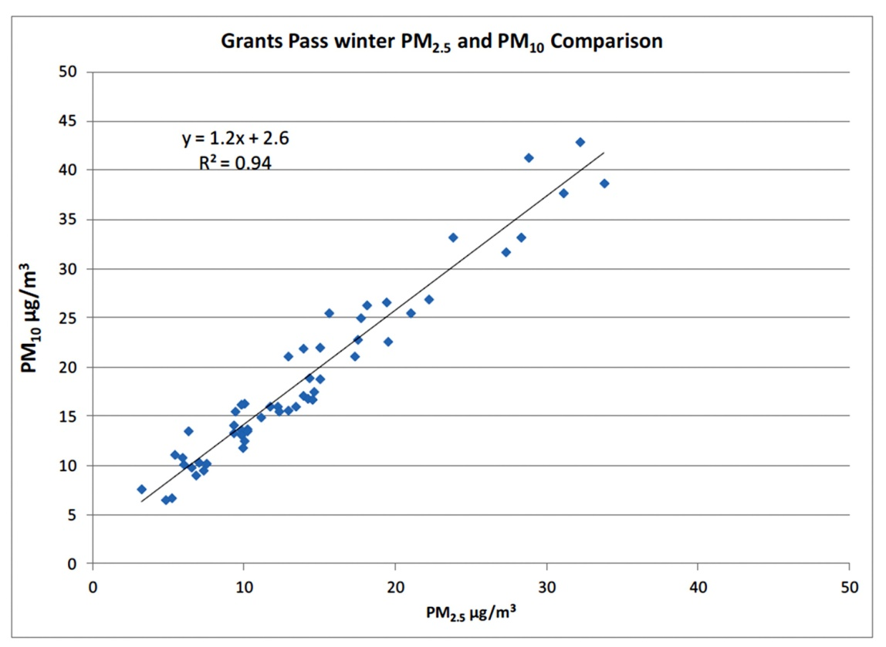

# 5. Limited Maintenance Plan Option

The EPA developed the Limited Maintenance Plan (LMP) option for areas with little risk of re-violating the PM10 standard (see 2001 Wegman Memo, Appendix A). EPA allows states to use this policy to prepare the required second 10-year maintenance plans, if the area meets three criteria in the EPA LMP Option Guidance. The first is that an area should be attaining the PM10 standard, the second that the average PM10 design value based on the most recent 5 years of air quality data should be at or below 98μg/m3, and the third that the area should expect only limited growth in on-road motor vehicle emissions and pass a motor vehicle regional emissions analysis test, in accordance with Appendix B of the LMP Guidance. The Grants Pass area meets all three criteria. As noted in Section 3, PM10 monitored data over the last 15 years have been well below the 24-hour standard.

EPA’s PM10 SIP Development Guideline outlines four approaches to determining the PM10 design value. DEQ relied upon the table look-up procedure, as noted in Table 6-1 of the guidance. [4] Calculating the design value using this method provides the most conservative design value. Two PM10 design values for Grants Pass are provided here. The first is 49 μg/m3, based on the most recent 5 years of FRM monitoring data (2004-2008) prior to removal of the PM10 monitor. The second design value is also 49 µg/m3, based on the most recent 5 years of estimated PM10 levels (2009-2013) using the equation in Figure 3. Both are well below the 98 µg/m3 value stipulated in the LMP Guidance. The area expects very limited growth in on-road motor vehicle emissions, as demonstrated by passing the Motor Vehicle Regional Analysis.[5]

# 6. Emission Inventory

This section presents the emissions inventory for the second 10-year maintenance plan and briefly describes its development. The LMP Guidance requires that the maintenance plan include an inventory with emission levels consistent with attainment of the PM10 standard. An inventory preparation plan, including a quality assurance plan, for the Grants Pass UGB was submitted to EPA in March 2014, and is provided in Appendix E. EPA reviewed the plan and agreed that the inventory be developed using EPA’s 2011 National Emission Inventory (NEI) data for Josephine County, as the most recent, complete, readily available emission inventory. This approach is consistent with the 1993 emission inventory developed for the first maintenance plan. In accordance with requirements for the LMP option, no emission projections were calculated.

Historically, exceedences of the 24-hr PM10 standard in Grants Pass have occurred during the winter months, or between November 1 and the end of February. As such, in addition to annual emissions, typical season day and worst-case season day emissions are included in the inventory. The term “worst-case day” describes the maximum activity/emissions that have occurred or could occur on a season day, for each emissions source. Worst-case day emissions are summed for all sources/categories, i.e. assumed to occur on the same day. This assumption is the basis for what would be needed to cause an exceedence of the 24-hr standard. The unit of measure for annual emissions is in tons per year (tpy), while the unit of measure for season day emissions is in pounds per day (lb/day). In addition, the county-wide EI data was spatially allocated to the Grants Pass UGB, and to buffers around the UGB or monitor, depending on emissions category.

At noted in Table 2 and Figures 5 and 6 below, the most significant categories of PM10 emissions in the Grants Pass UGB are area sources (mostly home wood-heating), on-road mobile sources (mostly re-entrained road dust), point sources (industry), and non-road (engine and equipment) sources. A detailed breakdown of the 2011 PM10 Emission Inventory is provided in Appendix B.

Table 2. 2011 Grants Pass UGB PM10 Daily and Annual Emission Inventory

|  |  |  |  |  |  |  |
| --- | --- | --- | --- | --- | --- | --- |
| Source Category | PM10 Emissions | | | | | |
| Annual Tons / Year | Annual percent | Season Lbs / Day | Season percent | Worst Case Day (lbs/day) | Worst Case percent |
| Stationary Point Sources | 27.5 | 4% | 187 | 3.9% | 1,357 | 19.3% |
| Stationary Area Sources | 431.6 | 64% | 3,540 | 73.4% | 4,477 | 63.7% |
| Non-Road Engine Sources | 4.9 | 1% | 20 | 0.4% | 20 | 0.3% |
| On-Road Mobile Sources | 209.7 | 31% | 1,078 | 22.3% | 1,177 | 16.7% |
| Total | 673.8 | 100% | 4,826 | 100% | 7,031 | 100% |

Figure 4. 2011 Grants Pass Annual PM10 Emissions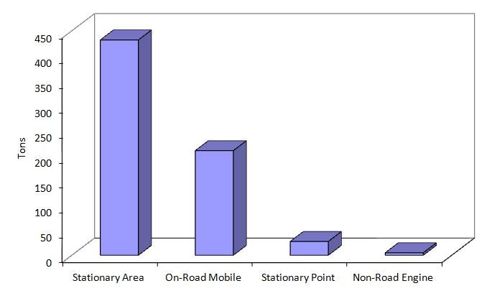

Figure 5. 2011 Grants Pass Worst Case Day PM10 Emissions

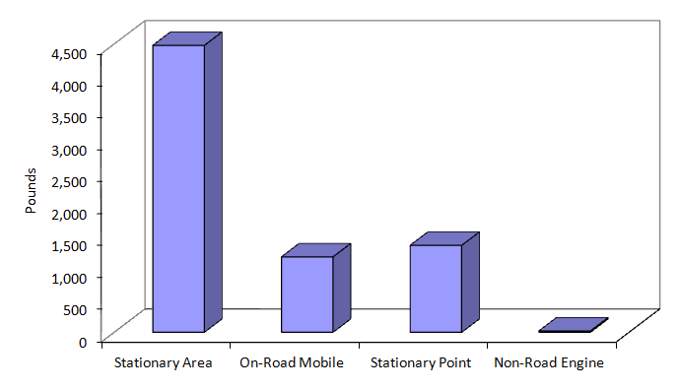

# 7. Continuing Control Measures

To qualify for the LMP option, the control measures from the first PM10 maintenance plan must remain in place and unchanged. The measures in Table 3 below were adopted in the first maintenance plan. They included a residential woodstove curtailment program, a ban on the use of uncertified woodstoves, outdoor open burning restrictions, prescribed forestry burning smoke management protection, and certain industrial requirements. The following table summarizes the primary control measures that will be retained under this limited maintenance plan, and the rule authority for each measure. The only measure not continued is the transportation conformity emissions budget, which is not required for a LMP.

Table 3. Grants Pass PM10 Continuing Control Measures

|  |  |  |
| --- | --- | --- |
| **Control Measure** | **Effective Date** | **DEQ rule authority** |
| Voluntary Woodstove Curtailment | 1991 | OAR 340-200-0040 |
| Wood stove Certification | 1990 | OAR 340-262-0600 |
| Ban on sale of used woodstoves | 1991 | OAR 340-262-0600 |
| Open Burning ventilation index | 1991 | OAR 340-264-0070 |
| New Source Review: BACT & offsets exemption | 1981 | OAR 340-224-0060 |
| Industrial controls on veneer dryers/wood-fired boilers | 1989 | OAR 340-240-0110  OAR 340-240-0120 |
| Forest Smoke Management Plan | 1990 | OAR 340-200-0040 |

Wood Heating Measures

Various measures were implemented to reduce wood-heating emissions in Grants Pass. As noted in the previous section, residential wood-heating emissions make up most of the stationary area source emissions, which represent well over 60 percent of the total annual and daily PM10 emissions in the Grants Pass UGB. The home wood heating curtailment program has been the most effective PM10 emission reduction strategy for Grants Pass. As noted in Table 3, woodstove emission control efforts include the emission certification standards for new stoves, change-out programs to encourage removal of non-certified stoves, and a local voluntary curtailment program to reduce wood burning during stagnant weather periods.

Open Burning

The Grants Pass UGB is wholly contained within the Rogue Basin Open Burning Control Area. Within this area, Oregon Administrative Rules prohibit commercial and industrial open burning, and limit domestic open burning to days with adequate ventilation. The City of Grants Pass prohibits open burning year round. The Josephine County Department of Health and Community Action apply the wood heating curtailment and open burning restrictions to a broader area surrounding the UGB as a voluntary program.

Industrial Sources

Under the major New Source Review rules, large new or expanding sources (greater than 15 tons per year of PM10) inside the Grants Pass UGB are required to install Best Available Control Technology (BACT), and provide PM10 offsets (an equivalent reduction in emissions within the UGB). BACT allows a source to consider cost in determining the best available emission controls. An exemption to offsets is allowed if modeling demonstrates that the new PM10 emissions, when combined with other PM10 emissions in the area, will not result in an air quality impact greater than120 µg/m3. Specific industrial controls for veneer dryers and wood-fired boilers will continue to apply within the Grants Pass UGB.

Forest Prescribed Burning

The Oregon Department of Forestry’s Smoke Management Plan restricts prescribed burning on poor air quality days on forested lands surrounding the Grants Pass UGB. This program is administered by the Department of Forestry. Grants Pass receives additional smoke management protection as a designated “Smoke Sensitive Receptor Area”, which means that any burning conducted in the region must avoid causing a smoke impact in Grants Pass, including during the winter months when historically 24-hr PM10 standard violations have occurred.

Conformity requirements

Federal transportation conformity rules (40 CFR parts 51 and 93) and general conformity rules (58 FR 63214) continue to apply under a limited maintenance plan. However, as noted in the Wegman Memo, these requirements are greatly simplified. An area under a LMP can demonstrate conformity without submitting an emissions budget, and as a result emissions do not need be capped nor a regional emissions analysis (including modeling) conducted.[6]

# 8. Contingency Measures

Section 175(A) of the Clean Air Act requires a maintenance plan include contingency measures necessary to ensure prompt correction of any violation of the standard that may occur after redesignation. The first Grants Pass maintenance plan contained contingency measures that would be implemented under two scenarios – if the official PM10 monitor registers a value of

120 µg/m3 or higher, or if a violation of the 24-hr PM10 standard were to occur. These two contingency scenarios will be continued under the limited maintenance plan. If the former, DEQ would initiate a study of the cause of the elevated level, and convene a planning group to evaluate the findings and identify strategies to be considered for implementation. If the later, DEQ would reinstate the New Source Review requirement for Lowest Achievable Emission Rate for new and expanding industry, and remove the offsets exemption. As described in the next section, EPA has approved a surrogate method for estimating PM10 levels for tracking and NAAQS compliance purposes.

# 9. Commitment to Continued Monitoring and Verification of Continued Attainment

As described in this plan, PM10 levels in the Grants Pass UGB have steadily declined over the last 15 years, and are not expected to increase or threaten compliance with the daily or annual PM10 standards.

As noted in Section 3, the Grants Pass PM10 monitor was removed in 2008 with EPA approval, and since then a surrogate method for estimating PM10 levels has been approved using a co-located FRM PM2.5 monitor. DEQ will comply with Title III, Section 319 of the Clean Air Act, and will continue to operate the PM2.5 monitor until the end of the maintenance period, and use the equation identified in Section 4 for calculating and tracking PM10 levels. In the event DEQ needs to remove the PM2.5 monitor, DEQ will first obtain EPA approval, and then install a Beta Attenuation Mass monitor, approved by EPA as a Federal Equivalent Method for measuring PM10, in order to track PM10 levels for the remainder of the limited maintenance plan. In the unlikely event that after exceptional events are discounted, the second highest PM10 concentration in a calendar year based on the PM2.5 monitor or BAM FEM monitor exceeds the LMP threshold of 98µg/m3, DEQ and EPA will discuss reestablishment of direct monitoring using an FRM PM10 monitor.

## Appendix A

## EPA 2001 Wegman Memo

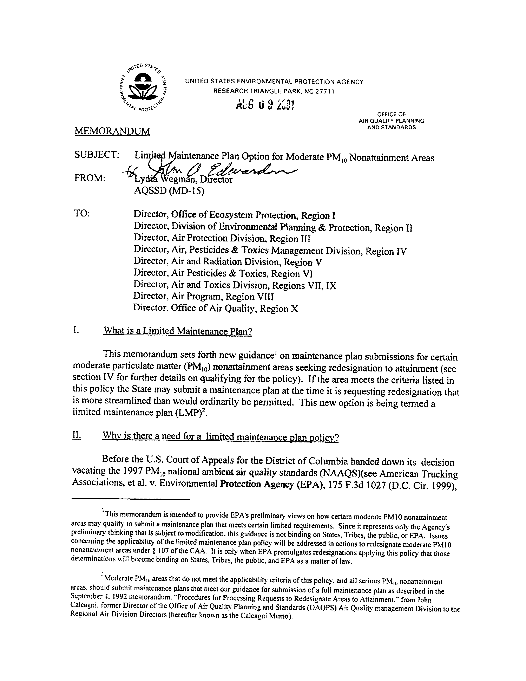

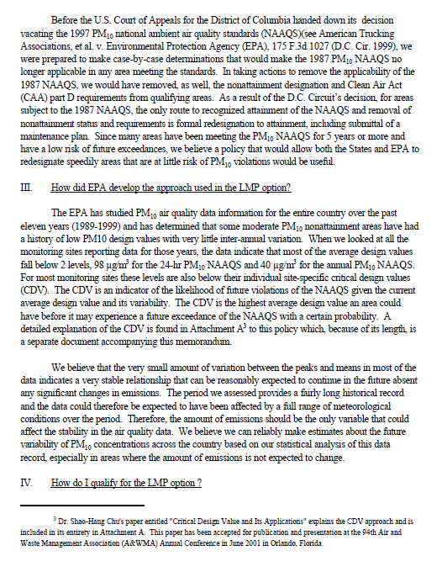

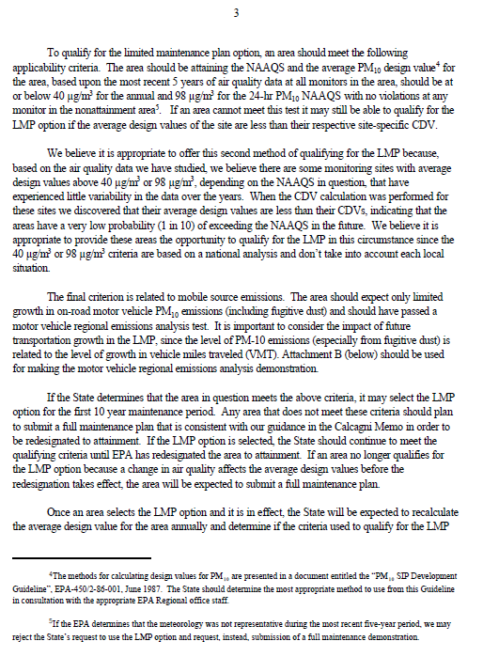

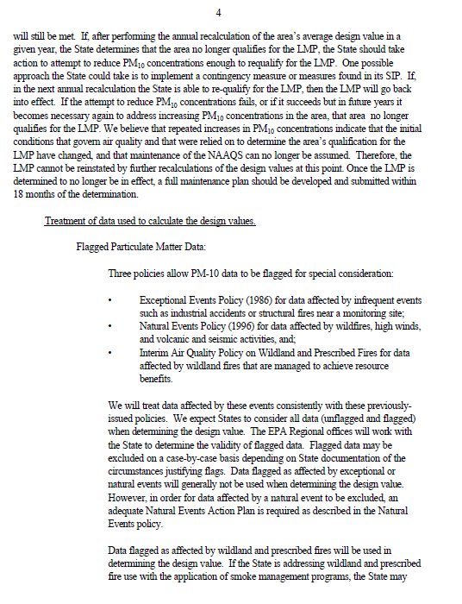

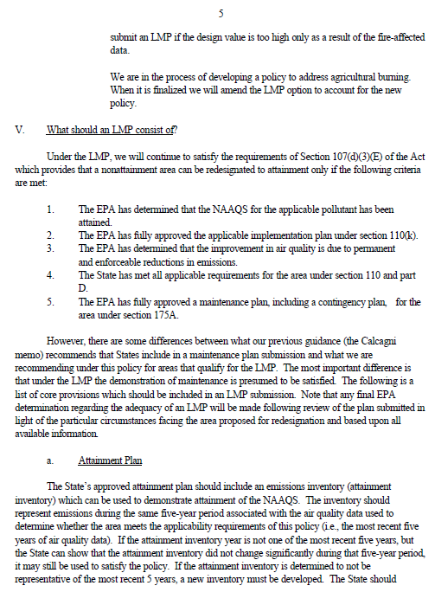

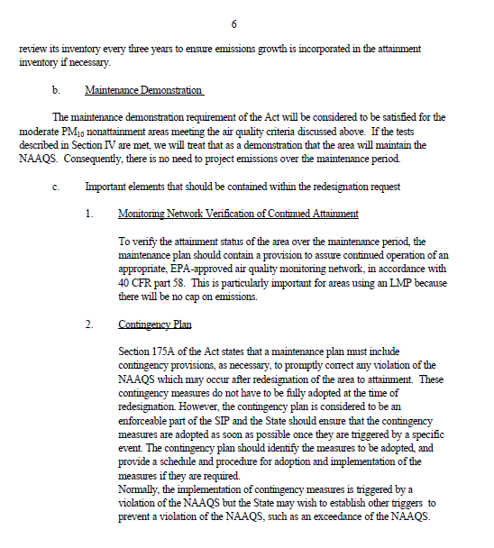

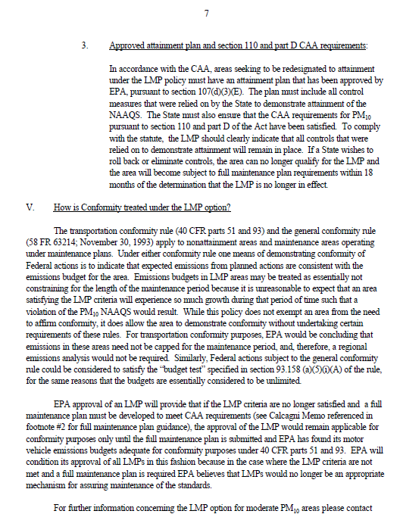

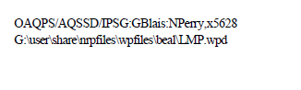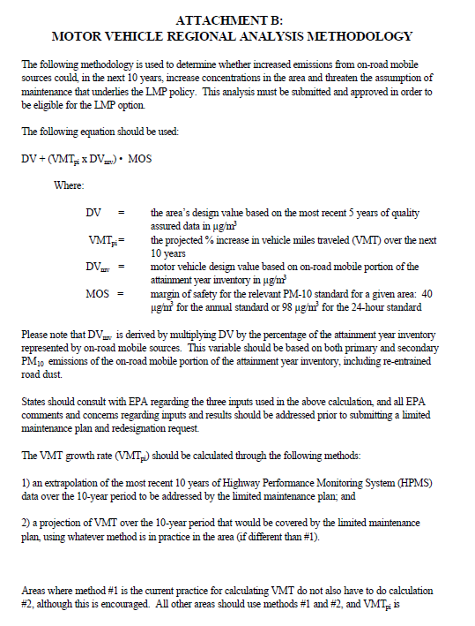

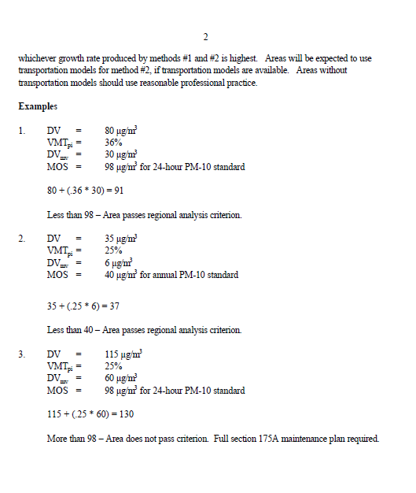

## Appendix B

## Grants Pass 2011 PM10 Emission Inventory

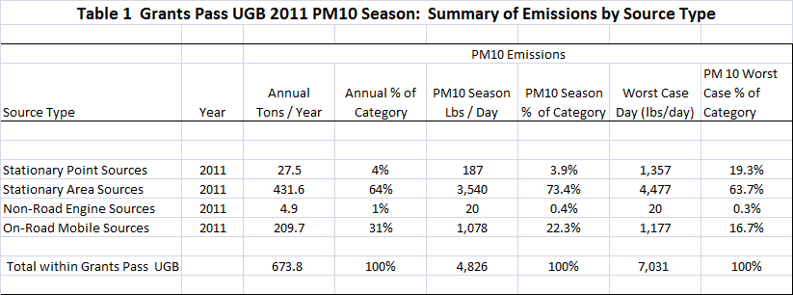



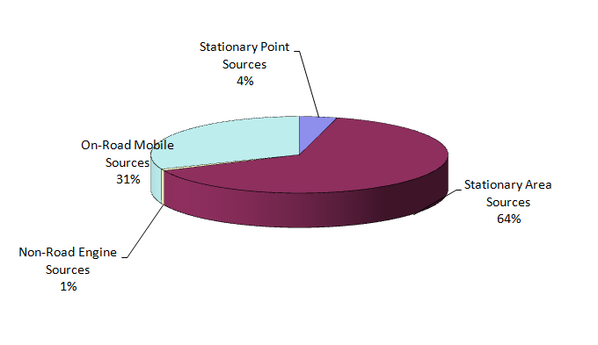

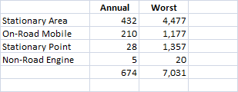



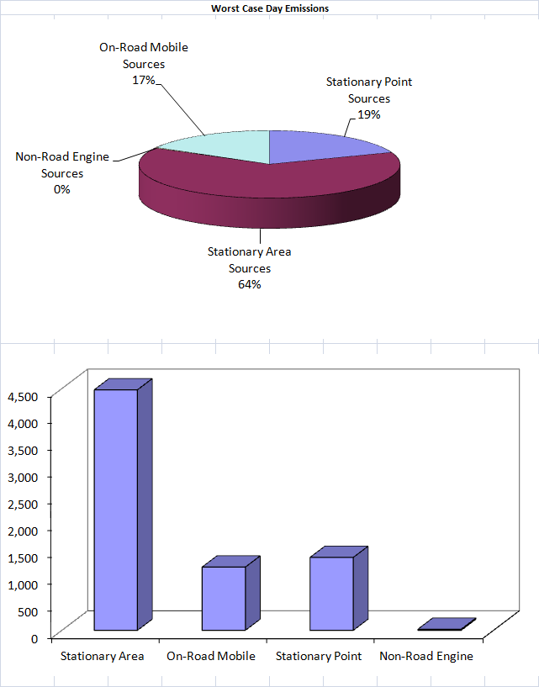

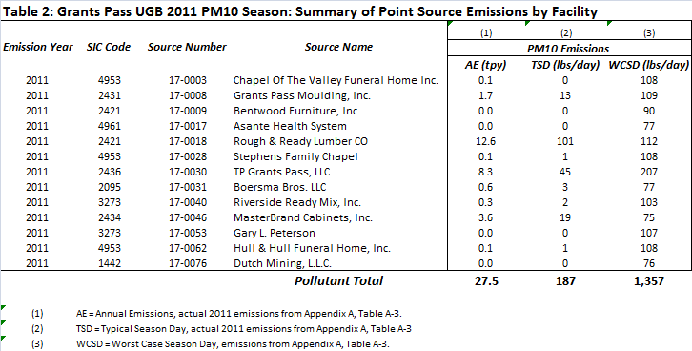

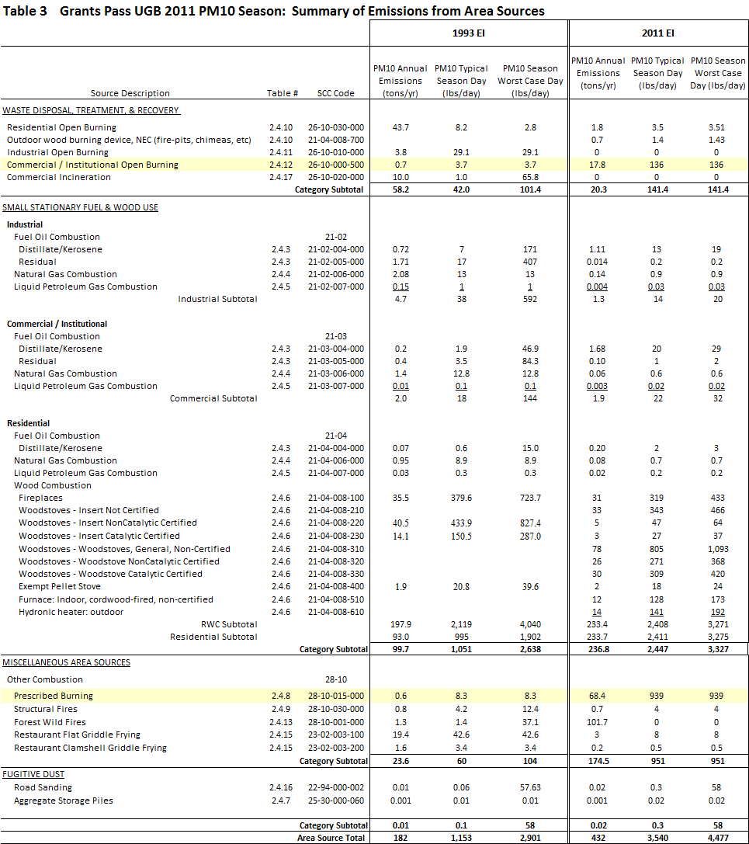



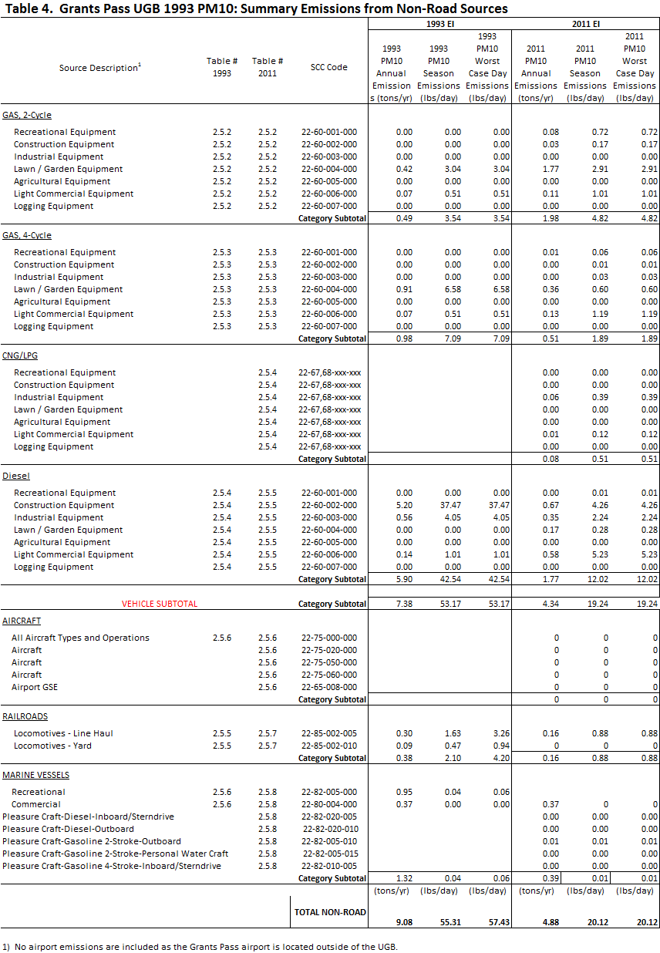

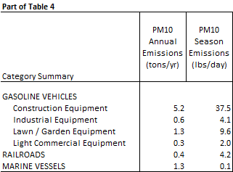

# 

# 

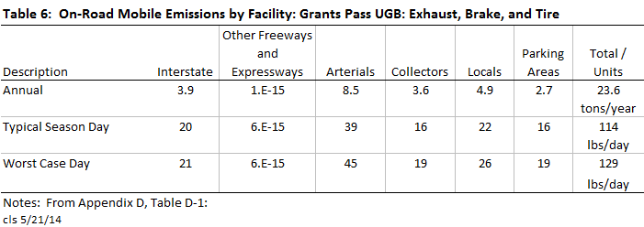

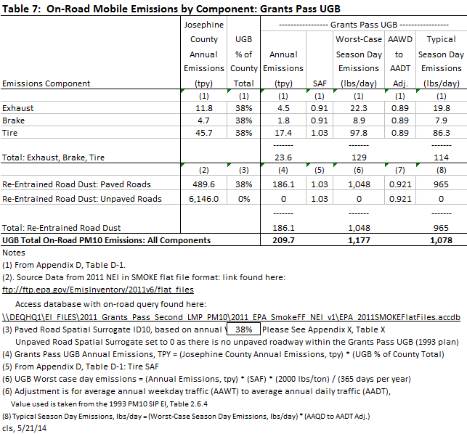

## Appendix C

## Motor Vehicle Regional Analysis Test

To qualify for the PM10 LMP option, an area should expect only limited growth in on-road motor vehicle PM10 emissions (including fugitive dust) and pass a motor vehicle regional emissions analysis test, found in Appendix B of the LMP Guidance.

The following methodology was used to determine whether increased emissions from on-road mobile sources could, in the next 10 years, increase concentrations in the Grants Pass UGB and threaten the assumption of maintenance that underlies the LMP Guidance.

DV + (VMTpi x DVmv) < MOS

Where:

DV = the area’s design value based on the most recent 5 years of data, μg/m3

VMTpi = The projected percent increase in vehicle miles traveled (VMT) over the next 10 years

DVmv = Motor vehicle design value based on on-road mobile portion of the attainment year inventory, μg/m3

MOS = Margin of safety for 24-hour PM-10 standard is 98 μg/m3

**Step 1:** Determine DV

The maximum from five complete years of data (2004-2008) is 49 μg/m3

**Step 2:** Determine the projected percent increase in VMT over the next 10 years

The VMT data for the Grants Pass for 2011 and 2021 was supplied by Oregon Department of Transportation, Transportation Planning Analysis Unit. Based on the Grants Pass OSUM Model (Years 2002 and 2025), the percentage increase in the 10‐year daily VMT between 2011 and 2021 is estimated to be 15%, and 2011 base year daily VMT is forecast to be 700,675.

**Step 3:** Calculate motor vehicle design value based on on-road mobile portion of the attainment year inventory

The 1996 Grants Pass maintenance plan identified that re-entrained road dust represented 42% and on-road mobile portion represented 1.4% of the attainment year inventory.

DVmv = DV x % Onroad Emissions

DVmv = 49 µg/m3 x 0.43 = 21.07 µg/m3

**Step 4:** Calculate the margin of safety

DV + VMTpi x DVmv = MOS

49 µg/m3 + 0.15 x 21.07 µg/m3 = **52 µg/m3**

Since 52 µg/m3 is much less than 98 µg/m3 the area passes the motor vehicle regional analysis and qualifies for the LMP approach.

## Appendix D

## DEQ Report: Justification for Discontinuation of Monitoring in Carbon Monoxide and PM10 Maintenance Areas, 2011

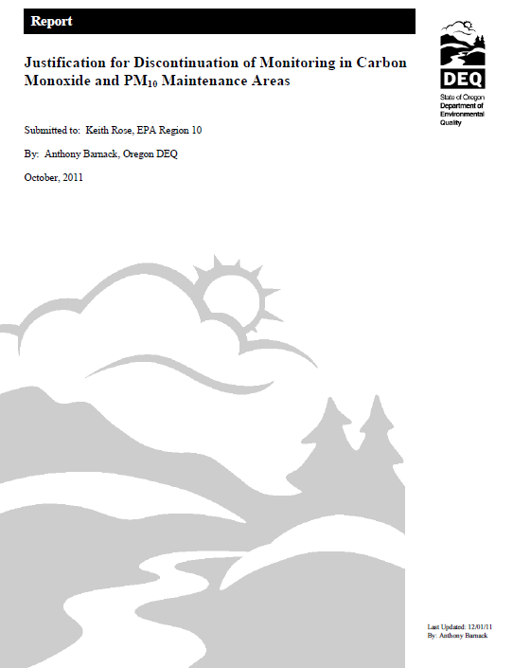

## 

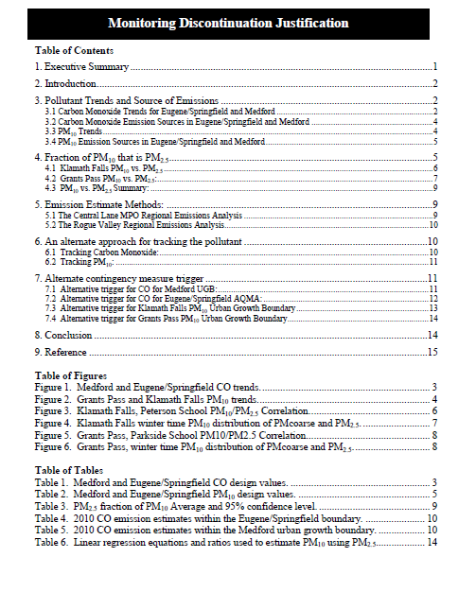

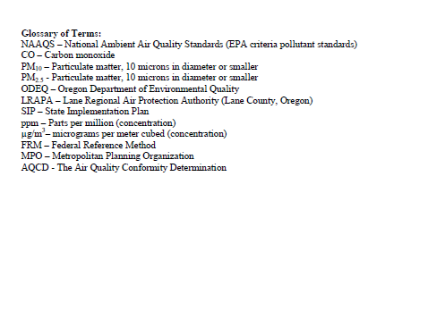

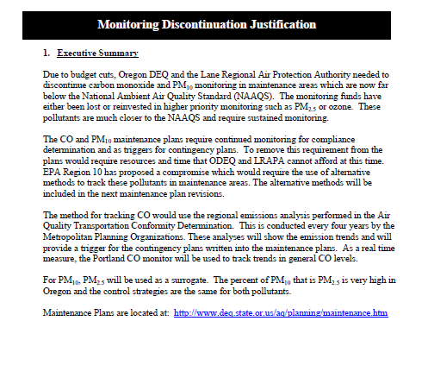

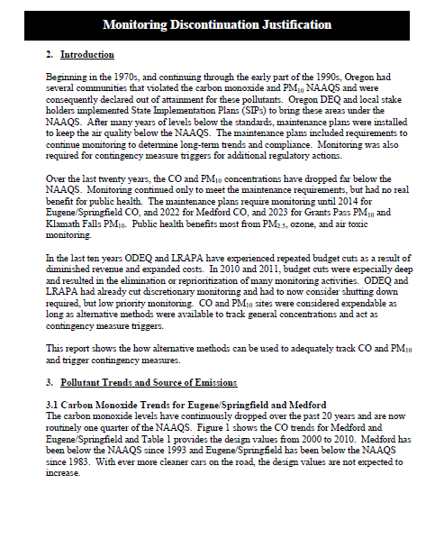

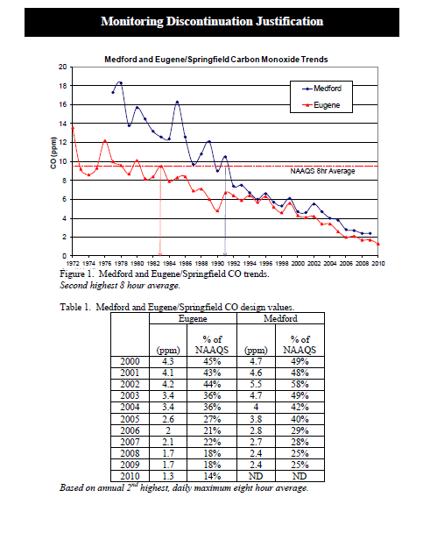

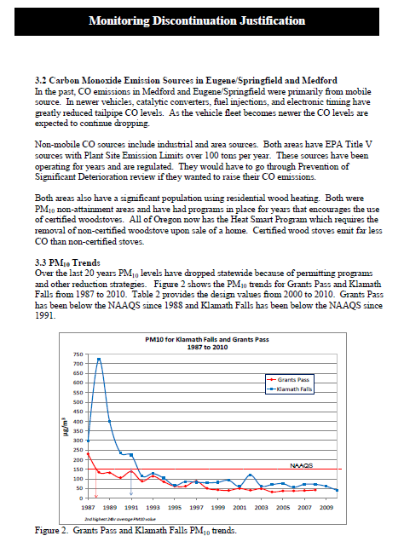

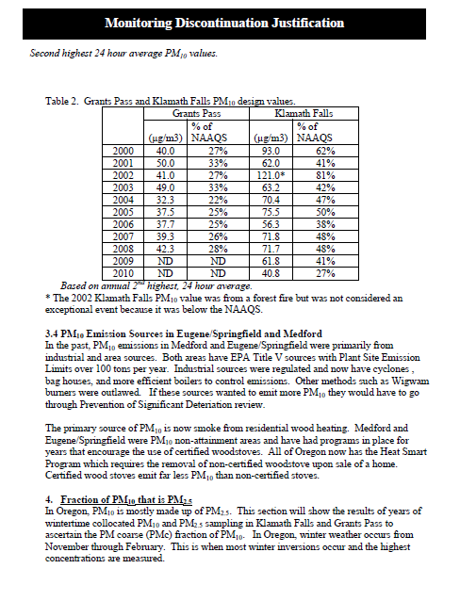

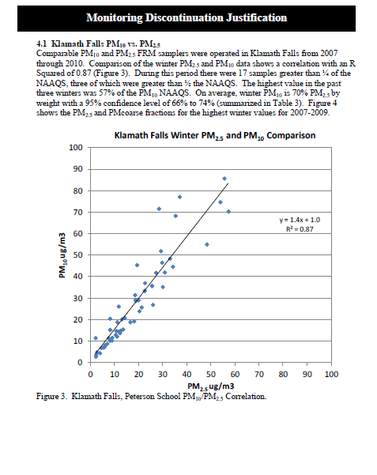

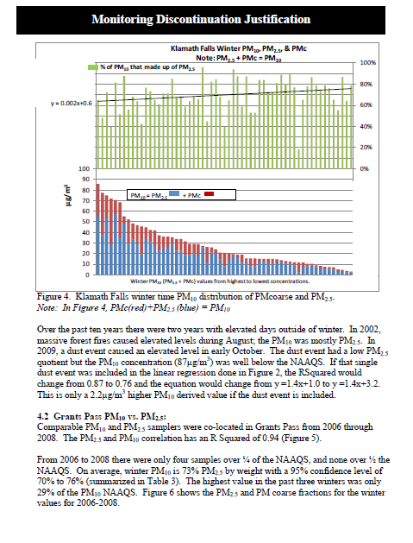

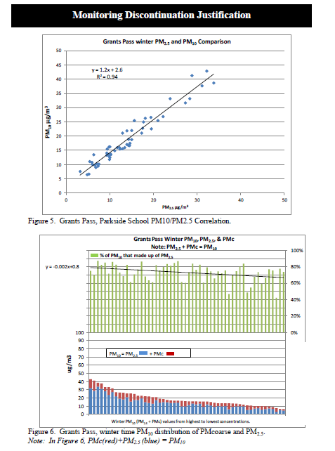

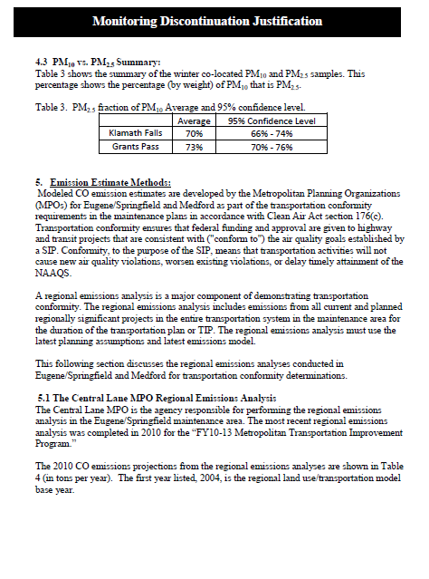

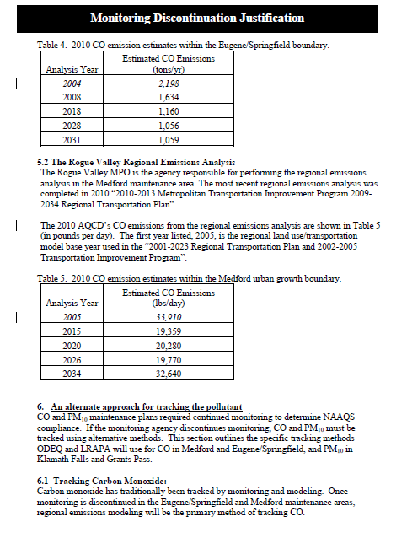

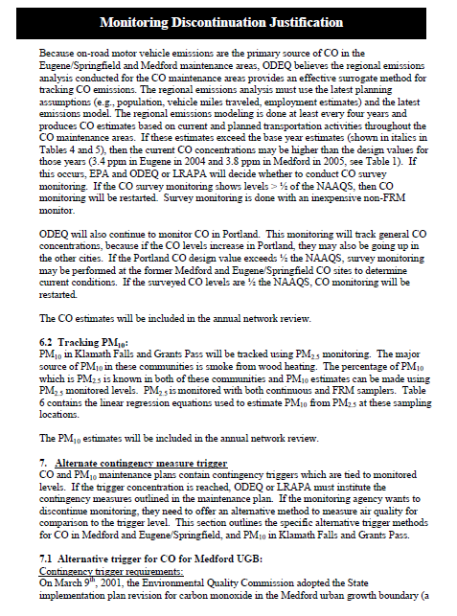

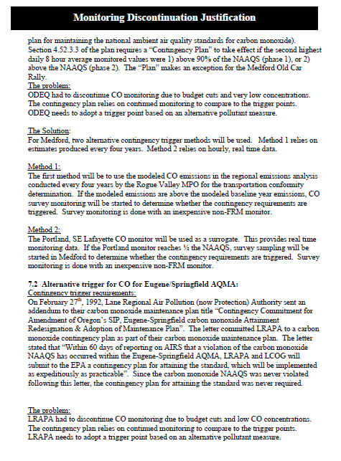

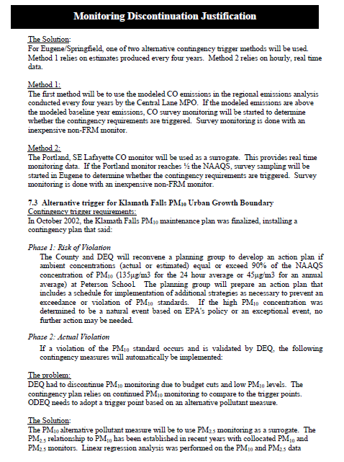

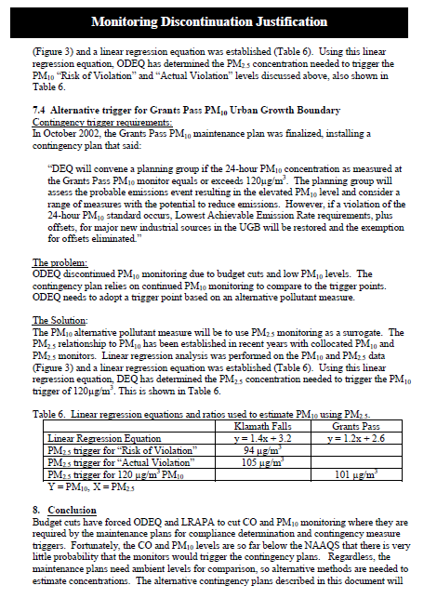

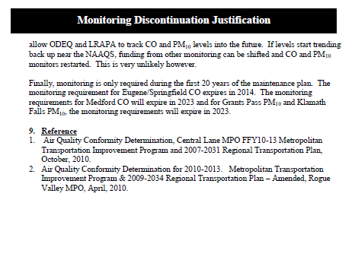

## Appendix E

## Inventory Preparation and Quality Assurance Plan

## for the

## Grants Pass Urban Growth Boundary Limited PM10 Maintenance Plan

Oregon Department of Environmental Quality

Air Quality Division – Technical Services Section

Inventory Preparation

and Quality Assurance Plan

for the

Grants Pass Urban Growth Boundary

Limited PM10 Maintenance Plan

**March 2014**

© Oregon Department of the Environmental Quality

Environmental Solutions Division, Technical Services Section

811 SW Sixth Avenue

Portland, Oregon 97204

Phone 503.229.5359 • Fax 503.229.5675

**TABLE OF CONTENTS**

TABLE OF CONTENTS 2

TABLE OF FIGURES 3

TABLE OF TABLES 3

1 INTRODUCTION 4

1.1 Geographic Area 4

1.2 Temporal Resolution 5

2 INVENTORY DEVELOPMENT 5

2.1 Data Categories 6

2.2 Emission Sectors 6

3 SPATIAL ALLOCATION METHODS 7

4 TEMPORAL ALLOCATION METHODS 9

4.1 Permitted Point 9

4.2 Aircraft and Locomotives 9

4.3 Nonpoint (area) and Nonroad Vehicles & Equipment 9

4.3.1 Open Burning 9

4.3.2 Small Stationary Fossil Fuel Combustion 9

4.3.3 Residential Wood Combustion 9

4.3.4 Wildfires and Prescribed Burning 10

4.3.5 Structure Fires 10

4.3.6 Commercial Food Preparation 10

4.3.7 Fugitive Dust 10

4.3.8 Nonroad Vehicles & Equipment Excluding Aircraft and Locomotives 10

4.4 On-Road Mobile 10

5 QUALITY ASSURANCE AND QUALITY CONTROL 10

6 EXTERNAL AUDITS 11

7 PERSONNEL 11

8 SCHEDULE 11

**TABLE OF FIGURES**

Figure 1‑1. Grants Pass UGB and Location of the Air Quality Monitoring Station 5

**TABLE OF TABLES**

Table 2.1. 1993 PM10 Seasonal Worst-Case Day Emissions by Category 6

Table 2.2. 1993 PM10 Seasonal Worst-Case Daily Emissions by Source Category 7

Table 3.1. Data Sources, Spatial Surrogates and Boundaries 8

Table 8.1. Draft Project Schedule: Grants Pass Limited Maintenance Plans for CO and PM10 12

**1. INTRODUCTION**

The Grants Pass PM10 maintenance area was classified as a “Group 1 Planning Area” in 1987 by the Environmental Protection Agency (EPA) for violating the 24-hour PM10 standard. In 1990, EPA formally designated Grants Pass as a moderate nonattainment area for the 24-hour standard, 150µg/m3.

Monitoring data shows that Grants Pass area has been in attainment of the standard since 1989. Full compliance for the area was achieved by 1990 with no exceedances recorded at the PM10 monitor for three consecutive years. The area was reclassified to attainment for the 24-hour PM10 standard in December 2003 when EPA approved the first maintenance plan designed to maintain compliance with the 24-hour PM10 standard through the year 2015. The second maintenance plan is due in 2015. Once approved by EPA, the second maintenance plan will fulfill the final maintenance planning requirements of the Clean Air Act. This Inventory Preparation Plan is in support of the development of the required second PM10 maintenance plan.

The Grants Pass Urban Growth Boundary (UGB) is the maintenance area for PM10. A PM10 monitor was located at 11th and K Streets in downtown Grants Pass from 1985 until 1999. Due to loss of property access in 1999, the monitor was relocated to the sewage treatment plant within the UGB. Measured PM10 levels were so low that the monitor was removed with EPA approval at the end of 2008. Since then, both continuous, non-reference method monitoring and Federal Reference Method (FRM) monitoring of PM2.5 has been conducted in Grants Pass, which has been correlated with a co-located PM10 monitor to provide estimated PM10 values. Figure 1-1 shows the Grants Pass UGB and the present location of the monitor.

The Grants Pass UGB qualifies for the Limited Maintenance Plan (LMP) approach because the area satisfies all criteria outlined in the Limited Maintenance Plan Option for Moderate PM10 Nonattainment Areas (Wegman memo, 2001). The design value for 2004-2008 was 49 µg/m3, and the risk to the community of exceeding the PM10 standard is low. According to the LMP guidance, EPA will consider the maintenance demonstration satisfied if the monitoring data show the design value to be at or below 98 µg/m3 for the 24-hr PM10 NAAQS, and if the area expects only limited growth in on-road motor vehicle emissions. The Grants Pass UGB passes the Motor Vehicle Regional Analysis outlined in Appendix B of the Wegman memo (Appendix B attached).

Oregon DEQ proposes using existing information from the EPA 2011 National Emission Inventory (NEI) to create the emissions inventory for PM10 sources in Grants Pass. This document describes the planned approach to the LMP EI and the basis for selecting that approach.

**1.1 Geographic Area**

The city of Grants Pass is located in the Rogue Valley, northwest of Medford and along the Rogue River. The city is approximately 11 sq. miles in area, and the US Census 2011 population was 34,533. The Grants Pass Parkside School Air Quality Monitoring Station is located at the corner of SW Wagner and M streets, at an elevation of 277 meters (801 ft). Figure 1-1 shows the geographic area of the Grants Pass UGB, along with the location of the monitor.



**Figure 1‑1. Grants Pass UGB and Location of the Air Quality Monitoring Station**

**1.2 Temporal Resolution**

Historical exceedences of the 24-hr PM10 standard have occurred during the PM season, which is defined as four consecutive months, November 1st through the end of February. As such, in addition to annual emissions typical season day and worst-case season day emissions will be included in the inventory. The term “worst-case day” describes the maximum activity/emissions that have occurred or could occur on a season day, for each emissions source. Worst-case day emissions are summed for all sources/categories, i.e. assumed to occur on the same day. The assumption: A “perfect storm” of emissions that could cause an exceedence. The unit of measure for annual emissions will be tons per year (tpy), and the unit of measure for season day emissions will be pounds per day (lb/day).

**2. INVENTORY DEVELOPMENT**

The DEQ will develop an emission inventory using EPA 2011 National Emissions Inventory (NEI) data for Josephine County. We will temporally allocate the EI data to PM season, and spatially allocate the county-wide NEI data to the Grants Pass UGB, or to buffers around the UGB or monitor, depending on emissions category. All data sources and allocation methods will be documented. The emission inventory will be consistent with the 1993 inventory.

**2.1 Data Categories**

From the base year (1993) emission inventory for the maintenance plan, the most significant categories of PM10 emissions in the Grants Pass UGB are re-entrained road dust, residential wood combustion, small stationary fossil fuel combustion, and permitted point source fossil fuel combustion. Table 2.1 shows the breakdown by category for worst-case day PM10 emissions in 1993.

**Table 2.1. 1993 PM10 Seasonal Worst-Case Day Emissions by Category**

|  |  |  |
| --- | --- | --- |
| **Emission Inventory Category** | **Emissions per Day (lb/day)** | **Percent of Worst-Case Day Emissions** |
| Re-Entrained Road Dust | 4,512 | 42% |
| Residential Wood Combustion | 4,064 | 38% |
| Small Stationary Fossil Fuel Combustion(a) | 1,064 | 10% |
| Permitted Point Sources | 591 | 6% |
| All other sources | 470 | 4% |
|  | ------- | ------- |
| Total | 10,701 | 100% |

1. Non-permitted stationary residential, industrial, commercial, and institutional fuel use

**2.2 Emission Sectors**

We propose 14 emission inventory sources be included in this LMP for the Grants Pass maintenance area. The sectors are based on a review of emission sectors listed in the 1993 maintenance plan, and an analysis of 2011 NEI data. Table 2.2 shows the breakdown by source category of average daily PM10 emissions in 1993 inventory; DEQ will use the same emission source categories as in the 1993 inventory.

**Table 2.2. 1993 PM10 Seasonal Worst-Case Daily Emissions by Source Category**

|  |  |  |
| --- | --- | --- |
| **Emission Source Category** | **Emissions per Day (lb/day)** | **Percent of Worst-Case Day Emissions** |
| Permitted Point Sources | 591 | 5.52% |
| Open Burning | 101 | 0.95% |
| Small Stationary Fossil Fuel Combustion(a) | 736 | 9.94% |
| Residential Wood Combustion | 4,064 | 37.98% |
| Wildfires & Prescribed Burning | 45 | 0.42% |
| Commercial Food Preparation(b) | 46 | 0.43% |
| Fugitive Dust | 58 | 0.54% |
| Structure Fires | 12 | 0.12% |
| Aircraft & Airport Related | 0(c) | 0% |
| Locomotives | 2 | 0.02% |
| Recreational Marine | 1 | 0.01% |
| Nonroad Vehicles & Equipment | 53 | 0.50% |
| Onroad Mobile: Exhaust + Brake + Tire | 148 | 1.40% |
| Re-Entrained Road Dust | 4,512 | 42.16% |
|  | ------- | -------- |
| Total | 10,701 | 100% |

1. Non-permitted stationary residential, industrial, commercial, and institutional fuel use
2. Particulate emissions from the cooking process only; fuel used by restaurants is covered under small stationary fossil fuel combustion.
3. Grants Pass Airport located outside the Grants Pass UGB, so emissions are not included. However, DEQ staff will verify that no additional airports/heliports are located within the UGB for the 2011 EI.

**3. SPATIAL ALLOCATION METHODS**

For emissions sources with specific coordinates, emissions will be mapped to either the UGB or to a buffer zone around the monitor or other boundary, depending on emissions source category. For sources without specific coordinates, spatial surrogates will be used to approximate both the location and magnitude of emissions. Spatial surrogates are typically used to approximate emissions inside smaller boundaries from larger boundaries. For sources without specific coordinates, county-wide emissions will be spatially allocated to UGB using the formula:

*EUGB = ECOUNTY * SurrogateUGB / SurrogateCOUNTY*

Where *EUGB* = emissions in UGB,

*ECOUNTY* = county-wide emissions

*SurrogateUGB* = surrogate activity in UGB

*SurrogateCOUNTY* = surrogate activity in county

Data sources, spatial surrogates or boundaries used for each category of emissions are detailed in Table 3-1.

**Table 3.1. Data Sources, Spatial Surrogates and Boundaries**



**4. TEMPORAL ALLOCATION METHODS**

Annual emissions will be adjusted from tons per year to lbs per typical season and worst-case season day for each source category. Methods for each category are described below, and all methods are consistent with the 1993 EI.

**4.1 Permitted Point**

Typical day emissions estimates will be calculated from annual emissions utilizing facility operating schedules taken from source permits. Worst-case day emissions will be actual emissions calculated from permits, source annual reports, and DEQ point source emissions estimation reports.

**4.2 Aircraft and Locomotives**

Aircraft and locomotive activity will be considered uniform throughout the year. Annual emissions will be divided by 365 days to estimate typical season day and worst-case day emissions.

**4.3 Nonpoint (area) and Nonroad Vehicles & Equipment**

For nonpoint (area) and nonroad vehicles and equipment (excluding aircraft and locomotive), temporal allocation to season will follow the formula:

***Annual to Typical Season Day = (Annual Emissions * SAF) / (weekly activity * 52 weeks/yr)***

Where SAF = Seasonal Adjustment Factor =

= *(Season Activity * 12 months) / (Annual Activity * Season Months)*

(Reference: EPA-450/4-91-016, p. 5-22)

**4.3.1 Open Burning**

Open burning will be temporally allocated using SAF values and activity in days per week taken from the 1993 EI. Open burning is prohibited during low-ventilation days; however a worst-case scenario will be calculated using estimates for illegal open burning activity as determined in the 1993 EI.

**4.3.2 Small Stationary Fossil Fuel Combustion**

Annual emissions from small stationary fossil fuel combustion will be temporally allocated using SAF values and activity in days per week taken from the 1993 EI. However, the residential heating SAF will be developed from base year (2011) heating degree day (HDD) data. Worst-case day for industrial/commercial/institutional fuel use will be assumed equal to typical season day. However, worst-case day for residential heating will be allocated from typical season day using a “multiplier” (scalar) calculated from HDD data.

**4.3.3 Residential Wood Combustion**

Residential wood combustion annual emissions will be allocated to season using SAF values calculated from 2011 heating degree day (HDD) data. A worst-case “multiplier” (scalar) based on 2011 HDD data will be used to estimate worst-case day emissions. Activity in days per week will be taken from the 1993 EI.

**4.3.4 Wildfires and Prescribed Burning**

As wildfires and prescribed burning are date-specific events, DEQ will temporally allocate emissions from these sources using fire date data, available in the EPA National Emission Inventory (NEI). SAF values will be calculated using annual and seasonal fire dates. Worst-case day emissions will be assumed to be equal to typical season day emissions.

**4.3.5 Structure Fires**

As structure fires are date-specific events, DEQ will temporally allocate emissions from these sources using fire date data. Fire data used by DEQ to estimate structure fire emissions for the NEI is supplied by the state fire marshal. A seasonal adjustment factor (SAF) will be estimated using annual and seasonal fire dates. Worst-case day emissions will be assumed equal to typical season day emissions.

**4.3.6 Commercial Food Preparation**

Emissions from commercial food preparation will be temporally allocated using SAF values and weekly activity taken from the 1993 EI. The SAF and weekly activity in the 1993 EI were estimated from a Commercial Food Preparation Survey conducted in Grants Pass specifically for the emission inventory.

**4.3.7 Fugitive Dust**

Fugitive dust emissions will be temporally allocated using SAF values and activity in days per week taken from the 1993 EI. Fugitive dust within the UGB was determined to come from road sanding and aggregate storage piles. The 1993 SAF and weekly data is based on aggregate storage pile disturbance by month, obtained from municipal records.

**4.3.8 Nonroad Vehicles & Equipment Excluding Aircraft and Locomotives**

Sources of emissions covered by the Nonroad model include the following categories:

* Recreational marine • Railway maintenance
* Agricultural • Lawn & garden
* Construction • Industrial
* Light commercial • Logging
* Airport Ground Support Equipment (GSE)

Emissions from these categories will be temporally allocated to season using SAFs and weekly activity taken from the 1993 emission inventory.

**4.4 On-Road Mobile**

Emissions from on-road mobile, including re-entrained road dust, will be temporally allocated to season using SAF data and weekly activity taken from the 1993 emission inventory.

**5. QUALITY ASSURANCE AND QUALITY CONTROL**

DEQ will be using existing data that has already been quality checked. DEQ staff will perform quality assurance for accuracy, completeness, and representativeness on the spatial and temporal allocation of emissions from the existing inventory.

**6. EXTERNAL AUDITS**

DEQ is willing to be audited by the EPA, and make changes to this inventory preparation and quality assurance plan if warranted.

**7. PERSONNEL**

DEQ personnel responsible for the Grants Pass PM10 Limited Maintenance Plan inventory include:

Wendy Wiles, DEQ Environmental Solutions Division Administrator

Jeffrey Stocum, Air Quality Technical Services Section Manager

*Emission Inventory and Air Quality Information Systems*

Christopher Swab, Senior Emission Inventory Analyst

Brandy Albertson, Emission Inventory Analyst

Wesley Risher, Emission Inventory Analyst

Miyoung Park, Emission Inventory Specialist

*Quality Assurance*

Anthony Barnack, Air Monitoring Coordinator

David Collier, Air Quality Planning & Development Manager

Aida Biberic, Air Quality Planner

**8. SCHEDULE**

Table 8.1 shows the draft schedule for document submittal to EPA Region 10 and other tasks to be completed. DEQ will submit a draft inventory to EPA upon their request, and will submit a final inventory to EPA according to this Inventory Preparation and Quality Assurance Plan.

**Table 8.1. Draft Project Schedule: Grants Pass Limited Maintenance Plans for CO and PM10**

1. See Appendix D: DEQ Report: Justification for Discontinuation of Monitoring in Carbon Monoxide and PM10 Maintenance Areas, October 2011.
2. See Appendix D: DEQ report “Justification for Discontinuation of Monitoring in Carbon Monoxide and PM10 Maintenance Areas”, October 2011
3. The PM10 standard allows one exceedance per year at any given location (averaged over a consecutive three-year period).
4. PM-10 SIP Development Guideline, publication EPA 450/2 86-001, Table 6-1, pp.6-5
5. See Appendix C: Motor Vehicle Regional Analysis Test.
6. See Wegman Memo in Appendix A for additional information on conformity requirements.