|  |
| --- |
| Summary of comments and DEQ responses |

**How to hide instructions and examples**

All cobalt blue text and EXAMPLES are in the Font Effects | Hidden. Word identifies hidden text by underlining it with dots. You may use one of the following methods to show/hide hidden text:

1. Press paragraph symbol displayed in Paragraph grouping.

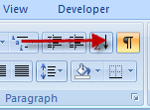

1. Press [Ctrl] [Shift] [8] keys simultaneously

To find and delete all hidden text before publishing, press [Ctrl] [F] keys, press Format button, and select the Font | Effects | Hidden box and press OK button. On the Replace tab, place cursor in Replace with: box and press Delete key then press Replace All button.

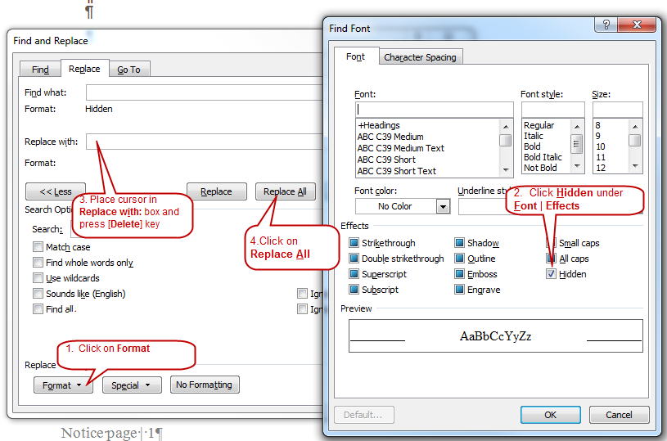

**Administrative Procedures Act Requirements**

All DEQ public writing for rulemaking must be clear and simple to meet requirements of the Administrative Procedures Act.

**ORS 183.750** Readability of Public Writingshttp://www.oregon.gov/DAS/Images/spacer.gif

Article Content

183.750 State agency required to prepare public writings in readable form.

(1) Every state agency shall prepare its public writings in language that is as clear and simple as possible.

(2) As used in this section:

(a) “Public writing” means any rule, form, license or notice prepared by a state agency.

(b) “State agency” means any officer, board, commission, department, division or institution in the executive or administrative branch of state government. [Formerly 183.025]

Note: 183.750 was enacted into law by the Legislative Assembly but was not added to or made a part of ORS chapter 183 or any series therein by legislative action. See Preface to Oregon Revised Statutes for further explanation.

**ORS 183.335**

Notice

(2)(a) The notice required by subsection (1) of this section must include:

…(B) An objective, simple and understandable statement summarizing the subject matter and purpose of the intended action in sufficient detail to inform a person that the persons interests may be affected, and the time, place and manner in which interested persons may present their views on the intended action.

For public comments received by the close of the public comment period, the following table organizes comments into Enter number of categories categories with cross references to the commenter number. DEQ’s response follows the summary. Original comments are on file with DEQ.

Select one option below

OPTION 1 DEQ did not change the proposed rules in response to comments.

OPTION 2 DEQ changed the proposed rules in response to comments described in the response sections below

1. **Comment** Enter a summary of this comment category. Text

DEQ received Enter the number of comments received for this category. comments in this category from commenters Cross reference to commenter number or numbers submitted in this category using format ##, ##, ## and ##. listed in the *Commenter* section below.

Response Enter DEQ’s response to this category of comments. Text

1. **Comment** Enter a summary of this comment category. Text

DEQ received Enter the number of comments received for this category. comments in this category from commenters Cross reference to commenter number or numbers submitted in this category using format ##, ##, ## and ##. listed in the *Commenter* section below.

Response Enter DEQ’s response to this category of comments. Text

1. **Comment** Enter a summary of this comment category. Text

DEQ received Enter the number of comments received for this category. comments in this category from commenters Cross reference to commenter number or numbers submitted in this category using format ##, ##, ## and ##. listed in the *Commenter* section below.

Response Enter DEQ’s response to this category of comments. Text

Add more comments by copying and pasting additional comment sections here.

|  |
| --- |
| Commenters |

DEQ complies with Oregon Revised Statute 192.501(29) to protect addresses for students who attend a public university or Oregon Health and Science University. DEQ established the Comment_CodeName accounts for students to comment on this proposal. Save student comment emails as *STUDENT.COMMENT.pdf*. and store on \\deqhq1\Rule_Development\Currrent Plan in folder 5.PublicCommentAnd Testimony for this rulemaking. Sometimes organizations may use this account to robo-comment. Collect and save these comments as ROBO.COMMENT.pdf and store in the same folder 5.

## Comments received by close of public comment period

The table below lists Enter the number of commenters. people and organizations that submitted public comments about the proposed rules by the deadline on Enter the date and time for comment closure. Example Feb. 14, 2014 at 5 p.m.. Original comments are on file with DEQ.

1. **Commenter** Enter name Text

AffiliationEnter name of party that this person represents.Text

This commenter submitted comments under categories Cross reference to comment category using ##, ##, ##, and ## format in the *Summary of comments and DEQ responses* section above.

1. **Commenter** Enter name Text

AffiliationEnter name of party that this person represents.Text

This commenter submitted comments under categories Cross reference to comment category using ##, ##, ##, and ## format in the *Summary of comments and DEQ responses* section above.

1. **Commenter** Enter name Text

AffiliationEnter name of party that this person represents.Text

This commenter submitted comments under categories Cross reference to comment category using ##, ##, ##, and ## format in the *Summary of comments and DEQ responses* section above.

Add more commenters by copying and pasting additional commenter sections here.