

Oregon Department of Environmental Quality

**MARCH 19-20, 2014**

Oregon Environmental Quality Commission Meeting

Rulemaking Action Item: #

**Incorporate Lane Regional Air Protection Agency Rules for**

**open burning into State Implementation Plan**

|  |
| --- |
| **DEQ recommendation to the EQC** |

DEQ recommends that the Environmental Quality Commission:

Adopt the proposed rules in Attachment A as part of chapter 340 of the Oregon Administrative Rules. Approve incorporating these rule amendments into the Oregon Clean Air Act State Implementation Plan under OAR 340-200-0040.

|  |
| --- |
| **Overview** |

Short summary

DEQ proposes to incorporate Lane Regional Air Protection Agency revised regulations for open burning into Oregon’s State Implementation Plan in Oregon Administrative Rule 340-200-0040. The LRAPA Board of Directors adopted open burning rules revisions in an effort to meet federal air quality standards for fine particulate matter, to bring LRAPA in line with state rules and to better coordinate with state and federal requirements. The LRAPA rules were revised to:

* Clarify when and where small recreational fires such as patio fireplace could occur and identify acceptable fuels for these fires,
* Include Hazeldell and Siuslaw Rural Fire Protection Districts in the special open-burning control area at the districts’ request,
* Allow daily end time on burn days to be set earlier than sunset,
* Restrict the open burning season in the outlying areas of Lane County, and
* Correct the meaning of the LRAPA acronym to Lane Regional Air Protection Agency.

Brief history

LRAPA, in consultation with DEQ and the U.S. Environmental Protection Agency, is responsible for ensuring that Lane County communities comply with federal air quality health standards, including enacting plans to restore healthy air quality in any area violating standards. LRAPA conducts air monitoring, permitting and compliance, inspection and enforcement, and regulates open burning and asbestos abatement throughout Lane County. It also has a woodstove advisory program, an open burning advisory program and conducts special projects focused on air quality. The agency is funded by local dues from Lane County and the cities of Lane County, industrial and other permitting fees, and LRAPA coordinates with DEQ to obtain EPA funding and state general funds.

On March 14, 2008, the LRAPA Board of Directors adopted the Title 47 open burning rules, provided at the end of this document, and the rules have been in effect in Lane County since their adoption. The Environmental Quality Commission and DEQ have oversight authority to ensure LRAPA meets Clean Air Act requirements. The State Implementation Plan is the State of Oregon Clean Air Act Implementation Plan as adopted by EQC under OAR 340-200-0040 and approved by EPA. EQC’s role is to review LRAPA rules to determine if they comply with state law and the Clean Air Act, approve those rules if they comply, and direct DEQ to submit the approved rules to EPA for federal approval as State Implementation Plan amendments.

Typically, DEQ submits LRAPA rules to EQC for incorporation into the State Implementation Plan immediately upon adoption by the LRAPA board. However, in this case, DEQ determined that the public notice process held jointly by DEQ and LRAPA several years ago did not meet requirements for State Implementation Plan rules, which are above and beyond requirements for normal rulemaking. Performing rulemaking is resource intensive and DEQ was unable to perform the additional public notice requirements until now.

Regulated parties

This proposal does not change the regulated parties or requirements for regulated parties from the rules that LRAPA’s board adopted in 2008. The 2008 rules affect residential open burning in Lane County.

|  |
| --- |
| **Stringency Review and Authorization** |

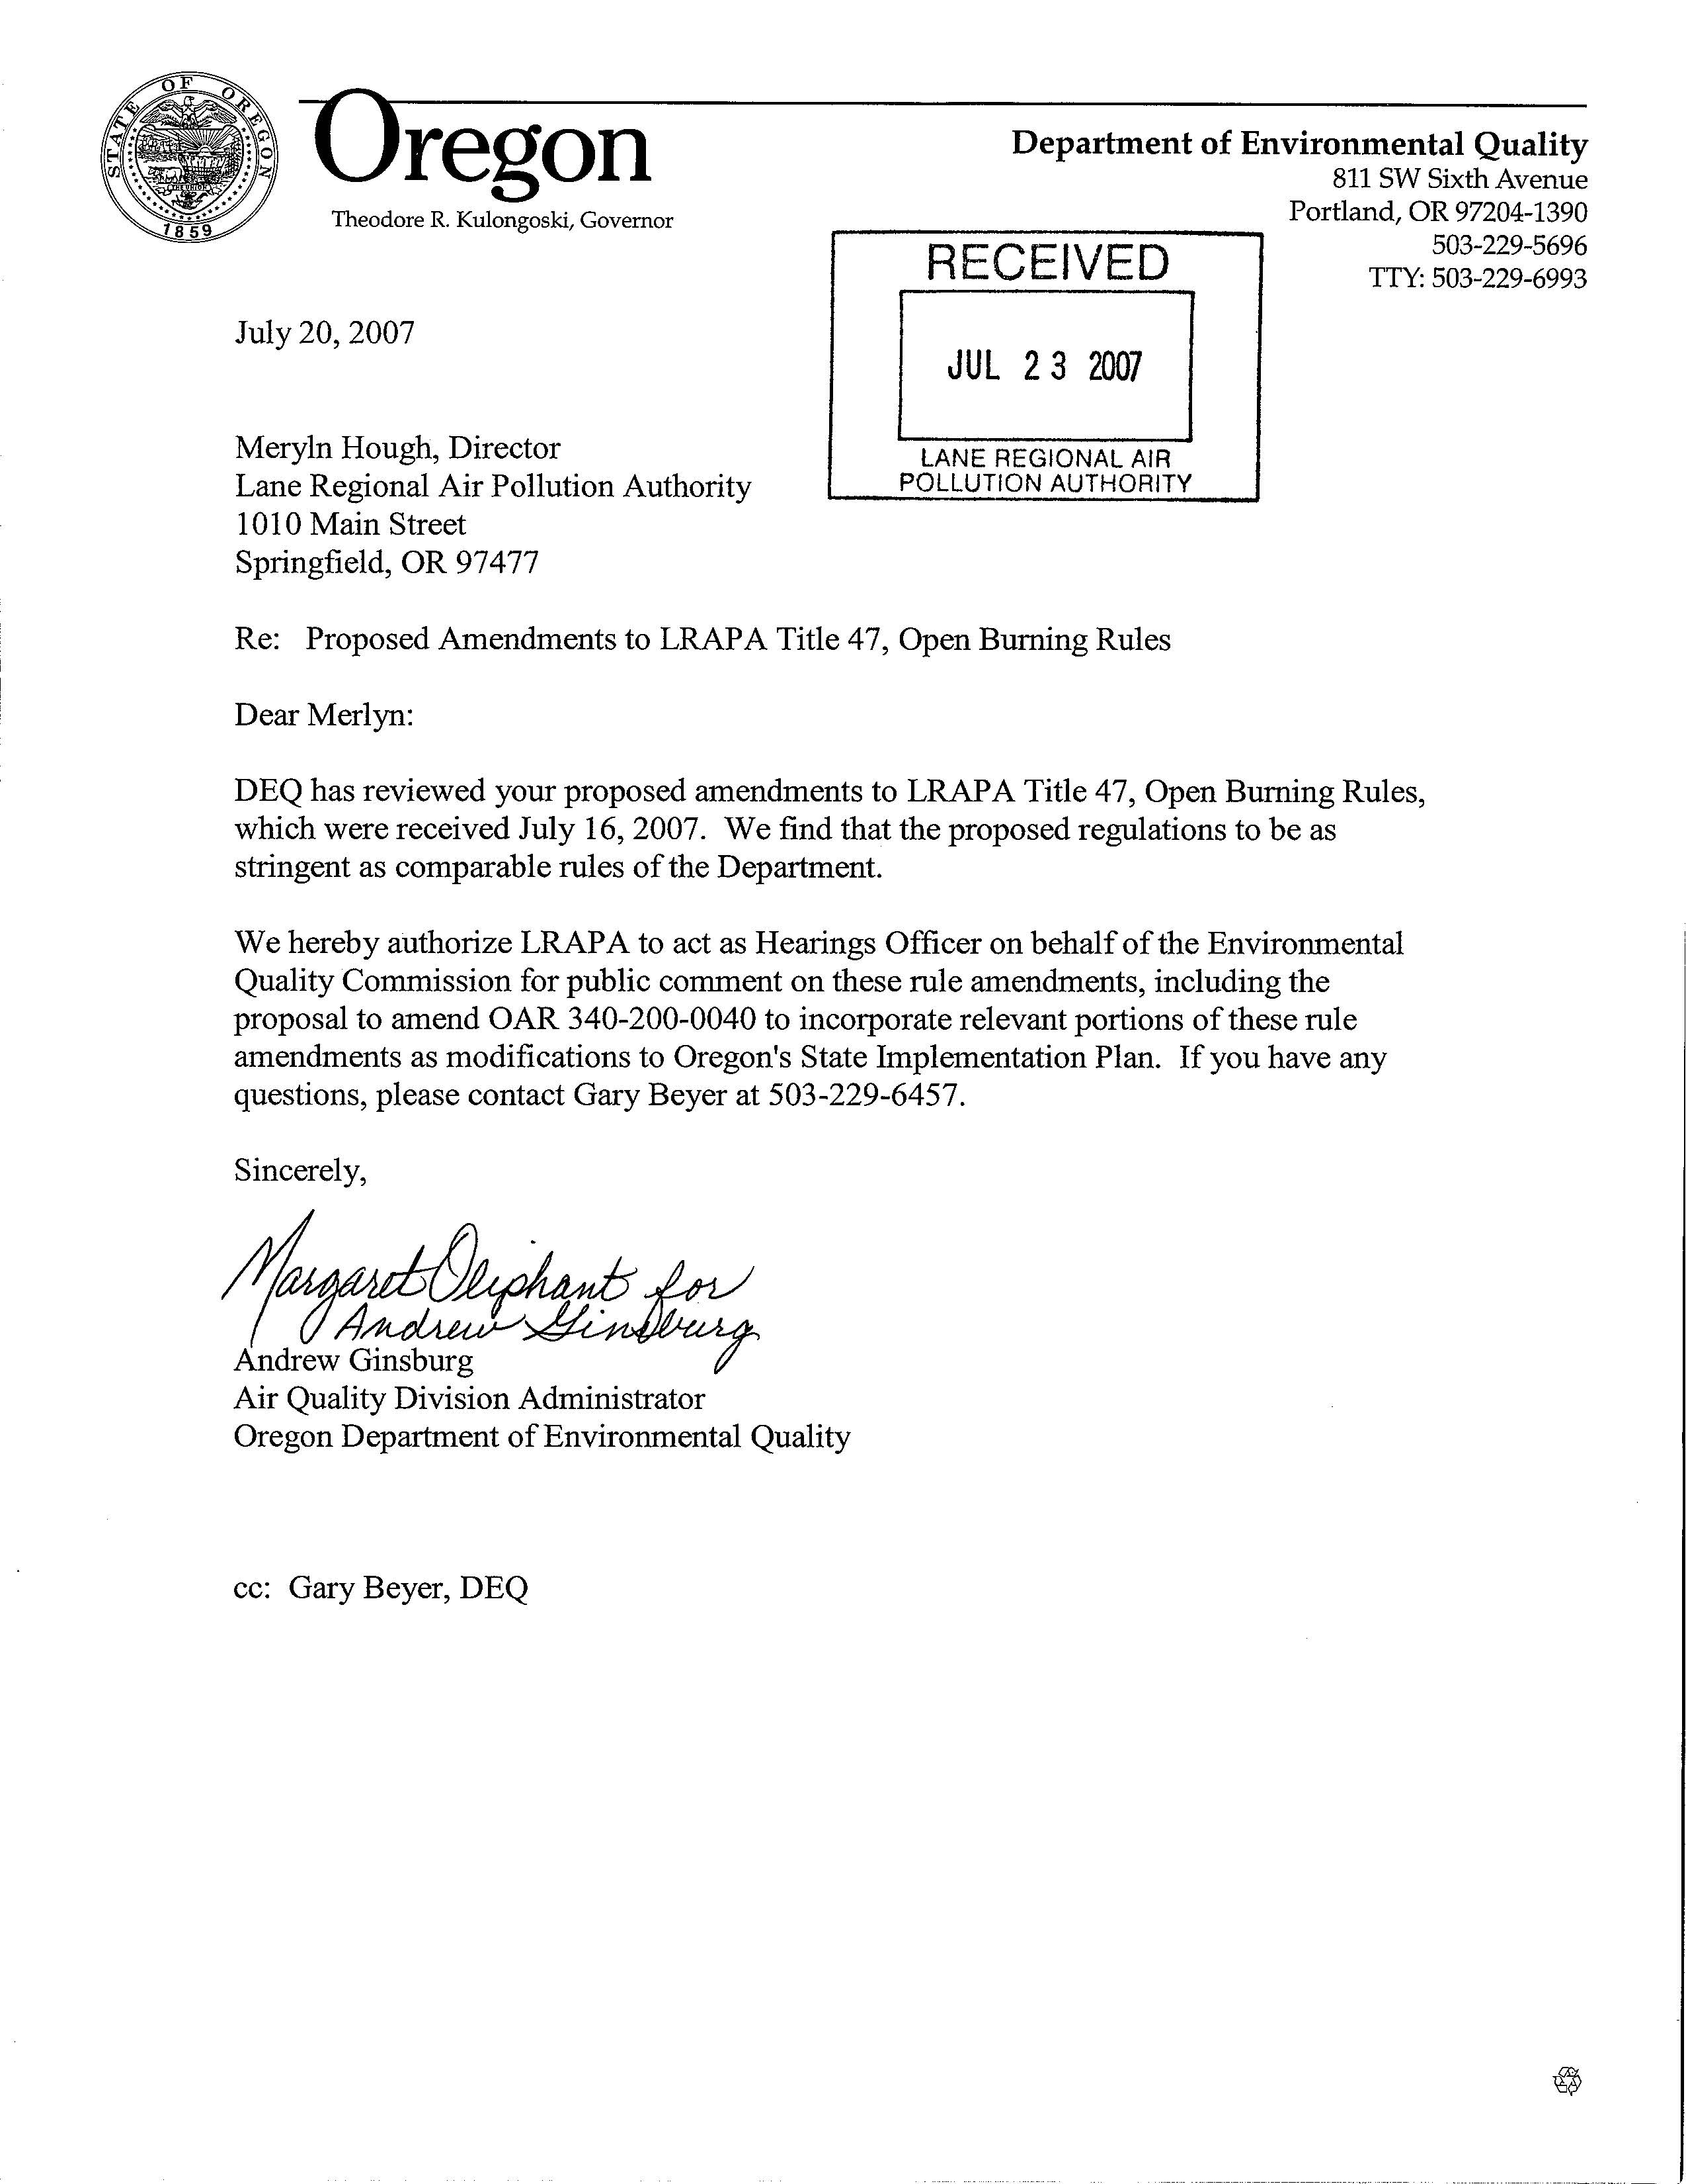

*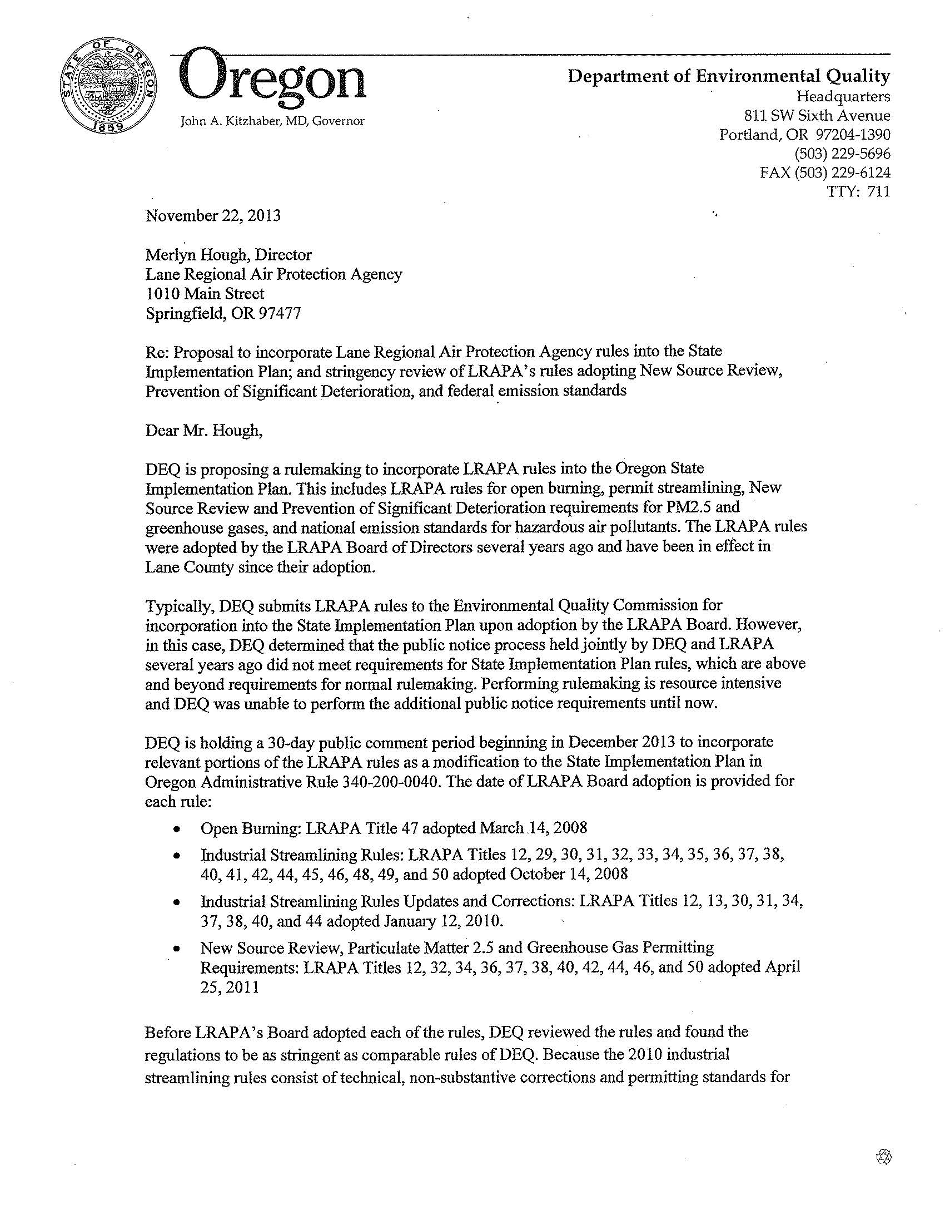c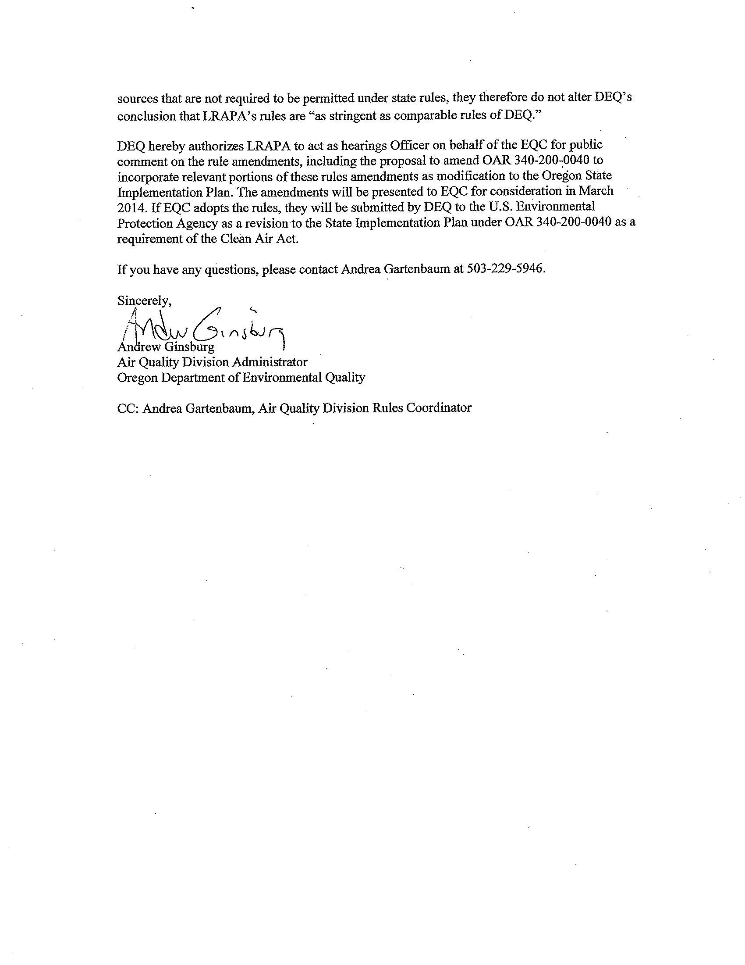*

|  |
| --- |
| **Statement of need** |

What need is DEQ trying to address?

For LRAPA and the state to maintain compliance with the Clean Air Act, EQC must review LRAPA’s rules and, if EQC concludes that the rules comply with state law and the Clean Air Act, approve the rules and direct DEQ to submit them to EPA for approval and incorporation, as appropriate, into the federally-approved State Implementation Plan. The State Implementation Plan does not contain the rules provided at the end of this document, which were adopted by the LRAPA Board of Director’s in 2008. LRAPA adopted changes to its Title 47 open burning rules in an effort to meet federal particulate standards for PM2.5.

Lane County records the highest levels of PM2.5 from November through February. LRAPA adopted changes to its Title 47 open burning rules to prohibit all open burning within the Eugene-Springfield maintenance area during this period to reduce the potential that areas of Lane County could exceed federal particulate standards for PM2.5. LRAPA’s old open burning rules did not adequately address small recreational fires or accommodate the Hazeldell and Siuslaw Rural Fire Protection Districts request to be included in the special open-burning control area. Some definitions were not clear or no longer met the current conditions.

Open burning and backyard burning are major sources of air pollution complaints that LRAPA receives and result in a significant portion of the monthly LRAPA enforcement cases. Open burning complaints were consistently less than 100 per year during 1990-2000 and steadily increased to an average of over 300 per year during 2007-2008.

How would the proposed rule address the need?

LRAPA’s open burning rules provide a consistent basis for complaint response and help prevent public nuisances and violations of PM2.5 National Ambient Air Quality Standards in Lane County.

How will DEQ know the need has been addressed?

The open burning control program will continue to require LRAPA’s diligent implementation to minimize air pollution impacts and nuisances. Indicators of the success of this program will be attainment and maintenance of PM10 and PM2.5 air quality health standards, reduced impacts of residential open burning on neighbors and fewer public complaints.

If EQC adopts the proposed rule, DEQ would submit the rule to EPA to update the federally-approved State Implementation Plan. DEQ will know the goals of this rulemaking have been addressed when EPA reviews and approves the changes to the State Implementation Plan.

Request for other options

During the public comment period, DEQ requested public comment on whether to consider other options for achieving the rule's substantive goals while reducing negative economic impact of the rule on business.

|  |
| --- |
| Rules affected, authorities, supporting documents |

Lead divisionProgram or activity

Air Quality Division State Implementation Plan

Chapter 340 action

|  |  |
| --- | --- |
| Amend | OAR 340-200-0040 |

Statutory authority

ORS 468.020, 468A.035, 468A.135

Other authority

LRAPA Title 13 General Duties and Powers of Board and Director

LRAPA Title 14 Rules of Practice and Procedure

Statute implemented Legislation

ORS 468 and 468A

Documents relied on for rulemaking [ORS 183.335(2)(b)(C)](http://www.leg.state.or.us/ors/183.html)

|  |  |
| --- | --- |
| **Document title** | **Document location** |
| LRAPA Title 47 Open burning rules adopted March 14, 2008 | Provided at the end of this document |
| LRAPA Board of Directors Meeting, March 14, 2008, Item 4: Adoption of Title 47 amendments | DEQ Headquarters  811 SW 6th Avenue  Portland, OR 97204 |
| Oregon Administrative Rules for Open Burning - Chapter 340 Division 264 | <http://arcweb.sos.state.or.us/pages/rules/oars_300/oar_340/340_264.html> |
| Letter from DEQ to LRAPA, July 20, 2007, Stringency review of Title 47 amendments | DEQ Headquarters  811 SW 6th Avenue  Portland, OR 97204 |
| Letter from DEQ to LRAPA, November 22, 2013, Proposal to incorporate Lane Regional Air Protection Agency rules into the State Implementation Plan and stringency review of LRAPA’s rules | DEQ Headquarters  811 SW 6th Avenue  Portland, OR 97204 |

|  |
| --- |
| Fee Analysis |

This rulemaking does not involve fees.

|  |
| --- |
| Statement of fiscal and economic impact [ORS 183.335 (2)(b)(E)](http://www.leg.state.or.us/ors/183.html) |

Fiscal and Economic Impact

The proposed rule has no significant fiscal or economic impact. This proposal involves minor clarifications and updates that primarily affect residential open burning in Lane County.

In 2008, LRAPA’s original analysis determined that the rule amendments have no significant fiscal or economic impact. In 2013, DEQ in consultation with LRAPA reevaluated the proposed rule and DEQ determined LRAPA’s original analysis is reasonable and still correct considering events that have occurred since 2008.

Statement of Cost of Compliance

Impacts on public

There is no significant fiscal or economic impact on the general public.

Impact on other government entities other than DEQ

1. Local governments No significant impact, including LRAPA
2. State agencies No significant impact

Impact on DEQ [ORS 183.335](http://www.leg.state.or.us/ors/183.html)

There is no significant fiscal or economic impact on DEQ.

Impact on large businesses (all businesses that are not small businesses below)

This proposal primarily affects residential open burning in Lane County and would have no significant fiscal or economic impact on large businesses.

Impact on small businesses (those with 50 or fewer employees) [ORS 183.336](http://www.leg.state.or.us/ors/183.html)

This proposal primarily affects residential open burning in Lane County and would have no significant fiscal or economic impact on small businesses.

|  |  |
| --- | --- |
| a) Estimated number of small businesses and types of businesses and industries with small businesses subject to proposed rule. | This proposal does not affect small businesses. |
| b) Projected reporting, recordkeeping and other administrative activities, including costs of professional services, required for small businesses to comply with the proposed rule. | This proposal does not affect small businesses; therefore, no additional activities apply to small businesses. |
| c) Projected equipment, supplies, labor and increased administration required for small businesses to comply with the proposed rule. | This proposal does not affect small businesses; therefore, small businesses do not need additional resources to comply. |
| d) Describe how DEQ involved small businesses in developing this proposed rule. | This proposal does not affect small businesses; therefore, small businesses were not involved in developing this proposal. |

Documents relied on for fiscal and economic impact

|  |  |
| --- | --- |
| **Document title** | **Document location** |
| LRAPA Title 47 Open burning rules adopted March 14, 2008 | Provided at the end of this document |
| LRAPA Board of Directors Meeting, March 14, 2008, Item 4: Adoption of Title 47 amendments | DEQ Headquarters  811 SW 6th Avenue  Portland, OR 97204 |
| Oregon Administrative Rules for Open Burning - Chapter 340 Division 264 | <http://arcweb.sos.state.or.us/pages/rules/oars_300/oar_340/340_264.html> |
| Letter from DEQ to LRAPA, July 20, 2007, Stringency review of Title 47 amendments | DEQ Headquarters  811 SW 6th Avenue  Portland, OR 97204 |
| Letter from DEQ to LRAPA, November 22, 2013, Proposal to incorporate Lane Regional Air Protection Agency rules into the State Implementation Plan and stringency review of LRAPA’s rules | DEQ Headquarters  811 SW 6th Avenue  Portland, OR 97204 |

Advisory committee

DEQ did not appoint an advisory committee. LRAPA followed appropriate requirements for rulemaking when it adopted its rules.

Housing cost

To comply with [ORS 183.534](http://www.leg.state.or.us/ors/183.html), DEQ determined the proposed rule would have no effect on the development cost of a 6,000-square-foot parcel and construction of a 1,200-square-foot detached, single-family dwelling on that parcel. Adoption of DEQ’s rules would provide for DEQ to submit LRAPA’s rules to EPA for incorporation into the State Implementation Plan. Any affects of LRAPA’s rules on residential open burning occurred when LRAPA adopted the rules, and the rules applied in Lane County upon LRAPA’s adoption.

|  |
| --- |
| **Federal relationship** |

*"It is the policy of this state that agencies shall seek to retain and promote the unique identity of Oregon by considering local conditions when an agency adopts policies and rules. However, since there are many federal laws and regulations that apply to activities that are also regulated by the state, it is also the policy of this state that agencies attempt to adopt rules that correspond with equivalent federal laws and rules..."* [ORS 183.332](http://www.oregonlaws.org/ors/183.332)

Relationship to federal requirements

This section complies with [OAR 340-011-0029](http://arcweb.sos.state.or.us/pages/rules/oars_300/oar_340/340_011.html) and [ORS 468A.327](http://www.oregonlaws.org/ors/468A.327) to clearly identify the relationship between the proposed rule and applicable federal requirements.

The proposed rule is “in addition to federal requirements.”

The 2008 LRAPA rules help to reduce the potential that areas of Lane County could exceed federal particulate standards for PM2.5. There are no federal rules applicable to open burning. LRAPA’s 2008 open burning rules are an element of the State Implementation Plan that is a federally approved and enforceable strategy outlining how Oregon will meet federal air quality standards to protect public health and the environment.

What alternatives did DEQ consider if any?

A total ban on open burning was not considered feasible in an area as diverse as Lane County. Open burning is recognized as an important tool for disposal of yard debris and reducing overall fire danger, especially on larger acreages in more rural areas of Lane County.

|  |
| --- |
| Land use |

*“It is the Commission's policy to coordinate the Department's programs, rules and actions that affect land use with local acknowledged plans to the fullest degree possible.”*  [ORS 197.180](http://www.oregonlaws.org/ors/197.180), [OAR 018-0010](http://arcweb.sos.state.or.us/pages/rules/oars_300/oar_340/340_018.html)

Land-use considerations

To determine whether the proposed rule involves programs or actions that are considered a *land-use action*, DEQ considered:

* Statewide planning goals for specific references. Section III, subsection 2 of the DEQ State Agency Coordination Program document identifies the following statewide goal relating to DEQ's authority:

**Goal Title**

5 Open Spaces, Scenic and Historic Areas, and Natural Resources

6 Air, Water and Land Resources Quality

11 Public Facilities and Services

16 Estuarial resources

19 Ocean Resources

* [OAR 340-018-0030](http://arcweb.sos.state.or.us/pages/rules/oars_300/oar_340/340_018.html) for EQC rules on land-use coordination. Division 18 requires DEQ to determine whether the proposed rule will significantly affect land use. If yes, how will DEQ:
  + Comply with statewide land-use goals, and
  + Ensure compatibility with acknowledged comprehensive plans, which DEQ most commonly achieves by requiring a [Land Use Compatibility Statement](http://www.deq.state.or.us/pubs/permithandbook/lucs.htm).
* DEQ’s mandate to protect public health and safety and the environment.
* Whether DEQ is the primary authority that is responsible for land-use programs or actions in the proposed rule.
* Present or future land uses identified in acknowledged comprehensive plans.

Determination

DEQ determined that the proposed rule, OAR 340-200-0040, **does not affect** existing rules, programs or activities that are considered land-use programs and actions in OAR 340-018-0030 or in the DEQ State Agency Coordination Program. LRAPA’s rules are consistent with land use in applicable Lane County land use plans.

|  |
| --- |
| Stakeholder and public involvement |

 Advisory committee

DEQ did not convene an advisory committee. LRAPA followed appropriate requirements for rulemaking when it adopted its rules.

 EQC prior involvement

DEQ shares general rulemaking information with EQC through the monthly Director’s Report. DEQ did not present additional information specific to this proposed rule revision.

Public notice

The January 2014[*Oregon Bulletin*](http://arcweb.sos.state.or.us/pages/rules/bulletin/past.html) published the Notice of Proposed Rulemaking with Hearing.

DEQ also:

* Posted notice on DEQ’s webpage <http://www.oregon.gov/deq/RulesandRegulations/Pages/2013/LRAPAOB.aspx> on Dec. 18, 2013.
* E-mailed notice on Dec. 18, 2013 to:
* Interested parties through GovDelivery
* Interested parties and stakeholders provided to DEQ by LRAPA
* The following key legislators required under [ORS 183.335](http://www.leg.state.or.us/ors/183.html):
  + Jules Bailey, Chair, House Energy and Environment Committee
  + Michael Dembrow, Chair, Senate Environment and Natural Resources Committee
* Members of LRAPA’s advisory committee
* Members of LRAPA’s Board of Directors
* Mailed the notice by U.S. Postal Service to 209 interested parties on December 18, 2013.
* Sent notice to EPA on Aug. 20, 2013.
* Published legal advertisement in the following newspapers on Dec. 18, 2013:
  + - Oregonian
    - Register Guard

Public hearings and comment

DEQ held one public hearing on the evening of Jan. 22, 2014. DEQ authorized LRAPA to act as hearings officer for the public hearing. DEQ received no public comments.

Presiding Officers’ Record

Presiding Officer Report Date: Jan. 28, 2014

Hearing

Location 1010 Main Street, Springfield, Oregon 97477

Date Jan. 22, 2014

Time Convened 5:30 p.m. Closed 6 p.m.

Presiding Officer Merlyn Hough, Permit Section Manager, Operations

Two people attended the hearing in person and no one provided comment.

At 5:45 p.m. before taking comments, the presiding officer summarized procedures for the hearing including notification that DEQ was recording the hearing. The presiding officer asked people who wanted to present verbal comments to complete, sign and submit a registration form to indicate their intent to present comments.

According to [Oregon Administrative Rule 137-001-0030](http://arcweb.sos.state.or.us/pages/rules/oars_100/oar_137/137_001.html), the presiding officer summarized the content of the notice given under [Oregon Revised Statute 183.335](http://www.leg.state.or.us/ors/183.html). This summary took about 10 minutes and included responses by the presiding officer and Merlyn Hough (Director of LRAPA) to questions about the rulemaking.

Close of public comment period

The comment period closed on Jan. 27, 2014 at 5:00 p.m.

|  |
| --- |
| Implementation |

Notification

The proposed rules would become effective upon filing with the Secretary of State, approximately March 21, 2014. DEQ will notify Lane Regional Protection Agency by email.

Compliance and enforcement

* Affected parties – The regulations do not change the regulated parties or requirements for regulated parties.
* DEQ staff – DEQ would submit the rules to the U.S. Environmental Protection Agency as a revision to the Oregon State Implementation Plan.

|  |
| --- |
| Five-year review |

Requirement ORS 183.405

The state Administrative Procedures Act requires DEQ to review **new** rules within five years of the date the EQC adopts the proposed rules. Though the review will align with any changes to the law in the intervening years, DEQ based its analysis on current law.

Exemption from five-year rule review

The Administrative Procedures Act exempts all of the proposed rules from the five-year rule review because the proposed rules would amend or repeal an existing rule. ORS 183.405 (4)

[Once this staff report is finalized, we’ll add the LRAPA rules to the end of this document]