

Oregon Department of Environmental Quality

**December 18, 2013**

Notice of Proposed Rulemaking

**Incorporate Lane Regional Air Protection Agency Rules for**

**permitting requirements into State Implementation Plan**

|  |
| --- |
| **Overview** |

Short summary

DEQ proposes to incorporate Lane Regional Air Protection Agency revised regulations for air quality permits into Oregon’s State Implementation Plan in Oregon Administrative Rule 340-200-0040. The LRAPA Board of Directors adopted the rules revisions in an effort to bring LRAPA in line with state rules and better coordinate with state and federal requirements.

The LRAPA rules contain:

* U.S. Environmental Protection Agency’s thresholds for New Source Review and Prevention of Significant Deterioration for fine particulate matter (PM2.5) and greenhouse gases
* New and amended federal New Source Performance Standards and National Emission Standards for Hazardous Air Pollutants applicable to non-major or area sources including aluminum, copper, and other nonferrous foundries; chemical manufacturing; ferroalloy production; metal fabrication and finishing; paint stripping and miscellaneous surface coating operations; and plating and polishing operations
* Permitting requirements necessary to implement the federal standards
* Registration options as an alternative to permitting
* Exemptions to permitting for emergency-use and small electrical power generating units
* Statutory requirements for small scale local energy projects
* Corrections to rule citations and definitions of terms

Brief history

LRAPA, in consultation with DEQ and the U.S. Environmental Protection Agency, is responsible for ensuring that Lane County communities comply with federal air quality health standards, including enacting plans to restore healthy air quality in any area violating standards. LRAPA conducts air monitoring, permitting and compliance, inspection and enforcement, and regulates open burning and asbestos abatement throughout Lane County. It also has a woodstove advisory program, an open burning advisory program and conducts special projects focused on air quality. The agency is funded by local dues from Lane County and the cities of Lane County, industrial and other permitting fees, and LRAPA coordinates with DEQ to obtain EPA funding and state general funds.

On April 25, 2011, the LRAPA Board of Directors adopted the permitting rules, provided at the end of this document, and the rules have been in effect in Lane County since their adoption. The Environmental Quality Commission and DEQ have oversight authority to ensure LRAPA meets Clean Air Act requirements. The State Implementation Plan is the State of Oregon Clean Air Act Implementation Plan as adopted by EQC under OAR 340-200-0040 and approved by EPA. EQC’s role is to review LRAPA rules to determine if they comply with state law and the Clean Air Act, approve those rules if they comply, and direct DEQ to submit the approved rules to EPA for federal approval as State Implementation Plan amendments.

Typically, DEQ submits LRAPA rules to EQC for incorporation into the State Implementation Plan immediately upon adoption by the LRAPA board. However, in this case, DEQ determined that the public notice process held jointly by DEQ and LRAPA several years ago did not meet requirements for State Implementation Plan rules, which are above and beyond requirements for normal rulemaking. Performing rulemaking is resource intensive and DEQ was unable to perform the additional public notice requirements until now.

Regulated parties

This proposal does not change the regulated parties or requirements for regulated parties from the rules that LRAPA’s board adopted in 2011. The regulated parties are subject to LRAPA’s Air Contaminant Discharge Permit and Title V Operating Permit requirements. The 2011 LRAPA rules:

* Affect facilities in Lane County.
* Regulate emissions of PM2.5 and greenhouse gases at all stationary sources emitting more than the ‘de minimis’ level of these pollutants.
* Regulate motor vehicle and mobile equipment surface coating and metal fabrication facilities subject to new and modified National Emission Standards for Hazardous Air Pollutants.

|  |
| --- |
| **Stringency Review and Authorization** |

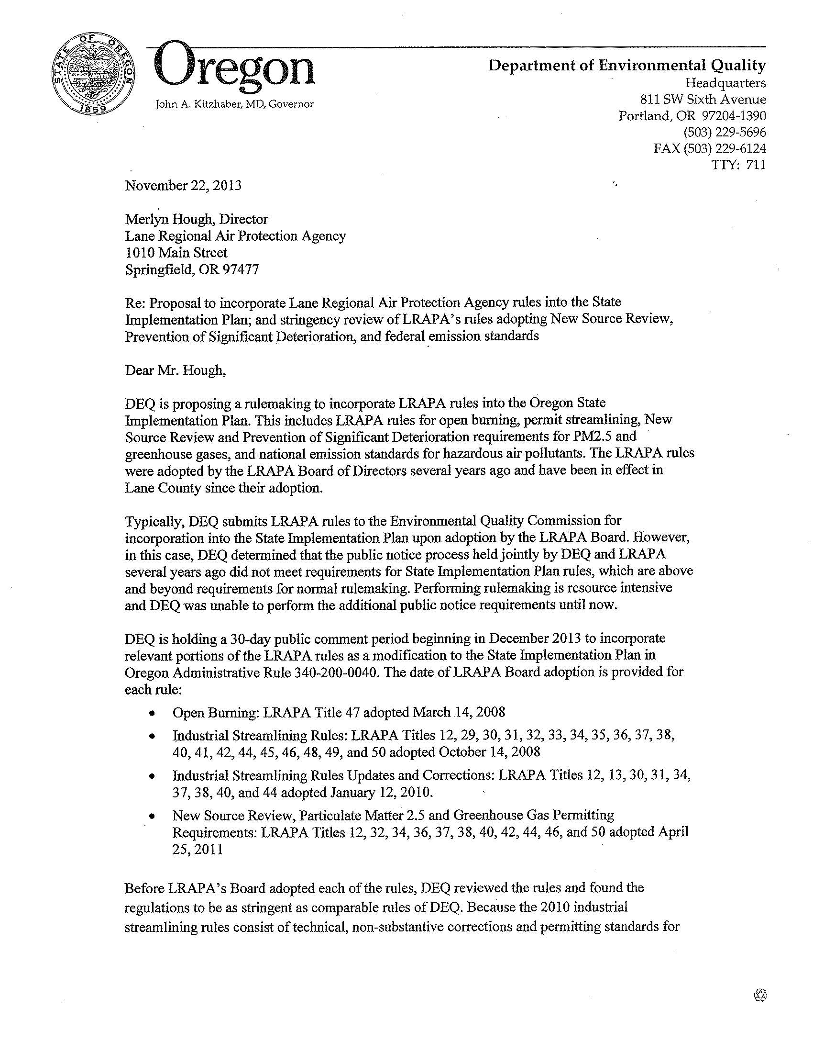

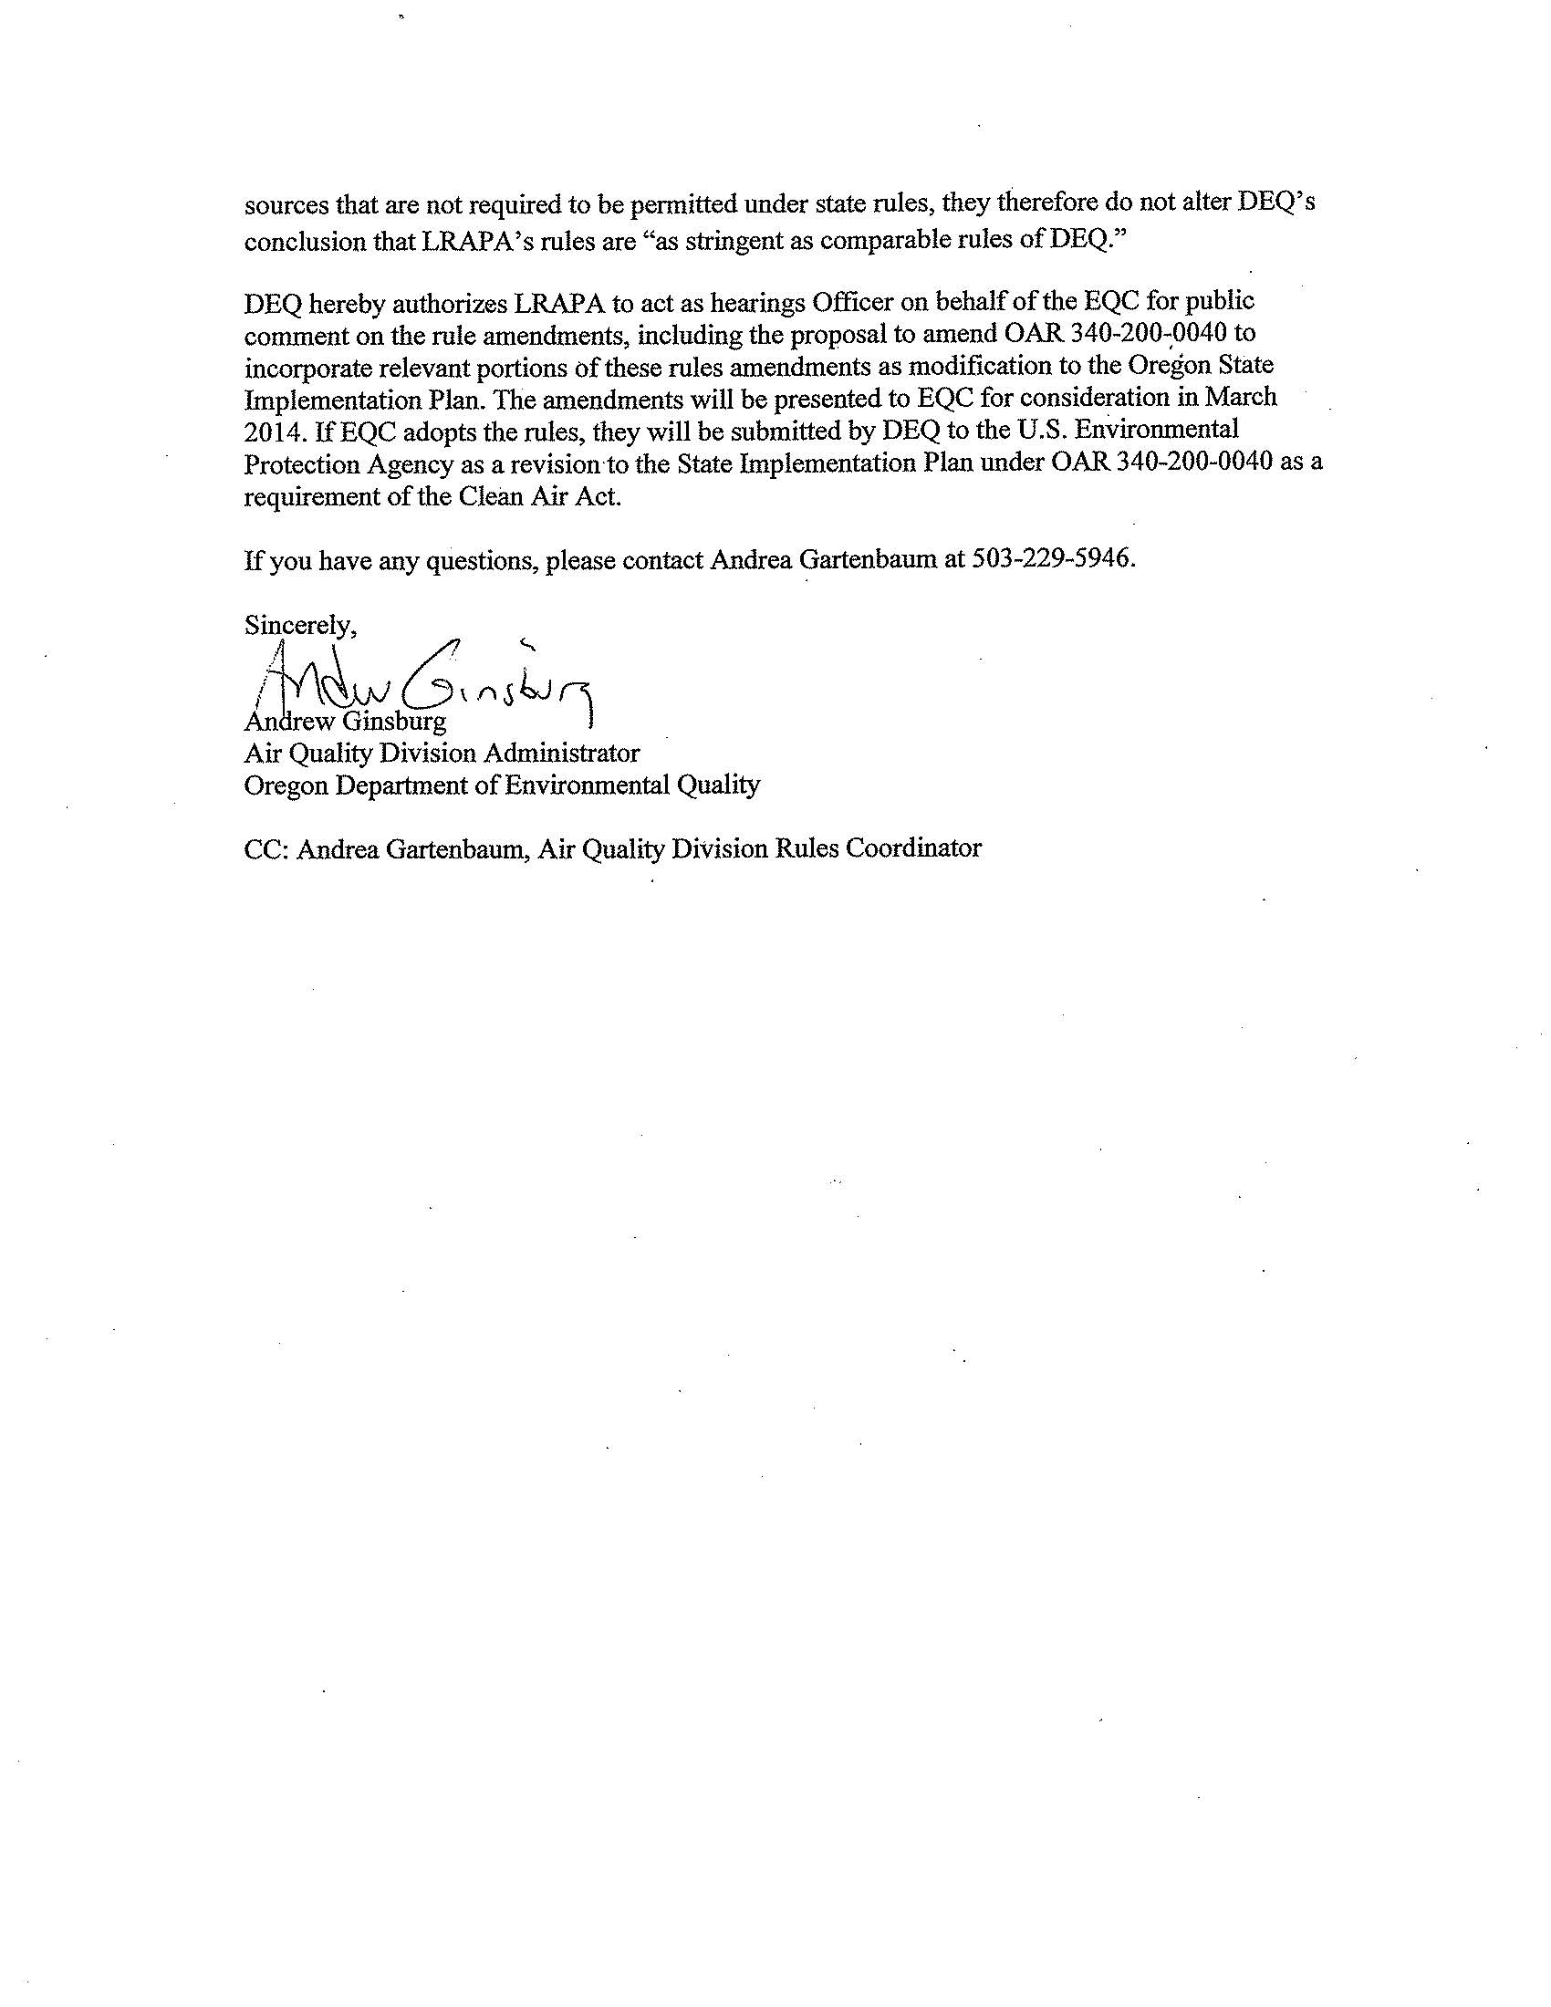

|  |
| --- |
| **Statement of need** |

What need is DEQ trying to address?

For LRAPA and the state to maintain compliance with the Clean Air Act, EQC must review LRAPA’s rules and, if the EQC concludes that the rules comply with state law and the Clean Air Act, approve the rules and direct DEQ to submit them to EPA for approval and incorporation, as appropriate, into the federally-approved State Implementation Plan. LRAPA’s permitting rules are already in effect in Lane County, but the rules have not been incorporated into the State Implementation Plan.

The 2011 LRAPA rules are needed to retain EPA’s approval to implement the Prevention of Significant Deterioration and Title V operating permit programs. Had LRAPA not adopted the rules, it could have lost federal approval to implement these programs and faced sanctions. The 2011 rules are also needed to align LRAPA with statutory requirements for small-scale local energy projects by providing the ability to obtain offsets within a nonattainment area.

How would the proposed rule address the need?

The LRAPA rules are effectively equivalent to DEQ rules and help LRAPA coordinate with and meet state and federal requirements.

How will DEQ know the need has been addressed?

If EQC adopts the rules, DEQ would submit the rules to EPA to update the federally-approved State Implementation Plan including a request for federal delegation of certain rule aspects, where appropriate. DEQ will know the goals of this rulemaking have been addressed when EPA reviews and approves the delegation request and changes to the State Implementation Plan.

Request for other options

During the public comment period, DEQ requests public comment on whether to consider other options for achieving the rule's substantive goals while reducing negative economic impact of the rule on business.

|  |
| --- |
| Rules affected, authorities, supporting documents |

Lead divisionProgram or activity

Air Quality State Implementation Plan

Chapter 340 action

|  |  |
| --- | --- |
| Amend | 340-200-0040 |

Statutory authority

ORS 468.020, 468.065, 468A.135

Other authority

LRAPA Title 13 General Duties and Powers of Board and Director

LRAPA Title 14 Rules of Practice and Procedure

Statute implemented Legislation

ORS 468 and 468A

Documents relied on for rulemaking [ORS 183.335(2)(b)(C)](http://www.leg.state.or.us/ors/183.html)

|  |  |
| --- | --- |
| **Document title** | **Document location** |
| LRAPA rules adopted April 25, 2011 | Provided at the end of this document |
| LRAPA Board of Directors Meeting, April 25, 2011, Item 5: Adoption of PM2.5 and Greenhouse Gas Air Contaminant Discharge Permitting, ACDP Permitting for Area Sources of Hazardous Air Pollutants, and Greenhouse Gas Reporting Fee Requirements, Titles 12, 32, 34, 36, 37, 38, 40, 42, 44, 46, and 50 | DEQ Headquarters  811 SW 6th Avenue  Portland, OR 97204 |
| Oregon Administrative Rules Chapter 340 Divisions 200, 202, 210, 215, 216, 222, 224, 225, 228, 246, and OAR 340-244-0238 through 0246 | <http://www.deq.state.or.us/regulations/rules.htm> |
| Letter from DEQ to LRAPA, November 22, 2013, Proposal to incorporate Lane Regional Air Protection Agency rules into the State Implementation Plan and stringency review of LRAPA’s rules | DEQ Headquarters  811 SW 6th Avenue  Portland, OR 97204 |
| DEQ Agenda item D, Rule adoption: New Source Review/particulate matter and greenhouse gas permitting requirements and other permitting updates April 21-22, 2011, Environmental Quality Commission Meeting | <http://www.deq.state.or.us/about/eqc/agendas/attachments/2011apr/D-GHG.pdf> |
| DEQ Agenda item P, Rule adoption: Adoption of federal air quality regulations December 10-11, 2009 Environmental Quality Commission Meeting | <http://www.deq.state.or.us/about/eqc/agendas/attachments/2009dec/P-NESHAP.pdf> |

|  |
| --- |
| Fee Analysis |

This rulemaking does not establish or revise fees.

|  |
| --- |
| Statement of fiscal and economic impact [ORS 183.335 (2)(b)(E)](http://www.leg.state.or.us/ors/183.html) |

Fiscal and Economic Impact

This rule proposal does not have a fiscal or economic impact. The proposed rule would incorporate Lane Regional Air Protection Agency revised regulations for air quality permits into Oregon’s State Implementation Plan in Oregon Administrative Rule 340-200-0040.

The LRAPA rules have been in effect in Lane County since their adoption in 2011. DEQ, in consultation with LRAPA, evaluated the rules and determined LRAPA’s original analysis of fiscal and economic impacts is reasonable and still correct considering events that have occurred since LRAPA’s rule adoption several years ago. This notice describes the fiscal and economic impacts resulting from LRAPA’s rule adoption in two sections. One section describes the impacts of LRAPA’s rules for New Source Review and Prevention of Significant Deterioration and second section describes the impacts of LRAPA’s permitting updates, including adoption of federal emission standards, and adoption of permit attachments and registrations as an alternative to permitting.

To reduce the administrative burden and cost of the new standards on affected businesses, LRAPA adopted options for General permit attachments as an alternative to requiring multiple permits, and LRAPA adopted registration as an alternative to permitting for auto body shops and dry cleaners certified through an approved environmental compliance certification program.

This notice does not describe LRAPA’s rule alignment with 2009 Oregon law (House Bill 2952) that established requirements for small-scale local energy sources in Lane County. Any fiscal and economic impacts occurred when the 2009 legislation became effective.

The LRAPA board adopted EPA standards for new electric power generating units on Jan. 12, 2010. The adoption triggered permitting of sources with emergency generators or extremely small engines. Any negative fiscal and economic impacts occurred when EPA adopted the rules because the rules applied in Lane County upon EPA’s adoption. LRAPA rules adopted April 25, 2011 provide an exemption for emergency generators and small electric power generating units to reduce the regulatory burden on these sources.

Statement of Cost of Compliance

Impacts on public: This rule proposal does not have an impact on the public.

**New Source Review/Prevention of Significant Deterioration:** DEQ does not anticipate any direct, negative fiscal or economic impacts from LRAPA’s 2011 rules on the public. Indirect fiscal or economic impacts to the public could occur through increased prices for services or products as a result of costs associated with additional control or process equipment that may be required if a facility triggers the new requirements. DEQ expects any such price increases to be small and lacks available information upon which it could accurately estimate potential increases.

The LRAPA rules could create positive, direct economic benefits by reducing health care costs because of the reduction in PM2.5 emissions allowed from new or expanding large businesses. EPA adopted standards for PM2.5 based on their link to serious health problems such as heart and lung disease. In addition, the rules could create positive, direct economic benefits by reducing health care costs because of reductions in greenhouse gas emissions allowed from new or expanding large businesses. Global warming may create public health problems that could have negative economic impacts. DEQ is unable to estimate those impacts because it lacks available information to project the complicated connection between reductions in those pollutants and the costs of health care.

**Permitting updates:** LRAPA’s 2011 adoption of the new federal area source National Emission Standards for Hazardous Air Pollutants does not indirectly impact the public because any negative fiscal and economic impacts occurred when EPA adopted the rules and EPA rules applied in Oregon upon adoption. The requirement that sources affected by a new federal area source emission standard obtain a permit could have an indirect impact on the public if the source increases the cost of goods and services to offset permitting fees.

Impact on other government entities other than DEQ

1. Local governments: This proposal does not have an impact on government entities.

**New Source Review/Prevention of Significant Deterioration:** LRAPA’s 2011 rule adoption has a negative fiscal and economic impact on local government agencies that build new sources and or modify existing sources and trigger New Source Review or Prevention of Significant Deterioration in Lane County. The costs are similar to those of small businesses. Currently, three county and local government agencies are subject to air permitting regulations. New facilities that would be large sources of PM2.5 and greenhouse gases would also be subject to the rules.

**Permitting updates:** The fiscal and economic impacts of LRAPA’s 2011 rules on local governments are expected to be the same as those estimated for small businesses.

1. State agencies: This proposal does not have an impact on state agencies.

**New Source Review/Prevention of Significant Deterioration:** State and federal government agencies incur the same fiscal and economic impacts as local government agencies mentioned above. Currently there are two state and no federal government agencies subject to air permitting regulations in Lane County.

**Permitting updates:** The fiscal and economic impacts of LRAPA’s 2011 rules on state agencies are expected to be the same as those estimated for small businesses.

Impact on DEQ [ORS 183.335](http://www.leg.state.or.us/ors/183.html)

**New Source Review/Prevention of Significant Deterioration:** Workload for DEQ does not increase as a result of LRAPA incorporating PM2.5 and greenhouse gases into permits. DEQ does not review nor coordinate in the issuance of LRAPA permits.

**Permitting updates:** There is no impact on DEQ for the implementation of the LRAPA permitting rules in Lane County.

Impact on large businesses (all businesses that are not small businesses below)

**New Source Review/Prevention of Significant Deterioration:** Nineteen large businesses are required to hold federal Title V Operating Permits and 101 large businesses hold Air Contaminant Discharge Permits with LRAPA. These permit holders are subject to the PM2.5 and greenhouse gas portions of the LRAPA rules. Additionally, proposed new facilities in Lane County that would be large sources of PM2.5 and greenhouse gases would also be subject to the rules. The fiscal and economic impacts of LRAPA’s 2011 rules on large businesses are expected to be the same as those estimated for small businesses.

**Permitting updates:** The fiscal and economic impacts on large businesses are expected to be the same as those estimated for small businesses.

Impact on small businesses (those with 50 or fewer employees) [ORS 183.336](http://www.leg.state.or.us/ors/183.html)

This proposal does not have an impact on small businesses. The 2011 LRAPA rules have the following impact on small businesses.

|  |  |
| --- | --- |
| a) Estimated number of small businesses and types of businesses and industries with small businesses subject to proposed rule. | **New Source Review/Prevention of Significant Deterioration:** About 100 small businesses in Lane County hold Air Contaminant Discharge Permits and none hold Title V permits. Some of these businesses are in the categories of businesses affected by the rules, including asphalt manufacturing; chemical manufacturing; coffee roasting; commercial bakeries; commercial boilers; crematories; educational institutions; electric power generation; furniture manufacturing; food processing; hospitals; natural gas and oil production and processing; pipe coaters; printers; sand, rock and gravel operations; seed and grain companies; synthetic resin manufacturing; and wood products manufacturing.  **Permitting updates:** About 50 small businesses in Lane County are subject to new area source emission standards or the requirement to have a permit, including paint stripping and miscellaneous surface coating facilities, metal fabrication, plating and polishing and dry cleaners. |
| b) Projected reporting, recordkeeping and other administrative activities, including costs of professional services, required for small businesses to comply with the proposed rule. | **New Source Review/Prevention of Significant Deterioration:** The fiscal and economic impact of LRAPA’s rulemaking is primarily due to federal requirements, although a portion of the impact is caused by incorporating the federal requirements into LRAPA’s unique program for New Source Review and Prevention of Significant Deterioration. LRAPA’s rule adoption created additional costs for reporting, recordkeeping and administrative activities. Affected businesses are required to make an initial estimate of PM2.5 and greenhouse emissions at time of permit renewal or modification so LRAPA can incorporate emission levels into permits. Businesses have the option of assuming that PM2.5 emissions are the same as PM10 emissions (already included in their permits), eliminating any additional costs for reporting, recordkeeping or other administrative activities. Affected businesses can estimate their greenhouse gas emissions using a process similar to their greenhouse gas reporting requirements, which were established separately.  **Permitting updates:** LRAPA’s adoption of national emission standards by reference has no negative fiscal and economic impacts because any negative fiscal and economic impacts occurred when EPA adopted the rules, and because the rules applied in Lane County upon EPA’s adoption. LRAPA’s rules are substantively identical to their federal counterparts.    The requirement that businesses affected by the new area source emission standards obtain a permit may increase the administrative activities or costs of professional services on small businesses. LRAPA adopted permitting requirements for facilities subject to area source National Emission Standards for Hazardous Air Pollutants. Sources that trigger the permitting requirement obtain a Standard Air Contaminant Discharge Permit and pay permitting fees. Standard permitting fees would have a negative fiscal and economic impact on affected businesses. To mitigate the fiscal and economic impact on affected businesses, many of which are small businesses, LRAPA’s rules added the new emission standards to the list of business categories eligible to obtain a Simple or General permits, which are less costly than Standard permits. At the time of LRAPA’s rule adoption, General permits in Lane County cost between $134 per year to $2,092 per year, Simple permits cost between $2,145 per year and $4,290 per year, and Standard permits cost $8,580 per year.  LRAPA’s rule adoption allows business subject to multiple emission standards or multiple General permits to obtain one General permit and one or more General permit attachments in lieu of a second permit. Affected businesses are charged the full annual fee for one General permit and a reduced annual fee for each permit attachment. This has a positive fiscal and economic impact on small businesses because it allows some businesses to avoid the requirement to obtain multiple general permits or a more costly Simple permit that covers all of the relevant emission standards.   * LRAPA’s rule adoption allows LRAPA to use registration as an alternative to permitting. This is available to businesses that participate in an environmental certification program. Registered businesses pay an annual registration fee that is equal to or less than the corresponding annual permitting fee. Registration helps ensure that businesses comply with the new area source emission standards and encourages them to adopt sustainable practices to achieve greater environmental benefits. The registration fee pays LRAPA’s cost for developing and implementing the registration program and ensuring compliance with the applicable standards. Registration has a positive fiscal and economic impact because the registration fee is equal to or less than the corresponding permitting fee and registrations carry fewer administrative reporting requirements compared to permitting. |
| c) Projected equipment, supplies, labor and increased administration required for small businesses to comply with the proposed rule. | **New Source Review/Prevention of Significant Deterioration:** Most of the costs are the result of federal requirements and do not change as a result of adding PM2.5 and greenhouse gases to the list of regulated pollutants in Lane County. This includes costs for employees or consultants to estimate emissions and prepare permit applications and labor for consultants to test stack emissions if a small business triggers New Source Review or Prevention of Significant Deterioration through facility modification or new construction. Additional costs could be incurred if the business had to add control equipment to meet control technology requirements. LRAPA requires businesses perform computer modeling to ensure they meet health standards and do not degrade air quality in wilderness areas. Because LRAPA performs New Source Review and Prevention of Significant Deterioration on a case-by-case analysis and the type of pollution controls and computer modeling varies for each case, DEQ lacks available information to estimate those costs accurately. However, DEQ acknowledges that the cost impact is typically significant. The application fee alone for this type of permit in Lane County was $46,922 at the time of LRAPA’s rule adoption in 2011.  **Permitting updates:** LRAPA’s adoption of national emission standards by reference has no negative fiscal and economic impacts because any negative fiscal and economic impacts occurred when EPA adopted the rules, and because the rules applied in Lane County upon EPA’s adoption. LRAPA’s rules are substantively identical to their federal counterparts. The requirement that businesses affected by the new area source emission standards obtain a permit may require small businesses to add equipment, supplies, labor or administration. To mitigate the burden on small businesses, this rulemaking proposes to allow businesses to register with LRAPA in lieu of obtaining a permit, as described in section b) above. |
| d) Describe how DEQ involved small businesses in developing this proposed rule. | DEQ did not involve small businesses in this rulemaking. LRAPA followed appropriate requirements for rulemaking when it adopted its rules, including outreach to small businesses. |

The following table illustrates the permit fees LRAPA adopted for area sources subject to the new area source emissions standards for General permits and General permit attachments; these are the actual fees paid in 2012.

|  |  |  |  |
| --- | --- | --- | --- |
| **Area Source National Emission Standards for Hazardous Air Pollutants** | **Air Contaminant Discharge Permit Type** | **Number of facilities in Lane County** | **Total annual fees for all facilities combined** |
| Motor Vehicle and Mobile Equipment Surface Coating Operations (6H) | Registration | 2 | $480 |
| Basic (< 20 gallons/yr) | 2 | $786 |
| General (>20 gallons/yr) | 18 | $15,680 |
| Paint Stripping and Miscellaneous Surface Coating Operations (6H) | General | 0 | -- |
| Metal Fabrication and Finishing Operations (6X) | General | 6 | $8,478 |
| General Attachment | 0 | -- |
| Paints and Allied Products Manufacturing (7C) | General | 0 | -- |
| Plating and Polishing Operations (6W) | General | 2 | $1,568 |
| General Attachment | 2 | $232 |
| Aluminum, Copper and Other Nonferrous Foundries (6Z) | General | 0 | -- |
| Ferroalloy Production Facilities (6Y) | General | 0 | -- |
| Perchloroethylene Dry Cleaning Operations (M) | Registration | 3 | $540 |
| Total fees collected by LRAPA in 2012 resulting from  LRAPA’s 2011 rule adoption: | | | $27,764 |

Documents relied on for fiscal and economic impact

|  |  |
| --- | --- |
| **Document title** | **Document location** |
| LRAPA rules adopted April 25, 2011 | Provided at the end of this document |
| LRAPA Board of Directors Meeting, April 25, 2011, Item 5: Adoption of PM2.5 and Greenhouse Gas Air Contaminant Discharge Permitting, ACDP Permitting for Area Sources of Hazardous Air Pollutants, and Greenhouse Gas Reporting Fee Requirements, Titles 12, 32, 34, 36, 37, 38, 40, 42, 44, 46, and 50 | DEQ Headquarters  811 SW 6th Avenue  Portland, OR 97204 |
| Oregon Administrative Rules Chapter 340 Divisions 200, 202, 210, 215, 216, 222, 224, 225, 228, 246, and OAR 340-244-0238 through 0246 | <http://www.deq.state.or.us/regulations/rules.htm> |
| Letter from DEQ to LRAPA, November 22, 2013, Proposal to incorporate Lane Regional Air Protection Agency rules into the State Implementation Plan and stringency review of LRAPA’s rules | DEQ Headquarters  811 SW 6th Avenue  Portland, OR 97204 |
| DEQ Agenda item D, Rule adoption: New Source Review/particulate matter and greenhouse gas permitting requirements and other permitting updates April 21-22, 2011, Environmental Quality Commission Meeting | <http://www.deq.state.or.us/about/eqc/agendas/attachments/2011apr/D-GHG.pdf> |
| DEQ Agenda item P, Rule adoption: Adoption of federal air quality regulations December 10-11, 2009 Environmental Quality Commission Meeting | <http://www.deq.state.or.us/about/eqc/agendas/attachments/2009dec/P-NESHAP.pdf> |

Advisory committee

DEQ did not appoint an advisory committee. LRAPA followed appropriate requirements for rulemaking when it adopted its rules.

Housing cost

To comply with [ORS 183.534](http://www.leg.state.or.us/ors/183.html), DEQ determined the proposed rule does not have an effect on the development cost of a 6,000-square-foot parcel and construction of a 1,200-square-foot detached, single-family dwelling on that parcel. Adoption of DEQ’s rule would provide for DEQ to submit LRAPA’s rules to EPA for incorporation into the State Implementation Plan. Any impact on housing costs occurred when LRAPA adopted the rules, and the rules applied in Lane County upon LRAPA’s adoption. LRAPA’s rules may have had an effect on housing cost. This impact could occur if permit holders affected by LRAPA’s rules pass their permitting fees or other costs to comply with the rules through to the consumer. DEQ does not have available information to quantify how many permit holders would pass the permit fee through to the consumer and any such estimate would be speculative.

|  |
| --- |
| **Federal relationship** <http://www.leg.state.or.us/ors/468a.html> |

*"It is the policy of this state that agencies shall seek to retain and promote the unique identity of Oregon by considering local conditions when an agency adopts policies and rules. However, since there are many federal laws and regulations that apply to activities that are also regulated by the state, it is also the policy of this state that agencies attempt to adopt rules that correspond with equivalent federal laws and rules..."*

Relationship to federal requirements

This section complies with [OAR 340-011-0029](http://arcweb.sos.state.or.us/pages/rules/oars_300/oar_340/340_011.html) and [ORS 468A.327](http://www.oregonlaws.org/ors/468A.327) to clearly identify the relationship between the proposed rule and applicable federal requirements.

The proposed rule is “in addition to federal requirements.” Adoption of DEQ’s rule would provide for DEQ to submit LRAPA’s rules to EPA for incorporation into the State Implementation Plan. Below, we describe how and why LRAPA’s rules adopted in 2011are different from the federal requirements. LRAPA’s rules protect public health, protect environment, and address administrative issues.

**New Source Review/Prevention of Significant Deterioration:** The LRAPA program provides a workable program to accomplish the Clean Air Act goal of preventing significant deterioration of air quality. LRAPA’s rules incorporate two new federally regulated pollutants (greenhouse gases and fine particulates) into LRAPA’s existing program which is, and has been different from the federal program since its inception in 1982.

The primary difference between LRAPA’s rules and the federal rules is how the baseline emission level, or netting basis, is established. Both the LRAPA and federal programs require preconstruction approval for new major air pollution sources or existing sources making modifications that will increase their emissions above a baseline level by a defined amount known as a “Significant Emission Rate.” The netting basis is the emission level in a defined baseline year, adjusted by any required decreases and approved increases of emissions. Under LRAPA’s program, the netting basis is based on actual emissions from a set time period, often the year 1977 or 1978, and is adjusted accordingly based on subsequent changes at the facility. If emissions increase above the netting basis by the Significant Emission Rate for a pollutant, the source triggers New Source Review or Prevention of Significant Deterioration. Under the federal program, New Source Review or Prevention of Significant Deterioration is also triggered by an increase over a Significant Emission Rate; however the concept of baseline and netting basis is different. Instead of having a fixed baseline period, the federal program typically requires a review of the highest actual emissions at a source over any two year period in the previous ten years. Following that review, an annual highest emission level is established and that level is used as the baseline for determining if emissions will increase by more than a Significant Emission Rate.

LRAPA’s rules maintain inherent differences between LRAPA’s permitting program rules and the federal rules for the purpose of administrative consistency with the exception of the Significant Impact Levels that are more stringent for Class II and Class III for environmental and administrative reasons. Significant Impact Levels are used to determine if additional air quality analysis is required during preconstruction approval. EPA’s Significant Impact Levels for PM2.5 were developed by scaling the existing PM10 levels using a PM2.5-to-PM10 National Ambient Air Quality Standard ratio. LRAPA adopted EPA’s Class I Significant Impact Levels. LRAPA adopted Class II and Class III Significant Impact Levels lower than EPA’s values because LRAPA established lower levels in the early 1990’s for PM10 due to DEQ’s establishment of the Significant Impact Levels statewide to address significant air quality problems in the Medford area. Air quality in this area has improved over time but it is still an area of concern. The lower Significant Impact Levels have been maintained as part of LRAPA’s State Implementation Plan to ensure that air quality does not deteriorate. Despite the lower PM10 levels, LRAPA has one area in the Lane County that does not meet ambient air quality standards for PM2.5. Since PM2.5 emissions consist of smaller particles and are considered a subset of PM10 emissions, LRAPA adopted a PM2.5 Significant Impact Level equal to LRAPA’s PM10 Significant Impact Level.

|  |  |  |  |
| --- | --- | --- | --- |
| EPA Significant Impact Levels | **Air Quality Area Designation** | | |
| Averaging Time: | Class I | Class II | Class III |
| Annual | 0.06 μg/m3 | 0.3 μg/m3 | 0.3 μg/m3 |
| 24-hour | 0.07 μg/m3 | 1.2 μg/m3 | 1.2 μg/m3 |

|  |  |  |  |
| --- | --- | --- | --- |
| LRAPA Significant Impact Levels | **Air Quality Area Designation** | | |
| Averaging Time: | Class I | Class II | Class III |
| Annual | 0.06 μg/m3 | 0.2 μg/m3 | 0.2 μg/m3 |
| 24-hour | 0.07 μg/m3 | 1.0 μg/m3 | 1.0 μg/m3 |

Adopting the federal program for some pollutants while maintaining the Oregon program for other pollutants could cause confusion and it would be resource intensive to administer two different programs in the state. Also converting the entire program to match the federal program would be a major undertaking, requiring significant resources and technical challenges. In addition to maintaining administrative consistency there are a number of other benefits to the LRAPA program.

For instance, Oregon’s New Source Review and Prevention of Significant Deterioration program was used as one of the models to support the development of the federal New Source Review reform rules. In particular, Oregon’s Plant Site Emission Limit was a model for the federal Plant-wide Applicability Limit. The federal limit is set by adding the Significant Emission Rate to the highest actual emissions over any two year period in the previous ten years.

The foundation for calculating net emission increases or decreases for determining applicability of the New Source Review and Prevention of Significant Deterioration program in the LRAPA rules is the Plant Site Emission Limit established for each source. Plant Site Emission Limits manage airshed capacity and provide the basis for:

1) assuring reasonable further progress towards attainment of ambient standards;

2) assuring compliance with ambient standards and Prevention of Significant Deterioration increments (the maximum concentration increase that is allowed to occur above a baseline concentration for a specific pollutant);

3) administering the emissions trading program; and

4) tracking Prevention of Significant Deterioration increment consumption (the cumulative impact of emissions growth in areas that meet air quality standards).

It is also important to note that any increase in actual emissions above the Plant Site Emission Limit requires the source to apply for, and LRAPA to approve, a revision to the Plant Site Emission Limit in the LRAPA air quality construction permit. The Plant Site Emission Limit rules are consistent with the requirements of the Clean Air Act as they allow increases in actual emissions only if such increases would not exceed applicable emission limitations, or cause ambient air quality standards, Prevention of Significant Deterioration increments or reasonable further progress to be violated. The LRAPA rules, therefore, have a more clearly established baseline than in EPA rules.

Because the Plant Site Emission Limit is typically based on actual emissions in the 1978 baseline year, the LRAPA approach is equivalent to how EPA determines whether there is a net emissions increase. Furthermore, LRAPA accumulates **all** emissions increases and decreases from physical changes or changes in operation since the baseline year or last major source permit, whichever is more recent, rather than just during a “contemporaneous” time period. This aspect of LRAPA’s program is similar to the federal Plantwide Applicability Limit. Both provide a net environmental benefit and flexibility because they create an incentive for sources to voluntarily reduce emissions in order to avoid triggering New Source Review and Prevention of Significant Deterioration. The Plant Site Emission Limit and Plantwide Applicability Limit both have provisions to be reduced if emission reductions at the sources occur and make the caps excessively high. The Plant Site Emission Limit and Plantwide Applicability Limit also eliminate the possibility of a gradual increase of emissions over time by piecemeal projects not triggering New Source Review and Prevention of Significant Deterioration. Under the federal rules where a Plantwide Applicability Limit is not chosen, an increase or decrease in actual emissions is contemporaneous. The increases from previous changes at the facility are only looked at if they occurred with 10 years of the date of a proposed new change.

In Lane County, all emissions units that contribute to the emissions increase above the Significant Emission Rate are required to install retrofit Best Available Control Technology, which is an emission limitation based on the maximum degree of emission reduction by the most stringent technology available for controlling emissions. This technology is required unless it can be demonstrated that it is not feasible for energy, environmental, or economic reasons. Under the federal program, the technology requirement applies to each individual new or modified affected emissions unit and pollutant emitting activity at which a net emissions increase would occur. Individual determinations are performed for each pollutant subject to a Prevention of Significant Deterioration review emitted from the same emission unit. Consequently, the determination must separately address, for each regulated pollutant with a significant emissions increase at the source, air pollution controls for each emissions unit or pollutant emitting activity subject to review.

**Small Scale Local Energy Project:** LRAPA’s rules changed how small scale local energy projects are evaluated under LRAPA’s rules based on recent changes to Oregon’s statutes resulting from House Bill 2952. EPA requires states to have minor source construction approval programs, in addition to the major source program described above, but gives flexibility in how to do this. LRAPA’s existing minor source construction approval program in effect applies major source New Source Review and Prevention of Significant Deterioration requirements to any source with emissions over the Significant Emission Rate. This is above and beyond what is required by the federal rules. HB 2952 revised how minor source construction approval works for small scale local energy projects in Lane County providing LRAPA with greater flexibility on how to implement the program. The changes in the proposed rule still meet EPA’s general requirement to have a construction approval program for minor sources and do not change the stringency of the rule.

**Permitting updates:** For the most part, LRAPA’s rulemaking adopted federal air quality requirements by reference and did not add new substantive requirements that are different or in addition to federal requirements contained in 40 CFR Part 63.

What alternatives did DEQ consider if any?

DEQ did not consider alternatives to this rulemaking. DEQ’s objective is to incorporate LRAPA’s rules into the State Implementation Plan and maintain consistency statewide in regards to implementing federal requirements

**New Source Review/Prevention of Significant Deterioration:** LRAPA considered EPA’s proposed options for Significant Impact Levels for Class II and Class III areas. However, EPA’s Class II and III Significant Impact Levels for PM2.5 are higher than LRAPA’s PM10 Significant Impact Levels since PM2.5 emissions consist of smaller particles and are considered a subset of PM10 emissions. Also adopting higher Significant Impact Levels for PM2.5 would not be consistent with the need to bring Oakridge (and Klamath Falls) into attainment, or meeting the ambient air quality standards for PM2.5.

LRAPA considered not taking delegation of the New Source Review and Prevention of Significant Deterioration program for greenhouse gases. The result of this alternative would be confusion in terms of administering, issuing, enforcing and complying with these requirements since New Source Review and Prevention of Significant Deterioration permits would be issued both by EPA and LRAPA. Depending on the pollutant, the New Source Review and Prevention of Significant Deterioration programs are implemented differently. It would require additional coordination and staffing to ensure LRAPA and EPA approved permits within a similar timeframe, otherwise construction could be delayed. This alternative was not pursued because it would make the New Source Review and Prevention of Significant Deterioration program very disconnected and would make administration of the program impractical.

There are at least two steps in EPA’s greenhouse gas tailoring rule that phase-in applicability for Prevention of Significant Deterioration and Title V permits for the largest emitters of greenhouse gases. For the first step, beginning on January 2, 2011, Prevention of Significant Deterioration or Title V requirements applied to sources’ greenhouse gas emissions only if the sources are subject to Prevention of Significant Deterioration or Title V anyway due to their non-greenhouse gas pollutants. Therefore, EPA doesn’t require sources or modifications to evaluate whether they are subject to Prevention of Significant Deterioration or Title V requirements solely on account of their greenhouse gas emissions. The second step of the Tailoring Rule, beginning on July 1, 2011, will phase in additional large sources of greenhouse gas emissions. New sources as well as existing sources not already subject to Title V that emit, or have the potential to emit, at least 100,000 tons per year CO2e (carbon dioxide equivalent) will become subject to the Prevention of Significant Deterioration and Title V requirements. In addition, sources that emit or have the potential to emit at least 100,000 tons per year CO2e and that undertake a modification that increases net emissions of greenhouse gases by at least 75,000 tons per year CO2e will also be subject to Prevention of Significant Deterioration requirements.

**Small Scale Local Energy Project:** LRAPA did not consider alternatives to this proposal because it the proposal is consistent with changes directed by legislature.

**Permitting Updates:** LRAPA’s rulemaking adopted federal air quality requirements by reference and did not add new substantive requirements that are different or in addition to federal requirements contained in 40 CFR Part 63.

|  |
| --- |
| Land use |

*“It is the Commission's policy to coordinate the Department's programs, rules and actions that affect land use with local acknowledged plans to the fullest degree possible.”* [ORS 197.180](http://www.oregonlaws.org/ors/197.180), [OAR 018-0010](http://arcweb.sos.state.or.us/pages/rules/oars_300/oar_340/340_018.html)

Land-use considerations

To determine whether the proposed rule involves programs or actions that are considered a *land-use action*, DEQ considered:

* Statewide planning goals for specific references. Section III, subsection 2 of the DEQ State Agency Coordination Program document identifies the following statewide goal relating to DEQ's authority:

**Goal Title**

5 Open Spaces, Scenic and Historic Areas, and Natural Resources

6 Air, Water and Land Resources Quality

11 Public Facilities and Services

16 Estuarial resources

19 Ocean Resources

* [OAR 340-018-0030](http://arcweb.sos.state.or.us/pages/rules/oars_300/oar_340/340_018.html) for EQC rules on land-use coordination. Division 18 requires DEQ to determine whether proposed rule will significantly affect land use. If yes, how will DEQ:
  + Comply with statewide land-use goals, and
  + Ensure compatibility with acknowledged comprehensive plans, which DEQ most commonly achieves by requiring a [Land Use Compatibility Statement](http://www.deq.state.or.us/pubs/permithandbook/lucs.htm).
* DEQ’s mandate to protect public health and safety and the environment.
* Whether DEQ is the primary authority responsible for land-use programs or actions in the proposed rule.
* Present or future land uses identified in acknowledged comprehensive plans.

Determination

DEQ determined that OAR 340-200-0040 is an existing rule that affect programs or activities that the DEQ State Agency Coordination Program considers a land-use program. DEQ’s statewide goal compliance and local plan compatibility procedures adequately cover the proposed rules. LRAPA implements these rules through their ACDP and Title V permitting programs. In LRAPA’s Rules and Regulations, new regulated pollutants will be added to those that are required to be permitted but the requirements for the permitting of these activities and the review of their land use impacts remain unchanged. Currently cities and counties must provide a Land Use Compatibility Statement approval before LRAPA issues these permits or approves a Notice of Construction.

|  |
| --- |
| Stakeholder and public involvement |

Advisory committee

DEQ did not appoint an advisory committee. LRAPA followed appropriate requirements for rulemaking when it adopted its rules.

 EQC prior involvement

DEQ shares general rulemaking information with EQC through the monthly Director’s Report. DEQ did not present additional information specific to this proposed rule revision.

Public notice

The January 2014[*Oregon Bulletin*](http://arcweb.sos.state.or.us/pages/rules/bulletin/past.html) will publish the Notice of Proposed Rulemaking with Hearing.

DEQ also:

* Posted notice on DEQ’s webpage <http://www.oregon.gov/deq/RulesandRegulations/Pages/2013/LRAPAFED.aspx> on Dec. 18, 2013.
* E-mailed notice on Dec. 18, 2013 to:
* Interested parties through GovDelivery
* Interested parties and stakeholders provided to DEQ by LRAPA
* The following key legislators required under [ORS 183.335](http://www.leg.state.or.us/ors/183.html):
  + Jules Bailey, Chair, House Energy and Environment Committee
  + Michael Dembrow, Chair, Senate Environment and Natural Resources Committee
* Members of LRAPA’s advisory committee.
* Members of LRAPA’s Board of Directors
* Mailed the notice by U.S. Postal Service to 508 interested parties on December 18, 2013.
* Sent notice to EPA on Aug. 20, 2013.
* Published legal advertisement in the following newspapers on Dec. 18, 2013:
  + - Oregonian
    - Register Guard

Public hearings

DEQ authorized LRAPA to act as hearings officer for the public hearing listed in the table below that includes information about how to participate in the public hearing. DEQ’s authorization is in the letter to LRAPA in the Stringency Review and Authorization section of this document.

Before taking public comment and according to [Oregon Administrative Rule 137-001-0030](http://arcweb.sos.state.or.us/pages/rules/oars_100/oar_137/137_001.html), the staff presenter will summarize the content of the notice given under [Oregon Revised Statute 183.335](http://www.leg.state.or.us/ors/183.html) and respond to any questions about the rulemaking.

DEQ will add the names, addresses and affiliations of all hearing attendees to the interested parties list for this rule if provided on a registration form or the attendee list. DEQ will consider all oral and written comments received at the hearings listed below before finalizing the proposed rule. DEQ will summarized and respond to all comments on the Environmental Quality Commission staff report.



Close of public comment period

The comment period will close on Jan. 27, 2014 at 5 p.m.