

*Words in italics are unique to this proposal, all other areas can be duplicated for all 4 LRAPA rules*

Oregon Department of Environmental Quality

**July 15, 2013**

Notice of Proposed Rulemaking

***Incorporate Lane Regional Air Pollution Authority Rules***

***For Open Burning into***

***Oregon’s State Implementation Plan***

|  |
| --- |
| **Overview** |

Short summary

OAR 340-200-0040

DEQ proposes amendments to Oregon Administrative Rule 340-200-0040 and Oregon’s State Implementation Plan to incorporate Lane Regional Air Pollution Agency rules *amended on Mar. 14, 2008.LRAPA’s board amended its open burning rules under Title 47. The Title 47 amendments:*

* *Clarify when and where small recreational fires such as patio fireplace could occur and identify acceptable fuels for these fires,*
* *Include Hazeldell and Siuslaw Rural Fire Protection Districts in the special open-burning control area at the districts’ request,*
* *Allow daily end time on burn days to be set earlier than sunset,*
* *Restrict the open burning season in the outlying areas of Lane County, and*
* *Correct the meaning of the LRAPA acronym to Lane Regional Air Protection Agency.*

Brief history

LRAPA, in consultation with DEQ and the U.S. Environmental Protection Agency, is responsible for ensuring that Lane County communities comply with federal air quality health standards, including enacting plans to restore healthy air quality in any area violating standards. LRAPA conducts air monitoring, permitting and compliance, inspection and enforcement, and regulates open burning and asbestos abatement throughout Lane County. It also has a woodstove advisory program, an open burning advisory and conducts special projects focused on air quality. The agency is funded from local dues from Lane County and the cities of Lane County, industrial and other permitting fees, and LRAPA coordinates with DEQ to obtain EPA funding and state general funds.

The Environmental Quality Commission and DEQ have oversight authority to ensure LRAPA meets Clean Air Act requirements. The State Implementation Plan is the State of Oregon Clean Air Act Implementation Plan as adopted by EQC under OAR 340-200-0040 and approved by EPA. EQC approves and directs DEQ to submit all LRAPA rules to EPA as SIP Amendments. Though this is not the case here, an exception to this requirement allows the DEQ to approve any LRAPA rules that are verbatim restatements of rules that the EQC has already approved.

Regulated parties

*The proposed rules affect residential open burning in Lane County.*

|  |
| --- |
| **Statement of need** |

What problem is DEQ trying to solve?

*LRAPA’s LRAPA’s*

*includes’s Title 47 EPA will not approve that Oakridge-Westfir PM2.5 Attainment Plan until EQC approves the LRAPA rules from 2008, 2010 and 2011, incorporates them into the SIP and submits them to EPA for approval. DEQ is proposing LRAPA rules for 2010 and 2011 in a separate rulemaking.*

*Failure to approve this proposal will jeopardize implementation of the Oakridge-Westfir PM2.5 Attainment Plan. [On Dec. 6, 2012](http://www.deq.state.or.us/about/eqc/agendas/2012/2012decEQCAgenda.htm), EQC approved the Oakridge-Westfir PM2.5 Attainment Plan and associated rules designed to bring this area into compliance with National Ambient Air Quality Standards for PM2.5 by the federal deadline of December 2014. If the attainment plan fails to achieve the federal standard by December 2014, additional measures and regulations in the contingency plan would increase the number of “red no-burn days” under the woodstove program from 20 to 30 days per year, increase the percentage of curtailment effectiveness and decrease the allowed opacity for woodstove emissions from 40 percent to 20 percent during the winter woodstove season.*

How would the proposed rule solve the problem?

*Approval of the LRAPA 2008 open burning rules will allow DEQ to submit the rules to EPA for approval as part of the SIP. LRAPA’s open burning rules help prevent PM2.5 NAAQS violations in Lane County. Adopting OAR 340-200-0040 would help reduce the backlog*

How will LRAPA/DEQ know the problem has been solved?

*LRAPA and DEQ will know the problem has been solved when PM2.5 pollution in Lane County generally, and Oakridge-Westfir specifically, is not violating the NAAQS.??*

*LRAPA will know the problem has been solved when*

*DEQ will know the problem has been solved when EPA approves Oakridge-Westfir PM2.5 Attainment Plan and associated rules.*

Request for other options

During the public comment period, DEQ requests public comment on whether to consider other options for achieving the rule's substantive goals while reducing negative economic impact of the rule on business.

|  |
| --- |
| Rules affected, authorities, supporting documents |

Lead divisionProgram or activity

For LRAPA: Enter text here Enter text here

For DEQ: Air Quality Enter text here

**MARGARET,** WE’LL NEED TO ASK THE REVIEWERS IF THER ARE OTHER RULES THAT NEED AMENDING.

Chapter 340 action

Recommendation Division Rule Title SIP/Land use*

amend 200 0040 TEXT SIP

Choose an item. 000 0000 TEXT Choose an item.

Choose an item. 000 0000 TEXT Choose an item.

* SIP – This rule is part of the State Implementation Plan.

* Land use – DEQ State Agency Coordination Program considers this rule, program or activity is a land use program.

Statutory authority

ORS 468.020, 468A.025 and 468A.460 ARE THERE OTHERS? DID ANYONE VERIFY?

Other authority

LRAPA Titles 13 and 14

Statute implemented Legislation Year

ORS Enter here [ENTER BILL #] Enter here yyyy

Documents relied on for rulemaking [ORS 183.335(2)(b)(C)](http://www.leg.state.or.us/ors/183.html)

|  |  |
| --- | --- |
| **Document title** | **Document location** |
| LRAPA Titles | [www.lrapa.org](http://www.lrapa.org) or at LRAPA office  1010 Main Street,  Springfield, OR 97477 |
| OTHERS |  |

|  |
| --- |
| Fees |

This rule proposal does not involve fees.

|  |
| --- |
| Statement of fiscal and economic impact [ORS 183.335 (2)(b)(E)](http://www.leg.state.or.us/ors/183.html) |

Fiscal and Economic Impact

*This proposal involves minor clarifications and updates that primarily affect residential open burning in Lane County. LRAPA analyzed fiscal and economic impacts of the proposed amendments in 2008 and found the amendments have no significant fiscal or economic impact. In June 2013, DEQ performed due diligence to determine whether the analysis is still correct. DEQ, in consultation with LRAPA, reviewed the analysis in light of events that have occurred since 2008. DEQ confirms that LRAPA’s analysis is reasonable and that the proposed amendments have no significant fiscal or economic impact.*

*This proposal involves minor clarifications and updates that primarily affects residential open burning in Lane County and have no significant fiscal or economic impact.*

Statement of Cost of Compliance

Impacts on general public

There is no significant fiscal or economic impact on the general public.

Impact on other government entities other than DEQ

* Local governments No significant impact, including LRAPA
* State agencies No significant impact

Impact on DEQ [ORS 183.335](http://www.leg.state.or.us/ors/183.html)

There is no significant fiscal or economic impact on DEQ.

Impact on large businesses (all businesses that are not small businesses below)

*This proposal primarily affects residential open burning in Lane County* and would have no significant fiscal or economic impact on large businesses.

Impact on small businesses (those with 50 or fewer employees) [ORS 183.336](http://www.leg.state.or.us/ors/183.html)

*This proposal primarily affects residential open burning in Lane County* and would have no significant fiscal or economic impact on small businesses.

|  |  |
| --- | --- |
| a) Estimated number of small businesses and types of businesses and industries with small businesses subject to proposed rule. | This proposal does not affect small businesses. |
| b) Projected reporting, recordkeeping and other administrative activities, including costs of professional services, required for small businesses to comply with the proposed rule. | This proposal does not affect small businesses; therefore, no additional activities apply to small businesses . |
| c) Projected equipment, supplies, labor and increased administration required for small businesses to comply with the proposed rule. | This proposal does not affect small businesses; therefore, small businesses do not need additional resources to comply. |
| d) Describe how DEQ involved small businesses in developing this proposed rule. | This proposal does not affect small businesses; therefore, small businesses were not involved in developing this proposal. |

Documents relied on for fiscal and economic impact

[THIS INFORMATION MAY BE A SUBSET OF Rules affected, authorities, supporting documents ABOVE. DOCUMENT RELIED ON FOR THE FISCAL MUST BE DUPLICATED HERE TO MEET APA REQUIREMENTS. ]

|  |  |
| --- | --- |
| **Document title** | **Document location** |
|  |  |
|  |  |

Advisory committee

When LRAOA developed the proposed amendments in 2008, it consulted the Citizens Advisory Committee and made minor revisions to the draft Title 47 amendments in response to committee comments.

The committee reviewed the information in this fiscal and economic impact statement. In compliance with [ORS 183.333](http://www.leg.state.or.us/ors/183.html), LRAPA asked for the committee’s recommendations on:

* Whether the proposed rules would have a fiscal impact,
* The extent of the impact, and
* Whether the proposed rules would have a significant impact on small businesses and compliance with [ORS 183.540](http://www.leg.state.or.us/ors/183.html).

[ADD ANY SPECIFICS ABOUT THE COMMITTEE’S INVOLVEMENT WITH THE FISCAL AND ECONOMIC IMPACT STATEMENT] Enter text

*The committee believes that the rules do not have a fiscal impact.* DEQ considered the committee’s findings in light of events that have occurred since 2008, and DEQ did not see reason to convene an additional advisory committee to review for the proposed amendments.

Housing cost

To comply with [ORS 183.534](http://www.leg.state.or.us/ors/183.html), DEQ determined the proposed rules would have no effect on the development cost of a 6,000-square-foot parcel and construction of a 1,200-square-foot detached, single-family dwelling on that parcel.

|  |
| --- |
| **Federal relationship** |

*"It is the policy of this state that agencies shall seek to retain and promote the unique identity of Oregon by considering local conditions when an agency adopts policies and rules. However, since there are many federal laws and regulations that apply to activities that are also regulated by the state, it is also the policy of this state that agencies attempt to adopt rules that correspond with equivalent federal laws and rules..."*

Relationship to federal requirements

As required under [ORS 468A.327(1)(a)](http://www.oregonlaws.org/ors/468A.327) and [OAR 340-011-0029(1)(a)](http://arcweb.sos.state.or.us/pages/rules/oars_300/oar_340/340_011.html), LRAPA determined this rule proposal is “in addition to federal requirements.” There are no federal rules applicable to open burning. The LRAPA open burning rules are an element of the State Implementation Plan that is a federally approved and enforceable strategy outlining how Oregon will meet federal air quality standards

What alternatives did LRAPA consider, if any?

[DESCRIBE ANY ALTERNATIVES CONSIDERED AND WHY WE DID NOT PURSUE THEM] Enter text here

|  |
| --- |
| Land use |

*“It is the Commission's policy to coordinate the Department's programs, rules and actions that affect land use with local acknowledged plans to the fullest degree possible.”*

[ORS 197.180](http://www.leg.state.or.us/ors/197.html), [OAR 660-030](http://arcweb.sos.state.or.us/pages/rules/oars_600/oar_660/660_tofc.html)

Land-use considerations

To determine whether the proposed rules involve programs or actions that are considered a *land-use action*, LRAPA considered:

* Statewide planning goals for specific references. Section III, subsection 2 of the DEQ State Agency Coordination Program document identifies the following statewide goal relating to DEQ's authority:

**Goal Title**

5 Open Spaces, Scenic and Historic Areas, and Natural Resources

6 Air, Water and Land Resources Quality

11 Public Facilities and Services

16 Estuarial resources

19 Ocean Resources

* [OAR 340-018-0030](http://arcweb.sos.state.or.us/pages/rules/oars_300/oar_340/340_018.html) for EQC rules on land-use coordination. Division 18 requires DEQ to determine whether proposed rules will significantly affect land use. If yes, how will DEQ:
  + Comply with statewide land-use goals, and
  + Ensure compatibility with acknowledged comprehensive plans, which DEQ most commonly achieves by requiring a [Land Use Compatibility Statement](http://www.deq.state.or.us/pubs/permithandbook/lucs.htm).
* DEQ’s mandate to protect public health and safety and the environment.
* Whether DEQ is the primary authority that is responsible for land-use programs or actions in the proposed rules.
* Present or future land uses identified in acknowledged comprehensive plans.

Determination

LRAPA determined that the proposed rules identified under the 'Chapter 340 Action' section above and Title 47 **do not affect** existing rules, programs or activities that are considered land-use programs and actions in OAR 340-018-0030 or in the DEQ State Agency Coordination Program.

The proposed rules are consistent with land use in applicable Lane County land use plans.

|  |
| --- |
| Stringency Review and Authorization |

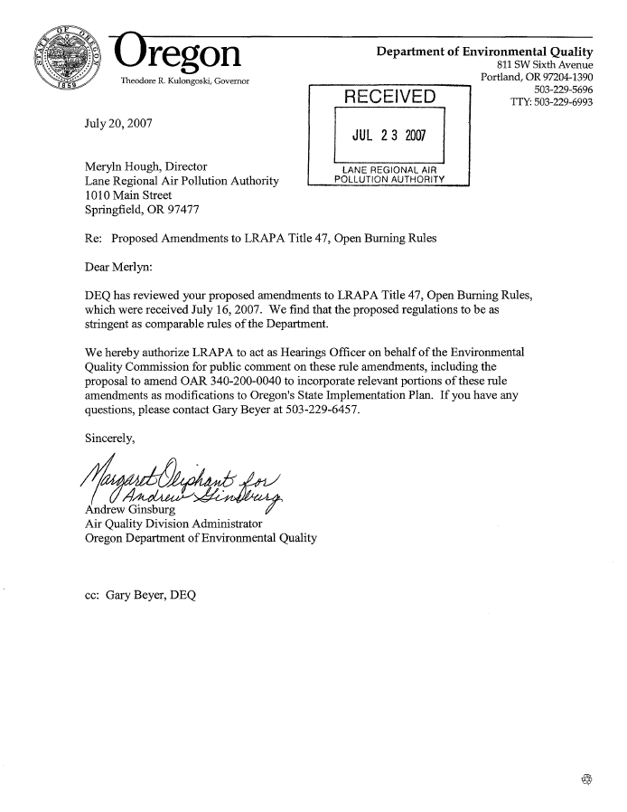

|  |
| --- |
| Stakeholder and public involvement |

Advisory committee

[SOME OF THIS INFORMATION WILL REPEAT THE Advisory Committee SUBSECTION OF THE Statement of Need and Economic Impact ABOVE. THOUGH THE TWO SECTIONS ARE NOT EXACT, MAKE SURE THEY DO NOT CAUSE AMBIGUITY. THE ADVISORY COMMITTEE INFORMATION IS IN THIS LOCATION TO PRESENT A COMPLETE PICTURE OF OUR PUBLIC INVOLVEMENT. THE INFORMATION IS IN THE Statement of Need and Economic Impact TO MEET APA REQUIREMENTS.]

LRAPA convened the [ENTER ADVISORY COMMITTTEE NAME] advisory committee on [DATE]. [DESCRIBE COMMITTEE CHARTER] Enter text here.

The ##-member committee included representatives from [GENERALLY DESCRIBE COMMITTEE MAKEUP.] The committee met ## times over ## months. The committee recommended that [SUMMARIZE RECOMMENDATION OR INVOLVEMENT AND LINK TO ANY FORMAL RECOMMENDATION.] The committee reviewed the fiscal impact statement, specifically impact on small businesses.

 EQC prior involvement

DEQ shares general rulemaking information with the EQC through the annual DEQ Rulemaking Plan review and monthly status report. DEQ and LRAPA did not share information with the EQC through the Director’s Dialogue or by an Information Item on the EQC agenda.

Public notice

The April 1, 2013 *Oregon Bulletin* will publish the Notice of Proposed Rulemaking with Hearing for this proposed rulemaking. LRAPA and DEQ Public outreach includes:

* Posted notice on DEQ’s webpage <http://www.deq.state.or.us/regulations/proposedrules.htm> on Mar. 15, 2013.
* E-mailed notice to:
* Approximately #### interested parties through GovDelivery on mmm dd, yyyy.
* #### stakeholders on the [LIST OTHER MAILING LIST].
* ## key legislators required under [ORS 183.335](http://www.leg.state.or.us/ors/183.html) on mmm dd, yyyy. Key legislators included:
  + Name, Title, Committee
  + Name, Title, Committee
  + Name, Title, Committee
* Members of the advisory committee on mmm dd, yyyy.
* Mailed the notice by U.S. Postal Service to ## interested parties on mmm dd, yyyy.
* Sent notice to EPA on mmm dd, yyyy.
* Other

Public hearings

LRAPA plans to hold one. The table(s) below includes information about how to participate in the public hearings.

Before taking public comment and according to [Oregon Administrative Rule 137-001-0030](http://arcweb.sos.state.or.us/pages/rules/oars_100/oar_137/137_001.html), the presiding officer will provide a brief summary of the content of the notice given under [Oregon Revised Statute 183.335](http://www.leg.state.or.us/ors/183.html) and respond to any questions about the rulemaking.

LRAPA will add the names, addresses and affiliations of all hearing attendees to the interested parties list for this rule if provided on a registration form or the attendee list. DEQ/LRAPA will consider all oral and written comments received at the hearings listed below before finalizing the proposed rules. All comments will be summarized and DEQ/LRAPA will respond to comments on the Environmental Quality Commission staff report.



Close of public comment period

The comment period will close on April 16, 2013 at 5 p.m.

|  |
| --- |
| Next steps |

DEQ will submit this proposal to the EQC to:

* Amend Oregon Administrative Rules,
* Approve LRAPA titles for inclusion into the Oregon Clean Air Act State Implementation Plan, and
* Direct DEQ to submit to EPA as SIP Amendments.

If approved, DEQ will submit the required documentation to federal Environmental Protection Agency for approval as a revision to the plan.