

Oregon Department of Environmental Quality

**September 15, 2013**

Notice of Proposed Rulemaking

***Incorporate Lane Regional Air Pollution Authority Rules***

***For Open Burning Into***

***Oregon’s State Implementation Plan***

|  |
| --- |
| **Overview** |

Short summary

DEQ proposes amendments to Oregon Administrative Rule 340-200-0040 and Oregon’s State Implementation Plan to incorporate Lane Regional Air Pollution Agency rules amended on March 14, 2008. LRAPA’s board amended LRAPA open burning rules under Title 47. The Title 47 amendments:

* Clarify when and where small recreational fires such as patio fireplace could occur and identify acceptable fuels for these fires,
* Include Hazeldell and Siuslaw Rural Fire Protection Districts in the special open-burning control area at the districts’ request,
* Allow daily end time on burn days to be set earlier than sunset,
* Restrict the open burning season in the outlying areas of Lane County, and
* Correct the meaning of the LRAPA acronym to Lane Regional Air Protection Agency.

Brief history

LRAPA, in consultation with DEQ and the U.S. Environmental Protection Agency, is responsible for ensuring that Lane County communities comply with federal air quality health standards, including enacting plans to restore healthy air quality in any area violating standards. LRAPA conducts air monitoring, permitting and compliance, inspection and enforcement, and regulates open burning and asbestos abatement throughout Lane County. It also has a woodstove advisory program, an open burning advisory and conducts special projects focused on air quality. The agency is funded from local dues from Lane County and the cities of Lane County, industrial and other permitting fees, and LRAPA coordinates with DEQ to obtain EPA funding and state general funds.

The Environmental Quality Commission and DEQ have oversight authority to ensure LRAPA meets Clean Air Act requirements. The State Implementation Plan is the State of Oregon Clean Air Act Implementation Plan as adopted by EQC under OAR 340-200-0040 and approved by EPA. EQC approves and directs DEQ to submit all LRAPA rules to EPA as SIP Amendments. Though this is not the case here, an exception to this requirement allows the DEQ to approve any LRAPA rules that are verbatim restatements of rules that the EQC has already approved.

LRAPA performed a public notice of the LRAPA open burning rules in 2008 before proposing the rules for adoption by the LRAPA board. DEQ is performing this public notice before proposing the LRAPA open burning rules for adoption by EQC to meet DEQ’s public notice procedural requirements.

Regulated parties

The proposed rules affect residential open burning in Lane County.

|  |
| --- |
| **Statement of need** |

What problem is DEQ trying to solve?

*We need more rationale in this section. The rationale for why the EQC should adopt the rules is not because failing to adopt them will undermine the Oakridge PM2.5 plan (though that could be noted), but because they are needed on their own terms. Review and add more to this section please…*

Lane County records the highest levels of PM2.5 from November through February. LRAPA’s Title 47 rules prohibit all open burning within the maintenance area during this period to reduce the potential that areas of Lane County could exceed federal particulate standards for PM2.5. LRAPA’s old open burning rules did not adequately address small recreational fires or accommodate the Hazeldell and Siuslaw Rural Fire Protection Districts request to be included in the special open-burning control area. Some definitions were not clear or no longer met the current conditions.

This proposal includes LRAPA’s Title 47 rules for open burning adopted in 2008. EPA will not approve that Oakridge-Westfir PM2.5 Attainment Plan until EQC approves the LRAPA rules from 2008 as well as two other rules DEQ is proposing in a separate, concurrent rulemaking, incorporates those adopted rules into the SIP and submits them to EPA for approval.

How would the proposed rule solve the problem?

*… Needs more....*

*LRAPA’s open burning rules help prevent PM2.5 NAAQS violations in Lane County.*

*Approval of the LRAPA 2008 open burning rules will allow DEQ to submit the rules to EPA for approval as part of the SIP.*

How will DEQ know the problem has been solved?

*…I don’t think these are good answers…*

*DEQ will know the problem has been solved when PM2.5 pollution in Lane County generally, and Oakridge-Westfir specifically, is not violating the NAAQS.*

*DEQ will know the problem has been solved when EPA approves Oakridge-Westfir PM2.5 Attainment Plan and associated rules.*

Request for other options

During the public comment period, DEQ requests public comment on whether to consider other options for achieving the rule's substantive goals while reducing negative economic impact of the rule on business.

|  |
| --- |
| Rules affected, authorities, supporting documents |

Lead divisionProgram or activity

For DEQ: Air Quality Enter text here

Chapter 340 action

Recommendation Division Rule Title SIP/Land use*

amend 200 0040 State of Oregon Clean Air Act Implementation Plan - SIP

* SIP – This rule is part of the State Implementation Plan.

* Land use – DEQ State Agency Coordination Program considers this rule, program or activity is a land use program.

Statutory authority

ORS 468.020, 468A.025 and 468A.460 ARE THERE OTHERS?

Other authority

LRAPA Titles 13 and 14??

Statute implemented Legislation Year

ORS Enter here [ENTER BILL #] Enter here yyyy

Documents relied on for rulemaking [ORS 183.335(2)(b)(C)](http://www.leg.state.or.us/ors/183.html)

|  |  |
| --- | --- |
| **Document title** | **Document location** |
| LRAPA Titles | [www.lrapa.org](http://www.lrapa.org) or at LRAPA office  1010 Main Street,  Springfield, OR 97477 |
| OTHERS |  |

|  |
| --- |
| Fees |

This rule proposal does not involve fees.

|  |
| --- |
| Statement of fiscal and economic impact [ORS 183.335 (2)(b)(E)](http://www.leg.state.or.us/ors/183.html) |

Fiscal and Economic Impact

This proposal involves minor clarifications and updates that primarily affect residential open burning in Lane County. In 2008, LRAPA analyzed fiscal and economic impacts of the proposed amendments and found the amendments have no significant fiscal or economic impact. In July 2013, DEQ in consultation with LRAPA reevaluated fiscal and economic impacts of the proposed rules and performed due diligence to determine whether the original analysis is still correct in light of events that have occurred since 2008. *[Note: We need to document this analysis. For the other rulemakings, because they have fiscal impacts, we need documentation of LRAPA’s analysis].* DEQ determined that the original analysis is reasonable and that the proposed amendments have no significant fiscal or economic impact. *[Is this correct?]*

Statement of Cost of Compliance

Impacts on general public

There is no significant fiscal or economic impact on the general public.

Impact on other government entities other than DEQ

* Local governments No significant impact, including LRAPA
* State agencies No significant impact

Impact on DEQ [ORS 183.335](http://www.leg.state.or.us/ors/183.html)

There is no significant fiscal or economic impact on DEQ.

Impact on large businesses (all businesses that are not small businesses below)

This proposal primarily affects residential open burning in Lane County and would have no significant fiscal or economic impact on large businesses.

Impact on small businesses (those with 50 or fewer employees) [ORS 183.336](http://www.leg.state.or.us/ors/183.html)

This proposal primarily affects residential open burning in Lane County and would have no significant fiscal or economic impact on small businesses.

|  |  |
| --- | --- |
| a) Estimated number of small businesses and types of businesses and industries with small businesses subject to proposed rule. | This proposal does not affect small businesses. |
| b) Projected reporting, recordkeeping and other administrative activities, including costs of professional services, required for small businesses to comply with the proposed rule. | This proposal does not affect small businesses; therefore, no additional activities apply to small businesses . |
| c) Projected equipment, supplies, labor and increased administration required for small businesses to comply with the proposed rule. | This proposal does not affect small businesses; therefore, small businesses do not need additional resources to comply. |
| d) Describe how DEQ involved small businesses in developing this proposed rule. | This proposal does not affect small businesses; therefore, small businesses were not involved in developing this proposal. |

Documents relied on for fiscal and economic impact

[THIS INFORMATION MAY BE A SUBSET OF Rules affected, authorities, supporting documents ABOVE. DOCUMENT RELIED ON FOR THE FISCAL MUST BE DUPLICATED HERE TO MEET APA REQUIREMENTS. ]

|  |  |
| --- | --- |
| **Document title** | **Document location** |
|  |  |
|  |  |

Advisory committee

DEQ did not convene an advisory committee to review the proposed amendments.

When LRAPA developed the proposed amendments in 2008, it consulted the Citizens Advisory Committee and made minor revisions to the draft Title 47 amendments in response to committee comments. *Right??Is there a committee report?*

***Did this happen?***The Citizens Advisory Committee reviewed the information in this fiscal and economic impact statement. In compliance with [ORS 183.333](http://www.leg.state.or.us/ors/183.html), LRAPA asked for the committee’s recommendations on:

* Whether the proposed rules would have a fiscal impact,
* The extent of the impact, and
* Whether the proposed rules would have a significant impact on small businesses and compliance with [ORS 183.540](http://www.leg.state.or.us/ors/183.html).

[ADD ANY SPECIFICS ABOUT THE COMMITTEE’S INVOLVEMENT WITH THE FISCAL AND ECONOMIC IMPACT STATEMENT] Enter text

***Did this happen?*** *The Citizens Advisory Committee determined that the rules do not have a fiscal impact. DEQ considered the committee’s findings in light of events that have occurred since 2008, and did not see reason to convene another advisory committee.*

Housing cost

To comply with [ORS 183.534](http://www.leg.state.or.us/ors/183.html), DEQ determined the proposed rules would have no effect on the development cost of a 6,000-square-foot parcel and construction of a 1,200-square-foot detached, single-family dwelling on that parcel.

|  |
| --- |
| **Federal relationship** |

*"It is the policy of this state that agencies shall seek to retain and promote the unique identity of Oregon by considering local conditions when an agency adopts policies and rules. However, since there are many federal laws and regulations that apply to activities that are also regulated by the state, it is also the policy of this state that agencies attempt to adopt rules that correspond with equivalent federal laws and rules..."*

Relationship to federal requirements

As required under [ORS 468A.327(1)(a)](http://www.oregonlaws.org/ors/468A.327) and [OAR 340-011-0029(1)(a)](http://arcweb.sos.state.or.us/pages/rules/oars_300/oar_340/340_011.html), DEQ determined this rule proposal is “in addition to federal requirements.” There are no federal rules applicable to open burning. The LRAPA open burning rules are an element of the State Implementation Plan that is a federally approved and enforceable strategy outlining how Oregon will meet federal air quality standards. *More…*

What alternatives did DEQ consider, if any?

[DESCRIBE ANY ALTERNATIVES CONSIDERED AND WHY WE DID NOT PURSUE THEM] Enter text here

|  |
| --- |
| Land use |

*“It is the Commission's policy to coordinate the Department's programs, rules and actions that affect land use with local acknowledged plans to the fullest degree possible.”*

[ORS 197.180](http://www.leg.state.or.us/ors/197.html), [OAR 660-030](http://arcweb.sos.state.or.us/pages/rules/oars_600/oar_660/660_tofc.html)

Land-use considerations

To determine whether the proposed rules involve programs or actions that are considered a *land-use action*, DEQ considered:

* Statewide planning goals for specific references. Section III, subsection 2 of the DEQ State Agency Coordination Program document identifies the following statewide goal relating to DEQ's authority:

**Goal Title**

5 Open Spaces, Scenic and Historic Areas, and Natural Resources

6 Air, Water and Land Resources Quality

11 Public Facilities and Services

16 Estuarial resources

19 Ocean Resources

* [OAR 340-018-0030](http://arcweb.sos.state.or.us/pages/rules/oars_300/oar_340/340_018.html) for EQC rules on land-use coordination. Division 18 requires DEQ to determine whether proposed rules will significantly affect land use. If yes, how will DEQ:
  + Comply with statewide land-use goals, and
  + Ensure compatibility with acknowledged comprehensive plans, which DEQ most commonly achieves by requiring a [Land Use Compatibility Statement](http://www.deq.state.or.us/pubs/permithandbook/lucs.htm).
* DEQ’s mandate to protect public health and safety and the environment.
* Whether DEQ is the primary authority that is responsible for land-use programs or actions in the proposed rules.
* Present or future land uses identified in acknowledged comprehensive plans.

Determination

DEQ determined that the proposed rules identified under the 'Chapter 340 Action' section above and Title 47 **do not affect** existing rules, programs or activities that are considered land-use programs and actions in OAR 340-018-0030 or in the DEQ State Agency Coordination Program.

The proposed rules are consistent with land use in applicable Lane County land use plans.

|  |
| --- |
| Stringency Review and Authorization |

*DEQ will need to send LRAPA an updated letter, similar to the one below, authorizing LRAPA to hold the public hearing.*

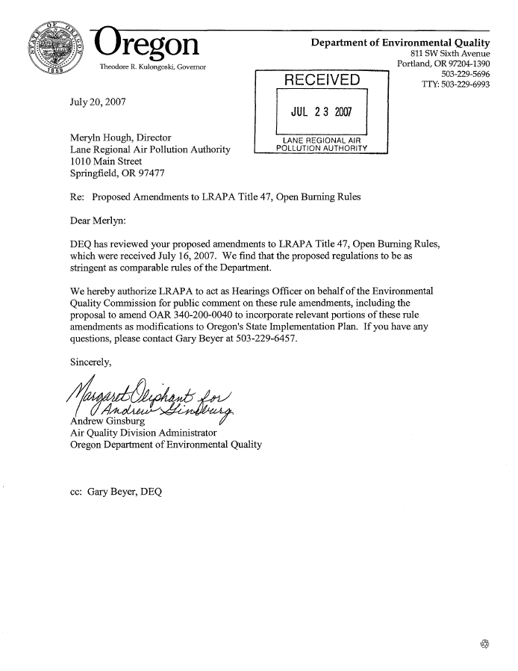

|  |
| --- |
| Stakeholder and public involvement |

Advisory committee

[SOME OF THIS INFORMATION WILL REPEAT THE Advisory Committee SUBSECTION OF THE Statement of Need and Economic Impact ABOVE. THOUGH THE TWO SECTIONS ARE NOT EXACT, MAKE SURE THEY DO NOT CAUSE AMBIGUITY. THE ADVISORY COMMITTEE INFORMATION IS IN THIS LOCATION TO PRESENT A COMPLETE PICTURE OF OUR PUBLIC INVOLVEMENT. THE INFORMATION IS IN THE Statement of Need and Economic Impact TO MEET APA REQUIREMENTS.]

LRAPA convened the [ENTER ADVISORY COMMITTTEE NAME] advisory committee on [DATE]. [DESCRIBE COMMITTEE CHARTER] Enter text here.

The ##-member committee included representatives from [GENERALLY DESCRIBE COMMITTEE MAKEUP.] The committee met ## times over ## months. The committee recommended that [SUMMARIZE RECOMMENDATION OR INVOLVEMENT AND LINK TO ANY FORMAL RECOMMENDATION.] The committee reviewed the fiscal impact statement, specifically impact on small businesses.

 EQC prior involvement

DEQ shares general rulemaking information with the EQC through the annual DEQ Rulemaking Plan review and monthly status report. DEQ and LRAPA did not share information with the EQC through the Director’s Dialogue or by an Information Item on the EQC agenda.

Public notice

The October 1, 2013 *Oregon Bulletin* will publish the Notice of Proposed Rulemaking with Hearing for this proposed rulemaking. LRAPA and DEQ Public outreach includes:

* Posted notice on DEQ’s webpage <http://www.deq.state.or.us/regulations/proposedrules.htm> on September 15, 2013.
* E-mailed notice on September 15, 2013 to:
* Approximately #### interested parties through GovDelivery. *DEQ will do this.*
* #### stakeholders on the [LIST OTHER MAILING LIST]. *LRAPA – please prepare a mailing list for DEQ. DEQ will perform the mailing.*
* ## key legislators required under [ORS 183.335](http://www.leg.state.or.us/ors/183.html). Key legislators included: DEQ will do this.
  + Name, Title, Committee
  + Name, Title, Committee
  + Name, Title, Committee
* *Members of the advisory committee???*
* Mailed the notice by U.S. Postal Service to ## interested parties on September 15, 2013. (Does LRAPA have any interested parties other than permit holders?)
* Sent notice to EPA on September 1, 2013. *DEQ will do this.*

Public hearings

LRAPA acted as DEQ’s hearings officer on behalf of the Environmental Quality Commission for public comment on the rule amendments. DEQ’s authorization is included in the letter to LRAPA in the Stringency Review and Authorization section of this document.

The table(s) below includes information about how to participate in the public hearings.

Before taking public comment and according to [Oregon Administrative Rule 137-001-0030](http://arcweb.sos.state.or.us/pages/rules/oars_100/oar_137/137_001.html), the presiding officer will provide a brief summary of the content of the notice given under [Oregon Revised Statute 183.335](http://www.leg.state.or.us/ors/183.html) and respond to any questions about the rulemaking.

DEQ will add the names, addresses and affiliations of all hearing attendees to the interested parties list for this rule if provided on a registration form or the attendee list. DEQ will consider all oral and written comments received at the hearings listed below before finalizing the proposed rules. All comments will be summarized and DEQ will respond to comments on the Environmental Quality Commission staff report.



Close of public comment period

The comment period will close on October 18, 2013 at 5 p.m.

|  |
| --- |
| Next steps |

DEQ will submit this proposal to the EQC to:

* Amend Oregon Administrative Rules,
* Approve LRAPA titles for inclusion into the Oregon Clean Air Act State Implementation Plan, and
* Direct DEQ to submit to EPA as SIP Amendments.

If approved, DEQ will submit the required documentation to federal Environmental Protection Agency for approval as a revision to the plan.