

Oregon Department of Environmental Quality

December 18, 2013
Notice of Proposed Rulemaking

Incorporate Lane Regional Air Protection Agency Rules for
permit streamlining into State Implementation Plan

Overview

Short summary

DEQ proposes to incorporate Lane Regional Air Protection Agency revised regulations for permit streamlining into Oregon’s State Implementation Plan in Oregon Administrative Rule 340-200-0040. The LRAPA Board of Directors adopted permit streamlining rules revisions in an effort to maximize efficiencies in LRAPA’s permitting program while maintaining the existing level of environmental protection, bring LRAPA in line with state rules, and better coordinate with state and federal requirements.

The LRAPA rules contain:
- State and federal National Emission Standards for Hazardous Air Pollutants and New Source Performance Standards that were in effect at the time of LRAPA’s rule adoption.
- Streamlined and improved permitting processes comparable to DEQ rules adopted in 2001 and 2007.
- Narrowing of an agriculture exemption comparable to DEQ rules adopted in 2008.
- Minor corrections and adjustments adopted by LRAPA’s Board in January 2010 to the regulations previously adopted by LRAPA’s Board in October 2008.

Brief history
LRAPA, in consultation with DEQ and the U.S. Environmental Protection Agency, is responsible for ensuring that Lane County communities comply with federal air quality health standards, including enacting plans to restore healthy air quality in any area violating standards. LRAPA conducts air monitoring, permitting and compliance, inspection and enforcement, and regulates open burning and asbestos abatement throughout Lane County. It also has a woodstove advisory program, an open burning advisory program and conducts special projects focused on air quality. The agency is funded by local dues from Lane County and the cities of Lane County, industrial and other permitting fees, and LRAPA coordinates with DEQ to obtain EPA funding and state general funds.
On October 14, 2008 and January 12, 2010, the LRAPA Board of Directors adopted the permit streamlining rules, provided at the end of this document, and the rules have been in effect in Lane County since their adoption. The Environmental Quality Commission and DEQ have oversight authority to ensure LRAPA meets Clean Air Act requirements. The State Implementation Plan is the State of Oregon Clean Air Act Implementation Plan as adopted by EQC under OAR 340-200-0040 and approved by EPA. EQC’s role is to review LRAPA rules to determine if they comply with state law and the Clean Air Act, approve those rules if they comply, and direct DEQ to submit the approved rules to EPA for federal approval as State Implementation Plan amendments.
Typically, DEQ submits LRAPA rules to EQC for incorporation into the State Implementation Plan immediately upon adoption by the LRAPA board. However, in this case, DEQ determined that the public notice process held jointly by DEQ and LRAPA several years ago did not meet requirements for State Implementation Plan rules, which are above and beyond requirements for normal rulemaking. Performing rulemaking is resource intensive and DEQ was unable to perform the additional public notice requirements until now.

Regulated parties
This proposal does not change the regulated parties or requirements for regulated parties from the rules that LRAPA’s board adopted in 2008 and 2010. The regulated parties include businesses in LRAPA’s jurisdiction subject to Air Contaminant Discharge Permits and Title V Operating Permits.

Stringency Review and Authorization

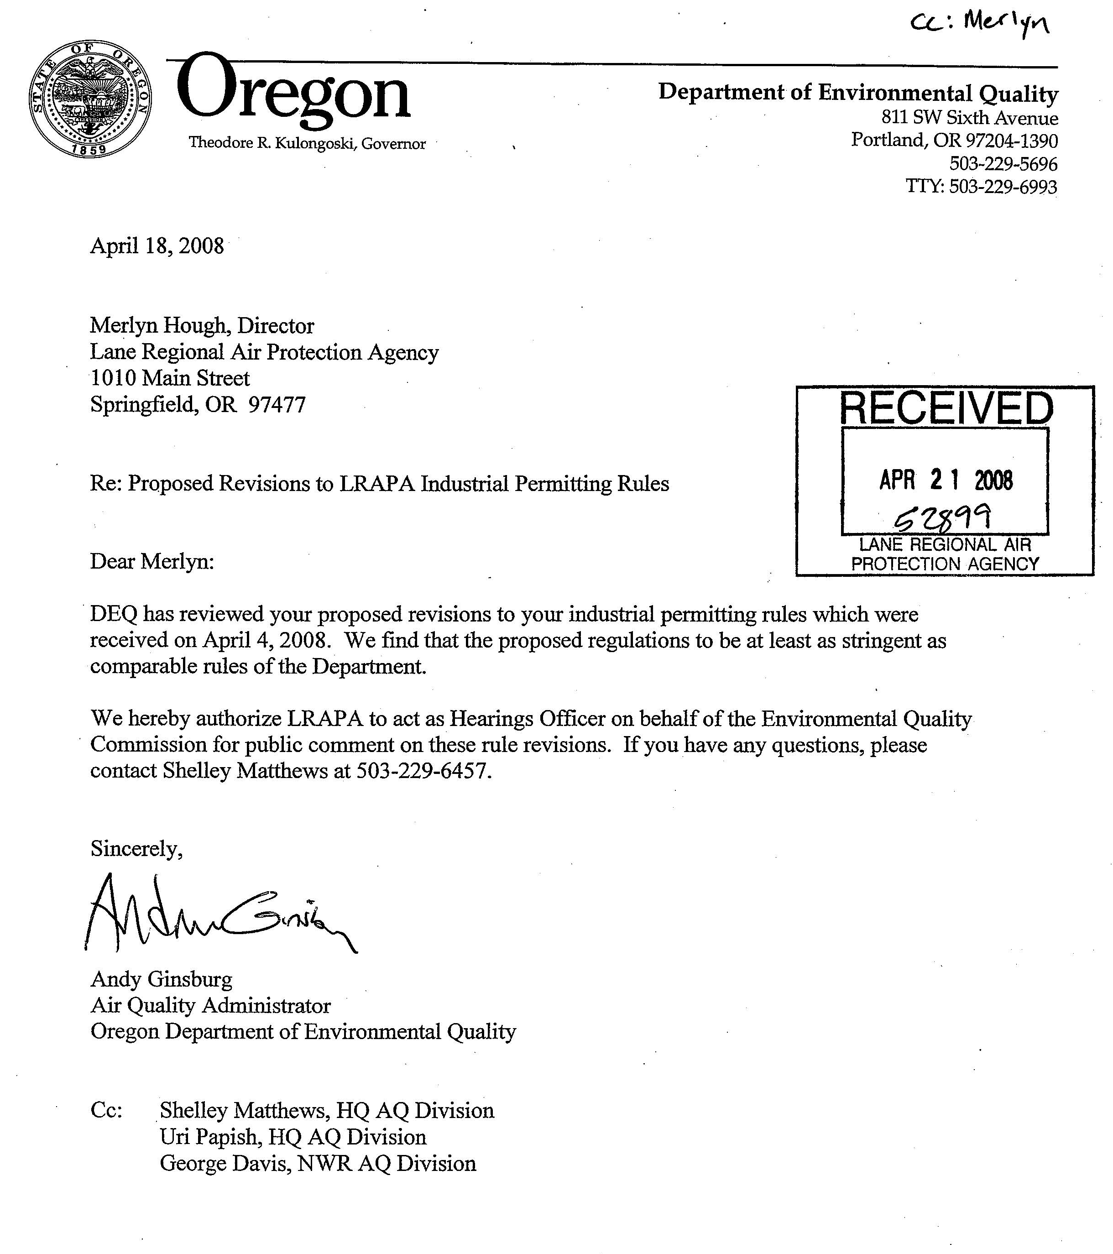

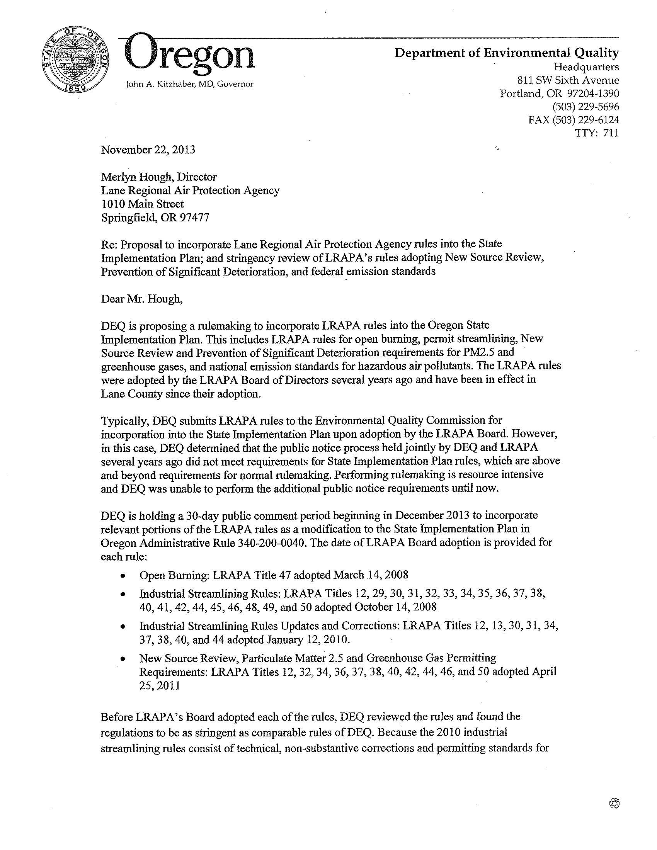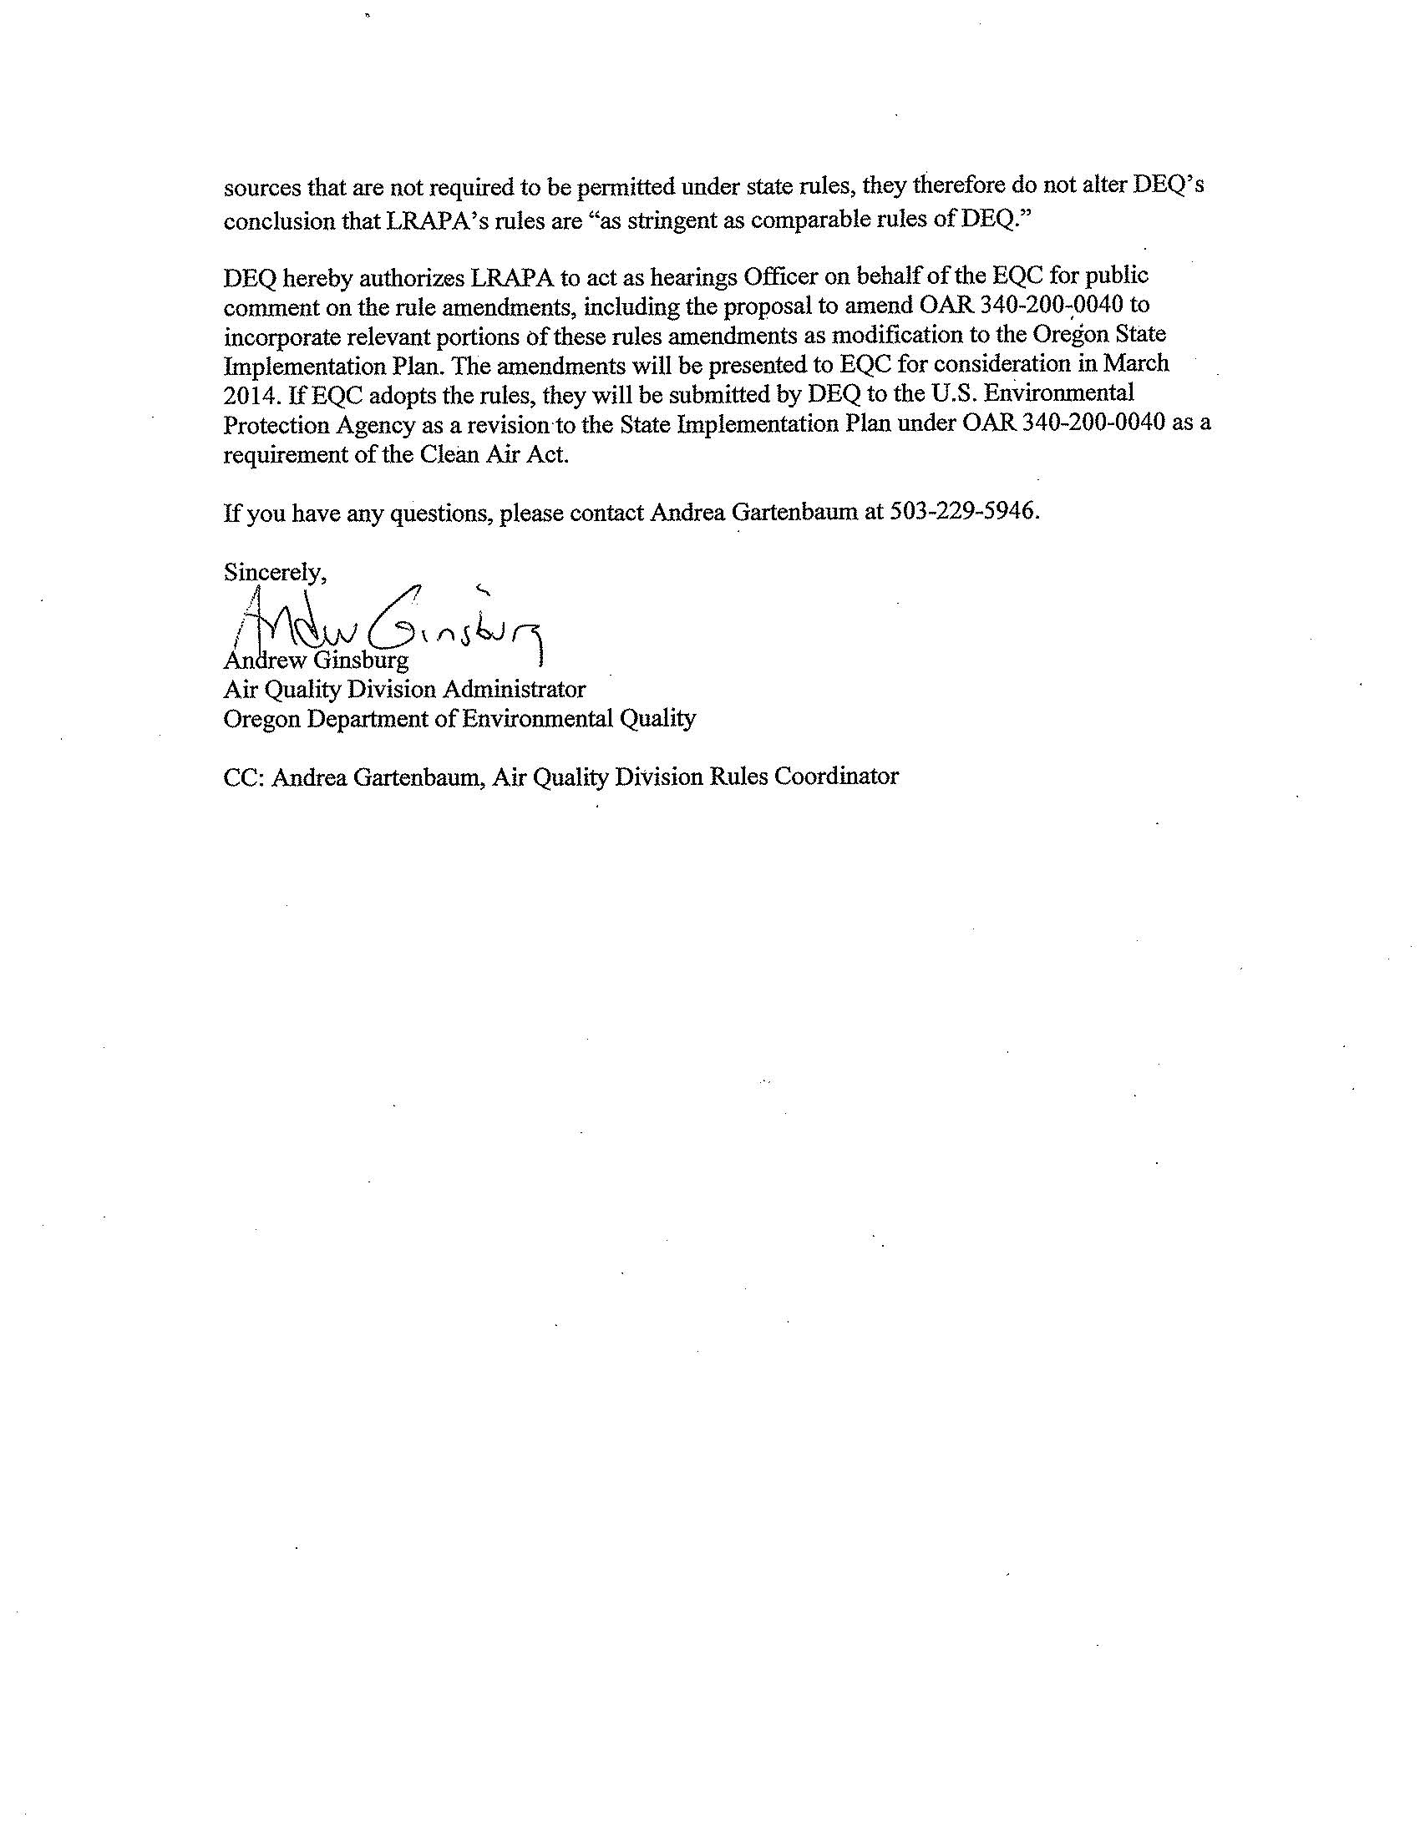

Statement of need

What need is DEQ trying to address?
For LRAPA and the state to maintain compliance with the Clean Air Act, EQC must review LRAPA’s rules and, if EQC concludes that the rules comply with state law and the Clean Air Act, approve the rules and direct DEQ to submit them to EPA for approval and incorporation, as appropriate, into the federally-approved State Implementation Plan. LRAPA’s permit streamlining rules are already in effect in Lane County, but the rules have not been incorporated into the State Implementation Plan.
The primary goal of LRAPA’s 2008 rulemaking was to streamline permitting and compliance by clarifying, simplifying and updating regulatory requirements. Clarifications occur through consolidating and standardizing definitions, adopting general permits, adopting generic Plant Site Emission Limits, improving the major New Source Review requirements, aligning sulfur dioxide standards with federal requirements, updating the incinerator rules, simplifying emission standards for board product manufacturing, simplifying the kraft pulp mill rules and consolidating the excess emissions requirements for notification, reporting and the emergency defense.
The primary goal of LRAPA’s 2010 rulemaking was to make typographical corrections in rule citations and references to other rule citations, adding definitions of “Unassigned Emissions” and “Title I modification”, and align the opacity limitation language for crematory units in the general permit with the rules. The rest of the changes allow LRAPA to keep small sources on the lowest cost permits by removing de minimis production and throughput thresholds for several source categories and allowing expanded criteria for sources to obtain a Simple Air Contaminant Discharge Permit under the low fee category.
How would the proposed rule address the need?
The LRAPA rules are effectively equivalent to DEQ rules and allow LRAPA to better coordinate with and meet state and federal requirements.
How will DEQ know the need has been addressed?

If EQC adopts the rules, DEQ would submit the rules to EPA to update the federally-approved State Implementation Plan including a request for federal delegation of certain rule aspects, where appropriate. DEQ will know the goals of this rulemaking have been addressed when EPA reviews and approves the delegation request and changes to the State Implementation Plan.
Request for other options
During the public comment period, DEQ requests public comment on whether to consider other options for achieving the rule's substantive goals while reducing negative economic impact of the rule on business.

Rules affected, authorities, supporting documents

Lead division Program or activity
Air Quality Division State Implementation Plan

Chapter 340 action

Amend | 340-200-0040

Statutory authority
ORS 468.020, 468A.035, 468A.135

Other authority
LRAPA Title 13 General Duties and Powers of Board and Director
LRAPA Title 14 Rules of Practice and Procedure

Statute implemented Legislation
ORS 468 and 468A

Documents relied on for rulemaking ORS 183.335(2)(b)(C)
In proposing changes to align its rules with state and federal requirements, LRAPA relied primarily on DEQ rules implemented in two phases to streamline and change DEQ’s implementation of Clean Air Act requirements for agriculture.

Document title | Document location
LRAPA rules adopted October 14, 2008 and January 12, 2010 | Provided at the end of this document
LRAPA Board of Directors Meeting, October 14, 2008, Item 6: Adoption of Proposed Industrial Permitting Rules, Titles 12, 29, 30, 31, 32, 33, 34, 35, 36, 37, 38, 40, 41, 42, 44, 45, 46, 48, 49, and 50 | DEQ Headquarters  811 SW 6th Avenue  Portland, OR 97204
LRAPA Board of Directors Meeting, January 12, 2010, Item 7: Adoption of Proposed Industrial Permitting Rules, Titles 12, 13, 30, 31, 34, 37, 38, 40, and 44 | DEQ Headquarters  811 SW 6th Avenue  Portland, OR 97204
Letter from DEQ to LRAPA, April 18, 2008, Stringency review of LRAPA Permit Streamlining amendments | DEQ Headquarters  811 SW 6th Avenue  Portland, OR 97204
Letter from DEQ to LRAPA, November 22, 2013, Proposal to incorporate Lane Regional Air Protection Agency rules into the State Implementation Plan and stringency review of LRAPA’s rules | DEQ Headquarters  811 SW 6th Avenue  Portland, OR 97204

Document title | Document location
Oregon Administrative Rules Chapter 340 Divisions 200, 202, 204, 208, 209, 210, 212, 214, 216, 222, 224, 225, 226, 230, 234, 236, 238, 244, and 268. | http://www.deq.state.or.us/regulations/rules.htm
Agenda Item G, Revisions to Point Source Air Management Rules (New Source Review, Plant Site Emission Limit, and Air Quality Permitting Requirements), EQC Meeting May 4, 2001 | DEQ Headquarters  811 SW 6th Avenue  Portland, OR 97204
Agenda Item D, Adoption of Air Quality Permit Program Streamlining and Updates; October 18, 2007 Environmental Quality Commission Meeting | http://www.deq.state.or.us/about/eqc/agendas/2007/200710EQCAgenda.htm
Agenda Item I, Adoption Authorizing the DEQ to implement the Clean Air Act requirements for agriculture; August 21, 2008 Environmental Quality Commission Meeting | http://www.deq.state.or.us/about/eqc/agendas/2008/2008augEQCagenda.htm

Fee Analysis

This rulemaking does not establish or revise fees. The fees described below are the amounts used in LRAPA’s 2008 rulemaking, where LRAPA aligned its fee structure with DEQ’s structure for Air Contaminant Discharge Permits.

LRAPA’s rules expanded LRAPA’s ability to write permits for categories of businesses; these are known as General permits and allow a permitted business to operate as if it had a source-specific permit. Issuing a source-specific permit is a resource intensive process. A business is assigned to a General permit if it meets the criteria for the General permit, whereas a business that is required to have a permit, but does not meet the criteria of a General permit, must obtain an individual, source-specific permit. LRAPA’s alignment with DEQ’s structure resulted in a fee reduction for businesses qualifying for General permits, and reduced the amount of time it took for LRAPA to issue permits to those businesses.

The following examples illustrate the change in fees for two source categories:

- A stationary asphaltic concrete paving plant was previously subject to Category 34a under LRAPA’s previous fee table. A typical facility paid annual compliance determination fees at $2,870 per year for ten years, two renewal fees at $1,318 each and a modification fee at $1,318 totaling $32,654 over the ten-year period. The 2008 LRAPA rules assigned this facility to a General ACDP-High Cost (Fee Class Three). The facility now pays a one-time assignment fee of $1,200 and annual fees of $1,872 per year totaling $19,920 over the ten-year period and saving the facility $12,734.

- A portable rock crusher subject to Category 42b under LRAPA’s previous fee table typically paid annual compliance determination fees at $1,525 per year for ten years, two renewal fees at $1,803 each, and a modification fee at $1,803, totaling $20,659 over the ten-year period. The 2008 LRAPA rules assigned this facility to a General ACDP-Medium Cost (Fee Class Two). Now the facility pays an assignment fee of $1,200 and annual fees of $1,296 per year for ten years totaling $14,160 over the ten-year period and saving the facility $6,499.

Statement of fiscal and economic impact ORS 183.335 (2)(b)(E)

Fiscal and Economic Impact

This rule proposal does not have a fiscal or economic impact. The proposed rule would incorporate Lane Regional Air Protection Agency revised regulations for permit streamlining into Oregon’s State Implementation Plan in Oregon Administrative Rule 340-200-0040.

The 2008 LRAPA rule resulted in simplification and streamlining, and updating and alignment with state and federal requirements, while maintaining equivalent environmental protection and stringency. The 2010 LRAPA rule resulted in corrections to the 2008 rule. The rules have been in effect in Lane County since their adoption in 2008 and 2010. DEQ, in consultation with LRAPA, evaluated the rules and determined LRAPA’s original analysis of fiscal and economic impacts is reasonable and still correct considering events that have occurred since LRAPA’s rule adoption several years ago.

Statement of Cost of Compliance

Impacts on public

This proposal does not have an impact on the public. The 2008 LRAPA rules instituted a tiered public involvement process that resulted in time savings for the public. Under the rules, major new sources and major modifications to existing sources can require preliminary informational meetings before LRAPA begins drafting a permit. This increased the up-front time necessary for the public to prepare for and participate in public meetings. A benefit from this procedure is better permits that require less time for review and public comment since the public can raise issues and LRAPA can address those issues before drafting the permit. Because the rules allow LRAPA to issue General permits to more categories of sources, instead of requiring issuing a source-specific permit to each source individually, comments from the public on one General permit have the effect of commenting on all of the individual permits that otherwise would have been drafted in place of the General Permit.

Impact on other government entities other than DEQ
- Local governments: This proposal does not have an impact on government entities. LRAPA experienced a reduction in fee revenue of about $32,000 annually after LRAPA’s 2008 revised permit fee structure became effective. As a result of permit streamlining, LRAPA experienced a reduction in resources spent issuing permits of about 0.5 full-time equivalent positions, which in 2008, was equivalent to about $49,000 annually.

Local governments that hold air quality permits, such as county–owned cogeneration facilities and school boilers, experienced the same impacts as small and large businesses as a result of LRAPA’s rule adoption.

- State agencies: This proposal does not have an impact on state agencies. State agencies that hold air quality permits, such as university-owned power generators, experienced the same impacts as small and large businesses as a result of LRAPA’s rule adoption.

Impact on DEQ ORS 183.335

See “Impacts on public” above.

Impact on large businesses (all businesses that are not small businesses below)

This proposal does not have an impact on large businesses. The 2008 LRAPA rules have the following impact on large businesses.
Reduced Time: The 2008 LRAPA rules eliminated redundant requirements and clarified rule language. This has been a benefit to businesses because it reduces the amount of time they spend on understanding and complying with the permit. For kraft pulp mills, the rules resulted in fewer permit conditions in cases where multiple permit conditions set similar limits for the same emission sources and pollutants.

The 2008 LRAPA rules reduced the amount of time and costs businesses spend maintaining their permits by reducing the time it takes to issue and renew permits and the need for permit modifications. This is primarily due to the use of generic Plant Site Emission Limits in place of source-specific ones, and the use of general permits for many source categories. In addition, changing the trigger level for Prevention of Significant Deterioration from the Significant Emission Rate to 100 or 250 tons per year reduced the time required by triggering PSD when modeling indicates that no standards will be violated. Reduced permit processing time enables businesses to better meet market-timing needs.

Permit structure: The 2008 LRAPA rules aligned LRAPA’s permit and fee structure with DEQ’s Air Contaminant Discharge Permit structure, including annual fees, initial permitting fees and special activity fees. The adopted fee structure summarized below is detailed in Title 37 Section 37-0020 Table 2 of this document. As a result, some large businesses switched to a Standard ACDP that includes an annual fee of $7,680 from the previous permits with fees ranging from approximately $1000 to $21,000 per year. Some businesses became subject to General and Simple Air Contaminant Discharge Permits. Overall, the fee changes were nearly revenue neutral for LRAPA, although some individual businesses now pay more or less than the fees they paid before LRAPA’s 2008 rule adoption.

Permit Type | Fee Type | Previous Fee (before LRAPA’s 2008 rulemaking) | Fee adopted by LRAPA in 2008
Standard | Filing fee  Initial permitting  Application processing  Annual compliance | $129 /5 yrs.  $3,400 to $17,000  $525 to $52,000 /5yrs  $800 to $27,000 | Not applicable  $12,000 to $42,000  Not applicable  $7680
Simple | Initial permitting  Annual compliance | Not applicable | $6,000  $1,920 to 3,840
General | Filing fee  Initial permitting  Application processing  Annual compliance | Not applicable | Not applicable  $1200  Not applicable  $720 to $1872
Basic | Initial permitting  Annual compliance | Not applicable | $120  $360
Short Term Activity | Initial permitting | Not applicable | $3,000
Construction | Initial permitting | Same as Standard | $9,600
Minimal |  | Same as Standard but annual compliance is paid every 5 years and application processing paid every 10 years | Not applicable

Triggering Applicable Requirements: The 2008 LRAPA rule adoption causes some sources to trigger or avoid triggering various applicable requirements. For example, changes to unassigned emissions causes some sources to trigger New Source Review sooner compared to the previous rules. Though there are currently no ozone nonattainment or maintenance areas in Lane County, the process to assess impacts due to ozone precursors could potentially require sources between 30 and 100 kilometers from a nonattainment or maintenance area to evaluate their impact on the area and mitigate the impact if it is significant. LRAPA’s new procedures for combining and splitting sources cause some sources to trigger or avoid triggering Title V or New Source Review rules.

Monitoring and Reporting Costs: The 2008 LRAPA rule adoption increased monitoring and reporting costs but decreased these costs for some sources. For example the rolling 12-month Plant Site Emission Limit in the permits made it necessary to report compliance twelve times in annual reports in place of once for the calendar year. However, eliminating the hourly or daily Plant Site Emission Limit reduced the burden of monitoring and reporting compliance with these short-term limits.

The 2008 LRAPA rule requires businesses to submit excess emission reports within fifteen days of their occurrence rather than semi-annually. This imposed a slight additional cost in reporting to permit holders that experience excess emissions. However, the fiscal impact is negligible because excess emissions reported within the required 15 days no longer need to be included in these facilities’ semi-annual reports.

Emission Reduction Credits: The 2008 LRAPA rule adoption likely increased the value of certain emission reduction credits. For example, sources use emission reductions from shutdowns like over control reductions to offset emission increases for sources going through New Source Review. Banking may be used to extend the life of a shutdown credit the same as other actual emission reductions. Under the previous rules, emission reductions due to shutdowns could only be used as offsets during the two years following the reduction and could not be banked.

Impact on small businesses (those with 50 or fewer employees) ORS 183.336
This rule proposal does not have an impact on small businesses. LRAPA’s 2008 rule simplification and streamlining created efficiencies and avoided additional permitting costs for small sources. LRAPA’s 2010 rule adoption also avoided permitting costs by allowing LRAPA to keep small sources on lower cost permits. EPA determined that there would be no significant impact on small businesses when it exempted HFE-7300 from the definition of Volatile Organic Compounds. The 2008 LRAPA rules adopted this exemption that likely benefits businesses because it reduces regulatory burden by lifting the requirement to track and limit use of this chemical and allows expanded use of a commercially valuable compound.

a) Estimated number of small businesses and types of businesses and industries with small businesses subject to proposed rule. | The LRAPA air quality programs affects approximately 50 to 70 small businesses in Lane County.
b) Projected reporting, recordkeeping and other administrative activities, including costs of professional services, required for small businesses to comply with the proposed rule. | The 2008 and 2010 LRAPA rules did not add new reporting requirements for small businesses. The rules reduced the complexity of current regulations, resulting in a more efficient permitting and compliance process for small businesses.
c) Projected equipment, supplies, labor and increased administration required for small businesses to comply with the proposed rule. | The 2008 and 2010 LRAPA’s rules did not add new equipment or administrative requirements for small businesses.
d) Describe how DEQ involved small businesses in developing this proposed rule. | DEQ did not involve small businesses in this rulemaking. LRAPA followed appropriate requirements for rulemaking when it adopted its rules, including outreach to small businesses.

Documents relied on for fiscal and economic impact
Document title | Document location
LRAPA rules adopted October 14, 2008 and January 12, 2010 | Provided at the end of this document
LRAPA Board of Directors Meeting, October 14, 2008, Item 6: Adoption of Proposed Industrial Permitting Rules, Titles 12, 29, 30, 31, 32, 33, 34, 35, 36, 37, 38, 40, 41, 42, 44, 45, 46, 48, 49, and 50 | DEQ Headquarters  811 SW 6th Avenue  Portland, OR 97204
LRAPA Board of Directors Meeting, January 12, 2010, Item 7: Adoption of Proposed Industrial Permitting Rules, Titles 12, 13, 30, 31, 34, 37, 38, 40, and 44 | DEQ Headquarters  811 SW 6th Avenue  Portland, OR 97204
Letter from DEQ to LRAPA, April 18, 2008, Stringency review of LRAPA Permit Streamlining amendments | DEQ Headquarters  811 SW 6th Avenue  Portland, OR 97204
Letter from DEQ to LRAPA, November 22, 2013, Proposal to incorporate Lane Regional Air Protection Agency rules into the State Implementation Plan and stringency review of LRAPA’s rules | DEQ Headquarters  811 SW 6th Avenue  Portland, OR 97204
Oregon Administrative Rules Chapter 340 Divisions 200, 202, 204, 208, 209, 210, 212, 214, 216, 222, 224, 225, 226, 230, 234, 236, 238, 244, and 268. | http://www.deq.state.or.us/regulations/rules.htm
Agenda Item G, Revisions to Point Source Air Management Rules (New Source Review, Plant Site Emission Limit, and Air Quality Permitting Requirements), EQC Meeting May 4, 2001 | DEQ Headquarters  811 SW 6th Avenue  Portland, OR 97204
Agenda Item D, Adoption of Air Quality Permit Program Streamlining and Updates; October 18, 2007 Environmental Quality Commission Meeting | http://www.deq.state.or.us/about/eqc/agendas/2007/200710EQCAgenda.htm
Agenda Item I, Adoption Authorizing the DEQ to implement the Clean Air Act requirements for agriculture; August 21, 2008 Environmental Quality Commission Meeting | http://www.deq.state.or.us/about/eqc/agendas/2008/2008augEQCagenda.htm

Advisory committee

DEQ did not appoint an advisory committee. LRAPA followed appropriate requirements for rulemaking when it adopted its rules.

Housing cost
To comply with ORS 183.534, DEQ determined the proposed rule does not have an effect on the development cost of a 6,000-square-foot parcel and construction of a 1,200-square-foot detached, single-family dwelling on that parcel. Adoption of this proposed rule would allow DEQ to submit the 2008 and 2010 LRAPA rules to EPA for incorporation into the State Implementation Plan. Any impact on housing costs occurred when LRAPA adopted the rules, and the rules applied in Lane County upon LRAPA’s 2008 and 2010 adoption. LRAPA’s rules may have had an impact on housing cost. This impact could occur if permit holders affected by LRAPA’s rules pass their permitting fees or other costs to comply with the rules through to the consumer. DEQ does not have available information to quantify how many permit holders would pass the permit fee through to the consumer and any such estimate would be speculative.

Federal relationship

"It is the policy of this state that agencies shall seek to retain and promote the unique identity of Oregon by considering local conditions when an agency adopts policies and rules. However, since there are many federal laws and regulations that apply to activities that are also regulated by the state, it is also the policy of this state that agencies attempt to adopt rules that correspond with equivalent federal laws and rules..." ORS 183.332

Relationship to federal requirements
This section complies with OAR 340-011-0029 and ORS 468A.327 to clearly identify the relationship between the proposed rule and applicable federal requirements.

The proposed rule is not “different from or in addition to federal requirements” and impose stringency equivalent to federal requirements.

The 2008 LRAPA rules include National Emission Standards for Hazardous Air Pollutants and New Source Performance Standards that were effective at the time of LRAPA’s rule adoption. LRAPA’s 2008 rules also allow regulation of agriculture to the extent necessary to comply with the federal Clean Air Act. If EQC adopts the rules, DEQ would submit the 2008 and 2010 rules to EPA to update the federally-approved State Implementation Plan including a request for federal delegation of certain rule aspects, where appropriate.

What alternatives did DEQ consider if any?
DEQ did not consider any alternatives to the propose rules. In order to be efficient and take advantage of the work done at the state level to create sensible rules for the unique and well-established stationary source permitting program in Oregon, LRAPA chose to be consistent with the revisions specified by DEQ in OAR Chapter 340 rules.

Land use

“It is the Commission's policy to coordinate the Department's programs, rules and actions that affect land use with local acknowledged plans to the fullest degree possible.” ORS 197.180, OAR 018-0010

Land-use considerations
To determine whether the proposed rule involves programs or actions that are considered a land-use action, DEQ considered:
- Statewide planning goals for specific references. Section III, subsection 2 of the DEQ State Agency Coordination Program document identifies the following statewide goal relating to DEQ's authority:

Goal Title
5 Open Spaces, Scenic and Historic Areas, and Natural Resources
6 Air, Water and Land Resources Quality
11 Public Facilities and Services
16 Estuarial resources
19 Ocean Resources

- OAR 340-018-0030 for EQC rules on land-use coordination. Division 18 requires DEQ to determine whether the proposed rule will significantly affect land use. If yes, how will DEQ:
  - Comply with statewide land-use goals, and
  - Ensure compatibility with acknowledged comprehensive plans, which DEQ most commonly achieves by requiring a Land Use Compatibility Statement.
- DEQ’s mandate to protect public health and safety and the environment.
- Whether DEQ is the primary authority that is responsible for land-use programs or actions in the proposed rule.
- Present or future land uses identified in acknowledged comprehensive plans.

Determination
DEQ determined that the proposed rule, OAR 340-200-0040, is an existing rule that affects programs or activities that the DEQ State Agency Coordination Program considers a land-use program.

DEQ’s statewide goal compliance and local plan compatibility procedures listed below adequately cover the proposed rule.

- 340-018-0040(1) - compliance with statewide planning goals achieved by ensuring compatibility with acknowledged comprehensive plans.
- 340-018-0050(2)(a) - ensuring compatibility with acknowledged comprehensive plans may be accomplished through a Land Use Compatibility Statement. LRAPA’s rules are consistent with land use in applicable Lane County land use plans.

Stakeholder and public involvement

Advisory committee
DEQ did not appoint an advisory committee. LRAPA followed appropriate requirements for rulemaking when it adopted its rules.

EQC prior involvement

DEQ shares general rulemaking information with EQC through the monthly Director’s Report. DEQ did not present additional information specific to this proposed rule revision.

Public notice

The January 2014 Oregon Bulletin will publish the Notice of Proposed Rulemaking with Hearing.

DEQ also:
- Posted notice on DEQ’s webpage http://www.oregon.gov/deq/RulesandRegulations/Pages/2013/LRAPAPS.aspx on Dec. 18, 2013.
- E-mailed notice on Dec. 18, 2013 to:
- Interested parties through GovDelivery
- Interested parties and stakeholders provided to DEQ by LRAPA
- The following key legislators required under ORS 183.335:
  - Jules Bailey, Chair, House Energy and Environment Committee
  - Michael Dembrow, Chair, Senate Environment and Natural Resources Committee
- Members of LRAPA’s advisory committee.
- Members of LRAPA’s Board of Directors
- Mailed the notice by U.S. Postal Service to 508 interested parties on December 18, 2013.
- Sent notice to EPA on Aug. 20, 2013.
- Published legal advertisement in the following newspapers on Dec. 18, 2013:
    - Oregonian
    - Register Guard

Public hearings

DEQ authorized LRAPA to act as hearings officer for the public hearing listed in the table below that includes information about how to participate in the public hearing. DEQ’s authorization is in the letter to LRAPA in the Stringency Review and Authorization section of this document.

Before taking public comment and according to Oregon Administrative Rule 137-001-0030, the staff presenter will summarize the content of the notice given under Oregon Revised Statute 183.335 and respond to any questions about the rulemaking.

DEQ will add the names, addresses and affiliations of all hearing attendees to the interested parties list for this rule if provided on a registration form or the attendee list. DEQ will consider all oral and written comments received at the hearings listed below before finalizing the proposed rule. DEQ will summarize all comments and respond to comments on the Environmental Quality Commission staff report.

Close of public comment period

The comment period will close on Jan. 27, 2014 at 5 p.m.

