

RULEMAKING Records Management

#### Operations Division

Last Update | [Date]

Purpose

This document provides information to help DEQ staff maintain the required rulemaking record. This information will help:

* Meet recordkeeping requirements
* Categorize rulemaking records within a single rulemaking and across agency rulemaking activities in a predictable, logical and consistent way
* Clarify records retention requirements
* Facilitate appropriate management of files during rulemaking
* Identify appropriate records management after rulemaking – transparent storage, retrieval, and destruction

Rulemaking record

DEQ must retain **all** records that document the formulation, development, notice and filing of our administrative rules. This includes the activities of any DEQ-appointed rulemaking or fiscal advisory committee or work group. The rulemaking record begins when the program explores adding a potential rulemaking to the DEQ Rulemaking Plan. It ends when staff completes all post-EQC activities, ensures that all records are in the required locations and the annual record audit determines that the record is ready to archive.

Why we keep the rulemaking record

* Oregon State Archives ORS 166-300-0015
* Administrative Procedures Act ORS 183.335
* Model Rules OAR 137-001-0040

**How long we keep it**

**OAR 166-300-0015 retention schedule**

* Hearing audio or videotapes until transcribed or summarized then destroy
* All administrative rule records 10 years after repeal of entire rule then destroy

**How we manage working and storage location**

* SharePoint
  + Templates preloaded
  + Working documents
  + Collaboration space
* Rules Development
  + Background work
  + Saved versions from SharePoint
  + Interim site for rulemaking record
* Rules Archive
  + Long-term site for rulemaking record
  + Write permissions - limited
  + Read permissions – all DEQ

*Rulemaking documents not allowed on personal, program or division drives.*

How we manage – Identical in all three locations

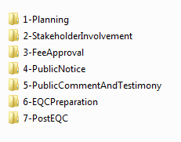

How we manage SharePoint

* Preloaded blank documents
* Already named using document convention

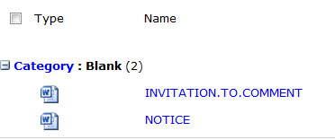

**SharePoint – check out a document**

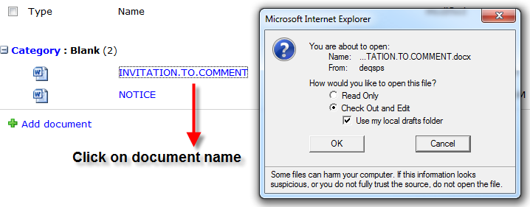

Version history here

**When DEQ drafts rules, we**

* Exercise power equal to the legislature.
* Must remain consistent the authorizing statute.
* Cannot limit, alter or expand the legislation.

Researching

History(“Hist.“) includes an expression similar to:

**DEQ 5-2008, f. & cert. ef. 3-20-08**

**SharePoint – advance document category**

* Select document
* Edit Properties
* Check out document
* Select new category
* Check in document
  + Add comment such as “Advanced category”

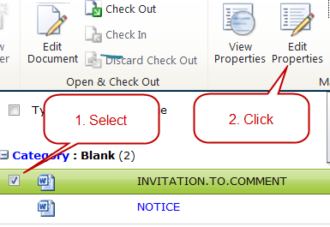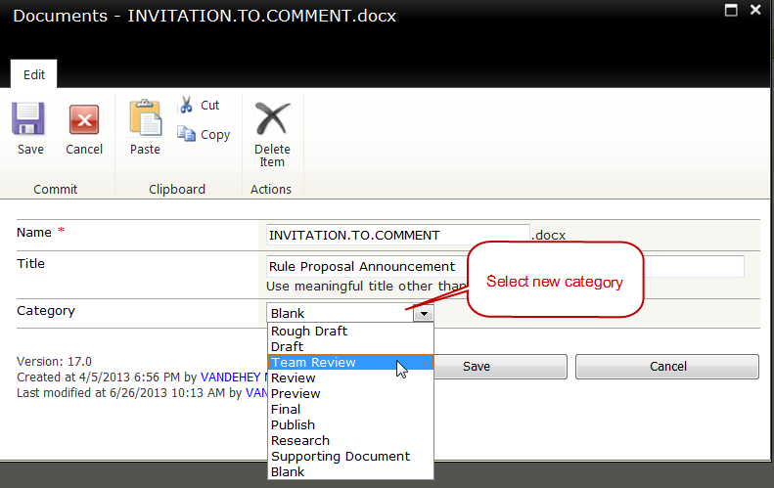

Do not change standard document names shown in upper case.

**Rulemaking record**

DEQ must retain all records that document the formulation, development, notice and filing of our agency’s administrative rules, including the activities of an agency-appointed advisory committee. The rulemaking record begins when the program explores adding a potential rulemaking to the DEQ annual rulemaking plan. It ends when the rule design team has completed all post-EQC activities. The following are general categories of rulemaking records.

* Planning documents, correspondence, statements of the objective of the rule and how the agency will evaluate whether the rule accomplishes the objective
* All advisory committee records including minutes and agendas, committee roster
* Draft rules and work notes, and associated correspondence
* DAS fee notifications or approval documents and documentation, associated correspondence
* Proof of news media publications.
* Notice documents, and copies of administrative orders filed with the Secretary of State:
  + Notice of Proposed Rulemaking or Notice of Proposed Rulemaking Hearing
  + Statement of Need and Justification
  + Statement of Need and Fiscal Impact for
  + Copies of all notices to legislators 183.335(15)
* All public comments and testimony

* + All data or views concerning proposed rules from interested persons
  + Any statements that DEQ provides at the opening of a public hearing
  + A recording or summary of oral submissions received at hearings held for the purpose of receiving public comment
  + All written materials submitted in response to a notice of intent to adopt, amend or repeal a rule
* The Presiding Officer’s Report
* Final rulemaking Staff Report to the EQC. The office of the director is the owner of the EQC record governed under the Public Meetings under [ORS 192.610 to 192.690](http://www.leg.state.or.us/ors/192.html). OD maintains the record of all EQC staff reports, minutes and meetings in perpetuity. EQC staff report does not need to be copied or stored with this part of the record.
* Filing documents:
  + SOS filing
  + Copy of adopted rules as filed with the SOS
  + Certificate and Order for Filing Permanent or Temporary Administrative Rules
  + Certificate of Filing Rules, Legislative Counsel

**Regulations**

The [State Agency General Records Retention Schedules](http://arcweb.sos.state.or.us/rules/OARS_100/OAR_166/166_300.html) identifies documents that make up the rulemaking record. OAR 166-300-0015(1). The Attorney General’s [Model Rules](http://www.sos.state.or.us/archives/rules/OARS_100/OAR_137/137_001.html) also describe the elements of the rulemaking record under OAR 137-001-0040 (4). The model rules govern DEQ’s rulemaking processes as incorporated under [OAR 340-011-0024](http://arcweb.sos.state.or.us/rules/OARs_300/OAR_340/340_011.html).

The [Administrative Procedures Act](http://www.leg.state.or.us/ors/183.html) defines “rule”, specifies public involvement, rule adoption and agency review of rules. ORS 183.335(3)(e) requires an agency to maintain a record of data or views from interested persons concerning proposed rules.

[ORS 192.005](http://www.leg.state.or.us/ors/192.html) to 192-170 describe the retention or destruction of public records in Oregon. Transferring public records to the State Archivist are under [ORS 357.805](http://www.leg.state.or.us/ors/357.html) to 357.895.

**Retention period**

The [State Agency General Records Retention Schedules](http://arcweb.sos.state.or.us/rules/OARS_100/OAR_166/166_300.html) identifies the period of time DEQ must maintain the records. OAR 166-300-0015(1).

1. Retain hearing audio or videotapes until transcribed or summarized then destroy.
2. Retain all other administrative rule records for 10 years after **repeal of entire rule** then destroy.

**Rulemaking file locations and format**

Though what was called the “official rulemaking record” is located on the 10th floor, the remainder of the records reside throughout the agency and in rule writers’ personal files and in various storage locations. During the next 18 months, there will be a centralized physical file location.

The rulemaking record begins when the program starts exploring adding a potential rulemaking to the annual DEQ rulemaking plan. The location of the rulemaking record changes as the rule progresses from concept to post filing.

Electronic records will be maintained and stored in the following locations:

\\deqhq1\rule_resources -- various planning and guidance documents.

\\deqhq1\rule_development -- in progress or incomplete records not on SharePoint

[Rulemaking SharePoint](http://deqmoss/sites/Rulemaking/default.aspx) -- rules in progress or incomplete records, entire site will be archived

\\deqhq1\rule_archives  -- complete records stored by year

**Emails**

Set up a separate email folder for the rulemaking using the folder name identified in the blueprint. When the rulemaking is complete, the rules group will ask you to release the email folder to archive them to the .pst folder for long-term storage.

The blueprint assigns a **RM** identifier on the Subject line. For example, all Conversion Technologies rulemaking emails will start with **RM-CT** to identify the email as part of the rulemaking record.

When you start a new email always start the Subject: line with **RM** identifier found in the blueprint followed by a clear description of the subject matter.

Always *Reply* to the original email only if the response relates to the Subject of the email.

Start a new email chain if your response has to do with a new Subject. Do not perpetuate an ever-changing subject matter by replying to an email on an unrelated subject.

The sender of the email is the custodian of the email chain for the rulemaking record.

**File names**

The rules group develops and maintains the Blueprint. The Blueprint applies the naming rules in this document to all forms, emails, letters and excerpts generated through the Blueprint. The name is in the footer along with the retention schedule and data classification.

# Records Checklists

The checklists below help staff capture DEQ’s rulemaking record. Using best practices for naming documents and organizing them in the recommended order helps reduce time spent on future records research.

The following rulemaking record checklists identify:

* Documents included in the official rulemaking record
* Names given to standard rulemaking documents
* Date format for multiple documents issued at different times
* Conventions used for non-standard documents

| Planning Record Checklist  Folder  1-Planning | | Binder  OFFICIAL.Planning.RECORD.pdf |
| --- | --- | --- |
| **Check if complete** | **Document Name** | **Notes** |
| 🞎 | RESOURCES |  |
| 🞎 | CONSIDERATIONS |  |
| 🞎 | SCHEDULE |  |
|  | Communications |  |
| 🞎 | CommunicationsPlan |  |
| 🞎 | MessageMap |  |
| 🞎 | StartingRules |  |
| 🞎 |  |  |
| 🞎 |  |  |

| Planning Record Checklist  Folder  2-StakeholderInvolvement | | Binder OFFICIAL.StakeholderInvolvement.RECORD.pdf |
| --- | --- | --- |
| **Check if complete** | **Document Name** | **Notes** |
| 🞎 | Roster |  |
| 🞎 | Invitation |  |
| 🞎 | Charter |  |
| 🞎 | WebPageImage |  |
| Meetings | | |
| 🞎 | 1Agenda.mm.dd.yyyy |  |
| 🞎 | 1Minutes.mm.dd.yyyy |  |
| 🞎 | 1Materials.mm.dd.yyyy |  |
| 🞎 | 1Notes.mm.dd.yyyy |  |
| 🞎 | 1Audio.mm.dd.yyyy |  |
| For additional meetings, precede document name with the next whole number and follow it by the meeting date. | | |
| 🞎 | Recommendations |  |
| 🞎 |  |  |
| 🞎 |  |  |
| 🞎 |  |  |
| 🞎 |  |  |

| Fee Approval Record Checklist  Folder  3-FeeApproval | | Binder  OFFICIAL.Fee.RECORD.pdf |
| --- | --- | --- |
| **Check if complete** | **Document Name** | **Notes** |
| 🞎 | FeeApprovalPart1Outgoing **OR** FeeNotificationAtNotice |  |
| 🞎 | FeeAnalysis |  |
| 🞎 | FeeDetail |  |
| 🞎 | FeeSupportingDocs |  |
| 🞎 | DASCorrespondenceAtNotice |  |
| 🞎 | DASDeliveryReceipt |  |
| 🞎 | FeeApprovalPart1Incoming.mm.dd.yyyy **OR** FeeDenialAtNotice.mm.dd.yyyy |  |
| 🞎 | FeeResponseToDASDenial.mm.dd.yyyy |  |
| 🞎 | FeeApprovalPart2Outgoing **OR**  FeeNotificationPostEQC |  |
| 🞎 | FeeApprovalPart2Incoming |  |
| 🞎 | DASDenialPart2Incoming |  |
| 🞎 | DASCorrespondencePostEQC |  |
| 🞎 |  |  |

| Rulemaking Record  Folder  4-Notice | | Binder  OFFICIAL.Fee.RECORD.pdf |
| --- | --- | --- |
| **Check if Complete** | **Document Name** | **Notes** |
| If more than one notice went out, add date and documents for each using “mm.dd.yyyy” as unique identifier | | |
| 🞎 | InvitationToComment.DEQ |  |
| 🞎 | ProposedRules.DEQ |  |
| 🞎 | Notice.DEQ |  |
| 🞎 | Notice.SOS |  |
| 🞎 | MMM SOS Bulletin |  |
| 🞎 | Fiscal.SOS |  |
| 🞎 | Notification.DEQ |  |
| 🞎 | NewspaperEmail |  |
| 🞎 | NewspaperQuote |  |
| 🞎 | NewspaperAdCopy |  |
| 🞎 | NewspaperAdAffidavit |  |
| 🞎 | LegislatorEmailNotificationNAME |  |
| 🞎 | CertificateOfMailing |  |
| 🞎 | RecipientListForMailing |  |
| 🞎 | DocumentsMailed |  |
| 🞎 | GovDeliveryMessage |  |
| 🞎 | GovDeliveryBulletinSummary |  |
| 🞎 | GovDeliveryRecipientList |  |
| 🞎 | BulletinExcerpt - cover and pages |  |
| 🞎 |  |  |
| 🞎 |  |  |
| 🞎 |  |  |

OFFICIAL.Hearing.RECORD.pdf

Comments, Correspondence

and Documents Relied Upon

**Originals of comments, correspondence, data, exhibits, and other material submitted on the proposed rulemaking**

**Tapes of hearings**

**Documents relied upon for the rulemaking or a list of the documents with citations if they are readily accessible**

**Other correspondence received or documents prepared for the rulemaking**

OFFICIAL.EQCPreparatrion.RECORD.pdf

Final Rulemaking Package

**Final Rulemaking Package as submitted to the EQC for adoption:**

* **EQC Staff Report with attachments:** 
  + **Proposed Rule Amendments (underline/strikeout)**
  + **Summary of Public Comments and Agency Responses**
  + **Presiding Officer’s Report**
  + **Advisory Committee membership and report Other materials (list)**

| Post EQC Record Checklist  Folder  7-PostEQC | | Permanent Rules  Binder  OFFICIAL.PostEQC.RECORD.pdf |
| --- | --- | --- |
| **Check if complete** | **Document Name** | **Notes** |
| 🞎 | Certificate.SOS |  |
| 🞎 | Rules.SOS |  |
| 🞎 | TablesFor###-###-#### |  |
| 🞎 | TablesFor###-###-#### |  |
| 🞎 | Authorization.SOS |  |
| 🞎 | Redline.LC |  |
| 🞎 | StampedCertificate.LC |  |
| 🞎 | ShuttleTracking.LC |  |
| 🞎 | EMAILS.PostEQC |  |
| 🞎 |  |  |

| Post EQC Record Checklist  Folder  7-PostEQC | | Temporary Rules  Binder  OFFICIAL.PostEQC.RECORD.pdf |
| --- | --- | --- |
| **Check if complete** | **Document Name** | **Notes** |
| 🞎 | Certificate.SOS |  |
| 🞎 | Justification.SOS |  |
| 🞎 | JustificationSigned.DEQ |  |
| 🞎 | Rules.SOS |  |
| 🞎 | TablesFor###-###-#### |  |
| 🞎 | TablesFor###-###-#### |  |
| 🞎 | HousingCosts.SOS |  |
| 🞎 | Authorization.SOS |  |
| 🞎 | Redline.LC |  |
| 🞎 | StampedCertificate.LC |  |
| 🞎 | ShuttleTracking.LC |  |
| 🞎 |  |  |
| 🞎 |  |  |

General categories of rulemaking records.

* Planning documents, correspondence, statements of the objective of the rule and how the agency will evaluate whether the rule accomplishes the objective
* All advisory committee records including minutes and agendas, committee roster
* Draft rules and work notes, and associated correspondence
* DAS fee notifications or approval documents and documentation, associated correspondence

Proof of news media publications.

DEQ captures stores and maintains **all** records that document chapter 340 rule:

* Formulation
* Development
* Advisory committee meetings and recomendations
* Public notices
* Public comment and testimony
* Amendments, adoptions, repeals
* Filings
* Notifications
* Work notes
* Correspondence – including emails
* Draft rules