**Corrections and Clarifications to Toxics Regulations Rulemaking**

May 16, 2013

**Agenda**

1. **Logistics, rulemaking process**
   1. Following new rulemaking process
   2. If you work on any aspect of the rulemaking use the following Q-time code: **42986**
   3. All documents are in the AquTox Sharepoint folder

<http://deqsps/programs/rulemaking/wq/alt/docs/Forms/byCategory.aspx>

This is where all the working documents are kept until they become final. Then they go to the official rulemaking folders. Need to maintain file naming conventions.

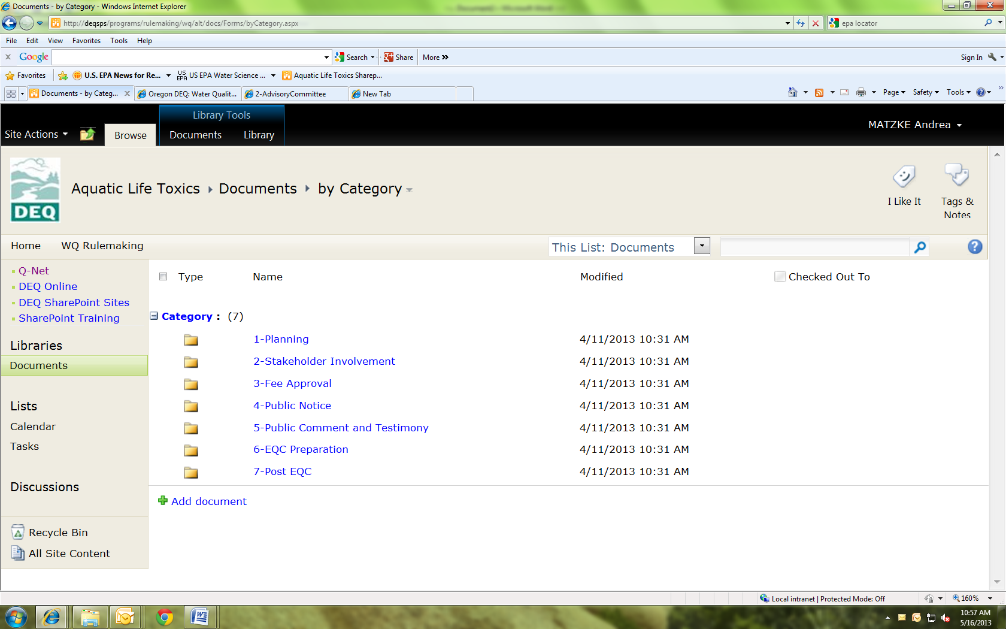

*This where the rule schedule and resources and considerations docs are found*

1. **Rulemaking Schedule** (see handout)
   1. EQC Adoption Dec. 11, 2013
   2. Stakeholder Meetings (2)
      1. Members confirmed (see handout)
      2. Week of June 24 (Info and Summary of Proposed Changes)
      3. Week of July 11(Fiscal Discussion) Dec EQC Adoption
      4. Develop committee charge: expectations, scope of rulemaking
      5. Open to the public
      6. Post meeting on website and Public Transparency website (may not be needed here). Two weeks ahead of meeting required?
   3. SOS Filing: 8/15/13
   4. Public Comment: 9/1 – 9/30
   5. Public Hearing (Portland): 9/18
   6. Submit EQC Staff Report: 11/1
2. **Develop ALC rulemaking website**
   1. Description and purpose of rulemaking
   2. Post Advisory Committee agenda, meeting materials, and minutes here
3. **Scope of Rulemaking**
   1. Re-adopt arsenic and Cr VI—inadvertently left off Table 33B. EPA took no action, but recommended reinstatement of the criteria.
   2. Express Se criteria as dissolved
   3. Correct 11 pesticides: Add note to ALC table that the frequency and duration of the pesticides is different. Clarify pesticide footnote
   4. Re-propose endosulfan-alpha, endosulfan-beta, and heptachlor epoxide
   5. Ag acute criterion: Remove Footnote P
   6. Endosulfan: Footnote P should be Footnote O
   7. Consolidate ALC into one table—clarify several footnotes, revise criteria to 2 sig. digits
   8. Minor typos in Table 40
   9. Correct typos in As Red Policy Rule
   10. Revisions to Toxics Rule in -0033 and associated revisions to GW rules from the removal of Table 20 (instead programs should point to the toxics rule in general rather than specifically Table 20)
4. **Resources**
   1. Andrea: Advisory committee materials, coordination, rulemaking docs, etc.
   2. Jennifer: Review and approval of rulemaking docs
   3. Deb: review of rulemaking docs
   4. Lori Pillsbury: review of consolidated ALC table
   5. Permitting/TMDL/groundwater/clean up staff: review of proposed rules