**TABLE 1**

**OAR 340-071-0220**

**MINIMUM SEPARATION DISTANCES**

|  |  |  |
| --- | --- | --- |
| **Items Requiring Setback** | **From**  **Subsurface**  **Absorption Area Including Replacement Area** | **From Septic Tank and**  **Other Treatment Units, Effluent Sewer and**  **Distribution Units** |
| 1. Groundwater Supplies and Wells. | *100' | 50' |
| 2. Springs:  • Upgradient.  • Downgradient. | 50'  100' | 50'  50' |
| **3. Surface Public Waters:  • Year round.  • Seasonal. | 100'  50' | 50'  50' |
| 4. Intermittent Streams:  • Piped (watertight not less than 25' from any part of the on-site system).  • Unpiped. | 20'  50' | 20'  50' |
| 5. Groundwater Interceptors:  • On a slope of 3% or less.  • On a slope greater than 3%:  y Upgradient.  y Downgradient. | 20'  10'  50' | 10'  5'  10' |
| 6. Irrigation Canals:  • Lined (watertight canal).  • Unlined:  y Upgradient.  y Downgradient. | 25'  25'  50' | 25'  25'  50' |
| 7. Cuts Manmade in Excess of 30 Inches  (top of downslope cut):  • Which Intersect Layers that Limit  Effective Soil Depth Within 48  Inches of Surface.  • Which Do Not Intersect Layers that  Limit Effective Soil Depth. | 50'  25' | 25'  10' |
| 8. Escarpments:  • Which Intersect Layers that Limit  Effective Soil Depth.  • Which Do Not Intersect Layers that  Limit Effective Soil Depth. | 50'  25' | 10'  10' |
| 9. Property Lines. | 10' | 5' |
| 10. Water Lines. | 10' | 10' |
| 11. Foundation Lines of any Building,  Including Garages and Out Buildings. | 10' | 5' |
| 12. Underground Utilities. | 10' | — |
| * 50-foot setback for wells constructed with special standards granted by WRD.  **This does not prevent stream crossings of pressure effluent sewers. | | |

**TABLE 2**

**OAR 340-071-0220**

**QUANTITIES OF SEWAGE FLOWS**

|  |  |  |  |
| --- | --- | --- | --- |
| **Type of Establishment** | | **Column 1** | **Column 2** |
| **Gallons Per Day** | **Minimum Gallons Per Establishment Per Day** |
| Airports | | 5 (per passenger) | 150 |
| Bathhouses and swimming pools | | 10 (per person) | 300 |
| Camps: (4  Persons per  Campsite, where  Applicable) | Campground with central comfort stations | 35 (per person) | 700 |
| With flush toilets, no showers | 25 (per person) | 500 |
| Construction camps — semi-permanent | 50 (per person) | 1000 |
| Day camps — no meals served | 15 (per person) | 300 |
| Resort camps (night and day) with limited  plumbing | 50 (per person) | 1000 |
| Luxury camps | 100 (per person) | 2000 |
| Churches | | 5 (per seat) | 150 |
| Country clubs | | 100 (per resident member) | 2000 |
| Country clubs | | 25 (per non-resident member  present) | — |
| Dwellings: | Boarding houses | 150 (per bedroom) | 600 |
| Boarding houses – additional for non-residential  boarders | 10 (per person) | — |
| Rooming houses | 80 (per person) | 500 |
| Condominiums, Multiple family dwellings —  including apartments | 300 (per unit) | 900 |
| Single family dwellings | 300 (not exceeding 2 bedrooms) | 450* |
| Single family dwellings — with more than 2  bedrooms | 75 (for third & each succeeding  bedroom) | 450 |
| Factories (exclusive of industrial wastes — with shower facilities) | | 35 (per person per shift) | 300 |
| Factories (exclusive of industrial wastes — without shower facilities) | | 15 (per person per shift) | 150 |
| Hospitals | | 250 (per bed space) | 2500 |
| Hotels with private baths | | 120 (per room) | 600 |
| Hotels without private baths | | 100 (per room) | 500 |
| Institutions other than hospitals | | 125 (per bed space) | 1250 |
| Laundries — self-service | | 500 (per machine) | 2500 |
| Mobile home parks | | 250 (per space) | 750 |
| Motels — with bath, toilet, and kitchen wastes | | 100 (per bedroom) | 500 |
| Motels — without kitchens | | 80 (per bedroom) | 400 |
| Picnic Parks — toilet wastes only | | 5 (per picnicker) | 150 |
| Picnic Parks — with bathhouses, showers, and flush toilets | | 10 (per picnicker) | 300 |
| Restaurants | | 40 (per seat) | 800 |
| Restaurants — single-service | | 2 (per customer) | 300 |
| Restaurants — with bars and/or lounges | | 50 (per seat) | 1000 |
| Schools: | Boarding | 100 (per person) | 3000 |
| Day — without gyms, cafeterias, or showers | 15 (per person) | 450 |
| Day — with gyms, cafeterias and showers | 25 (per person) | 750 |
| Day — with cafeteria, but without gyms or showers | 20 (per person) | 600 |
| Service Stations | | 10 (per vehicle served) | 500 |
| Swimming pools and bathhouses | | 10 (per person) | 300 |
| Theaters: | Movie | 5 (per seat) | 300 |
| Drive-In | 20 (per car space) | 1000 |
| Travel trailer parks — without individual water and sewer hookups | | 50 (per space) | 300 |
| Travel trailer parks — with individual water and sewer hookups | | 100 (per space) | 500 |
| Workers: | Construction — as semi-permanent camps | 50 (per person) | 1000 |
| Day — at schools and offices | 15 (per shift) | 150 |
| * Except as otherwise provided in these rules. | | | |

**TABLE 3**

**OAR 340-071-0220**

**SLOPE, EFFECTIVE SOIL DEPTH RELATIONSHIP**

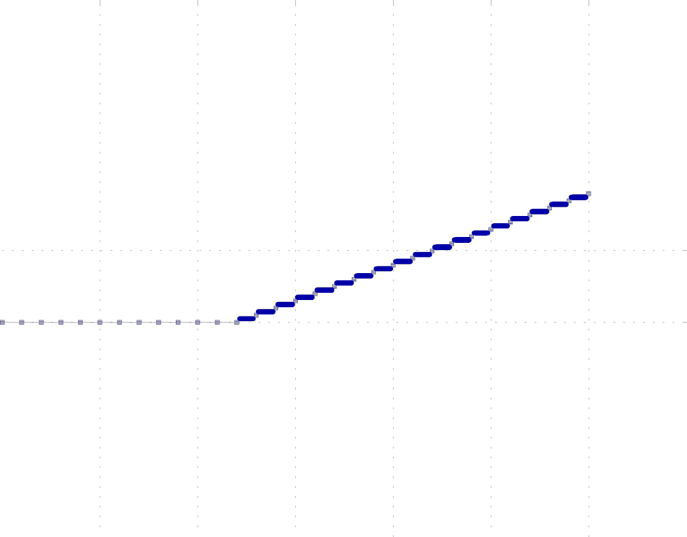









* When slope exceeds 30 percent, rules on steep slope systems apply. (Refer to OAR 340-71-0310.)

**TABLE 4**

**OAR 340-071-0220**

|  |  |  |  |
| --- | --- | --- | --- |
| Minimum length of absorption trench (linear feet) required per 150 gallons projected daily sewage flow determined from soil texture versus effective soil depth. | | | |
| **Effective Soil Depth** | **Soil Group** | | |
| **A** | **B** | **C** |
| 18" to Less than 24" | 125 | 150 | 175 |
| 24" to Less than 36" | 100 | 125 | 150 |
| 36" to Less than 48 | 75 | 100 | 125 |
| 48" or more | 50 | 75 | 125 |
| * Soil Group A — Sand, Loamy Sand, Sandy Loam.  Soil Group B — Sandy Clay Loam, Loam, Silt Loam, Silt, Clay Loam. Soil Group C — Silty Clay Loam, Sandy Clay, Silty Clay, Clay.  * If sand grains are fine or very fine, site according to Group B soils. | | | |

**TABLE 5**

**OAR 340-071-0220**

|  |  |  |  |
| --- | --- | --- | --- |
| Minimum length of absorption trench (linear feet) required per 150 gallons projected daily sewage flow determined from soil texture versus depth to temporary groundwater. | | | |
| **Depth to Temporary**  **Groundwater** | **Soil Group** | | |
| **A** | **B** | **C** |
| 24" to Less than 48" | 100 | 125 | 150 |
| 48" or More | 50 | 75 | 125 |
| * Soil Group A — Sand, Loamy Sand, Sandy Loam.  Soil Group B — Sandy Clay Loam, Loam, Silt Loam, Silt, Clay Loam. Soil Group C — Silty Clay Loam, Sandy Clay, Silty Clay, Clay.  * If sand grains are fine or very fine, site according to Group B soils. | | | |

TABLE6

OAR 340-071-0100

SOIL TEXTURAL CLASSIFICATION CHART

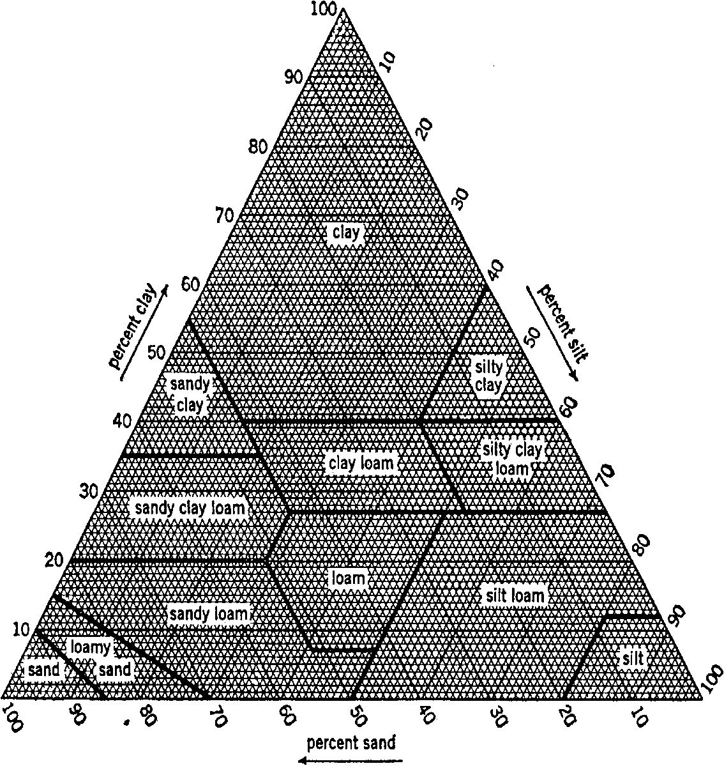

**TABLE 7**

**OAR 340-071-0100**

**USDA SOIL CLASSIFICATION SIZES OF SOIL SEPARATES**

**Sieve Sizes Millimeters**

Clay

Silt

.002

Very Fine Sand

270 .050

200 .075

140 .1

Fine Sand

60 .25

Medium Sand

35 .5

Coarse Sand

Very Coarse Sand

18 1.0

10 2.0

Fine Gravel

4 4.75

3/8" 9.5

Coarse Gravel

1/2 12.5

Cobbles

3" 76.2

**TABLE 8**

**OAR 340-071-0330**

**MINIMUM SEPARATION DISTANCES FOR**

**NONWATER-CARRIED WASTE DISPOSAL FACILITIES**

|  |  |  |
| --- | --- | --- |
|  | **Self-Contained Nonwater-Carried Waste Disposal** | **Unsealed Earth Type Privies, Gray Water Waste Disposal Sump and Seepage Chambers** |
| Groundwater supplies including springs and cisterns | 50' | 100' |
| Surface public waters, excluding intermittent streams | 50' | 100' |
| Intermittent streams | 50' | 50' |
| Property line | 25' | 25' |

**OAR 340-071-0140**

**ONSITE SYSTEM FEE SCHEDULE**

|  |  |
| --- | --- |
| Table 9A  **Site Evaluation and Existing System Evaluation Fees** | |
| New Site Evaluation fees. Fees in this section apply to each system for which site suitability is evaluated. |  |
| Single family dwelling - First lot | $680 |
| Single family dwelling - Each additional lot evaluated during initial visit | $680 |
| Commercial facility with a design capacity of 1,000 gpd or less | $680 |
| Commercial facility with a design capacity of 1,001-1,500 gpd | $856 |
| Commercial facility with a design capacity of 1,501-2,000 gpd | $1,032 |
| Commercial facility with a design capacity of 2,001-2,500 gpd | $1,208 |
| Commercial facility with a design capacity of 2,501-3,000 gpd | $1,384 |
| Commercial facility with a design capacity of 3,001-3,500 gpd | $1,560 |
| Commercial facility with a design capacity of 3,501-4,000 gpd | $1,736 |
| Commercial facility with a design capacity of 4,001-4,500 gpd | $1,912 |
| Commercial facility with a design capacity of 4,501-5,000 gpd | $2,088 |
| Commercial facility with a design flow greater than 5,000 gpd | $2,304 |
| Site Evaluation Report Review fee | $640 |
| Existing System Evaluation Report fee | $640 |

|  |  |  |  |  |  |  |  |
| --- | --- | --- | --- | --- | --- | --- | --- |
| Table 9B  **Permitting Fees for Systems Not Subject to WPCF Permits. Effective January 4, 2010 to January 2, 2011** | | | | | | | |
|  |  | Gray water waste disposal sumps | Holding tanks | Standard subsurface, Absorption trenches in saprolite, Evapotranspiration- absorption, Redundant, Seepage trench, Steep slope | Alternative treatment technologies, Capping fill, Pressurized distribution, Tile dewatering | Recirculating gravel filter, Sand filter (commercial or residential) | Plan Review fees for commercial facility systems. |
| Construction-Installation Permit fees. |  |  |  |  |  |  |  |
| For systems with a design capacity of less than 600 gpd |  | $364 | $702 | $819 | $1,027 | $1,235 | $0 |
| For systems with a design capacity of 600 gpd but not more than 1,000 gpd |  | $364 | $702 | $819 | $1,027 | $1,235 | $299 |
| For systems with a design capacity of 1,001-1,500 gpd |  | $442 | $780 | $897 | $1,105 | $1,313 | $351 |
| For systems with a design capacity of 1,501-2,000 gpd |  | $520 | $858 | $975 | $1,183 | $1,391 | $403 |
| For systems with a design capacity of 2,001-2,500 gpd |  | $598 | $936 | $1,053 | $1,261 | $1,469 | $455 |
| Reinspection fee | $100 |  |  |  |  |  |  |
| Pump Evaluation fee. For all permits that specify the use of a pump or dosing siphon except for sand filter, Alternative treatment technologies, Recirculating gravel filter, and pressurized distribution systems | $52 |  |  |  |  |  |  |

|  |  |  |  |  |  |  |  |
| --- | --- | --- | --- | --- | --- | --- | --- |
| Table 9B  **Permitting fees for systems not subject to WPCF permits. Effective January 3, 2011** | | | | | | | |
|  |  | Gray water waste disposal sumps | Holding tanks | Standard subsurface, Absorption trenches in saprolite, Evapotranspiration- absorption, Redundant, Seepage trench, Steep slope | Alternative treatment technologies, Capping fill, Pressurized distribution, Tile dewatering | Recirculating gravel filter, Sand filter (commercial or residential) | Plan Review fees for commercial facility systems. |
| Construction-Installation Permit fees. |  |  |  |  |  |  |  |
| For systems with a design capacity of less than 600 gpd |  | $448 | $864 | $1,008 | $1,235 | $1,520 | $0 |
| For systems with a design capacity of 600 gpd but not more than 1,000 gpd |  | $448 | $864 | $1,008 | $1,235 | $1,520 | $368 |
| For systems with a design capacity of 1,001-1,500 gpd |  | $544 | $960 | $1,104 | $1,313 | $1,660 | $432 |
| For systems with a design capacity of 1,501-2,000 gpd |  | $640 | $1,056 | $1,200 | $1,391 | $1,712 | $496 |
| For systems with a design capacity of 2,001-2,500 gpd |  | $736 | $1,152 | $1,296 | $1,469 | $1,808 | $560 |
| Reinspection fee | $100 |  |  |  |  |  |  |
| Pump Evaluation fee. For all permits that specify the use of a pump or dosing siphon except for sand filter, Alternative treatment technologies, Recirculating gravel filter, and pressurized distribution systems | $64 |  |  |  |  |  |  |

|  |  |  |  |
| --- | --- | --- | --- |
| Table 9C  **Other Permitting Fees for Systems Not Subject to WPCF permits. Effective January 4, 2010 to January 2, 2011** | | | |
|  |  | Field Visit required | No Field Visit required |
| Minor Alteration Permit | $215 |  |  |
| Major Alteration Permit | $449 |  |  |
| Minor Repair Permit - Single Family Dwelling | $215 |  |  |
| Major Repair Permit - Single Family Dwelling | $449 |  |  |
| Minor Repair Permit - Commercial Facility | $377 |  |  |
| Major Repair Permit - Commercial Facility | $819 or the applicable fee in Table 9B, whichever is lower. |  |  |
| Permit Denial Review | $352 |  |  |
| Permit Transfer, Reinstatement, or Renewal |  | $423 | $124 |
| Authorization Notice |  | $507 | $130 |
| Authorization Notice Denial Review | $640 |  |  |
| Renewal of hardship authorization for temporary dwelling |  | $330 | $100 |
| Alternative system inspection - Holding tanks | $312 |  |  |
| Alternative system inspection - Other alternative systems listed in Table 9B | $429 |  |  |
| Annual report evaluation - Holding tanks | $25 |  |  |
| Annual report evaluation - Commercial sand filters, recirculating gravel filters, and alternative treatment technology | $50 |  |  |
| Variance from onsite system rules | $2,080 |  |  |

|  |  |  |  |
| --- | --- | --- | --- |
| Table 9C  **Other Permitting Fees for Systems Not Subject to WPCF Permits. Effective January 3, 2011** | | | |
|  |  | Field Visit required | No Field Visit required |
| Minor Alteration Permit | $264 |  |  |
| Major Alteration Permit | $552 |  |  |
| Minor Repair Permit - Single Family Dwelling | $256 |  |  |
| Major Repair Permit - Single Family Dwelling | $535 |  |  |
| Minor Repair Permit - Commercial Facility | $464 |  |  |
| Major Repair Permit - Commercial Facility | $1,008 or the applicable fee in Table 9B, whichever is lower. |  |  |
| Permit Denial Review | $352 |  |  |
| Permit Transfer, Reinstatement, or Renewal |  | $520 | $152 |
| Authorization Notice |  | $624 | $160 |
| Authorization Notice Denial Review | $640 |  |  |
| Renewal of hardship authorization for temporary dwelling |  | $330 | $100 |
| Alternative system inspection - Holding tanks | $384 |  |  |
| Alternative system inspection - Other alternative systems listed in Table 9B | $528 |  |  |
| Annual report evaluation - Holding tanks | $30 |  |  |
| Annual report evaluation - Commercial sand filters, recirculating gravel filters, and alternative treatment technology | $60 |  |  |
| Variance from onsite system rules | $2,080 |  |  |

|  |  |  |  |  |  |  |
| --- | --- | --- | --- | --- | --- | --- |
| Table 9D  **WPCF Permit Fees** | | | | | | |
|  |  | Application filing fee (all systems) | Permit processing fees for onsite systems with a design capacity of 1,200 gpd or less. | Permit processing fees for onsite systems with a design capacity over 1,200 gpd: | Plan Review fee. | Annual Compliance Determination fee. |
| New application |  | $72 | $576 | $2,878 |  |  |
| Permit renewal (involving request for effluent limit modifications) |  | $72 | $287 | $1,440 |  |  |
| Permit renewal (without request for effluent limit modifications) |  | $72 | $145 | $718 |  |  |
| Permit modification (involving increase in effluent limitations) |  | $72 | $287 | $1,440 |  |  |
| Permit modification (not involving an increase in effluent limits) |  | $72 | $216 | $718 |  |  |
| For commercial facilities with a design capacity less than 600 gpd |  |  |  |  | $0 |  |
| For commercial facilities with a design capacity of 600 - 1,000 gpd |  |  |  |  | $275 |  |
| For commercial facilities with a design capacity of 1,001 - 1,500 gpd |  |  |  |  | $324 |  |
| For commercial facilities with a design capacity of 1,501 - 2,000 gpd |  |  |  |  | $372 |  |
| For commercial facilities with a design capacity of 2,001 - 2,500 gpd |  |  |  |  | $420 |  |
| For commercial facilities with a design capacity of 2,501 - 3,000 gpd |  |  |  |  | $492 |  |
| For commercial facilities with a design capacity of 3,001 - 3,500 gpd |  |  |  |  | $540 |  |
| For commercial facilities with a design capacity of 3,501 - 4,000 gpd |  |  |  |  | $588 |  |
| For commercial facilities with a design capacity of 4,001 - 4,500 gpd |  |  |  |  | $635 |  |
| For commercial facilities with a design capacity of 4,501 - 5,000 gpd |  |  |  |  | $683 |  |
| Commercial facilities with a design capacity greater than 5,000 gpd |  |  |  |  | $718 |  |
| Single family dwelling |  |  |  |  | $145 |  |
| Onsite sewage lagoon with no discharge |  |  |  |  |  | $863 |
| Treatment Standard 1 or better systems with design capacities less than 2,500 gpd |  |  |  |  |  | $360 |
| Treatment Standard 1 or better systems with design capacities of 2,501 - 20,000 gpd |  |  |  |  |  | $718 |
| Holding tanks, if by the date specified by the department, the owner does not submit written certification to the department that the holding tank has been operated the previous calendar year in full compliance with the permit or that the previous year's service logs for the holding tanks are not available for inspection by the department |  |  |  |  |  | $287 |
| Holding tanks, if by the date specified by the department, the owner submits written certification to the department that the holding tank has been operated the previous calendar year in full compliance with the permit and that the previous year's service logs for the holding tanks are available for inspection by the department. |  |  |  |  |  | $31 |
| Other systems with design capacities less than 20,000 gpd |  |  |  |  |  | $360 |
| Other systems with design capacities greater than 20,000 gpd |  |  |  |  |  | $718 |
| Site Evaluation Confirmation | $504 |  |  |  |  |  |

|  |  |
| --- | --- |
| Table 9E  **Sewage Disposal Service License and Truck Inspection Fees** | |
| New 3-year business license | $355 per year |
| Renewal of business license | $320 per year |
| Transfer of or amendments to license | $200 |
| Reinstatement of suspended license | $250 |
| Pumper truck inspections - First vehicle, each inspection | $100 |
| Pumper truck inspections - Each additional vehicle, each inspection | $50 |

|  |  |
| --- | --- |
| Table 9F  **Other Fees** | |
| Innovative or Alternative Technology or Material Review | $1,600 |
| Material Plan Review | $480 |
| Department surcharge | $60 |