Summary of Economic Analysis Requirements for Change in Water Quality Standards
Introduction
As presented in the Water Quality Standards Regulation, economic factors are taken into consideration at various points in the process of setting, enforcing, or changing Water Quality Standards. EPA has developed a series of guidelines for conducting economic analysis when a State is conducting a Use Attainability Analysis (UAA), considering a variance or determining if degradation of high-quality water is warranted (Anti-Degradation review). For the purposes of this discussion, we will be presenting information on how the guidelines are applied to granting variances for point source discharges.
These guidelines are presented in EPA’s Interim Economic Guidance for Water Quality Standards (March 1995) and a number of states have integrated the language into their own rules or state guidance documents. DEQ has incorporated parts of the EPA Guidance into our Anti-degradation Internal Management Directive (Anti-Deg IMD).
Minimum Treatment Requirements
The economic impacts considered are those that result from treatment beyond that required by technology-based regulations. Since water quality cannot be lower than that resulting from technology-based limits applied to direct and indirect point source discharges, these are considered to be the baseline. All economic impact analyses of water quality standards should, therefore, address only the cost of improving the discharge to meet water quality standards.
Key Language from Guidance
In order to remove a designated use through a UAA or obtain a variance, the State or discharger must demonstrate that attaining the water quality standard would result in “substantial and widespread economic and social impacts”. Each analysis of economic impacts must demonstrate:
- that the polluting entity, whether privately or publicly owned, would face substantial financial impacts due to the costs of the necessary pollution controls (substantial impacts), and
- that the affected community will bear significant adverse impacts if the entity is required to meet existing or proposed water quality standards (widespread impacts).
This is somewhat different from the test required for anti-degradation review, where it must be shown that lower water quality is necessary to “accommodate important social and economic development”.

Procedures for Public vs. Private Dischargers
A major factor in how the economic analysis is conducted is whether the pollution control is the responsibility of a privately or a publicly owned entity. Since the polluting entity or party may not be the one to pay for reductions, the analyses focus on the party that pays for pollution control. Differences in how the analyses are conducted stem from the differences in funding mechanisms available to the two distinct entities. For example, in the case of a privately-owned entity, the facility can raise the money through loans and equity funds but may try to pass some or all of the cost on to the consumer in the form of higher prices. In the case of a publicly-owned entity, the community can float bonds to pay for the capital costs, with the cost of the bonds and operating expenses covered by user fees and/or tax revenues. The federal guidance provides a distinct set of procedures for each entity (private / public) that reflect the various differences and relies upon different metrics for determining the magnitude of the key impacts (substantial / widespread).
Key Terms
The term "financial impacts" refers to impacts on the entity or party that will pay for the pollution control, whereas the term "socioeconomic impacts" refers to changes in the social and/or economic conditions of the affected community. For public-sector entities, such as a publicly owned treatment works (POTW), substantial impacts include financial impacts on the community, taking into consideration current socioeconomic conditions. Widespread, on the other hand, refers to changes in the community's socioeconomic conditions. By contrast, for private-sector entities, substantial impacts refer to financial impacts and widespread impacts refer to socioeconomic impacts on the surrounding community.
Substantial Impacts
A financial analysis of the discharger should be conducted to determine if the capital and the operating and maintenance costs of pollution control will have a substantial impact. This analysis is typically performed by the discharger and reviewed by DEQ. The first step is to estimate the capital and the operation and maintenance costs of the necessary pollution control (see Figure 1-1). The second step is to determine how the entity will finance the necessary reductions. If the entity is publicly-owned (e.g. a municipal sewage treatment plant), the households in the community will bear the cost either through an increase in user fees, an increase in taxes or a combination of both. The burden to households resulting from total annual pollution control costs must be estimated. In addition, the financial impact analysis must consider the community's ability to obtain financing and the general economic health of the community. Typically, much of the data and analysis required by this analysis are readily available from the POTW’s or service district’s General Sewer and/or Facility planning documents.
If the entity is privately-owned (e.g. a manufacturing facility), the analysis should consider factors such as the entity's ability to secure financing and the degree to which it will be able to pass the cost of pollution control on to its customers in the form of higher prices. The financial impact analysis of private-sector entities employs a variety of financial ratios and tests. Some of these ratios and tests include benchmark values to help in the analysis.
Demonstration of substantial financial impacts is not sufficient reason to modify a use or grant a variance from water quality standards. Rather, the applicant must also demonstrate that compliance would create widespread socioeconomic impacts on the affected community.
Widespread Impacts
DEQ and the discharger will need to consider the possibility that financial impacts could cause far reaching and serious impacts to the community. An important factor in determining the magnitude of these impacts is defining the geographical area affected. The affected area might be a town, city, region, county or some combination of these geographical units.
Equally important are the types of impacts that might occur. There are no economic ratios or tests per se to evaluate socioeconomic impacts. Instead, the relative magnitude of a group of indicators should be taken into account. For public-sector entities, the applicant will need to estimate the change in socioeconomic conditions that would occur as a result of compliance. Of particular importance are changes in factors such as median household income, unemployment, and overall net debt as a percent of full market value of taxable property. For private-sector entities, the assessment of widespread impacts should consider many of the same socioeconomic conditions. The analysis should also consider the effect of decreased tax revenues if the private-sector entity were to go out of business, income losses to the community if workers lose their jobs, and indirect effects on other businesses.
Conclusion
EPA’s guidance essentially provides a procedural description and series of metrics by which the degree and scope of a proposed action may economically affect a public or private entity, and the extended community. Additionally the guidance also includes a series of calculation worksheets to walk the applicant through the process. Although these are fairly comprehensive, in no-way is the economic analysis limited to only using the referenced process. Based upon the permit writer’s discretion, additional or alternative analysis may be required. The guidance serves as a typical path with a minimum set of requirements.
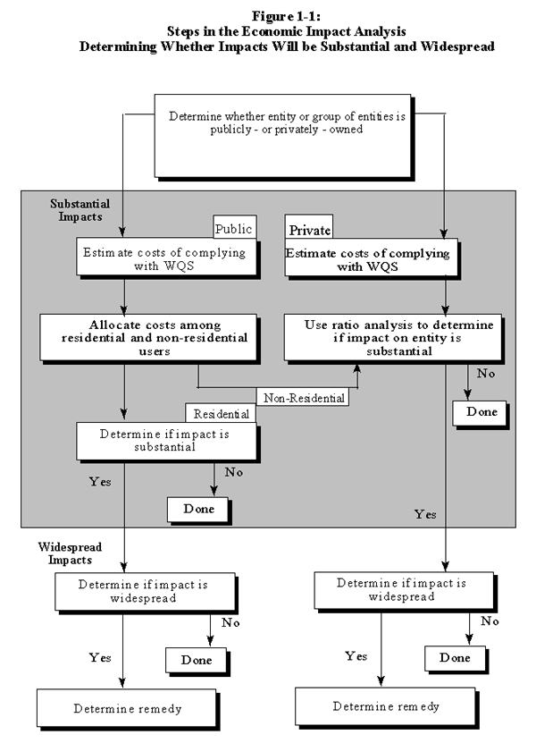

i.e. manufacturing facilities, agricultural operations, shopping centers and other commercial development, residential developments, and recreational developments
i.e. publicly owned sewage treatment works, roads, and other municipal infrastructure

