March 21, 2011

Andrea Matzke

DEQ - Water Quality Division

811 SW 6th Ave.

Portland, OR 97204

**RE:** Revised water quality standards for Human Health Toxics and implementation policies

Thank you for the opportunity for the Oregon Department of Agriculture (ODA) to provide comment on DEQ’s proposed revised water quality standards for human health toxic pollutants and revised water quality standards implementation policies. ODA’s close contact with the farmers and ranchers in Oregon, keeps ODA informed of their concerns regarding matters related to natural resource management in Oregon. The department has received feedback from farmers and ranchers regarding DEQ’s proposed revised water quality standards for human health toxic pollutants and revised water quality standards implementation policies. We have identified a number of key concerns that have been raised.

1. The fish consumption rate (175 grams per day or approximately 23 8-ounce fish meals per month) used to determine human health criteria is not an appropriate rate. The survey techniques to generate this estimate involved a very small sample of the population in Oregon and the amounts reported by those surveyed were based on anecdotal estimates. Farmers and ranchers have indicated that we need a scientifically based research project that documents consumption of toxics through fish consumption.
2. The fish consumption rate (175 grams per day or approximately 23 8-ounce fish meals per month) used to determine human health criteria were drawn from the main stem of the Columbia and Willamette rivers.** Information drawn from these areas is not applicable to other major rivers in the state or to many of the streams that feed the Columbia and Willamette main stems. Fish consumption rates (FCR) and the industrial toxics of concern are much lower when you leave the main stem Columbia and Willamette Rivers. Based on the original recommendation by ODEQ's Technical Advisory Committee (TAC), a tiered approach to the FCR, taking into account variable fish consumption across Oregon, should be developed which then would affect water quality standards for human health toxic pollutants.
3. Load allocation is not identified in ORS 568.900-933 or ORS 561. These statutes do indicate that the Agricultural Water Quality Management Program is responsible for the prevention and control of water pollution from agricultural activities and soil erosion. The statute also indicates that the EQC can petition the department if the plans and rules are not adequate to achieve compliance with applicable state and federal water quality standards. For these reasons, Oregon farmers and ranchers feel strongly that the program should be tied to achieving these identified goals. They believe DEQ can and should utilize Agricultural Water Quality Management plans and rules in describing state efforts to achieve water quality standards in the TMDLs implementation plans submitted to EPA by the state. They do not believe that DEQ can or should establish direction for Agricultural Water Quality Management plans and rules to meet load allocations.
4. The Agricultural Water Quality Management Program implemented by ODA is a very effective program. Agricultural representatives, environmental interests and others have been involved in the implementation of this condition-based program from its inception. We have seen tremendous landowner acceptance and effort to address water quality issues because of this program and efforts of the SWCDs. Where it has been needed, the program's enforcement authority has been effectively used to resolve issues. This program presently is effective in addressing source of toxics that may enter waters of the state via sediment. The program addresses sediment transport to water through education and outreach provided by the program in cooperation with SWCDs and through regulation implemented by ODA.
5. Farmers and ranchers do not support any effort to implement a practices based program or requirements. The model being implemented by ODA encourages landowner efforts that are more productive than what would be expected under a practice based program. A condition-based program allows the department and landowners to address the problem or concern that is not achieved under a mandatory practice based program. Any effort by DEQ to influence the adoption of practices would be counter productive to the success of this program and should not be considered.
6. Farmers and ranchers have expressed concern that DEQ’s proposed change OAR 340-041-0061(11) was developed so that DEQ may take direct enforcement action against agricultural landowners rather than refer problems to ODA to be dealt with under the Agricultural Water Quality Management Program. The last sentence in this section could be removed as it is not needed and does not diminish DEQs statutory responsibilities.

In a resolution developed by the Board of Agriculture December 2, 2011, the Board of Agriculture recognized “that the Environmental Quality Commission has authority for rules and standards relating to water pollution control and that landowners are subject to all remedies and sanctions available to the Department of Environmental Quality or the Environmental Quality Commission.” The Board of Agriculture resolution resolved that ODA should “implement water quality programs in a thorough, rigorous, and proactive manner such that enforcement of water quality regulations on agricultural lands by the Oregon Department of Environmental Quality is not necessary to ensure compliance with water quality standards.” The Board indicated that to achieve this goal the DEQ and ODA should update the 1997 Memorandum of Agreement (MOA) [signed in 1998] to coordinate mutual efforts to protect agricultural water quality. ODA and DEQ are working to revise the MOA and hope to have it finalized by June 2011, we believe it will provide a good foundation to describe expectations preventing and controlling water pollution from agriculture and erosion from rural lands. This MOA will include a framework for our cooperative efforts, including those related to enforcement. ODA fully intends to operate a compliance program that provides protection for water, people and the environment, as does the DEQ program.

Again, thank you for the opportunity to comment on these proposed rules.

Sincerely,

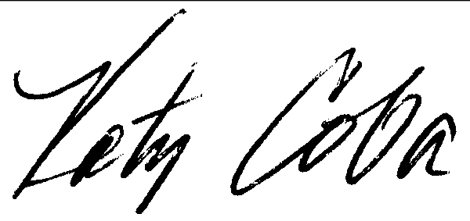

Katy Coba

Director

** The FCR was a result of a study based on fish consumption surveys across different population sub-groups (not toxic amounts detected in fish tissue). An influential study was a 1994 study by the Columbia River Inter Tribal Fish Commission (CRITFC) that surveyed the Umatilla, Nez Perce, Yakima and Warm Springs tribes of the Columbia River Basin. The TAC proposed multiple fish consumption rates (representing low, medium and high fish consumption) based on the studies they reviewed. The Policy Advisory Committee was concerned about how a multiple approach could be implemented and could not reach a consensus.