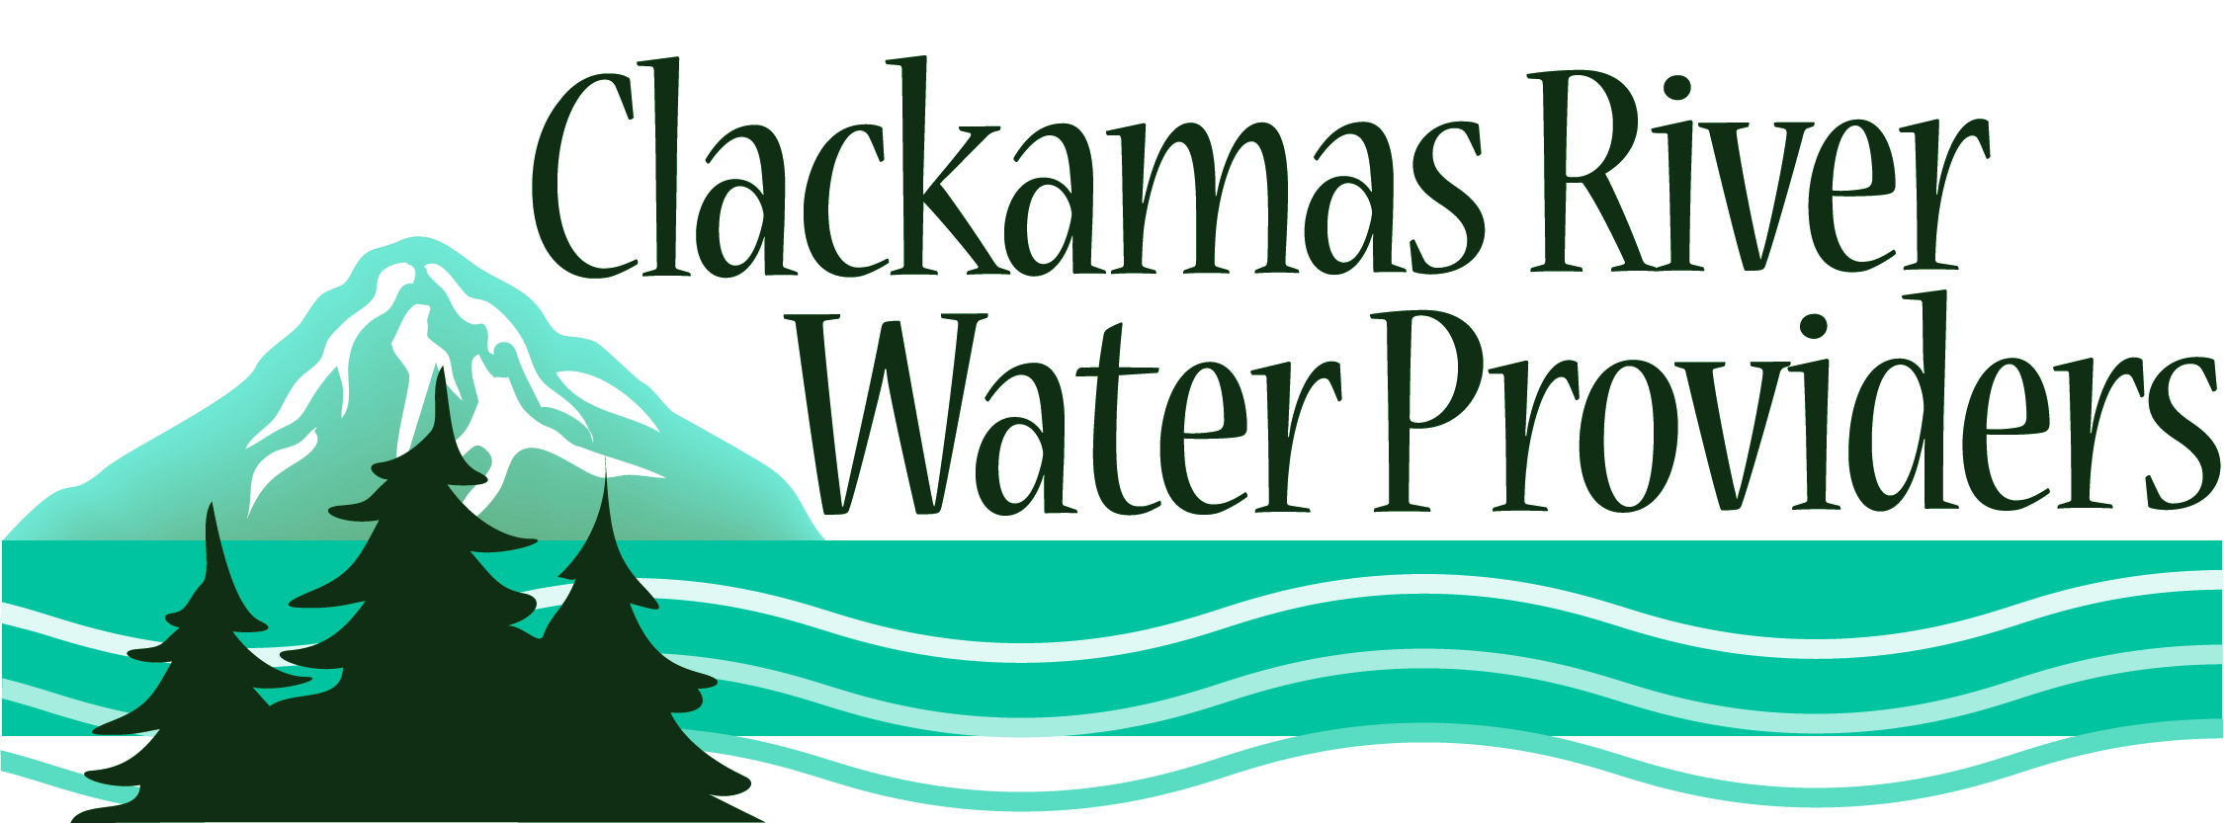
14275 S. Clackamas River Drive * Oregon City, OR 97045
Voice: (503) 723-3510 * Fax (503) 723-3508

Andrea Matzke
Oregon DEQ
Water Quality Division
811 SW Sixth Avenue
Portland, OR 97204

Re: Comments on Proposed Toxics Rulemaking
E-mailed to: ToxicsRuleMaking@deq.state.or.us

Dear Ms. Matzke,

The Clackamas River Water Providers (CRWP) is a coalition of municipal drinking water providers that draw water from the Clackamas River and is made up of representatives from the City of Estacada, the City of Lake Oswego, Clackamas River Water, the North Clackamas County Water Commission (City of Gladstone and Oak Lodge Water District), South Fork Water Board (Oregon City and West Linn), and Sunrise Water Authority (Happy Valley and Damascus). Collectively we provide drinking water to approximately 300,000 people in Clackamas County.

One of our the top priorities is to protect our water resources by identifying, preventing, and mitigating activities that have known or potentially harmful impacts on drinking water quality so that the Clackamas River can be preserved as a high quality drinking water source. So, we share DEQ’s concern regarding water quality in the Clackamas River. However, we are concerned the proposed new rules related to fish consumption may lead to unnecessarily restrictive control over point dischargers (e.g. municipal wastewater providers) while over-looking the larger problem associated with diffuse or non-point sources. Moreover, the new rules may force point dischargers to employ very expensive treatment technologies that may only produce a limited or non-quantifiable result in the desired control of toxins in fish tissue.

We would call for the agency to examine the efficacy of this rule and look to set priorities that target pollution prevention in the larger context of a particular toxin’s source rather than attempting to require expensive, possibly ineffective point source control. As examples, the CRWP is engaged in toxin reduction efforts through its support for drug take back programs, by sponsoring Pesticide Collection Events, and through implementing water wise and naturescaping workshops to reduce the use of fertilizers, pesticides and water use.

Therefore the CRWP encourages toxic reduction efforts. However, we believe that for these efforts to be effective they must address all sources of toxics from all sectors, and that meaningful reduction in toxics, and improved human health, cannot be achieved by regulating only point sources. In addition we believe that pollution prevention is one of the most effective and cost-effective means to achieve these reductions.

If DEQ is serious about toxics reduction, we encourage development of a strategy that incorporates all sources of toxics, and which does not put undue burden on one type of permit holder. DEQ needs to ensure that these efforts are coordinated and focused on the most effective actions to reduce toxics in Oregon. Adoption of the revised toxic water quality standards should not be undertaken until the overall toxic reduction strategy for Oregon is reviewed and approved by Environmental Quality Commission and the necessary steps to implement it initiated.

Thank you for the opportunity to comment.

Sincerely,

Kim Swan

Kimberly Swan
Water Resource Manager
Clackamas River Water Providers
14275 S. Clackamas River Rd.
Oregon City, OR 97045
(503) 723-3510
kims@clackamasproviders.org

