Discussion Draft
Background Information & Options:
Revising Oregon’s Human Health Criteria for Manganese

Review of Oregon’s Human Health Criteria for Manganese

As part of the Oregon Toxic Standards Review Project, the Oregon Department of Environmental Quality is reviewing its human health criteria of for manganese. DEQ agreed to review the criteria because manganese is a naturally occurring earth metal in Oregon and because the “water + organism” criterion is not based on levels needed to protect human health.

Background Information

According to the World Health Organization (1999), manganese (Mn) is a naturally occurring element that is found in rock, soil, water and food. Thus, all humans are exposed to manganese, and it is a normal component of the human body. Food is usually the most important route of exposure for humans. (See the Appendix for more information from this document.)

Studies of manganese concentrations in soils found that they generally range from 200 to 1000 µg/g in volcanically derived soils (Alloway, 1990 in DEQ, 2008); and natural background manganese concentrations in Washington State soils average between 700 and 1500 µg/g (Juan, 1994 in DEQ. 2008). Sampling by DEQ and USGS in the Molalla-Pudding subbasin of Oregon showed dissolved manganese concentrations in groundwater ranged from < 1 µg/l to 740 µg/l (DEQ, 2008).

Figure 1 shows surface water data for dissolved manganese from DEQ’s LASAR database. Out of over 7000 samples, less than a handful exceed 1000 µg/l and only a small portion exceed 200 µg/l dissolved manganese (see Figure 1). DEQ’s 303d list includes 26 water bodies as exceeding the current criterion of 50µg/l (Table 1). Figure 2 shows seasonal dissolved manganese data from Beaverton Creek, Oregon. Manganese concentrations increased through the spring and summer, peaking in late summer/early fall and dropping for late fall and winter. This indicates that concentrations are higher relative to low base flows and reduced during high runoff periods.

Oregon’s Current Human Health Criteria for Manganese

Oregon’s currently effective CWA criteria for manganese are:
- 50 µg/l manganese for “human health, water + organism,” and
- 100 µg/l manganese for “human health, organism only. “

These were EPA’s nationally recommended criteria at the time they were adopted. DEQ specified in 2004 that the manganese criteria are for dissolved concentrations.

Federal Criteria Requirements and Recommendations

Manganese is not included in Section 307(a) of the Clean Water Act and is, therefore, considered a “non-priority” pollutant. 40 CFR § 131.11 describes the federal criteria requirements applicable to non-priority pollutants. Under these requirements, states must adopt criteria based on sound scientific rationale that cover sufficient parameters to protect designated uses. Both numeric and narrative criteria may be applied to meet these requirements.

Protection of Domestic Water Supplies

EPA’s 1976 and 1986 Quality Criteria for Water (referred to as the “Red Book” and “Gold Book,” respectively) established 50 µg/l as the recommended water quality criterion for manganese for protection of domestic water supplies., This criterion was established to protect against objectionable tastes and laundry staining. The Red Book provides that, “a criterion for domestic water supplies of 50 µg/l [for manganese] should minimize the objectionable qualities” (text in brackets added). EPA’s recommendation for manganese in Water Quality Criteria 1972 (EPA, 1973) specified that the 0.05 mg/l (50 µ/l) soluble manganese not be exceeded in public water sources based on user preference. One study found that consumer complaints about brownish staining of laundry and objectionable tastes in beverages arise when manganese exceeds 150 µg/l (Griffin, 1960 IN EPA Red Book). The Red book also notes that manganese concentrations of 10 to 20 µg/l are acceptable to most consumers.

EPA’s manganese criterion recommendation of 50 µg/l for protection of domestic water supply uses established under the Clean Water Act is the same as the secondary maximum contaminant level (MCL) established in EPA’s National Secondary Drinking Water Regulations under the Safe Drinking Water Act. Secondary MCLs are established only as guidelines to assist public water systems in managing their drinking water for aesthetic considerations, such as taste, color and odor. These contaminants are not considered to present a risk to human health at the secondary MCL.

EPA has not recommended a manganese criterion for the protection of human health. Manganese is a vital micro-nutrient (EPA, 1976). EPA notes that the average human intake is approximately 10 mg/day and that while very large does of ingested manganese can cause some disease and liver damage, these are not known to occur in the United States. Additional information on human intake levels from the World Health Organization is provided in the appendix below.

Protection of Consumers of Marine Mollusks

While the EPA’s Red and Gold Books provide that “manganese is not considered to be a problem in fresh waters,” they do establish a recommended human health criterion for manganese of 100 µg/l in marine waters. The following information is provided in the Red Book (1976):

- The average human intake of manganese is approximately 10 mg (10,000 µg) per day.
- Very large doses of ingested manganese can cause some disease and liver damage but these are not known to occur in the United States.
- The ambient [marine] concentration of manganese is about 2 µg/l (Fairbridge, 1966). The material is rapidly assimilated and bioconcentrated into nodules that are deposited on the sea floor. The major problem with manganese may be concentration in the edible portions of mollusks, as bioaccumulation factors as high as 12,000 have been reported (NAS, 1974). In order to protect against a possible health hazard to humans by manganese accumulation in shellfish, a criterion of 100 µg/l is recommended for marine water.

More recent bioconcentration data from EPA’s ECOTOX database shows that while marine mollusks have higher bioconcentration factors than other species, the BCFs range from 677 to 2583, with 47 of the 53 BCFs being above 1000 (see Table 2).

Recent Actions in other States

As part of this review, information concerning manganese criteria revisions that have been conducted in other states is being considered. Information gathered to date is summarized below.

Missouri

In 2006, the State of Missouri removed its drinking water criterion of 50 µg/l for manganese. Support for EPA approval included the following:

- EPA’s recommended criterion for manganese of 50 µg/l is based on aesthetic (e.g., laundry staining) and organoleptic (i.e., taste) effects, and as such was not developed to protect against toxicological effects.
- EPA reviewed available information regarding potential human health effects from manganese and analyzed this information, in combination with water quality monitoring data from waters in Missouri, in order to estimate potential exposure to manganese. The results of this analysis led EPA to determine that the current levels of manganese in Missouri’s waters pose no long-term risk to human health, and that a numeric criterion for manganese is not necessary to ensure protection of Missouri’s Drinking Water Supply designated use. EPA concluded that the Missouri Department of Natural Resource’s remaining revised numeric metals criteria and narrative criteria protect the designated use.

DEQ Options and Recommendation

I) Water + fish ingestion criterion to protect public and private water supplies from taste and laundry staining effects.

Options:
- withdraw the criterion of 50 µg/l dissolved manganese, or
- revise the criterion to protect against taste and laundry staining effects.

DEQ Recommendation: DEQ recommends that the criterion for water + fish ingestion be withdrawn. This criterion is not based on human health effects. Oregon does not need a numeric manganese criterion to protect water supply based on aesthetic and organoleptic effects. Table 3 below shows that only 1 surface water supplier detected manganese in their finish water and the concentration was 0.8 µg/l, far below the levels where aesthetic or taste effects are objectionable (30 – 150 µg/l). In addition, DEQ has a narrative criterion for the protection of taste, odor and aesthetic affects should limits be required to protect a surface water domestic water supply source from particularly high levels of manganese from anthropogenic sources. And finally, EPA has a secondary MCL of 50µg/l in place under the Safe Drinking Water Act to provide guidance to water suppliers for these non-health effects.

II) Water + fish ingestion criterion for public/private water supply to protect human health.

The options for the “water + fish ingestion” manganese criterion are to:
- withdraw the 50 µg/l criterion, or
- revise the 50 µg/l criterion to protect against human health effects.

DEQ Recommendation: DEQ recommends that the 50 µg/l criterion for water + fish ingestion be withdrawn. This criterion was not based on health effects and EPA has not recommended a water + organism criterion for the protection of human health, nor have they recommended an MCL to protect against human health effects of manganese in drinking water. Manganese levels in Oregon surface waters are far below average daily human intake levels. There is no reason to believe that discharges of manganese will impact beneficial uses of Oregon’s fresh waters.

III) Fish consumption only criterion to protect human health

The options for the “fish consumption only” criterion are to:
- retain the 100ug/l criterion with 2004 clarification that it will be applied as a dissolved concentration,
- specify that the 100 µg/l criterion applies only to marine waters, keep 2004 clarification that will be applied as a dissolved concentration
- Revise the 100 µg/l manganese criterion
- Withdraw the criterion, demonstrating that it is not needed to protect the applicable designated use in Oregon.

DEQ Recommendation: DEQ recommends that the 100 µg/l “fish consumption only” criterion be retained for marine waters only. The 100µg/l criterion was recommended by EPA in 1976, prior to and, therefore, not based on the fish ingestion/BCF criteria derivation method published in 1980. However, it was recommended due to concerns about high bioconcentration rates among marine mollusks. A fish consumption criterion for freshwaters is not needed because BCFs for manganese in freshwater species are low.

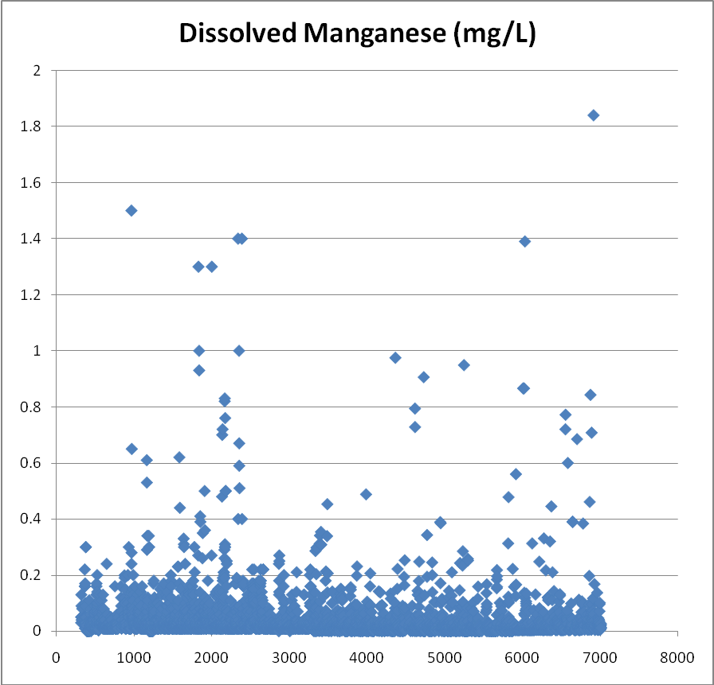

Figure 1. From Lasar data base. Surface water data for freshwaters of Oregon.
Note: 0.2 mg/l = 200 µg/l.

Table 1. Manganese Listings from 2004/06 303d Assessment, based on Table 20 Criteria
Watershed (USGS 4th Field Name) | Water Body (Stream/Lake) | River Miles |  | Samples exceeding
COOS | Isthmus Slough | 0 to 10.6 |  | 2 of 2
CROSSES SUBBASINS | Willamette River | 0 to 24.8 |  | 7 of 175
CROSSES SUBBASINS | Willamette River | 119.7 to 148.8 |  | 2 of 84
CROSSES SUBBASINS | Willamette River | 148.8 to 184.7 |  | 7 of 313
DONNER UND BLITZEN | Bridge Creek | 0 to 3.1 |  | 4 of 4
Lower Columbia | Unnamed Creek | 0 to 3.2 |  | 4 of 5
LOWER OWYHEE | Overstreet Drain | 0 to 0 |  | 2 of 3
LOWER WILLAMETTE | Arata Creek / Blue Lake | 0 to 0.9 |  | 7 of 25
LOWER WILLAMETTE | Columbia Slough | 0 to 8.5 |  | 7 of 8
LOWER WILLAMETTE | Columbia Slough | 0 to 9.8 |  | 45 of 61
LOWER WILLAMETTE | South Columbia Slough | 0 to 3.2 |  | 4 of 7
MCKENZIE | Blue River | 0 to 15.5 |  | 2 of 38
MIDDLE COLUMBIA-HOOD | Lenz Creek | 0 to 1.5 |  | 15 of 31
MIDDLE COLUMBIA-HOOD | Neal Creek | 0 to 6 |  | 0 of 13
MOLALLA-PUDDING | Pudding River | 0 to 35.4 |  | 7 of 72
MOLALLA-PUDDING | Zollner Creek | 0 to 7.8 |  | 2 of 2
NORTH UMPQUA | Sutherlin Creek | 0 to 16 |  | 20 of 26
SOUTH UMPQUA | Middle Creek | 0 to 12.8 |  | 5 of 13
SOUTH UMPQUA | South Fork Middle Creek | 0 to 4.4 |  | 8 of 12
TUALATIN | Beaverton Creek | 0 to 9.8 |  | 64 of 68
TUALATIN | Tualatin River | 0 to 80.8 |  | 151 of275
UMATILLA | Umatilla River | 0 to 32.1 |  | 11 of 50
UMATILLA | Wildhorse Creek | 0 to 33.2
UMPQUA | Cook Creek | 0 to 2.9
UPPER WILLAMETTE | Calapooia River | 0 to 42.8 |  | 9 of 39
UPPER WILLAMETTE | Long Tom River | 0 to 57.3 |  | 2 of 34
UPPER WILLAMETTE | Marys River | 0 to 41.1 |  | 4 of 39
YAMHILL | North Yamhill River | 0 to 32.5 |  | 3 of 63
YAMHILL | Salt Creek | 0 to 32.8 |  | 2 of 2
YAMHILL | Yamhill River | 0 to 11.2 |  | 3 of 67

Dissolved Mn ((µg/l)
Bi-MONTH
Figure 2. Seasonal Distribution of Dissolved Manganese (µg/l)
Beaverton Creek Near Orenco USGS and DEQ Data
0
50
100
150
200
250
300
350
400
450
500
550
JAN
-
FEB
MAR
-
APR
MAY
-
JUN
JUL
-
AUG
SEP
-
OCT
NOV
-
DEC
1991-2003
K-W 99%
WQ Criteria
(16)
(16)
(15)
(17)
(12)
(15)

Table 2. Summary of Manganese BCFs for Organisms in Saltwater and Freshwater
Media | Species Group | Number of BCFs | Range of BCF Values |  |  | Notes
Media | Species Group | Number of BCFs | Min | Max |  | Notes
Freshwater | Crustaceans | 1 | 65 | 65
Freshwater | Fish | 5 | 0.2 | 220
Freshwater | Worms | 2 | 8.5 | 9
Saltwater | Crustaceans | 14 | 0 | 3.18
Saltwater | Fish | 23 | 10 | 9090 |  | Only 5 of 23 BCFs were above 1000
Saltwater | Invertebrates | 8 | 3 | 61
Saltwater | Mollusks | 53 | 677 | 2683 |  | 47 of 53 BCFs were above 1000
Saltwater | Worms | 17 | 2.2 | 45
Values above 1000 considered high bioconcentration potential by EPA R6.
From “ECOTOX” database, EPA. http://cfpub.epa.gov/ecotox/

Table 3. Finish Water Data for Drinking Water Sources, Oregon. This table shows drinking water source finish data that exceeded detection limits for manganese. Please note that one sample is a surface water source and the other two are groundwater sources. Finish water is water that has undergone standard drinking water treatment.

Finish Water Data for Drinking Water Sources |  |  |  | Manganese
 |  |  |  | µg/l
SW | NPS OREGON CAVES NATL MON | EP FOR LAKE CREEK | 24-May-06 | 0.8
GW | SUNRIVER WATER LLC | ~EP FOR WELL 12 (SERVES CROSSWATERS) | 13-Sep-06 | 93
GW | CURRY CO PKS LOBSTER CREEK | EP FOR LOBSTER CREEK | 11-Sep-03 | 58
From: Safe Drinking Water Information System

Appendix

World Health Organization, Geneva, 1999. Concise International Chemical Assessment Document 12: Manganese and its Compounds. http://www.inchem.org/documents/cicads/cicads/cicad12.htm

Manganese (Mn) is a naturally occurring element that is found in rock, soil, water, and food. Thus, all humans are exposed to manganese, and it is a normal component of the human body. Food is usually the most important route of exposure for humans. The Food and Nutrition Board of the US National Research Council establishes Estimated Safe and Adequate Daily Dietary Intake (ESADDI) levels, which generally parallel amounts of the compound usually delivered via the diet, although some individuals consume greater or smaller amounts. The ESADDI levels for manganese are 0.3-0.6 mg/day for infants up to 6 months old, 0.6-1.0 mg/day for infants 6 months to 1 year old, 1.0-1.5 mg/day for children 1-3 years old, 1.0-2.0 mg/day for children 4-10 years old, and 2.0-5.0 mg/day for people over 10 years old (NRC, 1989).

In considering development of a guidance value for oral intake of manganese, it must be noted that there is wide variability in human intake of manganese (from all sources) and that manganese is an essential nutrient for humans and animals. Daily manganese intake from food is estimated to be about 2-9 mg for adults, with an absorbed amount of about 100-450 µg/day based upon 5% gastrointestinal absorption (WHO, 1981). Some studies have reported that neurological effects may be related to ingestion of manganese in non-worker populations. However, these reports provide little information on the levels of ingested manganese that were associated with these effects. Although neurological effects might be a potential concern for people working or living at or near sites where ingestion or inhalation of high levels of manganese can occur (see section 9.2), no firm conclusion on a guidance value level for oral intake of manganese other than estimated daily intake levels is considered possible.

More recently, Kondakis et al. (1989) reported that chronic intake of drinking-water containing elevated levels of manganese (1.8-2.3 mg/litre) led to an increased prevalence of neurological signs in elderly residents (average age 67 years) of two small towns in Greece. The effects were compared with those in similarly aged residents in two other communities where manganese levels were within ambient range (0.004 and 0.0015 mg/litre). The findings suggested that above-average oral exposure to manganese might be of health concern. However, although the comparison populations were reportedly very similar to each other, differences in age, occupational exposures, or general health status could have accounted for the small differences observed. Similarly, Goldsmith et al. (1990) investigated a cluster of Parkinson's disease in southern Israel. The authors suggested that excess levels of aluminum, iron, and manganese in the drinking-water and the use of agricultural chemicals, including maneb and paraquat, in the area were common environmental factors that may have contributed to the observed cluster. However, the observed symptoms could not be conclusively attributed to manganese poisoning alone. By contrast, a recent study by Vieregge et al. (1995) on the neurological impacts of chronic oral intake of manganese in well-water found no significant differences between exposed and control populations in northern Germany. A group of 41 subjects exposed to 0.300-160 mg manganese/litre in well-water was compared with a control group of 71 subjects (matched for age, sex, nutritional habits, and drug intake) exposed to a maximum manganese concentration in well-water of 0.050 mg/litre. Neurological assessments revealed no significant difference between the two groups. Although the effects reported by Kondakis et al. (1989) and Goldsmith et al. (1990) are consistent with the known toxicological effects of manganese, the findings are inconclusive and are contradicted by the results of Vieregge et al. (1995). As a result, no firm conclusions on manganese-induced neurological effects in humans from chronic oral intake of manganese in drinking-water can be made at this time.

In considering development of a guidance value for oral intake of manganese, it must be noted that there is wide variability in human intake of manganese (from all sources) and that manganese is an essential nutrient for humans and animals. Daily manganese intake from food is estimated to be about 2-9 mg for adults, with an absorbed amount of about 100-450 µg/day based upon 5% gastrointestinal absorption (WHO, 1981). Some studies have reported that neurological effects may be related to ingestion of manganese in non-worker populations. However, these reports provide little information on the levels of ingested manganese that were associated with these effects. Although neurological effects might be a potential concern for people working or living at or near sites where ingestion or inhalation of high levels of manganese can occur (see section 9.2), no firm conclusion on a guidance value level for oral intake of manganese other than estimated daily intake levels is considered possible.

Table 4: Manganese concentrations in selected foods.ª

Type of food Range of mean concentrations
(ppm; µg/g or mg/litre)

Nuts and nut products 18.21-46.83
Grains and grain products 0.42-40.70
Legumes 2.24-6.73
Fruits 0.20-10.38
Fruit juices and drinks 0.05-11.47
Vegetables and vegetable products 0.42-6.64
Desserts 0.04-7.98
Infant foods 0.17-4.83
Meat, poultry, fish, and eggs 0.10-3.99
Mixed dishes 0.69-2.98
Condiments, fats, and sweeteners 0.04-1.45
Beverages (including tea) 0.00-2.09
Soups 0.19-0.65
Milk and milk products 0.02-0.49

ª Adapted from Pennington et al. (1986).
Table 3: Summary of typical human exposure to manganese.ª

Parameter Exposure medium
Water Air Food

Typical concentration 4 µg/litre 0.023 µg/m³ 1.28 µg/calorie
in medium

Assumed daily 2 litres 20 m³ 3000 calories
intake of medium
by 70-kg adult

Estimated average 8 µg 0.46 µg^{b} 3800 µg
daily intake by
70-kg adult

Assumed 0.03^{c} 1^{c} 0.03^{d}
absorption fraction

Approximate 0.24 µg 0.46 µg 114 µg
absorbed dose

ª Adapted from US EPA (1984).
^{b} Assumes 100% deposition in the lungs.
^{c} No data; assumed value.
^{d} Davidsson et al. (1988).

EPA. 1994. Water Quality Standards Handbook, Second Edition. U.S. Environmental Protection Agency, Washington, D.C. EPA 823-B-94-005. Page 3-23. Available at: http://www.epa.gov/waterscience/standards/handbook/.
EPA. 1976. Quality Criteria for Water (“Red Book”). U.S. Environmental Protection Agency, Office of Water, Washington, D.C. PB-263 943. Available at: http://www.epa.gov/waterscience/criteria/library/redbook.pdf.
EPA. 1986. Quality Criteria for Water (“Gold Book”). U.S. Environmental Protection Agency, Office of Water, Washington, D.C. EPA 440/5-86-001. Available at: http://www.epa.gov/waterscience/criteria/library/goldbook.pdf.
EPA. 1992. Secondary Drinking Water Regulations: Guidance for Nuisance Chemicals. U.S. Environmental Protection Agency, Washington, D.C. EPA 810/K-92-001. Available at: http://www.epa.gov/safewater/consumer/2ndstandards.html.

