Fiscal Year 2017-2018

ADOPTED BUDGET

for the

COLUMBIA GATEWAY

URBAN RENEWAL AGENCY

City of The Dalles, Oregon

Columbia Gateway Urban Renewal Agency

# **Fiscal Year 2017-2018**

#### ADOPTED BUDGET

Steven Harris, AICP

Urban Renewal Manager

and Urban Renewal Budget Officer

#### Urban Renewal Budget Committee

Scott Baker Solea Kabakov

Steve Kramer Leon Surber

John Willer Corliss Marsh

Staci Coburn Richard Mays

Tanner Elliot Daniel Bonham

Linda Miller

Darcy Long-Curtiss

John Fredrick

#### Department Managers

City Attorney: Gene Parker  
Finance Director: Angie Wilson

# **BUDGET INDEX**

FINANCIAL RESOURCES ……………………………….…………………………… 1

OVERVIEW SUMMARY ……………………………………………………………… 1

CAPITAL PROJECTS FUND

Mission/Goals/Accomplishments...…………………………………….... 2

Projects as of June 30, 2017 - Table I ...…………………………………. 4

Project Financing Summary- Table II…………………………….…….. 5

FY17/18 Projects - Table III.……………………………………….…… 6

Projects in City Fund 018 - Table IV ………..…………………….…….. 6

Anticipated Project Expenditures Next Two Years - Table V ...….……. 7

Revenues and Expenditures …………………………………….……….. 8

DEBT SERVICE FUND

Mission/Goals/Accomplishments.………………………….…………… 9

Revenues and Expenditures ...…………………………………….……... 9

Debt Service Schedule …………………………………………….…….. 10

BUDGET WORKSHEET

Revenues and Expenditures……………………………………………… 11

RESOLUTION NO. 17-______________

ADOPTING FY17/18 URBAN RENEWAL BUDGET………………………………….14

Columbia Gateway Urban Renewal Agency

Fiscal Year 2017-2018

**Financial Resources**

The Columbia Gateway Urban Renewal Agency financial resources consist of Beginning Working Capital, Revenues, and Other Financing Sources. The FY 2017-2018 beginning balance of the combined funds is $2,272,171. Revenues consist of property taxes and interest income, and the combined total is $1,532,681. Other resources include sale of surplus property ($365,000), loan principal payments ($329,701) and loan interest payments ($19,729).

The property taxes are to be first received in the Debt Service Fund as required by the bond document. If there are revenues from property taxes remaining after debt service requirements have been met, then and only then are the remaining monies received in the Capital Projects Fund. We are anticipating this will happen in the budget for FY 2017-2018.

# **Proposed Budget**

**Overview Summary**



**Columbia Gateway Urban Renewal Agency**

**Fiscal Year 2017-2018**

**Agency: Urban Renewal Agency**

**Fund: Capital Projects Fund (200)**

**Program: Other (419)**

**Mission:**

By and through the Cooperation Agreement with the City of The Dalles, the primary mission of the Urban Renewal Agency Capital Project Fund is the enhancement of public and private properties, increasing the likelihood of investments in the City, and increasing property values in the District. In many cases, the Urban Renewal monies will be used as matching monies, along with grants and private monies, enhancing property within the Urban Renewal District through the removal of blight. The administration of this program is also expensed in this fund, covering all aspects of money management and planning. In FY12/13 it was determined that the Urban Renewal Agency had committed $20,223,000 to leverage $17,879,000 in grants and $51,335,000 in Private Investment (see attached table and chart on page 5).

**Description:**

The requirement of the Urban Renewal Agency is the creation of accounting funds being collected and the dispensing of monies covering the operation of the Agency. The Capital Projects fund covers all accounting of revenues and expenses in response to the above requirements. All administrative and capital outlay debt is paid from this fund.

**2017-18 Goals, Projects and Highlights**

* Continue the financing of the adopted Plan of the Urban Renewal Agency through the debt instrument (Cooperation Agreement) with the City of The Dalles, the bonded debt service, and the collection of property taxes. (See following pages for a list of projects).
* Continue funding of administrative and engineering services provided to the Agency by the City of The Dalles.
* Review and re-evaluate the Washington Street or Federal Street Plaza / 1st Street Streetscape project for possible construction beginning in FY 2017/18.
* Complete sale of Recreation and Blue buildings and commence redevelopment of Granada Theatre.
* Continue to budget $200,000 more than known projects in the Property Owner Rehabilitation Program.
* Provide up to $10,000 to Main Street to advocate for property owner rehabilitation program and to assist applicants.
* Complete sale of Sunshine Mill and payback of the Loan in FY17/18.

**2016-17 Accomplishments/Comments**

* Provided $300,000 in seed money for Civic Auditorium restoration.
* Continued façade restoration program for downtown buildings.
* Approved grant applications for the Lemke, Craig’s, Honald and The Dalles Area Chamber of Commerce buildings.
* Transferred Urban Renewal Program oversight to Planning Department.

**Major Issues to be Resolved in the Next 5 Years**

* Complete Granada Block redevelopment.
* Maximize opportunities for grants, partnerships, and matching grants for designed projects.
* West Gateway
* 3rd Street Downtown Streetscape
* 3rd Place Streetscape
* Downtown parking structure/parking plan
* 1st Street
* Mill Creek

## URBAN RENEWAL PROJECT TABLES

# **Fiscal Year 2017-2018**

### Table I

### Projects as of June 30, 2017

Completed Projects:

1. Downtown 2nd Street Streetscape project
2. Commodore II, building redevelopment
3. West 6th Street, Mill Creek Bridge restoration
4. Thompson Park sidewalk construction
5. Grain Elevator demolition
6. Downtown West Gateway/Transition area conceptual design with Thompson Park
7. Downtown Riverfront/Union Street Underpass construction
8. Arco parking lot construction
9. Construction of the East Gateway/Brewery Grade Streetscape Roundabout project
10. Historic Waldron Drug Store building repairs and stabilization
11. Mill Creek Greenway land purchase
12. Public Works facility relocation demolition
13. Marine Terminal Dock
14. Lewis and Clark Festival Park
15. Sunshine Mill/Wasco Warehouse Redevelopment
16. Lewis & Clark Fountain

Completed (*) or Ongoing Property Rehabilitation Grant and Loan Program Projects:

(**) Submitted Property Rehab Applications:

1. Columbia River Bank Building*
2. Sigman’s Building*
3. Granada Theater roof and marquee sign   
   (2 grants)*
4. Civic Auditorium (4 grants)*
5. Art Center*
6. Masonic Lodge*
7. American Legion (2 grants)*
8. Old St. Peter’s Landmark (2 grants)*
9. Creek View Townhomes demolition grant*
10. Hilco gas station site demolition grant*
11. Gayer Building (interest buydown ending 06/30/15)*
12. Mural Society (FY12/13)*
13. Art Center (FY12/13)*
14. St Peters Landmark window rehab (FY12/13)*
15. Civic Auditorium (FY 13/14)*
16. IOOF Hall (FY13/14).*
17. Wonderworks Children’s Museum*
18. CCU Church Windows (2 grants) (FY14/15)*
19. Canton Wok (interest buy down)*
20. Dong Xi (Canton Wok FY12/13) (interest buy down)
21. TDRE Façade Improvement (FY14/15)*
22. Petite Provence (façade)*
23. Windermere (façade)*
24. Columbia Gorge Real Estate (façade)*
25. Eagy’s (façade)*
26. Craig’s Office Building (rehab/facade)*
27. Freebridge (FY15/16)*
28. Wonderworks (FY15/16)*
29. Main Street (Way-finding kiosks)*
30. Elk’s Building (FY15/16)*
31. Chamber of Commerce Building(façade)
32. Lemke Building (façade)
33. Honald Building(rehab/façade) **
34. Sweetheart Bake Shop (2 grants and interest rate buy down) **
35. Herbring House **

### Table II

### Project Financing Summary

(as of 2017)

|  |  |
| --- | --- |
| **Summary Statistics** | |
| Urban Renewal Expenditures* | $18,950,559 |
| City Contributions | $364,000 |
| Property Owner/Developer Contributions | $51,792,826 |
| Federal Grants | $9,188,000 |
| State Grants | $5,187,000 |
| Local Grants | $315,000 |
| **Total** | **$85,797,385** |

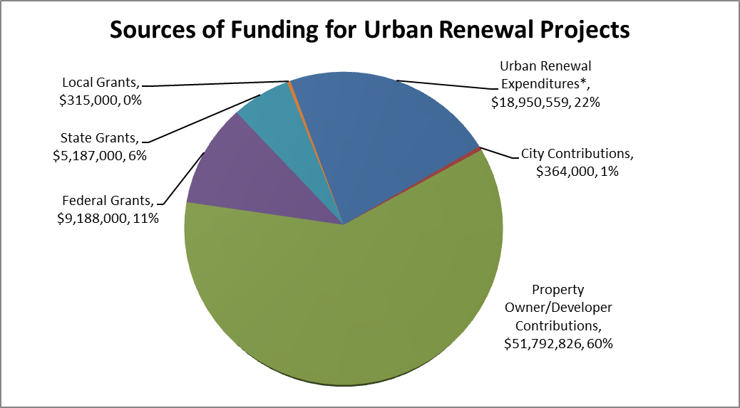

### Table III

### FY 2017-18 Projects

**PROJECTS AMOUNT TOTAL BUDGET ITEM BUDGET**

1. Projects by City in Fund 018 $ 689,904 Capital Projects by City $ 689,904

(See Table IV below)

2. Projects by Urban Renewal

Civic Auditorium Restoration $ 300,000

Opportunity Driven Projects 998,367

Sub-Total $1,298,367 Capital Projects by UR $1,298,367

3. Engineering Services

A. ½ Engineer Costs $ 58,120[1]

a. Wa. St Plaza/RR Underpass/ 1st St Construction;

b. Granada Block; c. Parking Structure

B. Mill Crk Trail Final Design $ 94,500

Sub-Total $ 152,620 Engineering Services $ 152,620

4. Property Rehabilitation

Dong Xi (Avg. $620/mo.) $ 6,676 Chamber of Commerce $ 39,517

Granada Theater Improvements 196,240 Applications Pending 107,950

Craig’s Office Bldg 21,602 New undetermined projects 200,000

Lemke Bldg 21,200

Sub-Total $593,185 Property Rehabilitation $ 593,185

TOTAL: Urban Renewal Projects $982,141 - Does not include Projects by City

Table IV

**Projects in City Fund 018**

# FUND 018 PROJECTS: Washington Street Plaza / 1st St Streetscape /

# Granada Block Redevelopment & Parking[2]

Table V

**Anticipated Project Expenditures Next 2 Years**

# Project FY 18-19 FY 19-20

Property Rehab Grant and Loan Program, New Projects $ 200,000 $ 200,000

West Gateway $ 1,400,000 $ 1,400,000

1st Street streetscaping, parking and bike lanes project $ 94,500

Total $ 1,694,500 $ 1,600,000

Columbia Gateway Urban Renewal

**Capital Projects Fund**

**Fiscal Year 2017-2018 Budget**



Columbia Gateway Urban Renewal Agency

**Fiscal Year 2017-2018**

**Agency: Urban Renewal Agency**

**Fund: Debt Service Fund (210)**

**Program: Debt Service (470)**

**Mission:**

The mission of the Debt Service Fund is to maintain the one-year reserve payment and to continue to make principal and interest payments on the bonded debt.

**Description**

The requirement of the bond document calls for all property taxes of the Urban Renewal Agency to be received in this fund before any of these financial resources are directed elsewhere. The revenues, along with the working capital amount of this fund, must be present for payment of debt when it is required. All recommended budgets meet this requirement.

**2017-2018 Goals, Projects and Highlights**

* A continuation of paying for debt created by bonded debt.

**2016-2017 Accomplishments/Comments**

* Debt payments made.

**Debt Service Fund**

**Fiscal Year 2017-2018 Budget**





**RESERVED FOR ADOPTING RESOLUTION**

1. Work done in priority order until engineer’s time is used up, 50 percent of one engineer for a year.
2. These projects also have funds in Fund 018 Beginning Balance from prior year transfers.